Asbestos Policy and Management Plan

2017-22

Policy Statement
The University of Chichester recognises the responsibilities and duties under the Health and Safety at Work Act 1974, to provide as healthy and safe an environment as is reasonably practicable for all employees, students, contractors, visitors and members of the public.

Under the Control of Asbestos Regulations 2012 the University recognises and accepts its duty to manage asbestos in non-domestic premises.

This Policy and Management Plan relates solely to the management of asbestos containing materials (hereafter known as ACMs), it is a live document and will be reviewed periodically as and when new legislation, Approved Code of Practice (ACOP) and good practice is changed.

Legal Responsibility
The University has an explicit duty to assess and manage the risks from asbestos. The Board of Governors of the University of Chichester is ultimately responsible for the implementation of the University’s Asbestos Policy. The Director of Estate Management has a professional and technical responsibility for the land, building fabric and the permanent services of the University’s estate and compliance with the University’s Asbestos Policy as the duty holder.

The University’s Asbestos Management Plan shall be controlled within the Estate Management Department and will ensure that asbestos management of the University is compliant with current legislation and the University’s asbestos policy.

Asbestos Management Hierarchy

University of Chichester

Board of Governors

Vice -Chancellor

Estates Property Development Director of Estate Management Manager (Responsible Person) Duty Holder

Estates Property Development

Manager Deputy (Responsible Person)
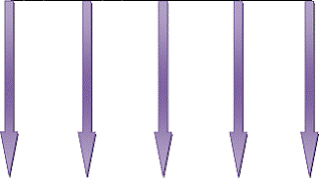

Removal Licensed Contractors
Accredited Analysts
Direct Labour Organisation
Faculties or Departments
External Contractors/ Consultants

Duty Holder’s Responsibility (Director of Estate Management)

- Survey the estate and assets within the University and take reasonable steps to determine the location of ACMs.
- Presume materials to contain asbestos unless there is evidence not to do so.
- Make and maintain a written record of the locations of asbestos materials.
- Assess the risk of exposure and document actions necessary to manage the asbestos. Identify and train personnel to oversee the Asbestos Management Plan (‘Approved Responsible Person’ ARP).

Responsible Person (Estate Management Property Development Manager)

- The Register of ACMs shall be kept up to date and shall provide a record of the location, condition, maintenance and removal for all ACMs on the University’s estate.
- To repair, seal, label or remove asbestos, if there is a risk of exposure due to its condition or location.
- Periodically monitor the condition of ACMs via the approved contractor, update the asbestos register and reassess the risk.
- Make information available to those who may come into contact or disturb ACMs. Information shall be provided in a written/electronic format and shall be correct on the date it is presented.
- Arrangements shall be put in place so that work which may disturb the ACMs comply with current legislation.

Faculty/Department Managers’ Responsibilities

- Ensure that prior to the commencement of any works which may have the potential to bring staff into contact with ACMs, the asbestos register is consulted and information used within the risk assessment for the works, following the University Asbestos Policy and this plan.

Employees’ Responsibilities

- Eat and drink only in agreed locations, keeping the work place clean.
- Follow carefully all the procedures set out in the ‘Method Statement’ for the works.
- Report any defects or suspected ACMs prior to starting/continuing with work.
- Make full and proper use of any control measures put in place for working with or adjacent ACMs e.g. PPE.

3.0 Asbestos Management Procedure
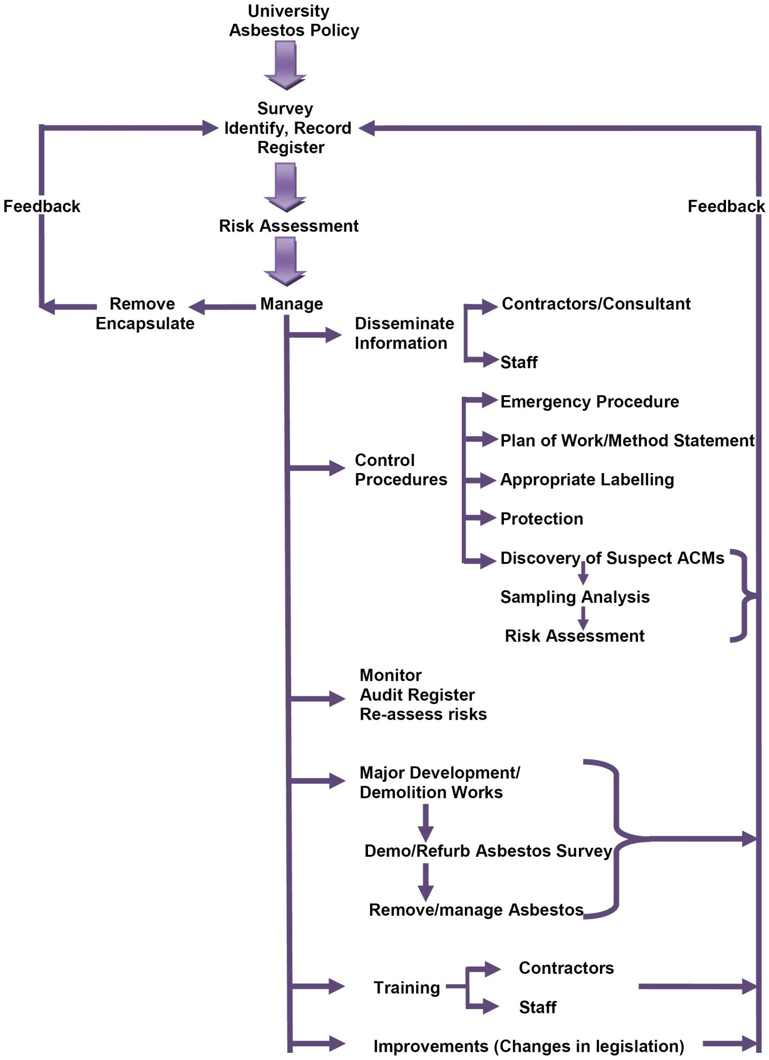

  - Surveying Premises for ACMs

In order to manage the risk from asbestos, the Duty Holder shall ensure that a suitable and sufficient assessment is carried out as to whether asbestos is or isn’t liable to be present on the University Estate.

An initial assessment shall be made as to whether ACMs may be present within the University buildings and areas of the Estate. This will be followed by a management asbestos survey as recommended in HSE Guidance document HSG 264. The survey shall be undertaken by a competent surveyor qualified to BOHS P402. Companies undertaking asbestos surveys and analysis shall be UKAS accredited to ISO17020 and ISO17025.

Asbestos survey reports shall be presented in hard copy or if requested in an electronic format compatible with the current University IT systems and asbestos register and shall provide the following minimum information:-

    - Purpose and date of survey
    - Annotated floor/site plans indicating sampling points and unique references
    - Asbestos material assessment

    - Priority Assessment (to be prepared in consultation with Duty Holder)
    - The Material score and Priority score are added to give the Total risk
    - Recommendation

In advance of all major refurbishment and demolition work a demo/refurb asbestos survey must be carried out as recommended in HSG 264. Survey reports shall be presented in hard copy, or if requested, in an electronic format compatible with the current University IT systems and asbestos register. All information from the survey shall be made available to the Principal Contractor (PC) and included in the Pre Tender Health and Safety Plan where appropriate.

If this is not possible before contract award the management survey will be issued in the pre-tender health & safety plan with amendments to contract that the PC is to complete their own Refurbishment/Demolition survey so the information is obtained pre-construction.

Most University buildings have been surveyed for asbestos. Asbestos risks assessments have been prepared and form part of the University asbestos register. Remaining properties shall be assessed, prioritised and surveyed for ACMs where appropriate as they become part of the building stock.

In the absence of information relating to ACMs within any property it shall be presumed that asbestos is present and therefore appropriate controls dependent on activity shall be put in place to avoid any exposure to asbestos.

Asbestos Register

The current asbestos register was formulated in 2005 and is due for renewal in 2013. A review was completed in 2015 and remains in its current form. Current ACM risk assessments were completed in 2005 and are based on a material/priority score and algorithm which is compatible with that recommended in MDHS 100.

Data contained within the asbestos register will be frequently reviewed and updated annually with physical alterations of the University Estate along with asbestos removal, encapsulation and environmental cleaning works being carried out.

Information regarding ACMs and general information on management of asbestos may be obtained by contacting the Estates Management Team on 6123.

The Estates Department strives to raise awareness of Asbestos materials and encourages University staff to check the asbestos register prior to commencing any work activity. Awareness training has been provided to key personnel within the University and this is regularly updated. Periodic

management reviews will ensure asbestos is considered in all activities and that appropriate checks are made from the asbestos register.

Audit process
Asbestos materials identified within the University asbestos register shall be fully reviewed during 2013.

The audit process shall involve a visual inspection of all ACMs listed in the asbestos register. Each material shall be re-assessed on its condition and likelihood of disturbance by an Accredited Analyst. Results from the audit survey will be fed back into the asbestos database. Where changes are identified, risk assessments and management surveys will be revised, priorities adjusted and appropriate management controls put in place.

Management of ACMs
Identified ACMs have been assessed for risk and categorised in priority order; examples are as follows:-

Priority 1 - High risk (A) Priority 2 - Medium risk (B) Priority 3 - Low risk (C)

The University is committed to reducing the risks from asbestos to a minimum.

The programme for asbestos removal and environmental cleaning work shall continue in accordance with the University Asbestos Policy and within available budgets.

Regardless of priority all ACMs shall as far as practicable be identified and totally removed by specialists in advance of major refurbishment and demolition works.

Asbestos Removal and Environmental Cleaning Works
Works involving the treatment, encapsulation or removal of ACMs shall only be undertaken by University approved HSE licensed contractors.

Licensed asbestos contractors engaged directly by Estates Department or the Principal Contractor for the removal or treatment of asbestos shall:

    - Consult the Asbestos Register and survey information in the Health and Safety plan to assess the risk and ascertain the scope and extent of asbestos removal.

    - Provide a ‘Plan of Work’ for the Project Manager/Principal Contractor as to how the asbestos shall be removed in compliance with current legislation and the University asbestos policy.

    - Notify Health and Safety Executive at least 14 days prior to works to which The Control of Asbestos Regulations 2006 requires this duty to be followed.

    - Notify The Responsible Person when preparing the works for removal to allow independent inspection and testing to be carried out, as required.

Airborne Monitoring
An Independent Analytical company UKAS accredited to ISO17025 (or equivalent) shall be employed to carry out these works on behalf of the University. The analyst must not be employed as a sub-contractor to the asbestos removal contractor.

Clearance Testing
All available information from the University’s Asbestos Register (applicable to areas concerned) shall be made available to the independent analyst prior to commencing these works.

On satisfactory completion of these works, the analyst shall produce a written report in a format that is compatible allowing the University’s Asbestos Register to be updated.

Reassurance Monitoring
Airborne monitoring shall be carried out in areas considered sensitive, or in situations where it is considered necessary, to provide documentary evidence that no leakage has occurred. Reassurance monitoring shall be carried out at the discretion of the Responsible Person.

Personal Monitoring
Licensed contractors ‘working with asbestos’, shall take adequate steps to monitor the exposure of their employees to asbestos, in accordance with current legislation.

Use of Direct Labour and External Contractor (non-licensed)
Direct labour and external contractors who are not licensed by the HSE for works on ACMs are not to carry out any work pertaining to ACM. This includes the following:

    - Asbestos cement – asbestos cement products
    - Articles of bitumen, resin or rubber which contain asbestos
    - Asbestos insulating board where the Control Limit is 0.1f/ml averaged over 4 hours and is sporadic and low intensity (i.e. not exceed an airborne fibre count of 0.6 f/ml averaged over 10 minutes) and be a short, non-continuous maintenance activity as per Regulation 8 under CAR 2006.

Control of Waste Asbestos

Storage and Disposal of ACMs
During and on completion of asbestos removal and environmental cleaning works, ACMs shall be double bagged/wrapped as it is produced. Bags shall be sealed, labelled and cleaned prior to removal from the enclosure.

Bags containing asbestos waste shall be transported along an agreed route for immediate removal from site, or safe storage within a lockable container located in an agreed position on site.

Final removal and disposal of these items shall be arranged via a licensed asbestos removal contractor. All asbestos waste shall be disposed of strictly at a site licensed to receive it all in accordance with the Hazardous Waste Regulations 2009 as amended. The Contractor responsible for disposal of asbestos waste shall provide the University with documentary evidence of safe disposal in accordance with all relevant legislation.

  - Work carried out by/on behalf of Faculties/Departments within the University Prior to commencement of any work where there is a possibility of disturbing ACMs (however minor), the manager who is intending to commission work shall carry out a risk assessment.

A check for the presence of ACMs should be made by contacting the Estates Team on ext 6123 who will check the register and provide appropriate information in a written or electronic report.

An assessment of the report affecting the works shall be made by a competent person who is able to interpret the information and correctly assess any risks identified.

If an initial enquiry is negative it must not be assumed that there is no asbestos. Although every effort has been made to identify locations, destructive investigations have not taken place and no building can be said to be completely free of asbestos. If any suspect material is encountered prior to or during works, works must cease and suspected material must be reported to Estate Department/Asbestos Responsible Person.

If there is any uncertainty as to the accuracy of the details in the register then an asbestos survey must be carried out.

The responsibility for checking information on the Asbestos Register in respect of proposed works by Estate Department will be that of the:

    - Property Management Development Manager
    - Person responsible for commissioning works or issuing works orders

Non-Removal of Asbestos during Building Work
Where a decision is taken by the University not to remove ACMs then precautionary measures shall be put in place. This will include:

    - Information regarding ACMs shall be made available to the contractor prior to the commencement of works.
    - The Contractor shall provide details of the measures to be taken in order to protect the material from damage/disturbance of ACMs arising from the works
    - Routine airborne monitoring of the working area may be requested as reassurance that the work is not disturbing ACMs.
    - Limitation of access controls to be put in place.
    - Limitation of extent of works to be put in place.

Notifiable Non-Licensed Work
All non-licensed work will be carried out with the appropriate controls in place. For notifiable non-licensed work (NNLW), the ARP will:

    - notify work with asbestos to the relevant enforcing authority;
    - ensure medical examinations are carried out; and
    - maintain registers of work (health records).

Non-Licensed Work (NLW)
NLW or non-licensed work shall be determined in each case and will depend on the type of work carried out, the type of material being worked on and its condition. The identification of the type of asbestos-containing material (ACM) to be worked on and an assessment of its condition are important parts of the risk assessment, which is completed before work starts.

If the work is exempt from the need for a licence, the ARP will determine if it is notifiable non- licensed work or non-licensed work by considering the following factors:

The type of work being carried out
    - Maintenance, e.g. drilling holes to attach fittings or pass cables through, painting, cleaning etc. Maintenance includes some removal where it is incidental to the main task,
e.g. removing an asbestos ceiling tile to allow inspection; or
    - Removal, e.g. as part of a refurbishment or redesign project; or
    - Encapsulation, e.g. work to enclose or seal asbestos materials in good condition; or
    - Air monitoring and control, and the collection and analysis of samples.

The asbestos type:
    - Friable? - the more friable a material is, the more likely it will release asbestos fibres when worked on and the greater the risk of exposure.
    - How firmly is the asbestos bonded in a matrix? (For removal work only) – Asbestos containing materials (ACMs) where the asbestos is coated, covered or contained within

another material, such as cement, paint or plastic are considered to be firmly bonded in a matrix, ACMs of this type in good condition can usually be treated as non-licensed work but where they are significantly damaged, and so more likely to release fibres, they will need to be treated as NNLW.

The material's condition:
    - Has the material been damaged or is it in poor condition? – removal of ACMs in poor condition e.g. due to flood or fire damage, will normally need to be treated as NNLW; and
    - Will the materials' matrix be destroyed when worked on? – e.g. deteriorating textured decorative coatings e.g. 'Artex' with gel or steam to remove it, will normally need to be treated as NNLW.

Examples of NNLW include:
- minor, short duration, maintenance work involving asbestos insulation board (AIB), e.g. repairing minor damage to a small section of pipe insulation where the exterior coating has been broken or damaged;
- minor removal work involving AIB, when short duration and as part of a refurbishment project, e.g. removing AIB panels fixed with screws following water damage;
- entry into the roof space above an AIB tiled ceiling, when no decontamination or cleaning has taken place;
- removal work involving textured decorative coatings where the method of removal requires deterioration of the material, e.g. where the material is treated by steam, hydrating gel etc. and scraped off the underlying surface, or where it is very badly flood-damaged;
- removal of asbestos paper and cardboard products if not firmly bonded in a matrix;
- removal of asbestos cement (AC) which is substantially degraded e.g. badly fire-damaged or de-laminated material, or where substantial breakage is unavoidable to achieve removal.

NNLW will not normally include the following, which will continue to be categorised as non- licensed work (which is not notifiable).
- short, non-continuous maintenance work involving AIB which is in good condition, e.g. drilling holes in AIB to attach a fitting or pass through a cable or pipe, cleaning light fittings attached to AIB, removing a door with AIB fire-proofing, or lifting ceiling tiles for inspection where there is no full-body entry into the roof space;
- short, non-continuous maintenance work on asbestos cement (AC), e.g. work on weathered AC roof tiles;
- removal of AC, which is kept virtually intact;
- short, non-continuous maintenance work on textured decorative coatings, e.g. drilling holes, inserting screws or painting;
- small-scale maintenance work with textured decorative coatings when this can be achieved without deterioration of the material, e.g. by careful cutting around backing sheets to achieve removal intact;
- removal, for example, of gaskets or asbestos rope cords from heating appliances, which can be left in situ for disposal or can be lifted out virtually intact, without substantial breakage;
- short, non-continuous maintenance work on clutch discs, brakes, friction products, etc., unless significant damage is required e.g. by power tools;
- removal of floor tiles or bitumen felt, when done with the appropriate controls, e.g. inline
- work to enclose or seal asbestos materials that are in good condition (and that do not require a licence);
- air monitoring and control, and the collection and analysis of samples.

Notification
The ARP will notify the relevant enforcing authority of any NNLW with asbestos:
- Notice is required before the work starts - there is no minimum notice period;
- The ARP does not need to wait for permission from the enforcing authority – the database will provide a PDF copy of your notification;
- If the project involves multiple NNLW jobs, the ARP can notify once for the whole project;

Medical Surveillance
- By 30 April 2015, all workers carrying out NNLW will have a medical examination.
Examinations will need to be repeated at least every 3 years, as long as the worker continues to do NNLW.
- After April 2015, workers carrying out NNLW for the first time will have an examination before they can start such work:
- The doctor will issue a certificate to confirm the examination has taken place and on what date. The ARP will keep this certificate for 4 years; Registers of work (health records) will be kept for 40 years.

Emergency Procedure: - Reporting of Suspected ACMs

Identification of Disaster Zone
The following procedure should be followed whenever suspected ACMs or a disaster zone is identified:-

    - Stop work immediately.
    - Isolate the area, i.e. shut doors and windows etc.
    - Post warning notices and inform people in the immediate area and request that everyone keep away.

    - Make contact with Estate Management Team on ext. 6123 and provide details of the occurrence.
    - In circumstances where no records are available Estates Department shall organise for samples to be taken for analysis by a UKAS accredited testing, sampling and analysis laboratory.
    - Appropriate risk assessments and control procedures shall be agreed following consultation with the University’s Estates Department, the Responsible Person and implemented to avoid exposure of ACMs to building users.

    - The Estates Department will check the register to establish whether ACMs are present.
    - Do not allow works to continue on any materials, which are suspected of containing asbestos.
    - If suspected ACMs have been damaged or disturbed during work(s) in progress, the materials should be left in-situ, the work(s) suspended and the area isolated pending further investigation.

    - Do not attempt to take a sample. The actual act of sampling asbestos can expose the sampler to dangerous levels of fibres and it is possible to contaminate the surrounding area.
    - If out of hours and the area requires specialist cleaning or making it safe, contact security or Estate caretakers who will contact the Estate Management Team.
    - Encapsulation, treatment or removal of disturbed ACMs shall be carried out in accordance with current legislation before areas are re-occupied.

In circumstances where a ‘site’ is under the control of a Principal Contractor and ACMs are discovered, the Procedures contained in the Construction Phase Health and Safety Plan should be followed and the Project Manager and Construction Design and Management Coordinator (CDMC) informed as soon as practical.

Training
It is essential that as well as recognising the hazard, every effort is made to minimise/eliminate the risks to the working population by effectively controlling and managing all work where asbestos is present. Training shall play an important role within the University Asbestos Risk Management System.

University Staff
Appropriate training shall be identified, prioritised and delivered to the following groups:

    - Managers (Estate Department) responsible for the:
      - Commissioning of asbestos surveys/bulk sample analysis.
      - Commissioning and management of specialist asbestos removal / environmental cleaning works
      - Management of the University’s asbestos register
      - Management, organisation and supervision of works carried out by contractors or staff
    - Managers (University wide) responsible for the:
      - Management, organisation and supervision of ‘works’ carried out by general contractors or staff
    - University Staff
      - Any person who may come into contact with ACM’s

Periodic refresher training shall be provided to keep abreast of changes in legislation and working practices. Records of training will be kept on the Health and Safety Training database.

Contractors
The University shall actively select contractors for inclusion on the approved General Contractors list that can demonstrate their competence and understanding of asbestos issues and provide evidence that staff have received asbestos awareness training. The effectiveness of training will be evaluated by audit of compliance to policy and procedures.

15.0 Review of Asbestos Management Plan
The Asbestos Management Plan shall be reviewed biannually by the Estates Department in respect of changes made to relevant legislation, University working practices or the University Asbestos Policy.

16.0 Relevant Legislation, Approved Codes of Practice (ACoPs) and HSE Guidance The Asbestos Management Plan has been drawn-up in accordance with, and to comply with, the following legislation.

Legislation

- Health & Safety at Work Act 1974
- Management of Health & Safety at Work 1999
- Control of Asbestos Regulations 2006 and 2012
- Hazardous Waste Regulations 2009
- Construction (Design and Management) Regulations 2007 Approved Codes of Practice (Health and Safety Commission)
- L127 Management of asbestos in non-domestic premises
- L143 Work with materials containing asbestos
- L144 CDM Regulations 2007

Guidance documents HSG 264
HSG 248
HSG 247
HSG 210
HSG 227 HSG 189/2

