Biodiversity Action Plan 2020-2022

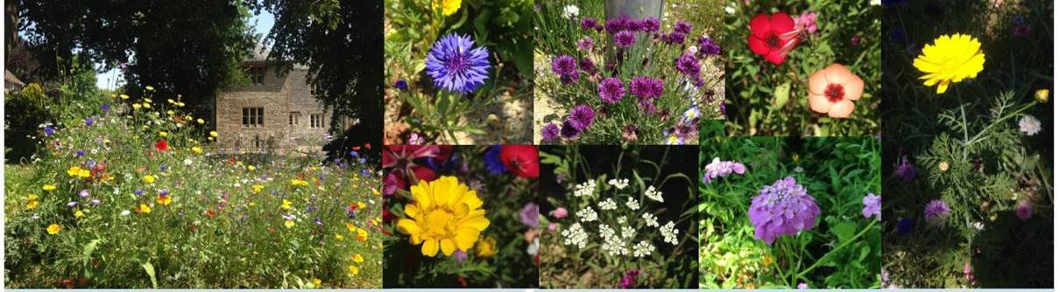

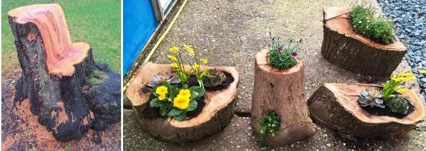

Contents

Section | Title | Page Number
1 | World Overview | 2
2 | The importance of biodiversity on University campuses | 2
3 | Background to biodiversity at The University of Chichester | 4
4 | Past biodiversity initiatives at The University of Chichester | 5
5 | Current state of biodiversity on the University’s campuses | 10
6 | Future actions | 11
6.1 | Species action plans | 11
6.2 | Overall action plan | 16

World Overview

Biological diversity, now commonly termed biodiversity, is defined as “ the existence of a wide variety of plant and animal species living in their natural environment”. Emphasis on the need to conserve biodiversity was initiated nearly 20 years ago at The United Nations Conference on Environment and Development held in Rio de Janeiro, Brazil in 1992. This conference became known as the Rio, or the Earth Summit and produced the Convention on Biological Diversity (CBD) which advocated the establishment of national policies that would identify existing biodiversity. It also enforced these national strategies through biodiversity action plans (BAPS) which were produced by each country. One hundred and ninety two states and the European Union were parties to this treaty that had three main aims;

  - the conservation of biological diversity
  - the sustainable use of components and
  - the fair and equitable sharing of benefits arising from genetic resources.

The objective of these BAPS was to identify, then plan to conserve, protect and where possible enhance existing biodiversity. The current UK BAP, the UK Post-2010 Biodiversity Framework, produced by the Joint Nature Conservation Committee (JNCC) and Defra, was published on 17 July 2012 and covers the period 2011 to 2020. The development of the Framework reflected a revised direction for nature conservation, towards an approach which aims to consider the management of the environment as a whole, and to acknowledge and account for the value of nature in decision-making.

The importance of biodiversity on University campuses

The Further and Higher Education (FHE) sectors have an important part to play in conserving our natural heritage. According to partial and approximate figures from the Higher Education Funding Council for England (HEFCE) (now the Office for Students), more than 11,400 hectares of land belong to Higher Education institutions in England. In total, the land area within FHE campuses across the UK is likely to amount to an area similar to the size of the Isle of Wight, about 38,000 hectares! It goes without saying therefore, if all FHE institutions conserve and enhance biodiversity this will make a massive difference to plants, animals and ecosystems.

FHE institutions also have a responsibility for educating the next generation of leaders about the importance of biodiversity and wider sustainability issues. This was recognised at the Rio+20 conference in 2012, where institutions across the world were encouraged to integrate sustainable development across disciplines and progress with related research. Biodiversity initiatives are a crucial way to engage students and staff in sustainable development and provide a visible example of best practice.

In 2006, the Environmental Association for Universities and Colleges (EAUC) identified nine benefits for universities that have an active biodiversity agenda, which still hold true today:

  - Improved reputation and image for environmental sustainability

  - Potential to develop partnerships between staff and students

  - Opportunities for incorporating sustainability and biodiversity in education and the curriculum

  - Campus contribution to healthy living and wellbeing

  - Enhanced volunteering opportunities for students

  - Greater support from local authorities for planning and new development

  - Cost savings in maintenance

  - Legislative compliance

  - Wider benefits in terms of flood reduction and carbon reduction.

This list of benefits further highlights how managing biodiversity on campus has far more wide-reaching effects beyond those of preserving wildlife. In addition to enhancing the diversity of habitats and species, an attractive natural environment can contribute to human physical and mental well-being. Engaging staff and students in biodiversity projects on campus can encourage a sense of ownership and belonging and provide opportunities for partnerships with the local community. From a financial perspective, managing land for biodiversity rather than intensive horticulture, can result in considerable cost savings. The BAP is an ideal opportunity for the campus to become both an interactive learning environment for students and a superb teaching resource.
Biodiversity initiatives can also play an important role in emphasising broader environmental and sustainability issues and will enhance environmental awareness and personal responsibility amongst graduates. The opportunities for voluntary work experience provided by student groups and societies can be invaluable and often contribute to securing paid employment following graduation.

Background to Biodiversity at the University of Chichester

In 2010, the University of Chichester published its first Environmental and Sustainable Development Strategy 2010-2013, in which the commitment to “maintain and improve diversity within the University’s estate” was stated. The first Biodiversity Action Plan produced by the University (UOC BAP), was published in April 2011 to help to achieve this aim and to contribute to the UK and Sussex local BAP. Since then, this commitment has continued through subsequent Environment and Sustainable Development plans and is now a key strategic theme in the University’s Strategic Plan 2018 to 2025 and the Estate Strategy 2018 to 2025. Both committing to “develop attractive and environmentally sustainable campuses”. This fourth, UOC BAP, is published to record the achievements of the past three years and to highlight those areas that continue to require actions.

The BAP seeks to fulfil the following objectives:
- To raise awareness of biodiversity on campus and the need to maintain and enhance it.

- To maintain and enhance biodiversity on campus through the implementation of the campus action plans

- To engage students and staff in biodiversity projects and initiatives that will enhance their University experience

- To incorporate biodiversity actions and monitoring into the curriculum.

Past biodiversity initiatives at The University of Chichester
Google maps of both campuses, Bishop Otter (BOC) and Bognor Regis (BRC) (Figures 1 and 2) show both contain many green areas and open spaces. These maps were produced in August 2018, before the construction of the Technology Park at BRC.

Figure 1 Google map of BOC Figure 2 Google map of BRC
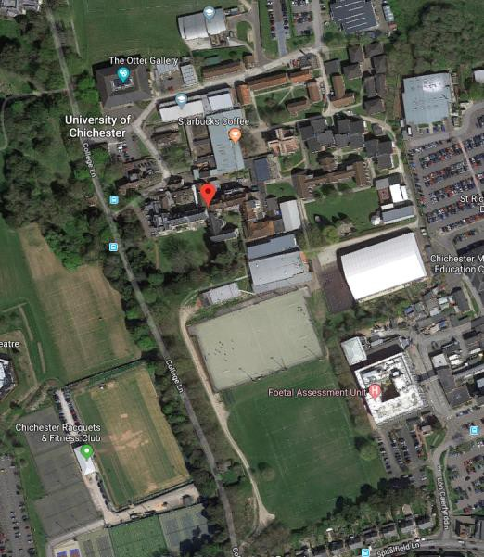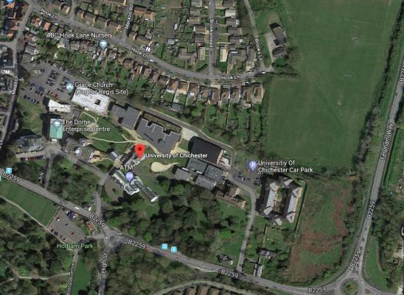

Since the first BAP was produced by the University in 2010, many actions to conserve habitats and species have focussed on ongoing maintenance of these areas. The following table details progress to the specific actions highlighted in the previous biodiversity plan, which was produced in 2017.

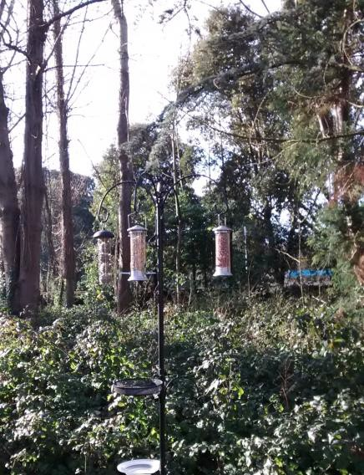Figure 3 Bird feeders on campus

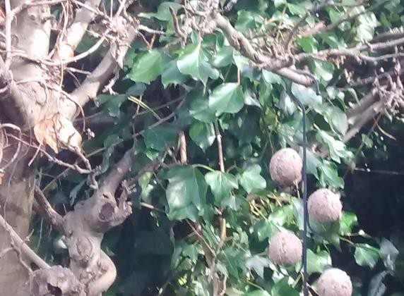

Objective | Previous actions | Actions required 2017 to 2020 | Progress
Conserve native, non-native, broadleaf and evergreen trees that are distributed across both campuses. Incorporate native broad leaf trees, oaks, beeches, birches and maples during the design stage of new planting schemes to provide habitats for flowering plants, fungi, lichens, birds,  mammals and invertebrates. | Oak trees were planted in 2012. | Continue with tree planting scheme. | Trees removed due to disease, including ash dieback, have continued to be replaced with native species. Native saplings continue to be grown by our gardening team to be planted on campus.
Support the Green Campus initiative to plant and reinstate orchards to encourage vascular, nonvascular organisms, flora and fauna.  Acquire mixed fruit trees, plant heritage varieties  where possible. | Fruit trees were planted in the allotment area behind the sports dome at BOC. | Identify further areas for establishing new orchards. Longbrook  green and the area by the serpentine wall have been identified. Green Campus Group funds are to be allocated to refresh  the existing Longbrook orchard by November 2020. | Due to works required on the serpentine wall, no trees have been planted in this area. The action to purchase fruit trees for the Longbrook orchard has been included in this BAP. An action to produce maps of both campuses highlighting areas designated to enhance  biodiversity has also been included in this BAP.
Preserve the existing areas of meadow land. Allow areas of rank vegetation to grow. Do not restrict the growth of other vegetation. Plant areas with wild flowers. Mow grass  less often. | Areas of grass identified Grass allowed to grow, without mowing on the Bognor Regis Campus. | Investigate the possibility of allowing the grass on the bank of Bishop Otter campus LRC to grow as an area of rank vegetation along with the area near the main car park. | Wildflower seeds were sown on the bank behind the LRC at BOC. The area was then left unmown. Due to the proximity of this site to the main entrance, this was not deemed to be the  best use of this land.
Aim to decrease the use of pesticides and chemicals on the land. Create barriers when  Used. |  | Provide records of pesticides and chemicals used. | Minimal chemicals used on campus.
Maintain the existing ponds. Increase and re-instate ponds across the campuses to provide habitats for amphibians, herptiles, birds, animals and insects. Use pond plants to encourage specific  species including dragon flies | Pond removed from BOC during construction works. | Monitor the existing pond. | The pond at BRC has been monitored and maintained.
Conserve the existing marsh land. Use the natural water supply to create or enhance marshes. Establish marsh  plants at both campuses. |  | Identify areas for establishing new marsh or bog areas. Work with design team for the new  Technology Park. | Fenced off areas used as balancing pool for displaced water.

Objective | Previous actions | Actions required 2017 to 2020 | Progress
Continue support for the Green Campus bird box initiative by checking the condition of the boxes and replacing those lost or damaged. As each newly planted tree grows to sufficient size, ensure a box is attached  to tree | Periodic checking of boxes carried out. | Aim to increase the number of boxes across both campuses. Provide more bird boxes over the next 3 years. | Twelve bird boxes were installed on trees across the campuses.
Continue support for the Green Campus bat box initiative. Aim to increase the number of boxes across both campuses. Periodically check the condition of the boxes. | Periodic checking of boxes carried out. | Organise a ‘bat watch’ during a summer evening or night. Survey external lighting to encourage migrating routes and roosting. Further watches being organised by the Estate Management Team as part of campus  developments. | External lighting was surveyed with a bat specialist in September 2018. Bat survey carried out as part of the Tech Park development. No progress on a bat watch. This action has been included in this BAP.
Ensure more allotments are established. Grow vegetables on the campuses to increase the biodiversity of plants and  help to decrease individual’s food miles. | Allotments on both campuses have been established. | Monitor the use of the allotments. Provide necessary equipment for the successful functioning of the allotments. | Construction of the Tech Park has led to the removal of allotment space at BRC. Support for the allotments at BOC has continued.
Maintain the landscaped areas at both campuses. Plant an increasing number and diversity of nectar rich flowering plants. | Wild flower seeds sown at various sites across the campuses. Areas, for example, at the back of the LRC at BOC  allowed to self seed. | Plant more nectar rich flowering plants on both campuses. | Wildflowers sown along the dual purpose path installed at BOC in July 2017.
Plant nut trees as a food source and habitat for squirrels. |  | Plant nut trees in new orchards by November 2018. | Due to budgetary constraints, no new nut trees were planted. This  action has been included in this BAP.
Increase habitats and food for bees. | A number of nectar rich plants have been planted across  the campuses. | Investigate the possibility of having permanent bee hives sited on both campuses by 2020. | The provision of bee hives is not deemed feasible at this time, on either campus.

In 2007, a group of University staff interested in biodiversity, formed the Green Campus Group. This group, which now also includes student members, continues to monitor, advise, suggest and take practical steps to help to contribute to the University’s ecosystem, working with the estate management team. The primary duty of the Green Campus Group is to ensure that environmental and sustainable development issues remain prominent in all University activities. The Group considers conservation in terms of global as well as a local scale. Since

its inception, the group has considered inter alia, ponds, bird boxes, bat boxes, bee keeping, allotments, Fairtrade, sustainable travel, solar energy, the design of new buildings on campus and the maintenance and planting of trees.

The Green Campus Group’s actions have included the installation of bat boxes and a pond at the Bognor Regis campus. At the Bishop Otter campus, bird boxes and bird feeders have recently been provided (Figure 3). In September 2018, a bat specialist was invited to both campuses to educate the group’s members and the Estate Management team on potential roosting and commuting areas for bats. Since 2011, the group has been involved in the annual Spring Fair to help raise funds for purchase of new trees, seeds, plants and equipment. Since 2015, the Green Campus group has worked with second year event management students to organise the fair. The students have taken on the role of event managers producing the fair on behalf of the Green Campus Group, as part of their assessed course work. This has helped to engage students in sustainability and incorporate sustainability in the curriculum. Social responsibility has been incorporated in the fairs with different local associations and charities being invited to attend. Groups attending have included the local fire brigade, bee keepers, St Wilfrid’s Hospice, cycling organisations and a local camera club. The Green Campus Group took part in the University’s Well Being week in 2018 with an exhibition and offered tree walks.

The University has continued to engage new students in sustainability and biodiversity initiatives through the annual Freshers’ Fair. In 2019, approximately 150 plants were given away to promote our biodiversity ethos (Figure 4).

Figure 4 Student engagement in sustainability and biodiversity at Freshers’ Fair 2019
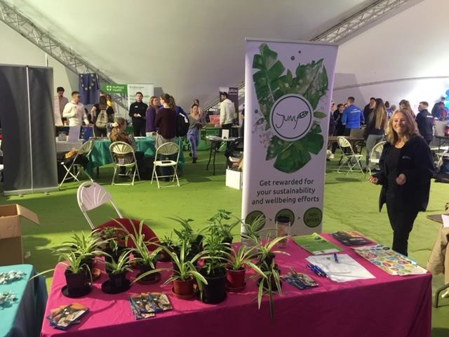

Biodiversity was also an integral part of Green Week held in November 2019. Events and activities designed to engage both staff and students included tree walks, a presentation on rhinoceros conservation in Africa, the presence of Nellie, a giant fish shaped bin to highlight plastic pollution in oceans (Figure 5), stalls selling eco products (Figure 6), a beach clean and the giving away of 150 plants. Beach cleans are now a monthly feature from our Bognor Regis campus.

Figure 5 Nellie a giant fish shaped bin made from recycled materials to highlight marine pollution
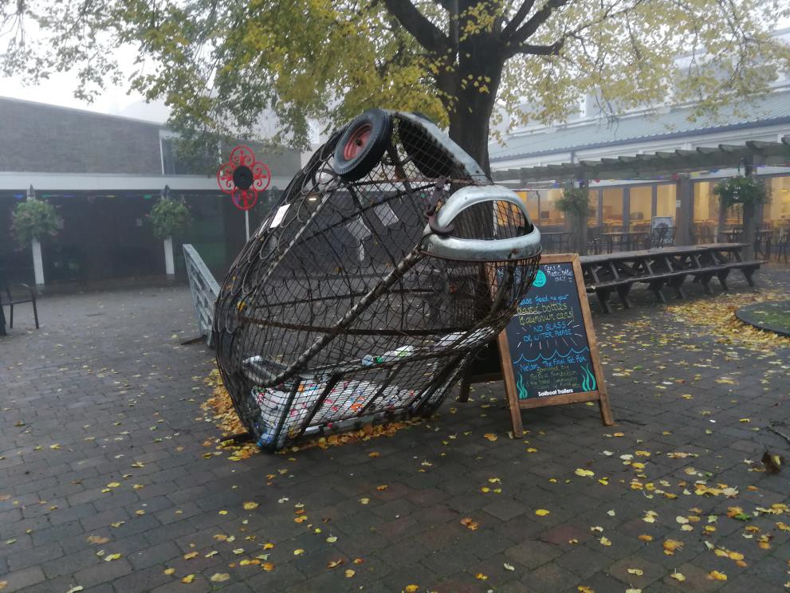

Figure 6 Sale of products made from reused materials
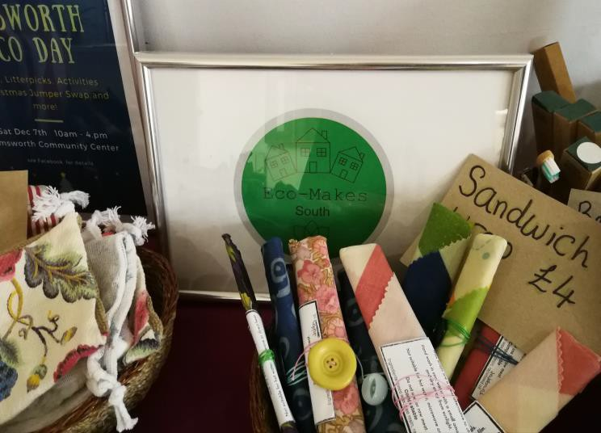

The University’s commitment to preserve and enhance biodiversity during construction of new builds and refurbishments, has continued through its BREEAM targets. These are outlined in the Environment and Sustainable Development Plan 2017 to 2022. Both the Academic Building and Technology Park received BREEAM excellent and refurbishment of the Music Block awarded BREEAM Very Good.

Current Status of Biodiversity on the University’s campuses
A list of species seen on campus grounds has been complied using excerpts from diaries kept by members of staff across both campuses since 2011. These journals and photographs help to identify species, inform and update the biodiversity plans. It is anticipated however, that changes to the campuses and in external areas in their immediate vicinity, may inadvertently impact local diversity. For example, since the development of the new Graylingwell Estate adjacent to the Bishop Otter campus, the continued siting of some species, such as deer, cannot be confirmed.

A number of ecological surveys on newts and other natural species, including bats, were carried out in 2015, before the construction of the Technology Park in 2017.

Bat activity in the Technology Park area was found to be relatively low and dominated by common pipistrelle (Pipistrellus pipstrellus). Both common and soprano pipistrelle (Pipistrellus pygmaeus) were recorded over the site. In addition, a small number of calls characteristic of Nauthusius pipistrelle (Pipistrellus nathusii were recorded and a single Myotis call. Commuting routes of bats were also identified along with social behaviour and foraging in the trees and gardens. Recommendations to enhance the habitat highlighted have been included in the campus action plans.

A bat specialist from the Hampshire Bat Society visited both campuses in September 2018. Many potential roosting sites and commuting routes were identified on both campuses which will also be maintained through the actions in this BAP.

The reptile survey at our Bognor Regis campus identified a low population of slow worm and common lizard to be present. Additional enhancements to improve the site post construction, including the creation of hibernacula and the implementation of a vegetation management scheme to benefit reptiles were highlighted. These have been included in the action plans.

In the past few years some trees were lost due to disease, landscaping, construction works and environmental conditions, including extreme high winds. More recently ash dieback has necessitated the removal of many trees. The University’s policy of replacing all trees lost, has continued. This policy has been boosted with the securement of 420 saplings from the Woodland Trust to be planted in November 2020. These saplings will comprise a mixture of hawthorn, hazel, rowan, blackthorn, silver birch and common oak to attract wildlife.

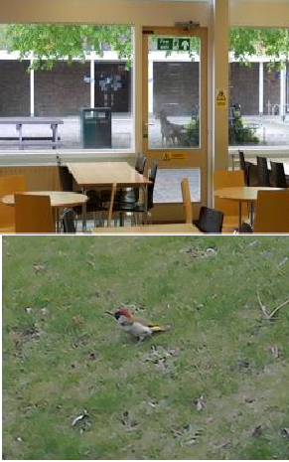
Below are a few pictures taken from previous Biodiversity Plans from the University showing a diverse range of animals that have been seen historically on the campuses. This information and information from the other sources mentioned earlier, has been used to form the species action plans (SAP).

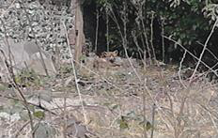 | A healthy fox on the Bognor Regis Campus Spring 2013. |  | These deer were seen during mid- winter in 2015.
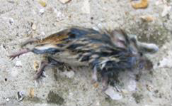 | A dead small rodent photographed on the Bishop Otter campus shows that these mammals have found homes on  the grounds. |  | Green woodpecker on the Bognor Regis Campus

Future Actions

Previous BAPs produced by the University have included ongoing actions for all species and habitats, with particular attention being paid to species identified from past sightings and those identified as ecologically important. In this BAP, those listed as UK BAP Priority species are also highlighted. The original species action plans (SAPs) reproduced in the sections below, have been used to produce fewer SMART targets to maintain and enhance biodiversity on our campuses. These SMART targets form the basis of the Action Plan 2020 to 2022 (Table X). Progress to these targets will be monitored and reviewed by the Green Campus Group and the Estate Management Team. In order to maintain and improve biodiversity on our campuses it is vital that we engage with all users of them. This prerequisite is included as a specific action in the plan.

  - Species action plans
Birds

Species | Ongoing action to enhance existing habitats | UK BAP  Priority List species?
Wood Pigeons (Columba  paulumbus) | Conserve existing habitats and food sources. Increase the number of invertebrates across the campuses as a  food source. | No
Blackbirds (Turdus merula) | Conserve existing habitats and food sources. Provide marsh or boggy environments for the mud linings of  Blackbird’s nests. | No
Chiffchaffs  (Phylloscopus collybita) | Conserve existing habitats. Conserve and grow trees that will reach a height of over 5 metres (circa 16 feet) tall. | No
Falcons (Falco). BOC only | Conserve existing habitats and food sources. Increase the number and species of birds (prey) across the  campuses. | No
House Martins (Delichon urbica) | Conserve existing habitats and food sources. Permit the species to build nests on buildings. | No
Magpies (Pica pica) | Conserve open grassland and hedgerows as feeding and  breeding areas. | No
Mistle Thrush (Turdus viscivorus) | Conserve Broad leaf trees as preferred habitats for this species. | No
Pheasants  (Phasianus colchicus) | Conserve existing habitats and food sources. Provide sources of water and maintain woody areas. | No
Robins, (Erithacus rubecula) | Conserve existing habitats and food sources. Increase the number of bird feeders across the campuses. Provide food on bird tables especially during harsh winters. | No
Tree-creepers (Certhia familiaris) | Continue support for the Green Campus bird box initiative. | No
Wagtails (Motacilla) | Conserve existing habitats and food sources. Increase the number of invertebrates across the campuses. | Yes – yellow wagtail
Woodpeckers (Picus) | Conserve existing habitats and food sources. Grow tall trees. Maintain environmentally friendly grounds to  ensure a plentiful supply of ants and insects as a food | No

 | source.
Seagulls (Larus) | Conserve the existing habitats. Treat the species as part of the ecosystem. Flocks may become prey for Falcons. | No
Jay (Garrulus  glandarius) | Conserve and grow trees, continue to provide wooded  areas and Oak trees for acorns as a source of food. | No
Black headed seagulls (Chroicocephalus  ridibundus) | Encourage insects as a food source. | No
Herring Gull (Larus argentatus) | Although these birds are scavengers they should be treated as part of the eco system, their numbers are  declining. | Yes
Nuthatches (Sitta europaea) | Conserve and grow trees that will reach a height of over 5 metres (circa 16 feet) tall. | No
Tits (Paridae) Blue  tits, great tits, coal tits, long tailed tits | Conserve and grow trees, some varieties of this bird will feed successfully in conifer trees. | No
Sparrow (Passer domesticus) | Although these birds are scavengers they should be treated as part of the eco system. Their numbers are  declining. The birds will also feed on insects in flight. | Yes
Wren (Troglodytes troglodytes) | Conserve and grow trees, encourage insects as a food source | No
Goldcrest (Regulus regulus) | Conserve and grow existing Pine trees. Encourage flocks of other small birds to visit the campus grounds.  Encourage insects as a food source. | No
Redstart (Phoenicurus phoenicurus) | This species of bird is on the Amber List of birds requiring conservation measures, their preferred habitats include oaks, hedgerows, streams, parkland and coastal scrub all  conditions available on the Bognor Regis Campus. | No
Crow (Corvus corone) | Although these birds will attack other bird’s chicks and eggs they should be treated as part of the eco system. | No
Pigeon  (Columbidae) | Conserve the existing habitats. Treat the species as part  of the ecosystem. Flocks may become prey for Falcons. | No
Collared dove  (Streptopelia decaocto) | Conserve existing habitats. Eats weed seeds and occasionally invertebrates and shoots.
Green finch (Carduelis chloris) | Conserve and grow trees including fruit trees as a source of food. | No
Blackcap (Sylvia atricapilla) | Conserve and grow trees including fruit trees as a source of food. | No
Redwing (Turdus iliacus) | Conserve and grow trees including fruit trees as a source of food. | No
Goldfinch (Carduelis carduelis) | Conserve and grow trees | No
Ducks (Anas) BRC only | Conserve habitats. Maintain open areas for the ducks to have easy access to wetlands. | No

Mammals

Species | Ongoing action to enhance existing habitats | UK BAP  Priority List species?
Grey squirrels (Sciurus carolinensis) | Conserve existing habitats and food sources. Plant nut trees as a food source and habitat. | No
Deer (Cervidae) BOC only | Conserve the existing habitats. | No
Badgers (Meles meles) | Conserve the existing habitats. | No
Bats (Chiroptera) | Conserve the existing habitats. Plant more specimens to attract moths. Aim to decrease surplus artificial light at night. | Yes - Barbastelle Bat, Bechstein's Bat, Noctule, Soprano Pipistrelle, Brown Longeared Bat Greater Horseshoe Bat,  Lesser Horseshoe Bat
Hedgehogs (Erinaceous europaeus) | Conserve existing habitats. Increase the existing population. Provide more habitats including compost bins and log tunnels. Increase the food  supply through environmentally friendly grounds maintenance. | Yes
Rabbits (Leporidae) | Conserve the existing habitats. Treat the species as part of the ecosystem as they will be a food source for a number of predators. | No
Foxes (Vulpes vulpes) | Conserve the existing habitats. Treat the species as part of the ecosystem | No
Dormice (Muscardinus avellanarius) | Conserve and grow trees including fruit trees with flowering plants as a source of food. | Yes
Shrews (Sorex araneus) | Encourage insects as a food source. | No
Domesticated Cats (Felis catus) | Conserve the areas used by these animals. Maintain the ecosystems of the campuses to attract more biodiversity. | No

Amphibians

Species | Ongoing action to enhance existing habitats | UK BAP  Priority List species?
Common frogs (Rana  temporaria) | Conserve the existing habitats. Aim to increase the numbers of herptiles across the campuses. Provide more marsh boggy areas and ponds. | No
Common toads (Bufo bufo) |  | Yes
Smooth newts  (Lissotriton vulgaris) |  | No

Invertebrates

Invertebrates are the most numerous and diverse species on earth, making up at least 65% of all species on the planet. They include insects, spiders, snails, woodlice, worms, millipedes and centipedes, false scorpions, mites and earthworms. They perform a range of vital functions within ecosystems such as pollination and decomposition, and are also essential prey for many bird, mammal and amphibian species. Invertebrates can be encouraged by the provision of an array of microhabitats on including ponds, compost heaps, rockeries, flower borders and shrubberies.

Species | Ongoing action to enhance existing habitats | UK BAP  Priority List species?
Slow Worms (Anguis fragilis) | Conserve existing habitats. | Yes
Aphids and all insects | Conserve existing habitats and food sources. Regard the insects as part of the ecosystem.
Moths | Plant moth ‘friendly’ trees and shrubs. | Specific species
Stag-beetles (Lucanus cervus). | Conserve existing habitats and food sources. Allow wood to decay on soil. Allow fruit to decay on soil. | Yes
Spiders (Araneae) | Conserve existing habitats and food sources. Construct  wood piles. Increase the number of insects on the campuses as a food source. Provide water sources. | No
Fig Wasps (Agaonidae). | Conserve the existing fig trees on the campuses as a food source and as habitats. When choosing figs to plant use species that are not self-fertile to attract fig  wasps. | No
Ladybirds (Coccinellidae) | Conserve existing habitats and food sources. | No
Bees (Apis) | Conserve existing habitats. Increase habitats and food sources. | No
Brimstone) Butterflies (Gonepteryx rhamni) | Conserve existing habitats and food sources. Increase the number and diversity of nectar rich plants across the campuses. Encourage the growth of thistles. | No
Orange Tip Butterflies  (Anthocharis cardamines) | Conserve existing habitats and food sources. Allow bluebells (Hyacinthoides) and dandelions (Taraxacum officinale) to naturalise and spread. | No

Tortoiseshell Butterflies (Aglais  urticae) | Conserve the existing habitats. Allow nettles, weeds and brambles to grow as food sources. Allow  hibernation within buildings on the campuses. | No
Worms | Conserve the existing habitats. Improve the condition of the soil.
Ants | Conserve the existing habitats. Maintain areas, trees  and the ecosystem using environmentally friendly methods.
Crickets (Gryllus) | Conserve the existing habitat that includes grass and bare earth patches. | Yes Mole and Field Crickets

Overall Action Plan

An action plan, containing combined SMART actions to protect and increase both species and habitat biodiversity, has been created for both campuses. Additionally, separate plans have been produced for each campus to take into account the differing natural and created habitats and species inhabiting them. This will ensure the ongoing actions identified in the SAPs are achieved. Progress towards these objectives will be reviewed at least annually by the Green Campus Group and the main achievements will be highlighted in the annual sustainability statistics to be included on the University’s website.

Both campuses

Objective | Action | Outcome | Target year | Resources required | Responsibility
Conserve and enhance habitats | Map land use on each campus including commuting routes such as hedgerows, feeding and breeding areas for wildlife, compost areas, orchard and nut tree areas, old tree trunks and basking sites for invertebrates.  Map quantity and location of bird and bat boxes, bug hotels, bird feeders and water. baths etc. | Habitat provision identified for maintenance and improvement | 2020 | Map production by Estate Surveyor | Environmental Co-ordinator
Conserve and enhance habitats | Increase the numbers of bird and bat boxes, bug hotels, bird feeders and water baths etc. where necessary. Add hedgehog  houses and feeding stations. | Deficiencies in habitat provision corrected. | 2020 | Funding for bat boxes etc. to be sought through Jump prize  money. | Environmental Co-ordinator
Conserve and  enhance habitats | Ensure recommendations from  tree survey are carried out in a timely fashion. | Tree cover and  diversity maximised. | 2020 |  | Estate Management

Objective | Action | Outcome | Target year | Resources required | Responsibility
Conserve and enhance habitats | Plant saplings obtained from the Woodland Trust. Encourage staff and students to help with  planting. | Increased tree cover to encourage  wildlife. | 2020 | Staff and student volunteers and  gardeners | Environmental Co-ordinator and Estate  Management
Conserve and enhance habitats | Install a water butt on each building where feasible. Use this water for garden watering, external cleaning, refilling ponds  and bird baths during times of drought. | Conservation of water | 2022 | Funding for water butts. | Environmental Co-ordinator and Estate Management
Conserve and enhance habitats | Achieve BREEAM excellent for new builds and very good for refurbishments obtaining maximum points for diversity where feasible. | Increased biodiversity on campuses during new builds and  refurbishments | Ongoing |  | Estate management
Provision of more space for wildlife | Using the biodiversity maps generated for each campus determine areas for mixed fruit trees, nut trees, native broad leaf trees such as oaks, beeches,  birches and maples and nectar rich plants. | Increased habitats for fauna and flora. | Areas chosen 2021  Areas  planted 2022 |  | Estate management
Provision of more space for wildlife | Ensure lighting is wildlife sensitive using advice from Hampshire bat survey | Bats not dissuaded from using areas due to lighting | 2020 | Expertise from Energy Officer | Environmental Co-ordinator
Provision of more space for wildlife | Ensure compost and undergrowth is left under trees. Leave old tree trunks and basking areas. | Natural foraging areas for bats, hedgehogs and other wildlife  created | Ongoing |  | Gardening Team

Objective | Action | Outcome | Target year | Resources required | Responsibility
Provision of more space for wildlife | Plant insect friendly plants such as honeysuckle and lavender ensuring they are native species. | Food supply for insects and wildlife created | 2021 | Consider using money from the Jump scheme | Gardening Team
Provision of more space for wildlife | Continue to avoid insecticide and herbicide use. | No damage to the ecosystem. Food supply for wildlife  maintained | Ongoing |  | Gardening Team
Update information on wildlife populations and species on campus | Conduct a bat survey using bat detectors | Information and provision of habitat suitable for bats on the  campuses. | April to October 2021 |  | Student and staff volunteers
Update information on wildlife populations and  species on campus | Conduct a bird survey possibly as part of the RSPB Big Bird Watch | Information and provision of environment suitable for  birds found on the campuses | January 2021 | Information from RSBP | GCG to consider
Encourage all users of the campus areas to respect all habitats and  biodiversity. | Achieve Hedgehog Friendly Campus accreditation | Staff and students work together to increase hedgehog  populations. | Bronze 2020  Silver 2021  Gold 2022 |  | Green Campus Group and Estate Management Team
Encourage all users of the campus areas to respect all habitats and  biodiversity. | Promote Green Campus Group to staff and students via newsletter, tweets, social media etc. | University community works together to conserve and increase  biodiversity. | Ongoing | Work with SU Sustainability Officer | Environmental Co-ordinator

Objective | Action | Outcome | Target year | Resources required | Responsibility
Encourage all users of the campus areas to respect all habitats and  biodiversity. | Communicate biodiversity events/news to staff and students to highlight biodiversity issues. | University community works together to conserve and increase  biodiversity. | Ongoing | Work with SU Sustainability Officer | Environmental Co-ordinator
Incorporate biodiversity actions and monitoring into the curriculum. | Work with academic staff to develop initiatives to include biodiversity in curriculum areas such as data analysis, marketing etc. | Students develop biodiversity awareness  through their studies. | 2022 | Work with academic staff | Environmental Co-ordinator

Bishop Otter campus

Objective | Action | Outcome | Target year | Resources required | Responsibility
Provision of more space  for wildlife | Create pond area on campus to encourage  insects and amphibians | Creation of food supply for bats and amphibian  area. | 2022 | Funding for a pond | Estate Management
Encourage all users of the campus areas to respect all  habitats and biodiversity. | Continue to encourage the growing of vegetables by students and staff by the provision of allotment space. | Biodiversity of plants on campus increased.  Food miles decreased. | Ongoing | Continued provision of space. | Estate Management
Conserve and enhance habitats | Consider using water from the boreholes to irrigate playing fields | Conservation of water | 2022 | Funding for irrigation and  pumping equipment | Estate Management

Bognor Regis campus

Objective | Action | Outcome | Target year | Resources required | Responsibility
Provision of more space for wildlife | Review status of actions to encourage bats at the Tech Park produced from  the bat survey July 2015 | Increased roosting provision for bats | 2020 |  | Environmental Co-ordinator
Provision of more space for wildlife | Aim to decrease surplus artificial light at night from the Tech Park | Increased roosting provision for bats | 2021 |  | Energy Officer as part of  reducing utility costs.
Provision of more space  for wildlife | Ensure pond is well maintained and topped  up with water. | Creation of food supply for bats and amphibian  area. | Ongoing |  | Environmental Co-ordinator
Provision of  more space for wildlife | Trial salt and vinegar as a natural herbicide | Preservation of the ecosystem | 2021 |  | Gardener
Encourage all users of the campus areas to respect all habitats and  biodiversity. | Consider the provision of allotment space for staff and students to encourage the growing of vegetables on campus. | Biodiversity of plants on campus increased.  Food miles decreased. | 2022 | Designated space for allotments | Estate Management
Conserve and  enhance habitats | Maintain the green roof on the LRC building | Biodiversity and building aesthetics enhanced | Ongoing |  | Estate Management

- Bibliography

https://www.westsussex.gov.uk/media/12616/pollinator_action_plan.pdf Accessed April 2020

https://www.westsussex.gov.uk/media/13936/ashdieback_actionplan.pdf Accessed April 2020

BREEAM Refurbishment and fit out 2014

https://www.gardenersworld.com/plants/10-ways-to-help-hedgehogs/ Accessed April 2020
https://jncc.gov.uk/our-work/uk-bap-priority-species/#uk-bap-priority-species-list Accessed April 2020
https://www.collinsdictionary.com/dictionary/english/biodiversity Accessed April 2020 https://www.sustainabilityexchange.ac.uk/fhe_action_for_biodiversity Accessed April 2020 Bognor Regis Campus Bat Survey Report July 2015 WSP/Parsons Brinckerhoff
Bognor Regis Campus Reptile Survey Report July 2015 WSP/Parsons Brinckerhoff Bat Conservation Trust UK bats http://www.bats.org.uk/pages/uk_bats.html
Biodiversity Reporting and Information Group (2007) Report on the Species and Habitat Review.

Report to the UK Biodiversity Partnership.

BTO BirdFacts http://www.bto.org/about-birds/birdfacts. Accessed April 2020

Buglife – The Invertebrate Conservation Trust: Why we need to conserve invertebrates. http://www.buglife.org.uk/conservation Accessed April 2020

Defra (2007) Conserving biodiversity – the UK approach. Defra publications, London.

Eaton MA, Brown AF, Noble DG, Musgrove AJ, Hearn R, Aebischer NJ, Gibbons DW, Evans A and Gregory RD (2009) Birds of Conservation Concern 3: the population status of birds in the United Kingdom, Channel Islands and the Isle of Man. British Birds 102, pp296–341

Environmental Association for Universities and Colleges (2006) Biodiversity on Campus: An EAUC practical guide. Cheltenham: EAUC.

Fuller RA, Irvine KN, Devine-Wright P, Warren PH and Gaston KJ (2007) Psychological benefits of greenspace increase with biodiversity. Biology Letters 3, 390-394

Leeds City Council (2001) Leeds Biodiversity Action Plan. http://www.ukbap.org.uk/lbap.aspx?id=506 Accessed August 2019].

Leeds Metropolitan University (2009) Biodiversity http://www.leedsmet.ac.uk/metoffice/estateservices/index_biodiversity.htm Accessed September 2009].

Leeds Trinity University College (2008) Campus Master Plan 2008. http://www.leedstrinity.ac.uk/aboutus/Documents/keydocs/Master Plan 2008.doc [Accessed September 2009].

Mammal Society mammal fact sheets. Online at: http://www.mammal.org.uk/index.php?option=com_content&view=article&id=211&Itemid= 244 [Accessed December 2010].

Natural England (2007) Minibeasts in your garden. Natural England, Peterborough.

RSPB Bird Guide. Online at: http://www.rspb.org.uk/wildlife/birdguide/. [Accessed December 2010]. Tzoulas K, Korpela K, Venn S, Yli-Pelkonen V, Kazmierczak A, Niemela, J. and James P (2007)

Promoting ecosystem and human health in urban areas using Green Infrastructure: A literature review. Landscape and Urban Planning 81, 167-178

University of Bradford (2009) Greening the campus.

http://www.brad.ac.uk/admin/estates/environment/greening.php [Accessed September 2009].

University of Huddersfield (2009) Go green. http://www2.hud.ac.uk/estates/go_green/ [Accessed September 2009].

University of Hull (2006) Hull University Biodiversity Action Plan. http://www2.hull.ac.uk/Administration/environment/universityaction/hullcampusbiodiversity. as px [Accessed August 2009].

University of Sheffield (2009) University of Sheffield Environmental Policy 2009.

http://www.shef.ac.uk/environment/policy-2009.html [Accessed September 2009].

