University of Chichester

Carbon Management Plan (CMP) 2019 – 2022

Date: October 2019 Version number: Final
Approval route | ESG | VCG | S&R Committee | Board of Governors
Date | 22/01/19 | 08/10/19

Contents

Management Summary 5
- Introduction 7
Purpose of the update to the Carbon Management Plan (2019 – 2022) 7
Process of producing the original Carbon Management Plan 7
Past achievements 8
Forward thinking 8
- Carbon Management strategy 9
Context and drivers for Carbon Management 9
Strategic themes 11
Targets 11
Scope 13
Sources of data 13
Baseline 15
Reportable carbon 15
    - Composition of the carbon footprint 16
    - Breakdown of emissions 2017-18 17
    - University of Chichester’s GIA Growth 18
Notional energy emissions 19
    - – Notional energy emissions (kg CO2) per meter² of GIA 2007/08 to 2017/18 19
    - – Notional energy emissions (kg CO2) per meter² of GIA to 2017/18 against peer group & Total GIA against peer group 20
2.7.6 - Carbon emissions 2007/08 to 2017 /18 22
2.7.7 - Total Scope 1 & 2 carbon emissions (kg CO2) against peer group (2017/18) 23
  - Emissions projections 23
    - Carbon footprints and projections for business as usual and achieving target reduction 24
    - Growth Metrics 24
    - Comparison of the actual emissions to the University’s growth metrics 25
  - Value at stake 25
    - Forecasted increases in the third-party costs that are a major contribution to the overall cost of electricity. 27
  - Projects completed: 27
  - Future carbon reduction projects: 27
  - Implementation Plan financing 28
  - Assumptions 28
  - Additional resources 28
  - Corporate Commitment 28
  - Data Management 29
  - Policy Alignment 29
  - Cultural Change 30
APPENDIX A: Emissions Scope 32
APPENDIX B: 33
Completed carbon reduction projects 33
Superseded projects 36
APPENDIX C: Future carbon reduction projects planned 37
APPENDIX D: IT carbon reduction projects 38
APPENDIX E: Carbon Management Matrix – Embedding. 39
APPENDIX F: Cultural Change action plan 40

Professor Jane Longmore, Vice-Chancellor, University of Chichester
Dear Colleague

This is the University of Chichester’s’ Carbon Management Plan (CMP). It is designed as one element of our commitment to environmental sustainability.
Climate change is one of the greatest challenges facing our planet and all Universities and colleges have a vital role in tackling it.
Our target set by OFS is to reduce our carbon emissions in absolute terms from our electricity, natural gas, oil, water and vehicle fuel use by 43% relative to our 2007-08 baseline by 2020.
Since our first CMP in 2010 we have made significant progress, investing over £2.6M (as at June 2018) in energy efficiency projects across the University’s expanding estate. However, we need to continue to reduce our carbon emissions if we are to achieve our 2020 target by adopting a wider range of energy efficient technologies and seek opportunities to incorporate Low and Zero Carbon (LZC) technologies into our building stock.
The whole of the University has a part to play and we are actively engaging with staff and students to enlist their support to meet our environmental objectives. This may include changes in the way we work and study and to continue to look for all the changes we can make on campus that will enable us to live and work more sustainably. Although this will require further investment, with ever increasing energy costs, many of the actions within this plan will also deliver financial benefits to the University.

Professor Jane Longmore Vice-Chancellor

Management Summary

This document provides the 2019 – 2022 update to the University of Chichester’s Carbon Management Plan (CMP), which sets out our strategy to achieve reductions in carbon emissions over the next four years to 2020-22. The CMP was produced in line with the Good Practice Guidance provided by the Higher Education Funding Council for England (HEFCE), now Office for Students (OfS).
The implementation of the CMP has achieved a 33.7% reduction in the University’s carbon emissions (expressed as tonnes CO2 equivalent) from 2007-08 levels by the end of academic year 2016-17. This was an intermediate step in our move towards achieving a 43% reduction in carbon emissions (relative to 2007-08) by 2020-21.
A carbon emissions baseline has been calculated using data from 2007-08 academic year, in line with OFS’s best practice advice, and has been compared with the most recent data from the 2009-10 through to 2017-18 academic years.
This updated plan identifies the projects necessary to achieve our 2020-21 emissions target, along with the organisational changes required to ensure that the necessary changes in policy, procedures and working practices are made.
In determining the University’s carbon footprint, we have included emissions resulting from our use of electricity, natural gas, heating oil, biomass, water and the fuel consumed by the vehicles that we operate (Scope 1 & 2 emissions). These emissions sources are compared with the emissions generated during the base year (2007-08). The calculated carbon footprints are as follows:

3,634 tonnes CO2e in 2007-08 (Baseline)
2,410.5 tonnes CO2e in 2017-18

The carbon footprint for the academic year 2017-18 was 33.7% below the 2007-08 baseline year.

Additional emissions data relating to waste management and staff and student commuting have been collected since 2012-13, which was not included in the 2007-8 baseline data. These emissions are referred to as Scope 3 emissions and additional data for other Scope 3 emissions will be collected as the method of measurement and collection becomes available to the University. If the Scope 3 emissions sources that have been collected so far are included in the total emissions for the University the carbon footprint for the academic year 2017-18 was 6,040 tCO2e. The emissions from these sources, especially staff and student commuting, are not directly controlled by the University, they can only be influenced. This makes application of a separate reduction target from Scope 3 emissions a relevant consideration in future years.
The projects identified to deliver the carbon savings are defined within this CMP and summarised as:
- Emission savings generated from projects already completed

- Projects scheduled for implementation with estimated emission savings

- University own funding for projects, or projects that form part of the long-term maintenance plan (LTM)
- Projects identified in energy saving surveys but subject to further feasibility review and scheduling
Cumulatively, all projects completed to date have a capital implementation cost of approximately £2.6M
Responsibility for the delivery of the CMP targets falls to the Director of Estate Management, supported by the University’s Energy Officer whilst the effective delivery of projects identified in the programme is essential, the need for continued funding approval is required. The development, adoption and implementation of the Carbon Management Plan demonstrates that the University takes seriously its corporate and social responsibilities, and aims to reduce the impact of the University of Chichester’s carbon emissions, thereby mitigating climate change.

Introduction

Purpose of the update to the Carbon Management Plan (2019 – 2022)

The 2019 -2022 Carbon Management Plan (CMP) provides the details of the steps required to manage and reduce our carbon footprint to meet our strategic objectives.
The original CMP produced in 2011 identified the University’s baseline carbon footprint (for the academic year 2005-06), and set targets for CO2e emissions reductions by 2014-15 and 2020/21. During the preparation of the original plan the historic data on which the targets for carbon reduction were re-examined. The data for 2005 is not considered to be robust and has therefore been excluded. In addition, data for the years either side of this baseline year are also believed to be inaccurate. Measurement of carbon reduction performance is now based on the 2007-08 baseline year, which is considered to be reasonably robust and shows some consistency with data for subsequent years.
Progress in implementing the measures necessary to achieve the revised target reductions is described in this plan.

Process of producing the original Carbon Management Plan

The University worked through a process in producing the original carbon management plan comprising:
- Mobilisation - cross-department co-operation has been established within the University to drive carbon reduction activities within their respective areas.
- Carbon Footprint - a carbon footprint has been established which reflects the activities of the University.
- Options to reduce carbon emissions - a programme of carbon reduction initiatives has been agreed covering all areas of the University’s activities, providing a cost-effective route to emissions reduction.
- Carbon emission reduction targets were set, based on implementation of the reduction measures.
- Carbon Management Plan - a carbon management plan has been produced to summarise the above steps and provide a record of our carbon reduction activities.

Past achievements

The University has recently accelerated its activities to achieve efficient buildings and to improve the carbon efficiency of its operations. These activities have been underpinned by:
- The adoption of an Environmental and Sustainable Development Plan (which is the foundation of this CMP)
- The University sought to support its Environmental and Sustainable Development Plan through the establishment of a Green Campus Group and the appointment of an Energy Officer and an Environment Officer (appointments in 2008-9).
- The adoption of BREEAM ‘Excellent’ standards for new buildings and ‘Very Good’ for refurbishment projects.
- The acquisition of a £125,000 Revolving Fund (RGF1) from Salix to finance appropriate “spend to save” energy effecting projects. To date these projects have reduced 385 tonnes CO2e and realise savings of £89,500 per annum
- The successful bid for funding totalling £500,000 in funding for LED lighting and controls, secured in 2013, from HEFCE’s third round of the Revolving Green Fund (RGF3). This project was completed in September 2014 and is estimated to save approximately 410 tonnes CO2e and realise savings of £101,600 per annum.
- The further bid for funding totalling £750,000 in funding for LED lighting and controls, secured in January 2015, from HEFCE’s fourth round of the Revolving Green Fund (RGF4). The project completed in August 2016 and is estimated to save approximately 627 tonnes CO2e and realise savings of £118,553 per annum.

Forward thinking

Significant progress has been made and should be celebrated. The reduction of 55% to 32kg per m2 of Energy Emissions in 2017/18 has placed the University in the top 4 lowest in the country, behind Bishop Grosseteste, University of Gloucester and SOAS University of London. (Winchester is 12th)
Recognition is also noted in terms of our total carbon emissions reduction. 33.7% overall reduction despite estate growth of 50%.

2. Carbon Management strategy

The University has developed this carbon management plan to respond to a range of drivers, both internal and external. These are outlined in this section and their significance discussed. Also outlined are our strategic themes, which explain the key areas in which we will respond to the drivers for carbon management. Finally, the target we will adopt for carbon reduction which quantifies our response is explained.
Context and drivers for Carbon Management

The scientific evidence indicates that global average temperature is continuing to rise in a manner that is causally related to elevated atmospheric concentrations of “greenhouse” gases, most notably carbon dioxide, CO2. This threat to global climate posed by increasing CO2 emissions is already defining new policy, regulation and legislation locally, nationally and internationally, a trend we can expect to accelerate.
Internationally, at the Copenhagen Climate Summit in December 2009, it was resolved that the world treaty on climate change will be delayed by up to a year. This should allow all countries to fully establish the level of emissions that they are able to commit to through legally binding reductions.
Nationally, the UK Government has set legally binding targets through the Committee on Climate Change for reductions in UK CO2 emissions of 34% by 2020 and 80% by 2050 against a 1990 baseline. To achieve these further drivers have been introduced, these are:
- Building Regulations 2010 – Part L (update 2013)

  - These set out requirements for energy efficiency and the effective control of buildings and associated plant. These regulations apply to both new buildings and refurbishments.
- EU Energy Performance of Building Directive (EPBD)

  - There is a set methodology for calculating the energy performance of buildings, the introduction of regular inspections of cooling, heating and boiler installations, a set of performance standards applicable to both new and existing buildings, and a certification scheme for both new and existing buildings.
  - Energy performance certification (EPC) is required for all new buildings and when existing buildings are rented out or sold on.

  - Display Energy Certificate (DEC) are required in public buildings larger than 250 m² (halving the previous threshold of 500 m² from 9th July 2015) that are occupied in whole or in part by a public authority and are frequently visited by the public. The DEC must be accompanied by an advisory report and both are valid for ten years. For buildings over 1,000 m² the DEC must still be renewed annually and the advisory report is valid for 7 years
- Office for Students (formerly HEFCE)

  - Office for Students (OfS) has committed the Higher Education sector to Government targets in respect of Scope 1 and Scope 2 emissions. As many HEI’s do not have robust carbon emissions data for 1990/91, OfS have converted the UK national targets to be equivalent to a 43% reduction relative to 2005/06 (reflecting the general increase in carbon emissions that had occurred in the HE Sector between 1990 and 2005). OfS also proposes that the HE sector commits to making reductions in Scope 3 emissions, with the intention of setting targets for these emissions when measurement technology permits (see Appendix A for the definitions of Scope 1, 2 and 3 emissions).
  - The then Department for Education mandated OfS to promote sustainable development actively and to reflect it in the capital funding allocation for Colleges and Universities. Accordingly, a requirement of CIF2 is that HEIs have an adequate Carbon Management Plan by the end of September 2010.
  - The HEFCE consultation on carbon reduction strategy (July 2009) regarded carbon management as part of the risk management process for an institution and HEFCE produced further best practice guidance on producing a carbon management plan.
There are in addition other significant drivers which impact upon the University:

- Value for money

  - As the public sector finances tighten, it is important that efficient use is made of public funds and that cost savings are realised wherever possible. Many carbon reduction measures correspond to efficiency improvements, yielding cost savings.

- Volatility of the energy markets

  - Over recent years the energy market has become increasingly volatile. Despite forecasts that energy markets will stabilise they have not and the underlying trend is for the costs to rise. In order to manage this risk, it is necessary to ensure that all energy is used as efficiently and effectively as possible.
- Reputation and Image

  - It is important that institutional reputation and appeal for future recruitment of both students and staff is considered. Further, our reputation to external stakeholders in acting to reduce carbon emissions should, going forward, be promoted through effective communication of a coherent strategy.

Strategic themes

The strategic themes in reducing our carbon emissions are:

- Integration of carbon reduction into existing University policies/procedures and development of new ones where required.
- Ensuring any new building or refurbishment projects are as low carbon as possible following the adoption of BREEAM ‘Excellent’ standards for new buildings and ‘Very Good’ for refurbishment projects.
- Ensuring that our estate is fit for purpose, space efficient, well maintained and effectively managed to minimise carbon emissions.
- Raising awareness across the University so that everyone can play their part in reducing our emissions.
- Implementing cost effective ‘spend to save’ energy efficiency measures.

- Seeking opportunities to incorporate Low and Zero Carbon (LZC) technologies into our building stock.
Targets

Our immediate target is to reduce our carbon emissions in absolute and relative terms in accordance with OfS guidance as follows:

Absolute

- a net reduction in carbon from the baseline year (2007/08) emissions.

- a net reduction in energy emissions per m2 of GIA

Relative

- the ratio of carbon emissions per student and staff FTE;

- the ratio of income to carbon emissions.

These targets shall be for our electricity, natural gas, oil, and vehicle fuel use in line with OFS CIF2 guidance.
The overriding target is to reduce carbon emissions in absolute terms by 2020-21 to support OfS to deliver the UK national target of a 43% reduction relative to 2005-06. We have taken a two-stage approach to targets by setting an interim target for 2014-15 and a longer-term target for 2020-21 as follows:
- 25% reduction in emissions levels from 2007-08 to 2014-15;

- Achieving guideline by 2020 (sector wide guideline of 43% reduction relative to 2007- 08 baseline).
Relative targets have been developed during 2018-19 to complement the University’s overarching absolute carbon reduction target.
Over the forthcoming years this CMP will be revised annually and fresh opportunities sought to accelerate our progress towards the 2020-21 target and beyond.

Scope

The emissions sources currently included in our baseline carbon footprint are, by scope of emissions:

Emission sources currently included in the carbon footprint

Scope 1 | Scope 2 | Scope 3
Natural gas consumption Heating oil consumption Biomass consumption  Owned/leased vehicle fuel use | Electricity consumption | Water consumption
See Appendix A for the definitions of Scope 1, 2 and 3 emissions

It is expected by 2030 the number of emissions sources included in the carbon footprint will be expanded once data is collected by the University. It will cover:

Emission sources to be included in the carbon footprint

Scope 1 | Scope 2 | Scope 3
Fugitive emissions from refrigerant gases |  | Procurement Business travel

Sources of data

All data used to produce the baseline emissions footprint, and that of subsequent years was taken from the Higher Education Data and Analysis (HESA) Estates Management Returns (EMR). The EMR data is based on actual reported usage. It should be noted that from 2012- 13 a deduction was made for gas and electricity used for commercial purposes from the

University supplies as part of the EMR statistics. (This included portions of usage in the Dome, Business Incubator Centre and the kitchens on both campuses). This was estimated to account for about 13% of total emissions from gas and 17% of total emissions from electricity.
As the composition of the fuel used to supply the national grid varies annually, the carbon intensity of the emissions for each kWh of electricity used also varies. Therefore, in line with best practice, a time-series for the emissions factors, taken from the UK Government Conversion Factors for Company Reporting for electricity for the appropriate year has been used. These emissions factors were substantially revised by Defra/DECC in 2013 with a new methodology for electricity reporting being introduced. Therefore, the carbon footprints calculated previously for the original CMP are not directly comparable with the carbon footprints calculated in this report.
EMR data collection was not mandatory until 2011 therefore institutions were not at liberty to provide some or all of the data. Data collection was originally driven by estate professionals, for estate professionals, in order to better manage the estate function. It relied on individual institutions committing appropriate resources to collate the data. Smaller institutions, with limited technical, professional and administrative resources, were at a disadvantage in being able to commit to data collection for a non-mandatory return.
The change to mandatory data collection and the use of the data by OFS and others for UK wide statistical and strategic planning purposes coupled with the use of the data to measure individual institution’s performance has meant that all institutions are investing in more accurate data collection.
An analysis of the historic data 2003 – 2007 shows missing data for carbon emissions for 2004/05 and an inconsistency in the measured floor area over the same period. The known floor area increases totalling 5,025 m², which occurred in 2006/07 (based on building handover dates) would appear to be attributed to 2005/06. There is limited correlation between usage, emissions, floor area, student/staff numbers and income. The collection of data for the period 2003 – 2007 was undertaken by an individual and from 2007 onward at least two people were involved. A full-time Energy Officer was appointed in 2009 with responsibilities for co- ordination of the collected energy data.

Data from 2007-08 is considered to be sufficiently reliable to use as a baseline to enable performance targets to be set. The quality of the historic data used in the 2011 CMP, upon re-examination, was not sufficient for the purposes of producing subsequent CMPs. Therefore, measurement of carbon reduction performance is now based on the

2007-08 baseline which is considered to be reasonably robust and shows some consistency with data for subsequent years.
Baseline

- Scope 1 and 2 baseline carbon footprint for the academic year 2007-08 was 3,634 tonnes CO2e.

Reportable carbon

The following graph, 2.7.1 illustrates the composition of the reportable carbon footprint:

The University of Chichester

Carbon Management Plan 2019-2022

    - Composition of the carbon footprint
Composition of the carbon footprint
(tonnes CO2e)
4000
3500
3000
46
2500
59
2000
1500

1.8
0.713

1000
500
0
2007/08 2008/09 2009/10 2010/11 2011/12 2012/13 2013/14 2014/15 2015/16 2016/17 2017/18
Gas Oil Biomass Electicity Water
70.7

1019
1108
65
1125
56.6
1180
54
1141
74
1121
57
1146
46
1292
53.6
1226
63
1530
80.5
1566
89
17.06
59.22
1
59
2.28
43.7
2
55
5
57
55
48
52
49

The majority (57.3% of 2017-18 overall emissions relate to Scope 3, Staff and Student commuting as shown in the pie chart, 2.7.2:

    - Breakdown of emissions 2017-18

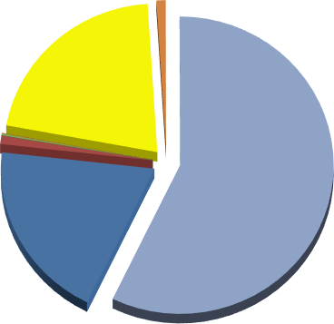0.9%
0.01%
0.2%
21.1%
19.5%
57.3%

1.0%

Gas Heating Oil
Owned / Leased vehicles Biomass
Electicity Water
Staff and student commuting

Though not reportable as part of the University’s submission, the University’s Sustainable Travel Plan has strategic goals to reduce Staff and Student commuting which are contained within the Travel Plan.
The University’s estate has changed significantly between 2007-08 and 2017-18, increasing in gross internal area by 50% to 75,710m²
The graph and table below, 2.7.3 shows at 2018/19 Gross Internal Area growth of the University relative to the baseline year of 2007-08

    - 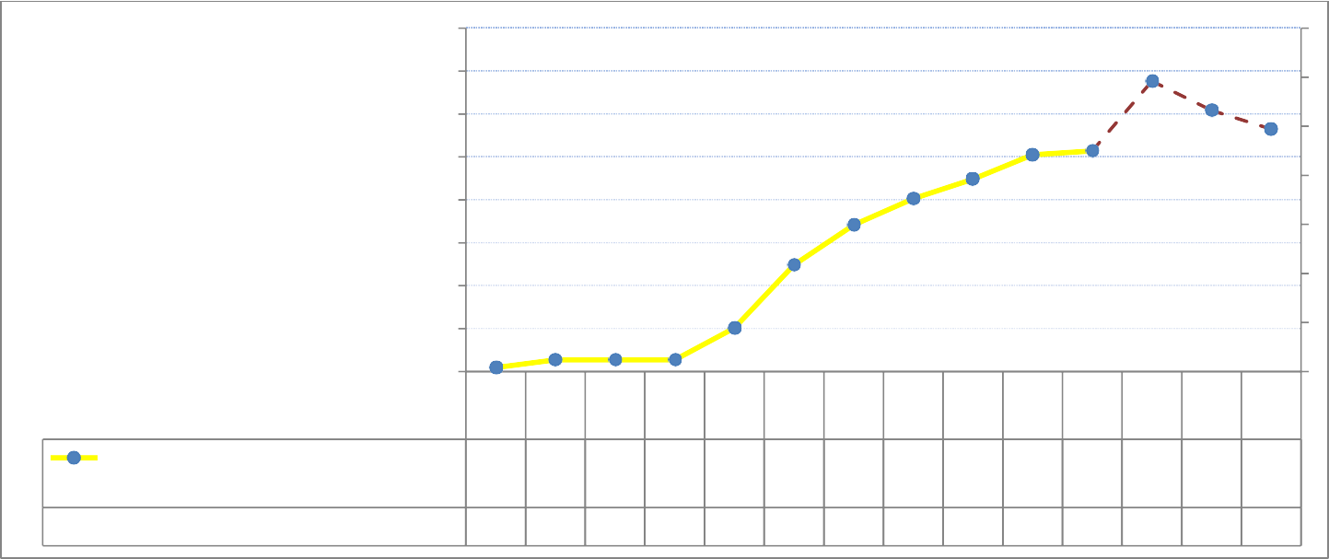University of Chichester’s GIA Growth
90000
85000
80000
75000
70000
65000
60000
55000
500000%
66%
59%

55%
50%
2007 2008 2009 2010 2011 2012 2013 2014 2015 2016 2017 2018 2019 2020
/08 /09 /10 /11 /12 /13 /14 /15 /16 /17 /18 /19 /20 /21
University of Chichester growth GIA 5046451374513745137455080624026707570130724157526975710838378042478242
(m2)
% variation to 2007 -08
0% 2% 2% 2% 9% 24% 33% 39% 43% 49% 50% 66% 59% 55%

Year | University of Chichester growth GIA  (m²) | baseline | % variation to 2007 -08 | Variation to previous year | Building name
2007/08 | 50464 | 50464 | 0% | 0%
2008/09 | 51374 | 50464 | 2% | 2%
2009/10 | 51374 | 50464 | 2% | 0%
2010/11 | 51374 | 50464 | 2% | 0%
2011/12 | 55080 | 50464 | 9% | 7% | BRC LRC
2012/13 | 62402 | 50464 | 24% | 15% | Managed Houses / Stockbridge E
2013/14 | 67075 | 50464 | 33% | 9% | Sports Dome, THCS
2014/15 | 70130 | 50464 | 39% | 6% | Stockbridge A,B,C,D
2015/16 | 72415 | 50464 | 43% | 5%
2016/17 | 75269 | 50464 | 49% | 6% | AMB, Music
2017/18 | 75710 | 50464 | 50% | 1% | Less Graylingwell (-624)
2018/19 | 83837 | 50464 | 66% | 16% | Tech Park (6600)/ Fishbourne Rd East (3947) less St  Christ/Mainline / 2  Bognor Rd(-1796)
2019/20 | 80424 | 50464 | 59% | -7% | Less Pinewood House (-1617)
2020/21 | 78242 | 50464 | 55% | -4% | Future disposals: (-2182)

In 2018/19 the 6600m² Tech Park opened at our Bognor Regis Campus and the addition of new 3650m² student accommodation at Fishbourne Halls East. This increase in gross internal area (GIA) was marginally compensated by the disposal of four student accommodation properties at Grayingwell Drive but resulted in a net increase of the GIA to 66%. Going forward the projection for 2019/20 is a reduction to 59% after the disposal of Pinewood House. Further planned building disposals from 2020 will further reduce the GIA increase to approximately 55%.
Notional energy emissions

The Notional energy emissions (kg CO2) per meter² of GIA has reduced by 55% from the baseline year 2007/08 to 2016/17 as shown on graph 3.3.4 below. This metric indicates the average energy intensity of the University.
The acceleration of reduction of these emissions through 2009-10 to 2010-11 can be attributed to when the University sought to support its Environmental and Sustainable Development Strategy through the establishment of a Green Campus Group and the appointment of an Energy Officer and an Environment Officer (appointments in 2008-09).
Notional energy emissions (kg CO2) per m ² of GIA 2007/08 to 2017/18
85

 |  |  | 75
75 |  | 71 |  | 70
65
55
 |  |  |  |  |  | 48 | 47
45 |  |  |  |  |  |  |  | 43 | 41
 |  |  |  |  |  |  |  |  |  | 38
 |  |  |  |  |  |  |  |  |  |  | 34 | 32
35
25
 |  | 200 | 200 | 200 | 201 | 201 | 201 | 201 | 201 | 201 | 201 | 201 | 201 | 201 | 202
 |  | 7/08 | 8/09 | 9/10 | 0/11 | 1/12 | 2/13 | 3/14 | 4/15 | 5/16 | 6/17 | 7/18 | 8/19 | 9/20 | 0/21
 | Notional energy emissions (kg CO2) per metre2 of GIA | 71 | 75 | 70 | 49 | 48 | 47 | 43 | 41 | 38 | 34 | 32
 | % variation to 2007 -08 | 0% | 6% | -1% | -31% | -32% | -34% | -39% | -42% | -46% | -52% | -55%

    - – Notional energy emissions (kg CO2) per meter² of GIA 2007/08 to 2017/18

Notional energy emissions are vital KPI that indicates how much energy the University uses per square meter of internal area. 2017/18 has placed the University in the top 3 lowest in the country, behind Bishop Grosseteste, University of Gloucester and joint 3rd position with SOAS University of London.

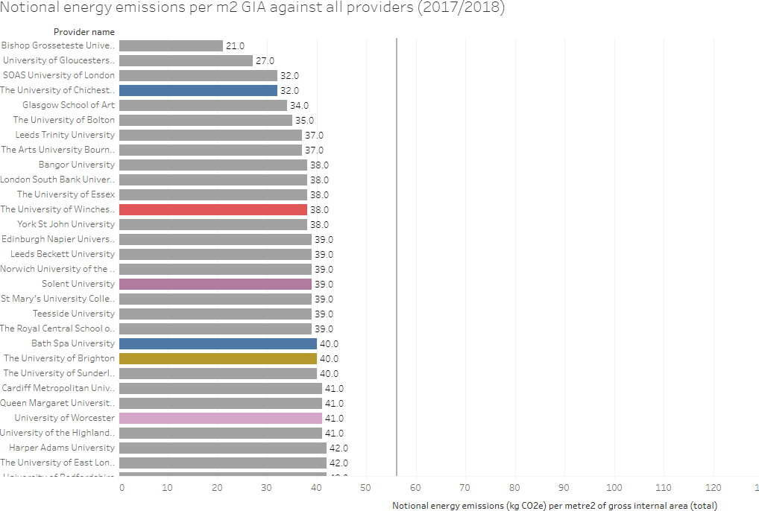

    - – Notional energy emissions (kg CO2) per meter² of GIA to 2017/18 against peer group & Total GIA against peer group
The table below shows how the University is performing against our peer group in terms of energy intensity and internal area.
The University of Chichester is ranked at 1st position - despite having a higher GIA than The University of Winchester and Bath Spa University

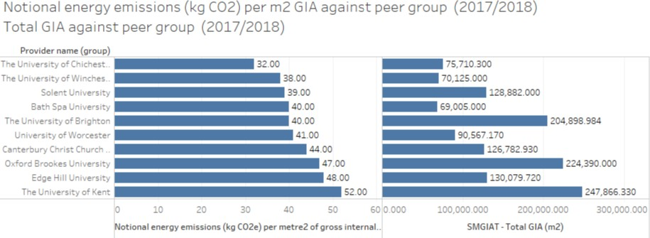

Cumulatively the effect of estate changes and the carbon reduction projects implemented has been an overall reduction in emissions by 33.7% between 2007/8 and 2017/18, primarily due to reduced electricity and heating fuel consumption. See graph 2.7.6 below:

The University of Chichester

Carbon Management Plan 2019-2022

    - 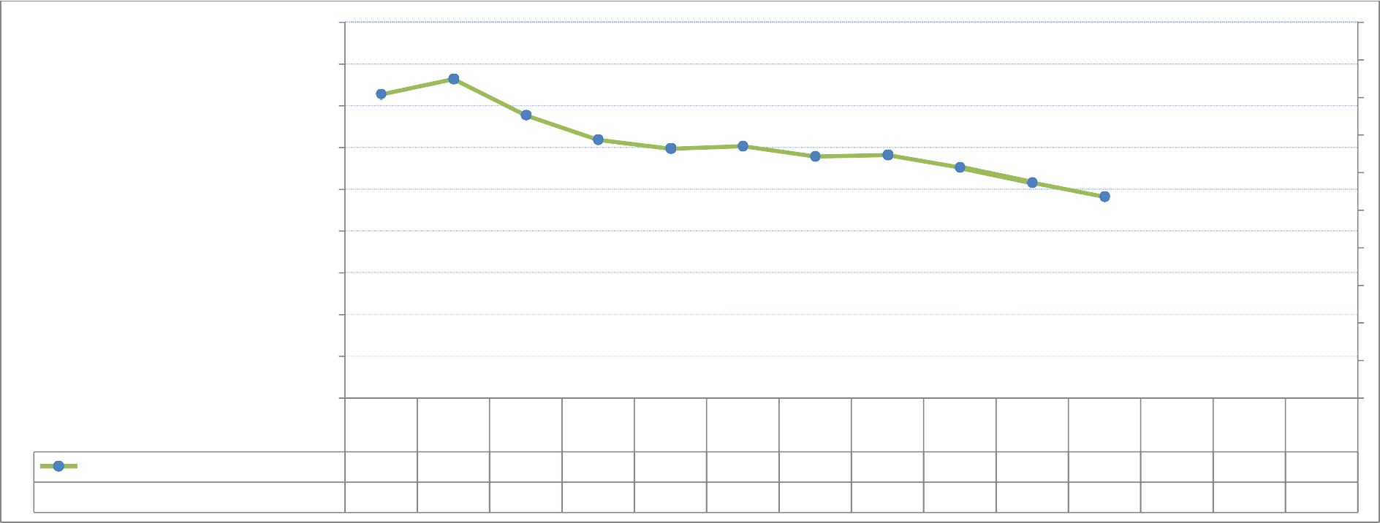- Carbon emissions 2007/08 to 2017 /18
4500.00

4000.00

3500.00

3000.00

2500.00

2000.00
-33.7%
1500.00

1000.00

500.00
0.00
2007/0 2008/0 2009/1 2010/1 2011/1 2012/1 2013/1 2014/1 2015/1 2016/1 2017/1 2018/1 2019/2 2020/2
8 9 0 1 2 3 4 5 6 7 8 9 0 1
Carbon Emmisions (CO2 Tonnes) 3634.00 3820.00 3386.00 3093.00 2987.00 3016.00 2895.00 2911.00 2763.00 2581.71 2410.5
% variation to 2007 -08 0% 5% -7% -15% -18% -17% -20% -20% -24% -29% -33.7%

    - - Total Scope 1 & 2 carbon emissions ¹(kg CO2) against peer group (2017/18)

The table below shows the total scope 1 & 2 positions compared with our peers and places the University of Chichester in 1st position.
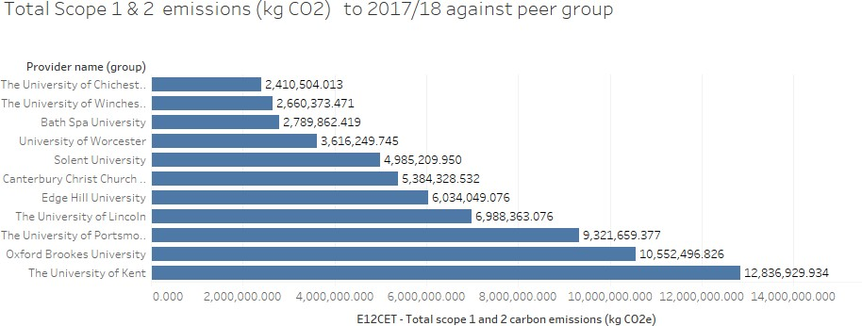

The University is committed to achieving BREEAM credentials to new builds and refurbishment projects, seeking opportunities to incorporate Low and Zero Carbon (LZC) technologies into our building stock such as photovoltaic energy generation which has been added to the Music and Academic buildings which opened in 2016, and the Tech Park which opened in October 2018.
  - Emissions projections

The projected carbon emissions for a ‘business as usual’ (BAU) scenario have been calculated and are shown in the following graph (2.8.1).
Significant developments to the University’s estate from 2007/8 to 2018-19 have resulted in an increase of 24,805m² of GIA. Details of the developments and disposals can be found in section 3.3.3
2018 saw the opening of the new 6600m² Engineering and Digital Technology Park, known solely as the Tech Park, the University’s flagship building at our Bognor Regis Campus, along with new 3650m² student accommodation at Fishbourne Halls East

1 Scope 1 emissions are direct emissions from owned or controlled sources e.g. fuel used in company vehicles. Scope 2 emissions are indirect emissions from the generation of purchased energy such as gas and electricity.

Further developments to the way we utilise the University’s estate will see an increase in the University’s carbon emissions; this could include longer opening hours at some buildings, and weekend operation.
The OFS guideline of 43% for carbon reduction by 2020 for the HE sector as a whole is challenging for the University of Chichester – 27% of the buildings within the University’s estate are listed. This is disproportionately higher than the sector medium of 7%. This presents major difficulties to the University’s ability to reduce carbon emissions. The University is also subject to constraints as large parts of the estate are located within conservation areas. This places limitations on the University’s ability to introduce some low carbon technologies such as photovoltaic cells and wind turbines.
The below graph 2.8.1 illustrates the estimated effect of implementing the projects outlined in Appendix C on the University’s carbon footprint. Currently a further 243 tonnes CO2e are required to be identified to achieve the 2020-21 target.

    - Carbon footprints and projections for business as usual and achieving target reduction

4500
2429
2366
3634 3820
2168
3386 3093 2987 3016
2895 2911 2763 2582
2411

4000

3500
CO 2e emissions (tonnes)

3000

2500

2000

1500

1000

500

0
2007/08
2008/09
2009/10
2010/11
2011/12
2012/13
2013/14
2014/15
2015/16
2016/17
2017/18
2018/19
2019/20
2020/21

Total (tonnes CO2e) Predicted emissions (tonnes CO2e) including estate growth

Target emissions Projected emission savings in this plan (tonnes CO2e)

    - Growth Metrics

The growth of the University can also be compared to the change in its emissions using growth metrics which are derived from the Estates Management Returns. In addition to GIA they also consist of staff and student

numbers (measured using Full Time Equivalent) and HEI income. The staff and student numbers reflect the numbers of people regularly using the building whilst the HEI income can reflect other activities at the University such as conferencing which also impact on the University’s emissions. When the University’s actual emissions are compared to these growth metrics they show a continuous reduction, as illustrated in
    - below. They reduced by about 46.3% relative to staff and student numbers and 60.8% relative to HEI Income, between 2008-09 and 2017-18. A significant reduction in actual emissions has therefore already occurred relative to the University’s growth.

2.8.3 Comparison of the actual emissions to the University’s growth metrics

1.200

1.000

0.800

Actual emissions (tonnes CO2e)/staff + student (FTE)

0.600

Actual emissions (tonnes CO2e)/HEI income (£0 000's)
0.400

0.200

Trend line

0.000

  - Value at stake

The University’s three-year flexible business energy contract commenced in September 2018. Previously the University has had a fixed price contract. The benefits of the flexible business contract allowing the University to only lock in some of the costs at one time, providing scope for costs to fall if the market falls over the contract period. The overall cost increase for electricity of this new contract is expected to be 34% higher than the previous 3-year fixed price contract which commenced in 2015. Approximately 55% of this price increase is due to the non-energy components and Government Levies (2010 – 2022)

Chart 2.9.1 below shows the forecasted increases in the third-party costs that are a major contribution to the overall cost of electricity. These different components cover the cost of generation and delivering the

electricity to the meter and also include the various Government levies applied to fund decarbonisation of the supply network. It can be categorised into the following three sectors:

Operating Cost | This covers the suppliers cost of managing the accounts, issuing bills etc. (Customer Service / Operations / Management)
Third Party Costs  Distribution  Taxes | Costs for maintaining the grid and getting the energy delivered to the premises. (Power Cables, Repairs, Meter )
Government levies and charges to support green energy and promote carbon efficient technologies. (VAT, CCL, Capacity
Charges etc)
Environmental Cost

Non-Energy Components have increased substantially and are scheduled to increase further over the next few years. These increases are unavoidable and are being increased by the UK Government to recover money to support its environmental policies and reinforce the overall de-carbonisation of the electricity infrastructure.

    - Forecasted increases in the third-party costs that are a major contribution to the overall cost of electricity.
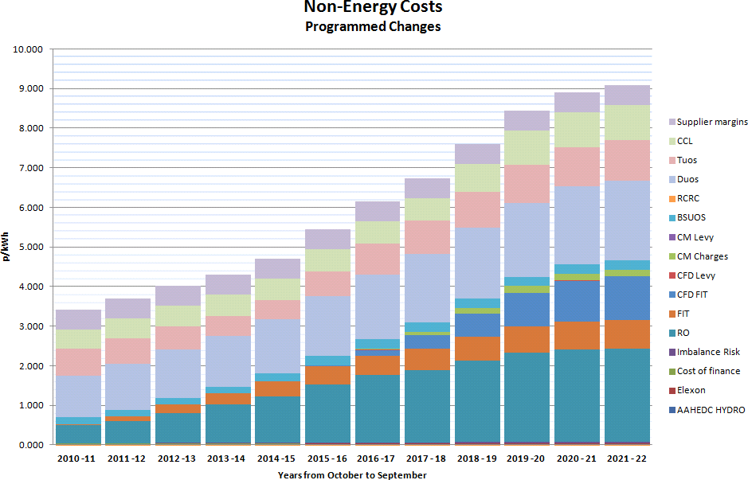

It can be seen that when the electricity contract comes to renewal in 2021, the third-party costs are expected to increase by a further 20%

  - Projects completed:

Appendix B summarises the projects completed since the CMP commenced in 2010. Together their net annual effect was estimated as saving 1600 tonnes CO2e, and £394,000 for a capital investment of
£2,598,576. The emissions reduction associated with these projects has been assumed to take full effect in the year following the project’s completion.
  - Future carbon reduction projects:

A series of carbon reduction projects are planned for implementation and are summarised in Appendix C. Energy surveys of the University buildings have been conducted to identify further carbon reduction measures, the total savings are summarised in Appendix D. The implementation of the projects identified in the surveys and their scheduling has still to be determined. The IT related projects are summarised in appendix E, with estimates of savings where available. This list is not exclusive and further opportunities will be investigated.

  - Implementation Plan financing

This plan proposes a capital investment of £100k from year 2020/21 onwards - subject to approval by the Capital Projects Monitoring Group. Details of planned future carbon reduction projects can be found in Appendix C, The payback period for these projects is estimated to be up to seven years and are expected to save £15,390 annually.
As well as the quantifiable financial and carbon reduction benefits there are additional non-financial benefits for the University:
- enhanced reputation;

- improved building comfort for staff and students

  - Assumptions

The current gas and electricity utility costs are fixed for the next year but will then change over the remaining year of the four-year plan, with energy costs likely to increase. This may have the effect of reducing the payback period for some measures as cost savings increase, assuming that implementation costs do not suffer a corresponding increase.
  - Additional resources

Many of the measures outlined in Section 4 involve staff resource to implement. In some cases, this would be time that they would already be spending in implementing the measures (such as refurbishments) but others will require additional time to be spent investigating new opportunities for carbon reduction. This may add additional costs for some projects, which has not been quantified at this stage. Any significant additional staff costs will be assessed as the measures are approved.
  - Corporate Commitment

The University demonstrates its commitment to carbon reduction by making this plan publicly available on our website and linking it to our awareness raising activities. The University already has Environmental targets on energy use and carbon reduction within its strategic plan. As part of the review process for the corporate plan, annual targets will be established and all existing ones will be updated to ensure compatibility with the findings of the CMP.
All current and new University strategies are required to respond to the University’s strategic plan and, therefore, the targets on energy and carbon reduction. In addition, in November 2017 the Board of Governors approved the University’s third Environmental and Sustainable Development Plan, which has efficient use of all resources and reduction of the University’s carbon footprint at its core. The aim is to embed environmental decision making within all the University’s activities.

We will ensure that our carbon reduction target is included in our Operating Statements which forms the University’s Strategic Plan when it is next reviewed.
Similarly, when professional services or academic department strategic plans are reviewed we will ensure that carbon reduction is included with relevant areas for action outlined in each case. This will ensure that local commitment to action is achieved by finding specific relevant carbon reduction priorities and ensuring that it is appropriately resourced.
  - Data Management

There are actions which we will aim take to improve data management:

- Electricity, gas and water data capture can be improved by the provision of Automatic Meter Reading and sub-metering which makes accessible meter readings every half-hour. Automatic Monitoring and Targeting (aM&T) software is the key management tool for identifying and reducing utility waste thereby helping to cut costs and carbon emissions.
- The University has produced the Sustainable Travel Plan 2017-2022 update. This covers both commuting to sites and business travel. Since the implementation of the last travel plan, a more robust method for obtaining data on commuting patterns (Traffic information Computer System Standard Assessment Method - TRICS SAM) has been used. This method will continue to be used in the future.
- In September 2017 the University renewed its’ waste management contract. As part of the contract negotiation, the contractor agreed to provide data on the weight of operational waste removed from our campuses
A complete data set will be collected annually for use by the Environmental and Sustainable Group (ESG), with Estate Management staff responsible for leading the data collection process. The data will be used to monitor carbon reduction projects and ensure that they remain on target to deliver the savings expected.
The data will be provided as required for use in awareness raising activities.

  - Policy Alignment

It is important that all key policies for the University include carbon management so that it can be fully integrated as best practice in the University’s day to day operations. There will be an on-going review of these policies by the Environmental and Sustainable Development Steering Group to ensure that they remain fit for purpose.
The University could adopt Operational Energy Standards. These would include a heating policy, a cooling policy, a controls policy and an energy efficient IT policy:
- A heating policy could cover: the suitable temperatures; areas that are challenging to heat will be managed, including controlled use of portable heaters; and the times that areas will be heated. This

could be extended to include how, in future years, use could be made of the existing card heating controls fitted to Chilgrove, Amberley and Harting residential halls of accommodation at Chichester and Barbara Smith Halls and the majority of Longbrook House which are also halls of accommodation at Bognor Regis. These controls would enable a base amount of heating to be covered in the rent with incentives for lower use and penalties for higher use, driving student engagement towards efficient use of heating.
- A cooling policy could cover: appropriate use of cooling systems; temperature settings to avoid conflict with heating; time controls; appropriate use of office fans and installation of new comfort cooling systems.
- A controls policy could cover: the need for tamper proof controls; the use of thermostatic radiator valves; the use and setting of motion sensors for lighting; external lighting controls; and the use and setting of urinal controls.
- An energy efficient IT policy could cover: energy efficiency standards for all new IT purchases (such as thin clients, laptops, monitors, servers, printers, photocopiers, scanners and telephony systems);
- IT procurement routes; use of switch off software for out of hours and periods of daytime inactivity; use of timers to control IT peripherals out of hours.

University wide procurement guidance could be extended to deal with major energy consuming appliances such as sports therapy equipment and replacement IT equipment so that energy efficiency is considered as part of the procurement process. The cost of running the equipment needs to be considered over its expected life, as well as the initial capital costs when deciding which items to procure.

4.0 Cultural Change

To date, cultural change has been encouraged through the University’s sustainability and well-being scheme, Jump, messaging through posters at the point of impact, communications to new students, discussion at staff inductions and on-line quizzes. This year a “let’s go green week” is being organised by the University and Students’ Union. Activities and events to engage both students and staff will be held each day focussing on different Sustainable Development Goals. This will, of course, include climate action.
There is no doubt however, that more could be achieved if a community wide approach was adopted, with the aim of creating an energy efficient ethos throughout the whole organisation. This would require support and input from all levels in the University, academic and professional services department heads. Simple changes such as an emphasis on the need for staff to ensure all AV equipment and personal equipment is

turned off after use and checks put in place to ensure all lights are turned off at the end of the day and windows are closed, would make a difference. A University wide approach could also include initiatives such as procurement guidelines for energy efficient equipment and energy efficient practices in workplace procedures.

Other Universities use change programmes specifically designed to engage students in energy conservation in halls of residence. Such programmes include the NUS’s Student Switch and Student Blackout and The Student Energy Project (TSEP). Although these programmes would cost the University about £5k per year, energy savings of 5 to 10% are anticipated.

The programme to reduce the University’s carbon footprint will be taken forward by the Environmental and Sustainable Group. This committee has the responsibility to monitor the University’s environmental performance, establish task and finish groups on environmental impacts and ensure that the profile of environmental issues remains high amongst staff and students. Although many of the projects identified by the Carbon Management Plan will be implemented by different departments, the ESG will maintain an overview. The group will monitor the performance of the University to ensure it is on track to reduce carbon emissions in line with Government recommendations. The group will also oversee the implementation of the University’s Sustainable Travel Plan thereby ensuring that all carbon reduction activities are coherent and co-ordinated across the University. Specifically, the group will:
- Be responsible for monitoring the University’s performance regarding the implementation of the carbon reduction interventions identified in the CMP
- Review the University’s carbon emissions to ensure targets are achieved and progress on carbon reduction is made
- Coordinate measures that embed the measuring of carbon emissions and the actions to reduce emissions across the University community
- Report to the Vice-Chancellor and Board of Governors on progress made by the University to reduce emissions
The ESG is chaired by the Director of Estate Management and reports to the Vice Chancellor’s Group and the Board of Governors. The Group will meet three times per year and will undertake an annual review of the current progress of carbon reduction projects against planned level of achievement. The Group will assess any unforeseen events or significant risks to the plan to ensure that it remains on track to achieve its target emissions reduction. The results of the review will be reported by the Director of Estate Management to the Board of Governors and University community.

APPENDIX A: Emissions Scope

The World Resource Institute developed a classification of emission sources around three ‘scopes’:

  - Scope 1: emissions are direct emissions that occur from sources owned or controlled by the organisation, for example emissions from combustion in owned or controlled boilers/ furnaces/ vehicles.

  - Scope 2: accounts for emissions from the generation of purchased electricity consumed by the organisation.

  - Scope 3: covers all other indirect emissions which are a consequence of the activities of the organisation, but occur from sources not owned or controlled by the organisation – for example, commuting and procurement

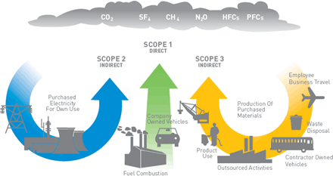

APPENDIX B:

Completed carbon reduction projects

The following table summarises the projects completed since the CMP was commenced. The savings from electricity related projects have been adjusted to reflect the latest emission factor methodology as outlined in section 3.2:

Funding Source | Sum of Cost (inc VAT) | Sum of Financial savings | Average of Payback  in years | Sum of Annual kWh  savings
 |  |  |  |  | Sum of tCO2 pa
Salix | £235,441 | £94,734 | 3.5 | 1,822,404 | 406.0
Electricity | £84,012 | £29,430 | 4.5 | 258,629 | 115.2
2010/11
Time switches | £5,848 | £1,390 | 4.2 | 12,087 | 5.4
2011/12
Compact Fluorescent including changing the fitting | £1,229 | £247 | 12.3 | 2,227 | 1.0
Halogen to LED including changing the fitting | £1,728 | £527 | 4.9 | 4,762 | 2.1
Heating pipework insulation (internal) | £3,006 | £908 | 3.3 | 8,198 | 3.7
Hot Water - distribution improvements | £468 | £528 | 0.9 | 4,770 | 2.1
T5 lighting retrofit using adaptors | £1,984 | £613 | 3.2 | 5,542 | 2.5
2012/13
Flood lighting to LED including changing the fitting | £1,400 | £275 | 5.1 | 2,620 | 1.2
2013/14
Incandescent to LED using same  fitting | £8,818 | £3,538 | 2.3 | 31,231 | 13.9
T12/T8 to LED including new  fitting | £3,360 | £968 | 3.5 | 8,569 | 3.8
2016/17
T12/T8 to LED including new  fitting | £32,069 | £5,989 | 5.4 | 53,000 | 23.6
2015/16
Hot Water - distribution improvements | £2,000 | £389 | 5.1 | 3,381 | 1.5
Ventilation - Cooling | £22,102 | £14,058 | 1.7 | 122,242 | 54.5
Gas | £141,295 | £60,804 | 2.4 | 1,516,404 | 279.1
2010/11
BEMS - not remotely managed | £4,686 | £1,652 | 2.8 | 33,046 | 6.1
Heating - discrete controls | £2,000 | £3,875 | 0.5 | 193,734 | 35.7
Heating pipework insulation (internal) | £7,998 | £3,063 | 2.7 | 61,257 | 11.3
Roof insulation | £66,843 | £31,793 | 2.1 | 635,868 | 117.0

2011/12
BEMS - remotely managed | £9,108 | £2,771 | 3.3 | 92,359 | 17.0
Heating pipework insulation (internal) | £5,125 | £2,563 | 2.0 | 85,420 | 15.7
2012/13
Cavity wall insulation | £15,402 | £5,773 | 2.6 | 192,449 | 35.4
Heating pipework insulation (internal) | £2,640 | £1,377 | 1.9 | 45,889 | 8.4
2015/16
Hot Water - distribution improvements | £27,493 | £7,937 | 3.5 | 176,382 | 32.5
Oil | £10,134 | £4,500 | 2.3 | 47,371 | 11.7
2010/11
Roof insulation | £10,134 | £4,500 | 2.3 | 47,371 | 11.7
Split fund | £37,830 | £4,868 | 3.7 | 98,382 | 20.2
Electricity | £2,150 | £825 | 2.6 | 7,854 | 3.5
2013/14
BEMS - remotely managed | £2,150 | £825 | 2.6 | 7,854 | 3.5
Gas | £35,680 | £4,043 | 4.1 | 90,528 | 16.7
2010/11
Roof insulation | £11,930 | £2,109 | 5.7 | 42,171 | 7.8
2013/14
BEMS - remotely managed | £12,900 | £1,934 | 6.7 | 48,357 | 8.9
2016/17
Boilers - replacement condensing | £10,850 | £0 | 0.0 | 0 | 0.0
University own Fund | £644,632 | £55,942 | 28.2 | 890,642 | 224.7
Electricity | £315,583 | £26,575 | 30.5 | 232,549 | 103.6
2010/11
Lighting - discrete controls | £1,519 | £149 | 10.2 | 1,349 | 0.6
Voltage reduction equipment | £83,769 | £22,447 | 3.7 | 195,187 | 87.0
2011/12
Halogen to LED using same  fitting | £603 | £344 | 1.7 | 3,109 | 1.4
T5 lighting retrofit using adaptors | £954 | £349 | 2.7 | 3,150 | 1.4
2012/13
Flood lighting to LED including changing the fitting | £4,914 | £1,073 | 4.6 | 10,218 | 4.6
2013/14
IT: Computer Replacement | £223,824 | £2,213 | 92.8 | 19,536 | 8.7
Gas | £329,049 | £29,367 | 23.6 | 658,093 | 121.1
2010/11
Heating pipework insulation (internal) | £24,049 | £15,627 | 1.6 | 312,539 | 57.5
2012/13
Boilers - replacement modular | £210,000 | £3,120 | 67.3 | 78,000 | 14.4
2014/15

Boilers - replacement modular | £90,000 | £10,491 | 8.6 | 262,284 | 48.3
Boilers - replacement Combination | £5,000 | £129 | 38.8 | 5,270 | 1.0
RGF3 | £500,000 | £101,602 | 4.9 | 784,449 | 349.5
Electricity | £500,000 | £101,602 | 4.9 | 784,449 | 349.5
2014/15
Compact Fluorescent to LED including new fitting | £500,000 | £101,602 | 4.9 | 784,449 | 349.5
RGF4 | £750,000 | £97,383 | 7.0 | 864,055 | 464.0
Electricity | £750,000 | £97,383 | 7.0 | 864,055 | 464.0
2015/16
Lighting - discrete controls | £89,492 | £15,083 | 5.9 | 134,337 | 72.1
Compact Fluorescent to LED including new fitting | £660,508 | £82,300 | 8.0 | 729,718 | 391.9
RGF4 + | £430,673 | £39,320 | 7.9 | 267,091 | 136.9
Electricity | £422,323 | £38,371 | 7.6 | 240,834 | 132.1
2016/17
Compact Fluorescent to LED including new fitting | £176,734 | £22,116 | 8.0 | 157,976 | 60.7
Hot Water - point of use heaters | £32,927 | £4,655 | 7.1 |  | 39.5
2017/18
Compact Fluorescent to LED including new fitting | £212,662 | £11,600 | 7.7 | 82,858 | 31.9
Gas | £8,350 | £949 | 8.8 | 26,257 | 4.8
2016/17
Boilers - replacement condensing | £8,350 | £949 | 8.8 | 26,257 | 4.8
Grand Total | £2,598,576 | £393,849 | 10.3 | 4,727,023 | 1601.2

Superseded projects

The following table summarises the completed projects which have been superseded by boiler replacements or major refurbishments have been removed to avoid double counting savings.

Funding Source | Sum of Cost (inc VAT) | Sum of Financial savings | Average of Payback in years | Sum of Annual kWh savings | Sum of tCO2  pa
Salix | £92,743 | £28,727 | 3.4 | 277,274 | 115.5
Compact Fluorescent including changing the fitting | £21,574 | £6,878 | 3.7 | 62,136 | 27.7
Compact Fluorescent using same fitting | £20,418 | £4,266 | 4.7 | 39,641 | 17.7
Heating pipework insulation (internal) | £2,353 | £1,531 | 1.4 | 30,623 | 5.6
Incandescent to LED using same fitting | £5,718 | £1,242 | 4.6 | 11,830 | 5.3
Lighting - discrete controls | £4,408 | £981 | 4.5 | 8,863 | 3.9
T5 lighting retrofit using adaptors | £17,267 | £7,934 | 2.0 | 71,674 | 31.9
Time switches | £15,228 | £4,585 | 3.4 | 40,689 | 18.1
T8 lighting including changing the fitting | £5,777 | £1,308 | 4.4 | 11,818 | 5.3
University own Fund | £30,472 | £13,113 | 2.8 | 126,988 | 52.5
Compact Fluorescent including changing the fitting | £449 | £389 | 1.2 | 3,518 | 1.6
Compact Fluorescent using same fitting | £248 | £29 | 8.7 | 258 | 0.1
Heating pipework insulation (internal) | £919 | £778 | 1.2 | 15,560 | 2.9
T5 lighting retrofit using adaptors | £28,856 | £11,917 | 2.6 | 107,652 | 48.0
Grand Total | £123,215 | £41,840 | 3.2 | 404,262 | 168.0

APPENDIX C: Future carbon reduction projects planned

The following table summarises the further projects planned for implementation over the next three years. The savings from electricity related projects have been adjusted to reflect the latest emission factor methodology as outlined in section 3.2:

Funding Source | Sum of Cost (inc Sum of  VAT) Financial  savings | Average of Payback in  years |  | Sum of Annual kWh  savings | Sum of  tCO2  pa
University own Fund | £180,000 £28,215.00 |  | 7.0 | 151,250 | 45.5
2019/20
Electricity | £30,000 £5,130.00 |  | 7.0 | 27,500 | 8.3
LED Lighting | £30,000 £5,130.00 |  | 7.0 | 27,500 | 8.3
Further LED lighting and controls | £30,000 £5,130.00 |  | 7.0 | 27,500 | 8.3
2020/21
Electricity | £50,000 £7,695.00 |  | 7.0 | 41,250 | 12.4
LED Lighting | £50,000 £7,695.00 |  | 7.0 | 41,250 | 12.4
Further LED lighting and controls | £50,000 £7,695.00 |  | 7.0 | 41,250 | 12.4
2021/22
Electricity | £100,000 £15,390.00 |  | 7.0 | 82,500 | 24.8
LED Lighting | £100,000 £15,390.00 |  | 7.0 | 82,500 | 24.8
Further LED lighting and controls | £100,000 £15,390.00 |  | 7.0 | 82,500 | 24.8
Grand Total | £180,000 £28,215.00 | 7.0 |  | 151,250 | 45.5

.

APPENDIX D: IT carbon reduction projects

The following table summarises the IT projects that generate a carbon reduction:

Funding Source | Sum of Cost (inc VAT) | Sum of Financial savings | Average of Payback in years | Sum of Annual kWh savings | Sum of tCO2  pa
Salix | £22,102 | £14,058 | 1.7 | 122,242 | 54.5
Electricity | £22,102 | £14,058 | 1.7 | 122,242 | 54.5
2015/16
Ventilation - Cooling | £22,102 | £14,058 | 1.7 | 122,242 | 54.5
DX Cooling Phase 1 | £8,342 | £4,433 | 1.9 | 38,544 | 17.2
DX Cooling Phase 2 | £13,760 | £9,625 | 1.4 | 83,698 | 37.3
University own Fund | £223,824 | £2,213 | 92.8 | 19,536 | 8.7
Electricity | £223,824 | £2,213 | 92.8 | 19,536 | 8.7
2013/14
IT: Computer Replacement | £223,824 | £2,213 | 92.8 | 19,536 | 8.7
Staff Desktop Computer Replacement  2014 | £108,486 | £1,586 | 68.4 | 13,997 | 6.2

*1 The on-going programme of refreshing computer desktop equipment is designed to ensure University users can benefit from the latest technologies. As the funding for this project relates to enhancing IT provision and has not been specifically provided to introduce a carbon reduction initiative, the pay back years is not applicable. The positive carbon reduction outcome is, however, a consequence of utilising modern and more energy efficient technology.

APPENDIX E: Carbon Management Matrix – Embedding.

Current status of the University is highlighted below.

 | POLICY | ORGANISATION | INFORMATION AND DATA | COMMUNICATION AND TRAINING | FINANCE | MONITORING & EVALUATION
5 | Specific sustainability / climate change policy with targets signed off and implemented.  Action plan with clear goals and regular reviews to confirm actions undertaken and targets achieved/being progressed. | Accountabilities for  sustainability /climate change defined at senior level, e.g. senior  Sustainability / climate change responsibilities integrated into responsibilities of relevant people in different departments, e.g. Teaching, Finance, Estates | CO2 emissions compiled for all main HEI sources for a baseline year and regular collation of annual emissions data.  Data externally verified. | Formalised communication and training plan for all staff on carbon and energy related  matters, including  integration in induction and other normal training processes.  Communication on carbon and energy related matters with the academic and student body and other key business partners | Use of innovative external funding mechanisms for carbon related projects.  Development of internal financing mechanisms, e.g. self sustaining fund, specifically for carbon related projects | Management Review of carbon management process by senior management.  Regular reviews by core team on progress with carbon management.
4 | Specific sustainability / climate change policy with targets developed and signed off, but not implemented | Sustainability / climate change responsibilities integrated into responsibilities of relevant people in different departments, e.g Teaching, Finance, Estates | CO2 emissions compiled for all main HEI sources for a baseline year (i.e. buildings, transport and commuting, etc.  Data internally reviewed. | Formalised communication and training plan for all staff on carbon and energy related  matters, including  integration in induction and other training, and awareness raising | Strategic plan for developing internal financing mechanisms and obtaining funds from external sources | Regular reviews on progress with carbon management (e.g. review of actions, check against emissions profile and targets, addition of new opportunities etc.)
3 | Sustainability / Climate change included in wider policy documents | Sustainability / climate change/ carbon management is part-time responsibility of moderate ranking personnel, e.g. Energy Manager, Sustainability/Environment Officer | CO2 emissions data compiled for some sources for a baseline year (e.g. buildings) and  source data available for other sources (e.g. transport) | Ad hoc  communication and training delivered to all staff/students on carbon and energy related matters | Some internal financing on an ad hoc basis for carbon and/or energy efficiency related projects  Review conducted on applicable  external funding sources | Ad hoc  assessment of all aspects of carbon/energy policies/strategies, targets and action plans
2 | Sustainability / Climate change as an aspiration in | Sustainability / climate change/carbon management is part-time | No CO2 emissions data compiled for any sources but energy data | Communication and training to specific groups in the HEI (e.g. environment  team) on | Some internal financing on an ad hoc basis for carbon and/or energy | Ad hoc reviews of specific aspects of carbon/energy policies/strategies,

 | non-policy documents | responsibility of low ranking personnel | compiled on a regular basis | carbon/energy related matters | efficiency related projects | targets and action plans
1 | No sustainability / climate change policy or strategy and no mention of climate change in policy/strategy documents | No individual with responsibility for sustainability / climate change issues | No CO2 emissions data compiled for any sources and energy data not compiled on a regular basis | No communication or training to  staff/students on carbon or energy related matters | No internal financing or funding for carbon and/or energy efficiency related projects | No monitoring of carbon/energy policies/strategies, targets and action plans

APPENDIX F: Cultural Change action plan

Cultural change action plan

Initiative | Description | Timescale | Estimated cost
Jump | Sustainability and wellbeing scheme awarding points for sustainable behaviours  including energy saving. | Ongoing since October 2014 | £5160 per annum  In budget
Let’s Go Green Week | Week of events and activities to highlight the sustainable development goals including climate action organised by the SU  and university. | November 11th to 15th 2019 | £500  In budget
Student blackout | Night when students (and staff) switch off all lights and equipment left on over a weekend in university  buildings | 2020 | None
Energy switch off campaign | Internal university wide approach aimed at creating an energy efficient ethos throughout the university  community | 2020/21 | £50
Student engagement scheme such as NUS’s Student Switch or The  Student Energy Project (TSEP). | Projects run by external organisations specifically designed to engage students in energy reduction | Subject to budget availability | £5000  If budget permits
Energy efficient practices incorporated  into workplace procedures | This will form part of the changes put in place for ISO  14001 certification | December 2021 | £5212 for ISO 14001  certification audits Subject to a report to VCG.

