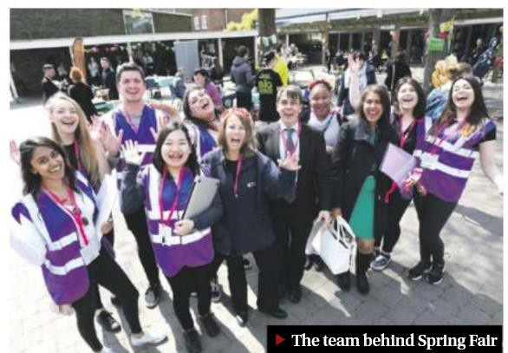

Environmental and Sustainable Development Plan

2017–22

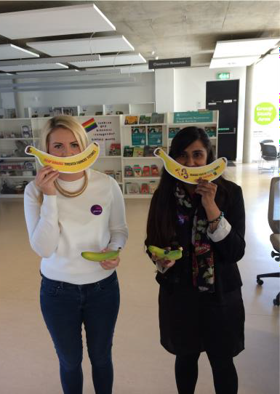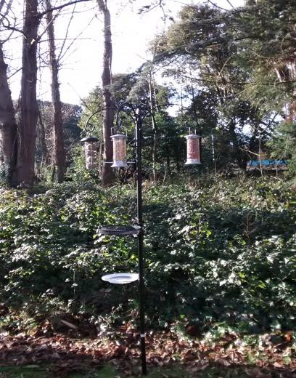

Foreword by Deputy Vice-Chancellor (Sustainability and Enterprise)

I am delighted to introduce this third edition of the University of Chichester’s Environment and Sustainable Development Plan. As part of our commitment to environmental sustainability we believe we must manage all aspects of our operations that impact on the environment and deliver a sustainable future for the University, our local community and our global community.

Since the publication of the first Environment and Sustainable Development Plan 2010, the University has made significant strides to reduce its environmental impact and change the culture of the organisation to one which considers sustainability as the norm.

In this edition we aim to provide an update of our activities carried out over the last three years to reduce our impact, the drivers necessitating further change and the measures we intend to put in place to effect this change, over the next five years.

Professor Seamus Higson

Contents

Section | Title | Page  No
 | Foreword | 2
1. | Introduction | 4
2. | Review of recent achievements and drivers for further change | 5
2.1 | Environmental governance | 6
2.2 | Environmental legal compliance | 6
2.3 | Environmental Management System | 7
2.4 | Managing waste and recycling | 8
2.5 | Sustainable construction | 10
2.6. | Utilities management | 11
2.7 | Sustainable procurement | 12
2.8 | Sustainable travel | 13
2.9 | Biodiversity management | 15
2.10 | Embedding sustainability in the curriculum | 16
2.11 | Awareness raising and communications | 16
3 | Objectives and targets for further improvement | 19
3.1 | Environmental Management System | 19
3.2 | Managing waste and recycling | 20
3.3 | Sustainable construction | 20
3.4 | Utilities management | 21
3.5 | Sustainable procurement | 22
3.6 | Sustainable travel | 22
3.7 | Biodiversity management | 23
3.8 | Embedding sustainability in the curriculum | 23
3.9 | Awareness raising and communications | 24
4 | Monitoring and Review | 25
 | Appendix 1 Overview of AUDE Green Scorecard | 28
 | Appendix 2 Flexible Framework produced by DEFRA | 29
 | Appendix 3 Action Plan | 31

- Introduction
In June 2010 the University of Chichester produced its first Environmental and Sustainable Development Plan, which was updated in 2013. Both documents detail the organisation’s responsibilities towards the environment as well as the huge contribution it can make by imparting knowledge to enable its graduates to show leadership and aspire to a sustainable future.

The strategies described a number of practical actions which needed to be implemented to allow the University to improve its environmental management and begin to address the principles of sustainable development in its day to day activities, as well as longer term decision making. These included:

  - Integrating environmental management within the University’s governance.
  - Improving procedures for the efficient use of resources.
  - Establishing management systems for performance assessment.
  - Creating a sustainable culture and ethos through staff and student engagement

It was stressed that with ownership and support of the strategies, the University should make significant progress, improving upon its environmental performance and embedding sustainability in all areas of its business.

However, it was also recognised that making environment and sustainability a central consideration within the University’s decision making would not always be easy. This was because although many environmental actions result in rapid financial returns, those that require investment now, to save in the future, might not always be seen as a priority, given the current financial reality. Another significant challenge to achieving the sustainable vision for the University highlighted that words alone are not enough – sustainability requires people to think, then act differently, make more sustainable choices and change their behaviour. Whilst procedural and technical changes can be instrumental in managing impacts, they can only go so far. Winning the hearts and minds of the people within the University is crucial.

The purpose of this document is to provide an update to these earlier strategies and outline objectives and targets for the future. It describes improvements in environmental performance achieved since the introduction of the second plan, highlights renewed drivers for change and provides objectives and targets for continual advancement.

This update has been developed by an iterative process. Existing documentation and performance data has been reviewed, best practice within the sector has been identified and staff and students consulted. This document has gone out for committee review including the Environmental Sustainability Group, Green Campus Group, Governors’
Strategy and Resources Committee, Chief Executive’s Team and the Strategy, Risk and Projects Group (StRAP).

Review of Recent Achievements and Drivers for further change

Key Facts

- A large number of initiatives have been successfully completed since the implementation of the last Environmental and Sustainable Development Plan.
- Initiatives have focussed on all objectives of the plan.

One of the methods which the University has been able to use in the past as an indicator of its success in improving its environmental performance, has been the People & Planet Green League Table1. This process has enabled a comparison of progress against other Higher Education Institutions (HEIs). Comparison of data obtained over the past three years suggests that the aspirations of the Environmental Plan 2013 – 2016 have at least been partly met and that the measures put in place have had positive effects. In 2012, the University’s environmental performance was ranked as joint 47th and we were awarded an upper second class degree. In 2013, our ranking had improved to 28th and the level of award achieved had increased to a first. In 2015 we were again awarded a first class degree and our ranking had further improved to 18.

However, although being the only “recognised” system for the comparison of HEIs environmental performance, problems have been encountered with the methodology used. In 2014/15, a number of HEIs decided not to submit data to People & Planet and started to work with the Association of University Directors of Estates (AUDE)2 to develop their own method for the measurement of environmental performance. The University has since adopted this system, known as the AUDE Green Scorecard, as the basis for target setting and performance monitoring in the future (Appendix 1).

A number of key themes were identified in the original plan and have continued to be progressed in the 2013 to 2016 plan. These were;

  - Environmental governance
  - Environmental legal compliance
  - Environmental management system
  - Managing waste and recycling
  - Sustainable construction
  - Utilities management
  - Sustainable procurement
  - Sustainable travel

¹ People & Planet Green League http://peopleandplanet.org/greenleague
² http//aude.ac.uk

  - Biodiversity Management
  - Embedding Sustainability into the Curriculum
  - Awareness Raising and Communication

A review of the developments made in each of these areas over the past three years and drivers for continual change will be presented in turn.

2.1. Environmental Governance

To achieve change an organisation must engage with all sectors of the community. In 2010, it was recognised that in order to realise environmental progress and attain behavioural change, environmental and sustainable decision making must be fully integrated into the University’s operations and the commitment of senior management must be clearly apparent. Although isolated areas of good practice were evident, no formal structures were in place to provide leadership in this area, ensure effective decision making or disseminate information through the organisation.

In 2011, an Environmental and Sustainable Development Steering Group was set up. This group has continued to meet on a quarterly basis and is now chaired by the Deputy Vice-Chancellor (Sustainability and Enterprise). Membership comprises representatives from Professional Services (Finance, Estates and Human Resources), academic staff and the Students’ Union. The Group has established a monitoring and reporting structure for environmental and sustainability issues within University operations, facilitated the progression of the Environmental Management System (EMS), helped to start the process of embedding sustainability into the curriculum and promote environmental awareness amongst staff and students. In 2016, the name of the group was changed to the Environmental Sustainability Group.

Task groups have been set up with the assistance of senior management to address issues such as sustainable travel and health and safety co-ordinators have continued to carry out environmental audits to assist in the delivery of the EMS.

  - Environmental Legal Compliance

The University is subject to environmental legislation just like any organisation that produces waste, consumes energy and resources, releases emissions into air or water or has chemicals stored on its premises. Under this legislation the University has a duty of care to demonstrate controls are in place to reduce risks to the environment both locally, nationally and internationally.

When the original document was compiled it was apparent that although areas of the University’s activities subject to different environmental legislation were largely compliant, there was no common approach for ensuring applicable legislation was met. Furthermore, there was no methodology in place to ensure that any opportunities or threats from impending or future legislation, could be realised.

The University has continued to identify all environmental legislation relevant to its operations and has implemented an audit process to ensure that the University’s procedures and activities meet statutory environmental compliance.

  - Environmental Management System (EMS)

An Environmental Management System (EMS) is a set of processes and practices that enable an organisation to reduce its environmental impacts and increase its operating efficiency through consistent control of its operations.

Over the past three years the Environmental Management System certified to BS8555 phases 1 to 4 has been further developed (Figure 1). In 2014, the scope of the EMS was extended by the external certification of the system to phase 5 of BS8555. The EMS ensures that senior management is committed to reducing the impact of the University’s activities on the environment, legal requirements have been identified and complied with and that objectives and targets for environmental improvement have been set. It also ensures that the system has been implemented and is operated so that the training awareness and culture change programme continues in parallel to continual improvement in environmental impact reduction. Increasing the scope of BS8555 demonstrates that the University is continually improving the system and that senior management are fully aware of any deficiencies, providing the resources for improvement. Extension of the system also means that the University is closer to achieving the more recognisable international standard for environmental management systems ISO14001 (see section 3.3). This standard has recently been revised and six members of staff have attended training on the new version (ISO 14001:2015).

Figure 1 BS8555 uses a staged approach to the implementation of an Environmental Management System

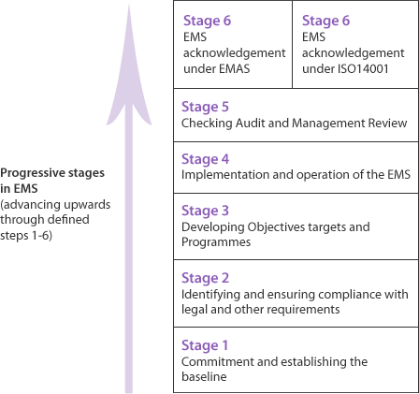

  - Managing Waste and Recycling

As recognised in the original plan, waste has a major impact on the environment and the most cost effective and sustainable approach for the University is to make better use of resources and avoid creating waste in the first instance.

A number of initiatives have been undertaken to achieve the waste hierarchy “Reduce, Re-use, Repair, Recycle”.

As mentioned in the previous plan, the current contract for operational waste ensures than none of this waste type is sent to landfill and a reduced charge is made for the collection of recyclable waste. There is therefore a huge incentive for the University to maximise the amount of recyclable waste produced, from both a financial and environmental perspective.

Awareness campaigns have therefore continued to be run for staff and students to encourage recycling. These have included the use of posters strategically placed in buildings, new bin signage introduced across the campuses, information sent to first year students before their arrival, recycling games played at Fresher’s and Refresher’s

Fairs and special arrangements for student departures. Two business school students have also produced their final year dissertations on waste issues at the University and their recommendations are being incorporated into future waste management strategies. Despite these efforts, the amount of operational waste generated over the past four years remains at over 100 kg/head (Figure 2).

Figure 2 Operational waste remains at a similar level
120

100

80

60

40

20

0
2012/13
2013/14
2014/15
2015/16
Operational waste generated
per head (kg)

More positively, the proportion of operational waste recycled has increased from 40% to 45% over the past year. This recycling rate is however still believed to be considerably lower than other similar universities (Figure 3).

Figure 3 The University’s recycling rate has increased over the past academic year
The University of Chichester 2015/16
The University of Chichester 2014/15 The University of Chichester 2013/14 The University of Chichester 2012/13

Southampton Solent University The University of Brighton Canterbury Christ Church University Oxford Brookes University
The University of Lincoln Bournemouth University
The University of Northampton The University of Kent
The University of Winchester The University of Portsmouth University of Gloucestershire University of Worcester
0
10
20
30
40
50
60
70
80
90
Amount of operational waste recycled (%)

In the summer of 2016, issues with recyclability of hot drinks cups was widely publicised in the press. Until September 2016, hot drinks cups on our campuses were being collected in our mixed recyclable stream, in the belief that they could be recycled.
However, this was later found not to be the case and they are now collected in the waste to energy stream, further reducing our recycling rate. Discussions are underway with our waste management contractor to find a recycling outlet for the cups, or to determine an alternative cup type which can be recycled. Our catering contractor, Elior, is also offering a discount on all hot drinks purchased from their catering outlets, if a reusable cup is provided by the customer. This issue highlights the need for the University to work closely with their waste management contractor to maximise the potential to reduce the impact of waste generated on our campuses. This is an aspect which will be further pursued as part of the forward plan.
In October 2016, a campaign to further educate staff and students about what happens to the operational waste generated on our campuses and why they should segregate
their recyclable waste has been run. The University’s printing department has also launched Operation Paper Cut to try to reduce staff print consumption. Linked to the Jump scheme this campaign aims to change departmental practice in addition to individual behaviours. It is hoped that these two initiatives will help to reduce the amount of waste generated and further increase our recycling rate.

Prevention and reuse of construction waste has long been a policy at the University driven predominantly by BREEAM criteria. EMR data shows that in 2014/15 the university was in the third quartile for reduction of construction waste when compared with all HEIs in the UK.
  - Sustainable Construction

The University recognises the need to develop and operate its buildings and estate in a way that conserves resources and minimises the impact on the environment. By using the opportunities of new construction and refurbishments to improve resource efficiencies such as energy and water, both environmental and financial benefits can be enjoyed by the University.

In the original plan, a target was set for all new builds/refurbishments to be rated by the Building Research Establishment Environmental Assessment Method (BREEAM) as “very good” or higher. Such a rating ensures that not only is the resultant build resource efficient, but additionally that other factors during construction such as waste, site management and procurement are also considered.
The target for the major refurbishment of The Dome at BRC for a very good BREEAM status was achieved. We are currently waiting for the outcome of the audit submissions for the recent refurbishment of the music block and the new academic building.
Where technically and financially viable, sustainable improvements are incorporated in all works. Construction of the Tudor Hale Centre for Sport, which was opened in January 2017, created an extra 160 cycle parking spaces, 80 of which are in covered stores with an access code for added security.

Soil from the refurbishment of the music block has been used to create an amphitheatre outside for musical performance. Construction of the academic building has involved enhancement to the entrance to the Bishop Otter campus allowing buses easier access, with a covered bus stop and real-time bus information display.

Work has also recently commenced on the construction of a new Engineering and Digital Technology Park at our Bognor Regis campus. The target for this construction will again be BREEAM excellent. This major development, planned for completion in September 2018, will support a year-on-year increase in student numbers to a maximum of 1500 additional students by 2021/22. Staff numbers will also increase by 80 new members of staff by 2021/22. The new development, will enable the University to offer over 30 more undergraduate courses in Science, Technology, Engineering and Maths (STEM) subjects, including courses in environmental management and sustainability (see section 2.10).

The University appreciates that the construction and subsequent use of the Technology Park will impact the local area and has incorporated measures in its design using feedback from local residents to reduce potential impacts and enhance the area. For example, the campus will link to the cycle route on the public highway. A new vehicular

access enabling local buses, as well as the University’s intercampus bus service, to pick up and drop off at a designated bus stop within the campus will be constructed and limited car parking that meets West Sussex County Council parking standards will be installed.

Gold coloured metal panels installed on the building will reflect the sun and glow differently in the changing light of the day. The massing of the building has been developed to ensure the most efficient use of space, to suit the spatial requirements of a complex building type and to maintain the right distance between the spaces. The plant rooms and roof top plant spaces have been calculated and adequately sized for the building. Noise break-out will be carefully controlled and will meet all necessary guidelines. Media consultants have been appointed to ensure professional standards in the studio spaces are met and a specialist acoustics consultant is advising on all matters affecting the building and its surroundings. The construction will include solar panels and ground source heat pumps. A flood risk assessment has been carried out and a sustainable approach for drainage of the site is being taken. Sustainable Drainage System approaches are being employed to ensure that there is no increase in runoff as a result of the proposed development. Landscaping will include a wetland feature. Our published Biodiversity plan will continue to be updated to include how we will incorporate biodiversity, as changes are made to the Bognor Regis campus (section 2.9).

  - Utilities Management

Utility costs at the University are significant. Promoting energy efficiency not only saves costs, but also reduces the environmental impact of generating and using energy.
Our most recent Carbon Management Plan (CMP) was produced in September 20143 and is updated annually. Our CMP target is to reduce our carbon emissions from electricity, natural gas, oil, water and vehicle fuel use by 43pc relative to our 2007/2008 baseline by 2020.

Since our first CMP in 2010 we have made significant progress, investing over £2.1M (August 2016) in energy efficiency projects across the University estate. Carbon emissions have been offset by 1,645 tonnes which is equivalent to 3,942,498 miles driven by an average passenger vehicle. Due to the significant growth in our estate, in absolute terms, our carbon emissions have been reduced by 873 tonnes. Had the significant growth in estate and activities not occurred, the reduction would be in the order of 1989 tonnes CO2e (45% reduction). Reductions in carbon emissions have been achieved through the adoption of a wide range of energy efficient technologies and by measures to change the ethos of the University community.

³ Carbon Management Plan, University of Chichester 2014 http://d3mcbia3evjswv.cloudfront.net/files/CMP.pdf?DAvdBO4HA9c3hP03D4NAHJf2YhJ7KtJF

More information on our recent achievements in carbon management and the drivers for further change are given in the Carbon Management Plan and subsequent updates.

  - Sustainable Procurement

Prior to the publication of the first Environmental and Sustainable Development Plan, the University had already embarked upon actions to encourage sustainable procurement through the attainment of Fairtrade status in August 2009. It was envisaged that this great example of good practice could be extended to other areas of procurement. Over the past three years, staff and student collaboration has enabled Fairtrade accreditation to be maintained and more emphasis has been placed on extending communications and awareness of the underlying principles of Fairtrade, particularly through activities during Fairtrade Fortnight. From September 2013 to August 2014 and September 2014 to May 2015 the monetary value of Fairtrade products offered across the campuses through our catering outlets alone, increased by nearly 94% from £20.5k to £39.9k. As part of the new academic building construction, a new and much larger Students’ Union shop was opened in January 2017. This will enable a greater range of Fairtrade products to be offered for sale to the student community.

One of the aims in the previous plan was to incorporate sustainability aspects into three contracts by the end of 2014. One of the most important contracts in relation to potential sustainability issues awarded during this time scale was the catering contract in 2013. Although the University had worked on this aspect with the previous incumbent, the opportunity was taken to ensure sustainability was included in all elements of the contract from food sourcing to energy use in the restaurants. An IT contract to supply computer equipment was awarded to a company certified to the environmental management systems standard ISO 14001. This company is also a member of the Electronic Industry Citizenship Coalition which supports CSR throughout the supply chain. Environmental credentials included the supply of energy star rated machines and reduced packaging materials.

The University has no centralised procurement department. Procurement activities from the tendering of large projects through to individual purchases of smaller items, such as furniture and stationary are carried out by all departments, although a purchasing policy and guidelines are in place. In November 2015, a Procurement Group was formed comprising individuals across the organisation with purchasing experience to share best practice. This group will also be used to disseminate sustainable purchasing information and influence future policy.

The Flexible Framework4 (Appendix 2) is also being used as guidance to enable the University to measure and monitor progress on sustainable procurement over time.

⁴ Sustainable Procurement in Government – Guide to the Flexible Framework http://sd.defra.gov.uk/documents/flexible-framework-guidance.pdf

  - Sustainable Travel

To support the reduction in the University’s carbon footprint, a Sustainable Travel Plan5 was produced in 2010. In 2013, staff and students with an interest in travel, were invited to join a working group to help develop an updated plan6.

Using comments from this group and the knowledge gained from a staff and student travel survey in late 2012, a number of initiatives have been put in place following the travel hierarchy (Figure 4). The aim of the plan was also changed to include the consideration of business travel.

Figure 4 Staff and students are encouraged to use the travel hierarchy
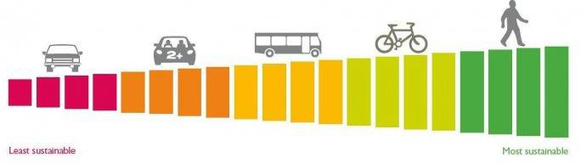

Initiatives include the provision of a dedicated mini bus to transport students and staff directly from the LRC at one campus to the LRC at the other campus. Known as the Uniflyer, this bus now achieves 100% utilisation during peak times and has cut journey times between the campuses to 20 minutes. Negotiations with Stagecoach (our local bus provider) has enabled a number of public buses to stop on our BOC campus negating the safety concerns of the on road bus stop. This issue will be addressed at our BRC campus with the construction of the technology park (see section 2.5).
Working in conjunction with WSCC, real time bus information is now available at the campus bus stop at BOC and in the LRCs at both campuses encouraging bus travel.

Cycle storage facilities have been improved on our BOC as part of the academic building project and cycle to work roadshows involving both of our scheme providers have been held at both campuses. These roadshows resulted in more staff purchasing bikes through the scheme. A dual purpose walking and cycle path has been constructed from the bottom of College Lane through our grounds at BOC onto campus. The narrowness of College Lane has long been a barrier to staff and students cycling (and to a lesser extent walking) to BOC.

The University has worked with the charity Living Streets at both campuses to encourage staff and students to walk, both as a leisure activity and as a mode of

⁵ Green Travel plan 2011-2014 University of Chichester

commuting. Competitions and led walks exploring the historic areas of Chichester and shark egg cases on a local beach at Bognor, have been held.

During the past four years, the University has changed the way it measures commuter travel.

Historically the University has used on-line questionnaires to provide data on the modes of transport utilised by both staff and students and the reasoning behind the travel modes chosen. These questionnaires have also proved useful in helping to identify the barriers preventing staff and students from choosing more sustainable forms of transport. However, since the production of the first Travel Plan in 2010, more reliable measures of transport analysis have been developed. Therefore, in order to produce the most recent Travel Plan 2017 to 20227, a TRICS UK Standard Assessment Method for Travel Plans (SAM) survey was carried out at the Bishop Otter campus (BOC) in October 2015 and at the Bognor Regis campus (BRC) in February 2017. These surveys involved the recording of the travel modes of 6131 individuals at BOC and 1903 at BRC and will be used as the baseline to monitor the future progress to travel plan targets.

The TRICS surveys suggest that the main mode of transport to both campuses is walking (Figure 5).

Figure 4 Most staff and students commute to the University on foot
60

50

40

30

20

10

0
Walking
BOC 56.8
BRC 44.6
Cycling
2.9
5.4
Bus
7.2
11.0
Train
0.6
0.7
Car share Car alone
12.0 20.4
17.6 20.7
Staff and students (%)

This figure is greater for our Bishop Otter campus with 56.8% of staff and students walking compared to 44.6% at our Bognor Regis campus. However, car sharing is more prevalent at BRC, with 17.6% travelling by this mode compared to 12% at BOC.

Figures for staff and students travelling as single occupants in cars is similar for both campuses (20.4% for BOC and 20.7% for BRC). Rail travel is also similar for both campuses and surprisingly low at less than one percent of travellers. Although recently there have been many comments from staff and students about the uncertainty of rail travel due to the Southern Rail dispute, which may have affected these figures.

The favoured public transport mode at both campuses is the bus, with 7.2 % of staff and students at BOC using this method and 11.0% at BRC. Despite the installation of additional facilities for cyclists at both campuses, such as more covered secure cycle spaces and showers, only a low percentage of staff and students cycle to the University (2.9% at BOC and 5.4% at BRC). This may be because staff are now living further away from the University, as shown by the questionnaire results and more students are choosing to live at home.

  - Biodiversity Management

A Biodiversity Action Plan was first developed by the Green Campus Group, a staff association of highly motivated employees promoting and raising awareness of green issues, in April 2011. This plan has since been updated with the most recent edition being produced in January 2017 (see section 2.11). The plans have been devised to ensure the maintenance and improvement of biodiversity within the University’s estate, taking into account opportunities presented by campus developments including the construction of the Technology Park. A number of initiatives have been put into place since the implementation of the last plan.

Re-usable water bottles have been provided to all staff and a large number of students at events such as Freshers’ Fair, bearing the Green Campus group logo. Information on the impact of the production of plastic on the environment and the location of water dispensers on our campuses, where the bottles can be refilled, has been provided with the bottles. Strimmers have been made available at both campuses for use in the
allotment areas and support has been provided by the University’s catering supplier to the Students’ Union’s newly formed vegetarian and vegan society. A project is currently underway to provide signage on the Bognor Regis campus highlighting where wildlife can be found and how it should be protected. This signage will encourage staff, students and members of the local community to explore the fauna and flora on the campus.

Since 2011, Spring Fairs have been held annually on our campuses to celebrate and promote sustainability and biodiversity. For the past three years this event has been organised by our second year event management students as partial fulfilment of their degree. The organisation of the event by our students not only helps to increase the individuals involved knowledge of sustainability and biodiversity, but has also proved successful in encouraging more students to attend pushing biodiversity concepts further through the student community. This year ethical and local companies such as Lush, The Body Shop and Pinks Ice Cream had stalls at the fair. Re-use was encouraged

through the book and DVD stall and healthy living was addressed through Zumba and yoga taster classes.

  - Embedding Sustainability in the Curriculum

It is widely recognised that HEIs are uniquely positioned to engage with people on sustainable development and provide the skills and knowledge needed for future challenges.

A new Learning and Teaching Strategy8 was produced in 2014. One of the five priorities identified in the new strategy is internationalism and global citizenship. Through this theme, the University is focusing on education for global citizenship and sustainable development, recognising the connections between the social, the cultural, the economic and natural world.
Since the instigation of the Technology Park, the Learning, Teaching and Student Experience Committee has been developing undergraduate and post graduate courses in environmental management and sustainability in business, which will be offered from September 2018. The implementation of these courses will pave the way for the introduction of sustainability education in other academic areas.

  - Awareness Raising and Communication

As mentioned in the introduction to this document, winning the hearts and minds of the University community, getting them to think and act differently is crucial to achieving the sustainable vision for the University. Since the introduction of the last plan, a number of techniques and initiatives have continued to be used to make progress on this important task.

A variety of communications media have been used in an attempt to engage the majority of the University population. Banners have been placed in the restaurants on both campuses so that students and staff and visitors to the site are aware of our commitment to Fairtrade and that the university, Students’ Union and our catering contractor are working together to promote Fairtrade. Posters containing information on different topics such as energy saving, waste segregation and the car share scheme, have been placed in strategic areas and announcements on the University’s Intranet and Moodle have been made at frequent intervals. Information on University initiatives such as the Jump scheme and Green Campus Group meetings have also been communicated using the Intranet, department Twitter accounts, Facebook groups and electronic screens located in the Support and Information Zones. Lectures have been given to students on invitation from various academic departments such as fine art and the business school. To encourage new students to think about sustainability, a waste segregation game has been played at Freshers’ and Refreshers’ Fairs, where students

⁸ Learning and Teaching Strategy 2014-2020, University of Chichester

were encouraged to place various waste types in the correct bin, in return for chocolate (Fairtrade of course!).

The Green Campus Group has continued to be instrumental in bringing about change and representing a platform from which to roll out initiatives, championing sustainability as a strategic direction for the University (see section 2.9). Their involvement in biodiversity has led to the construction of a pond outside The Dome at BRC, the provision of bird baths and the provision of water butts to collect rainwater for use on the allotments. In October 2016, the group supported an exhibition and competition to try to dispel the myths around what happens to our operational waste and engage more of the University community to think about their waste as an issue. As mentioned previously. for the past three years the Green Campus Group has worked with second year event management students to produce the Spring fair. This co-operation not only provides the students with a valid event to organise as an integral part of their course, but also provides the Green Campus Group with an event promoting sustainability and well- being. Using students to produce the event also has the knock on effect of encouraging more students to attend.

It is acknowledged that the student body is a vital partner in making future progress. Every opportunity has been taken to involve students in events and projects. Since 2014, six business school students have carried out their ten week work placement in the environment department and at least seven have completed their management projects on aspects of sustainability at the University with topics on sustainable travel, recycling in halls and across campus, the influence of CSR on food procurement and reducing paper consumption. This not only helps to engender a sustainable ethos into the individuals, but also provides the University with vital information on how sustainability improvements can be made by use of the recommendations from their work.

This academic year has also seen greater student representation on the Environmental Sustainability Group (ESG), sustainable food group and Green Campus Group, with the elected SU environment officer, SU President and SU Vice President (Welfare) in attendance.

In October 2014, the University launched a brand new fun sustainability and well-being scheme which enables all staff and students to earn points for “good behaviour”. Called Jump the scheme awards points to individuals which are then totalled to produce department scores. The scheme had never been operated in a University engaging both staff and students before, hence we have become the “showcase”. Jump is tailored to our wellbeing and sustainability strategy and our staff development programme. The scheme not only encourages staff and students to change their behaviours, but also provides opportunities for students. Since its launch second year event management students have produced the annual award ceremony as part of their coursework (Figures 5, 6 and 7) and students have been trained as Jump Ambassadors actively engaging with other students to encourage them to join. Last year a number of students were trained as assessors, providing verification of staff claims made and collecting

valuable feedback on how the scheme could be improved. All these activities will encourage more of the University community to become involved in environmental activities, will create better employability prospects for our students, will help to create an environmental ethos on the campuses and will enable environmental improvements to be made. It is hoped that the role of Jump Ambassador and Jump Assessor will be included in the HEAR in the near future.

Figure 5 The Jump Awards Ceremony 2017
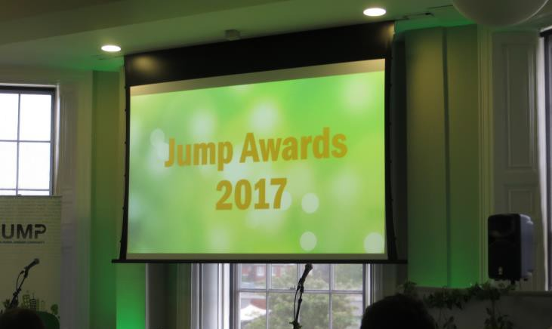

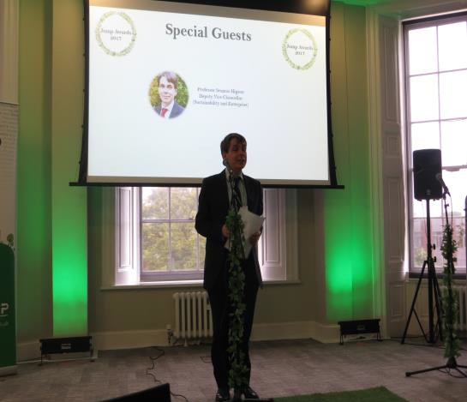Figure 6 Professor Seamus Higson provides information on the importance of sustainability to the University at the Jump Awards 2017

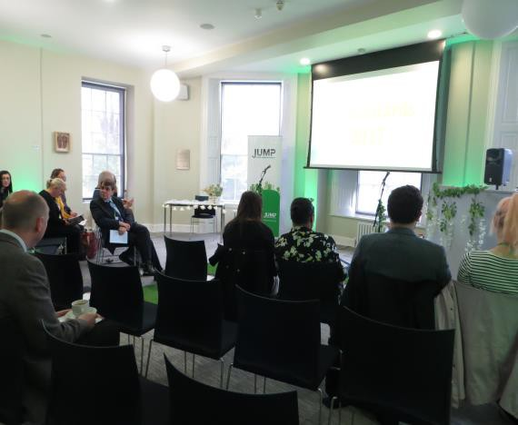Figure 7 University staff and external personnel await the start of the Jump Awards 2017

Objectives and targets for further improvement

Key Facts

- The AUDE Green Scorecard has been used as a basis for target setting enabling consistency with other Higher Education Institutes (HEIs) approaches.
- Further development and integration of the environmental management system into our business to meet the requirements of ISO 14001:2015, will help to ensure consistency of our approach.

Objectives and targets for each of the key themes for progress have been developed and are described in the following sections. An action plan identifying all actions and resources required to meet these objectives and targets is given in Appendix 3. For most areas, relevant targets from the AUDE Green score card have been used.

Specific objectives and targets for environmental governance and legal compliance are not included, as these are covered by the continued development of the Environmental Management System.

  - Environmental Management System

The University has implemented an EMS certified to BS8555 Phases 1 to 5. Phase 6 is the acknowledgement of this and subsequent preparation for certification against one of the internationally recognised schemes, most frequently ISO 14001 or the less popular scheme, EMAS. The current ISO 14001 standard was updated in September 2015. As previously mentioned, once the Technology Park development is complete in September 2018, the University will offer courses with greater sustainability content. To coincide with this the University will also develop the EMS further to be compliant with ISO 14001:2015 by this date.

Summary of EMS objectives
    - To continue to develop the EMS to be compliant with ISO 14001:2015 and integrate it into the business.

Target
- Achieve ISO 14001:2015 certification by the end of September 2018.

  - Managing Waste and Recycling

Waste management issues are still pertinent to the University. A number of initiatives have been carried out involving different sectors of the University community to raise awareness of operational waste management issues. However, the amount of operational waste produced on our campuses compared to our benchmarks in the sector is still high and our operational waste recycling rate remains at a low level.
Where feasible, construction waste is recycled and BREEAM is used to reduce waste, although further opportunities to design out waste in construction projects exist. Food waste segregation should be considered when the waste management contract is re- tendered in the summer of 2017.

Summary of Waste Management objectives
    - To decrease the amount of operational waste created and increase the proportion recycled.
    - To decrease the amount of construction waste generated.

Targets
    - Segregate food waste from main restaurant areas and dispose of using the best feasible option by the end of the 2017/18 academic year.
    - Increase the proportion of operational waste recycled by 1% by the end of the 2018/19 academic year and by 2% by the end of the 2020/21 academic year.
    - Reduce the amount of operational waste generated by 1% by the end of the 2018/19 academic year and by 2% by the end of the 2020/21 academic year.
    - Increase the proportion of operational waste diverted from landfill to above 89% by the end of the 2018/19 academic year and to above 90% by the end of the 2020/21 academic year.
    - Develop and adopt guidelines for reducing waste in construction projects by the end of the 2020/21 academic year.

  - Sustainable Construction

The University has adopted the Building Research Establishment Environmental Assessment Method (BREEAM) standard. This standard is the most widely used assessment method for the built environment and promotes best practice in sustainable construction, design and the environmental performance of buildings. Some work on adaptation for climate change has been carried out, but more focus is required in this area.

Summary of Sustainable Construction objectives
    - To continue to ensure that the environmental impact of the construction phase of all new builds and refurbishments is minimised, that all are low carbon developments and energy and water efficient.

    - To be mindful of potential climate change issues and ensure the University Estate is equipped to deal with these, where practicable.

Targets
    - Achieve BREEAM rating of very good or higher for all new buildings and major refurbishments.
    - Use BREEAM to focus on University priority areas of sustainability.
    - Carry out a climate change risk assessment for the University's buildings and operations which is used to inform policy by the end of the 2020/21 academic year.
    - Model and understand the potential impact of climate change on the likelihood of flooding of the University’s buildings and the impact on operations by the end of the 2020/21 academic year.
    - Consider overheating issues within existing buildings on campus as part of the business continuity plan by the end of the 2020/21 academic year.
    - Ensure new buildings are able to cope with temperatures expected during their first refurbishment cycle (approximately 25 years).
    - Prepare a specific climate change adaptation policy for new developments, including soft and hard landscaping and operational issues, based on risk assessment for integration into University policies at a later stage.

  - Utilities Management

Objectives and targets for utilities management are described in the Carbon Management Plan 2017 - 2020 9.

  - Sustainable Procurement

The University is concentrating on the three areas of sustainable procurement, economic, environment and social. Actions are required to ensure that sustainability is embedded into contracts through specifications, supplier selection, evaluation and award and contract management. In order to do this, different elements of the Flexible Framework (Appendix 2) will be required to be fulfilled such as staff training, supplier engagement and supply chain mapping.

Summary of Sustainable Procurement objectives
    - To continue to develop the sustainable procurement process and integrate it into the business.

Targets
    - Reach level 2 of the Flexible Framework by the end of the 2018/19 academic year.
    - Maintain Fairtrade accreditation by successful renewal of status in September 2017, September 2019 and September 2021.

⁹ Carbon Management Plan 2017 - 2020 University of Chichester

  - Sustainable Travel

The University has recently produced its third travel plan7 for the next five years (2017 to 2022). This travel plan describes recent initiatives which have been put into place to encourage staff, students and visitors to travel to the University by more sustainable means and objectives and targets for the future. As previously mentioned, a more reliable method of travel monitoring has recently been trialled and will be used at both campuses, to monitor the impact of future initiatives.

Summary of Sustainable Travel objectives
    - To continue to develop sustainable travel initiatives according to the travel hierarchy and develop a sustainable travel ethos throughout the University community.

Targets
    - Reduction in fuel emissions from HEI own vehicles by the end of the 2018/19 academic year.
    - Improvement in the proportion of fleet that are low or zero carbon by the end of the 2018/19 academic year.
    - Increase in zero carbon travel (cycling and walking) for staff by 0.25% by the end of the 2019/2020 academic year and by 0.5% by the end of the 2021/22 academic year.
    - Increase in zero and low carbon travel (cycling, walking and public transport) for staff by 0.5% by the end of the 2019/20 academic year and by 1.0% by the end of the 2021/22 academic year.
    - Increase in zero carbon travel (cycling and walking) for students by 0.25% by the end of the 2019/20 academic year and by 0.5% by the end of the 2021/22 academic year.
    - Increase in zero and low carbon travel (cycling, walking and public transport) for students by 0.5% by the end of the 2019/20 academic year and by 1.0% by the end of the 2021/22 academic year.

  - Biodiversity and Landscape Management

The University recognises that one of its greatest assets is the green space at both campuses. Much work has been carried out to maintain and develop this asset, particularly by the Green Campus Group and through the use of BREEAM. This emphasis should be continued and integrated to ensure further opportunities to enhance biodiversity are identified and appropriate actions taken.

Summary of Biodiversity Management objectives
    - To maintain and improve biodiversity within the University’s estate.

Targets
    - Biodiversity action plan in place and adopted as part of the landscape management and development plan by the end of 2020/21 academic year.
    - Increasing biodiversity is a driving factor in the landscape plan and given comparable priority with creating amenity space and other requirements by the end of the 2020/21 academic year.
    - Inclusion of habitats integrated biodiversity is included in the brief for all relevant building projects in response to a campus-wide policy by the end of the 2020/21 academic year.
    - Active Green Campus Group fully supported by the University.
    - A requirement to follow the Sustainable Drainage hierarchy (or similar) included within the brief for all relevant construction projects by the end of the 2020/21 academic year.

  - Embedding Sustainability into the Curriculum

With the expansion of the diversity of subjects offered through the development of the Technology Park, the University has increased opportunities to embed sustainability into the existing curriculum and ensure it is incorporated in the newly created curriculum.
These opportunities will be embraced in line with the goals identified in the University’s Learning and Teaching Strategy.

Summary of Embedding Sustainability into the Curriculum objectives
To continue to embed sustainability into the curriculum taking full advantage of evolving curricula due to the Technology Park development.

Targets
    - To work with AQSS to explore the feasibility that reference to ESD is considered in future programme developments.
    - To engage with the University’s Learning and Teaching Conference and Festival organisers to ensure that environment and sustainable development events are included in the respective programmes,
    - To liaise with the Learning and Teaching Lecture Series co-ordinator to ensure that there is at least one speaker per academic year that focuses on the environment and sustainable development.
    - To explore the opportunities to develop a module on sustainability/global citizenship which can be adopted by programmes across the University
    - Support opportunities for student engagement in line with the goals identified in the University’s Learning and Teaching Strategy.

  - Awareness Raising and Communication

Many schemes and ideas have been utilised to try to engage with the whole of the University community and spread an environmental ethos throughout the organisation. Whilst it is recognised that there are areas of good practice within the University, such

as the Green Campus Group and the Jump members, further work is required to catalyse wider cultural change. The changing student population also provides further impetus for continual effort in this area. Current areas of student involvement in green events and actions should be further developed and extended across the University.

Summary of Awareness Raising and Communication objectives
    - Ensure all staff and students are able to engage in the process of improving the University’s environment and sustainability performance.

Targets
    - Increase membership of the Jump scheme (or similar) year on year until the end of the 2020/21 academic year.
    - Hold at least one environmental sustainability campaign or event each academic year involving both staff and students.
    - Produce one form of communication on environment and sustainable development issues or activities each week.

Monitoring and Review

Key Facts

- The Aude Green Scorecard and EMR data will be used to monitor development to most targets.
- Progress to different themes will be reviewed and monitored by specific committees or working groups.
- Overall progress to the Environmental and Sustainable Development Plan targets and completion of initiatives will be reviewed and reported to senior management through the Environmental Sustainability group (ESG).

Methods used to implement this Environment and Sustainability Plan at the University are illustrated in Figure 8.
Most objectives and targets described in this plan are developed from the AUDE Green Scorecard and will use data from the annual EMR (Estate Management Records) returns to monitor progress. Where data is not produced as part of the EMR, progress will be monitored through the completion of actions. Working groups or committees have been set up to facilitate change in most areas. Progress in all areas is reported to senior management through the Environmental Sustainability Group.

Procurement Group
Learning and Teaching Strategy
Biodiversity Action Plan
Waste Management Plan
Carbon Management Plan
Sustainable Travel Plan

Food Charter
Figure 8 Implementation of the environmental and sustainability plan through the University

Vice Chancellor’s Group

Environmental Management
system
Awareness
raising and communication
Sustainable
Procurement
Sustainable
construction
Utilities
management
Managing
waste and
recycling
Sustainable
travel
Biodiversity and
land management
Embedding
sustainability in the curriculum
Environment and Sustainability Plan
Certification Body Assessment
Environmental Sustainability Group

Jump Scheme

Fairtrade Steering Group
BREEAM
Assessment

Waste Group

Travel Group
Green Campus Group
Learning, Teaching and Student Experience Committee

The University of Chichester

Key to Figure 5

Environmental sustainability theme
Sustainable Procurement

University document or system
Carbon Management Plan

University committee or group

Travel Group

External body
BREEAM
Assessment

28

Appendix 1 Overview of the AUDE Scorecard using data from the 2014/2015 academic year and targets for the end of the 2017/2018 academic year

Green Scorecard Output
The University of Chichester
Indicator Detail

E1 - Ctlan ge in bujlding energ consumpiion - absolute
E2 - Ch,rn,ge in building en@rg11 cot1surnl)tion - noflllali d by floor rija
E3 - Renewables generaled
i-- ...,-

2 3 4

M1 • BREEAM 2
E4 - en.ewahles pure hasec! 11'1111 green taritts ::::-·::.- ·- :_·::-·--::..
E5 - Change in tol.lI sco 1&2 emissicioo ■ - 1

M3 - Mamigement 01 sus1alne:lllll1y on construction proj ts.i- - _"•'-.,•.- ■ ■::::::,t
E6 - Rectuction from 2000 ba1ie1i ei-- ...,- ■ - 1

t.12 - Al ematil'e s11si aina b,ili1y ra ing schemes : M4 • Envlronmi n I M nagemant S lllim

E7 - Carbon reduc on larget•s .,._ ...,_ -■I
E8 - Low GWP refri,ge1ant use
E9' - Energy Aw,1reness
EID - l1SO5-0001

e1 -

S i.sr ta ma ble O f\lina geTec ll ni qu es ,._ I -cc--1<' 2"""T. s
-"I 4
MANAGEMENT
ENERGY EMISSIONS
T1 • Emissions from1uel used In HEI cmned vehiclesi-- -.- •2"'""-- +- 4 - 1
■

62 - Oree lng bullcilngs-. - • - - • - -
T2 • PTOpmtion of neet ll'mt are elecbic -rell icl es ,---.

B3 - $pe,cl!:'s rl chnessi- - ... --.--
84 - Protec1ion of e,: ologl,:;al te.il s and hablta,1$;,- - -. - - .. --i
6 5 - Ellodlverslly Acllon Plan;,- - -. - - lllj-
ee -
Bats, blr<-:ls al'!ld pol natol':$• - • - - et·---------- ----------
T3 - % modal $pl-i of iero ,rbon t1c1v'l l by s_1a
T4 - % modal split of IO¥\ ca, oon lral'., I by sta ff - improvem.,nt T5 - % modal split of low carbon travel b'/ staff - absolute T6 - % modaI spli of zero carbDntr.i,.,.,I by studer;ts
-::·-,--·--:

T7 - % mo-dal sprn of row carbon tr.iveI lb\' studer;ts-i- - ..
-- i

BIODIVERSITY LANDSCAPE TRANSPORT

PROCUREMENT
P1- we s,1re'11l 1--2.-1 -i-3-1---4-·
SIiis a1nable loo--d a 1f m a l :
WATER
WT-1
W.it'lrr e<uJc oo t"rgmets
1 --· 2 3 4

P2 • SllstaJnablerood • human rights l$$Ue$
P3 - Sust;in abl e constndom - local IJI0tu remerit ::::::,-:,-:, •--•-•
/
P4 - Sustalna ie conslruc1loo - education anel enwlronmerit - _
P5 - IJse ot FlexIbleFra e\\!or'k . .. ............
WT2 - Wo1l'l 1 cons.umption - imp10¥em'l ril
WT3 - Water consum p1t00 - absolute :::::·
\NT4 - Propor1ion suppliedby rain wat1er and grey water WT5 - Carbon emissions rrom waMe;,rater treatment

C::i Ef.f r! S:.c
cor,a, DD- El-1 con:
OpUona.1 w, Sccrre­
ADAPTATION
WASTE
ws, - li• - •2• - •a_. 4
WS2 - Op1eration.al waste ,. -i
Totat was e generare)■ll ■l _..,

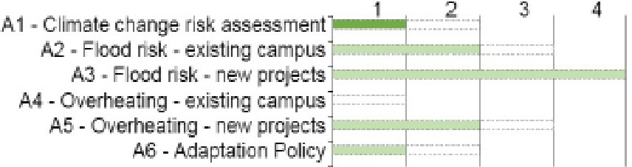
Optio.naJ oo,. '1-1 R co.re E»1Rr ,.c t Sc«<
1"'041 r T;r Srn
1-k.1;'7.a , d
WSJ - Prop . of burlclings waste diverted fro-m lan clfill - improve,ment)■
WS4 - Proporii,m of bu il di ngs waste, diverted from landfill - absoluts)lllo- • - -
WS5 - Proportion of buildings was.le rec led_l- _. lf
'I'/&, - Proportion Qf buildi11gs was1-e composled)lllo- • - - • - - • -

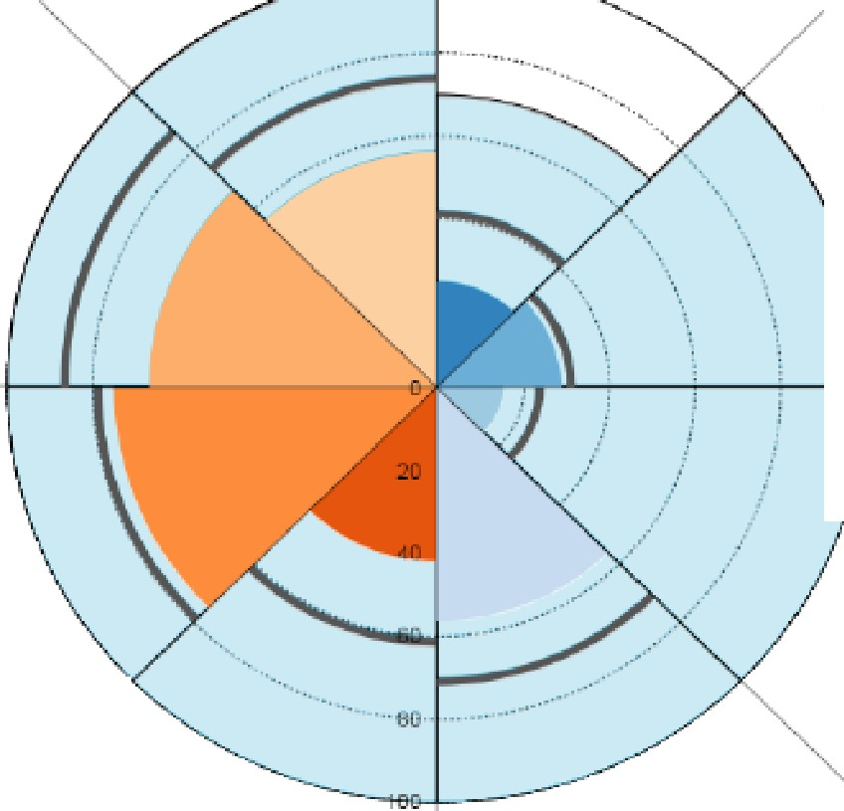
P-G t:mna l -SC:o r T ra- t Scor e-
1A .11)(rrn 1rm S co r l!!'
WS7 - Minimf\satio n of con&1ruction waste t,..:•..:- x:;;:: :1111'.:=
WSS - Segreg-a1ion of food waste ·- - -- _: j

ARUP

Appendix 2 Flexible Framework produced by DEFRA

 | Foundation - Level 1 | Embed - Level 2 | Practice - Level 3 | Enhance - Level 4 | Lead - Level 5
PEOPLE | Sustainable Procurement | All procurement staff have | Targeted refresher | Sustainable Procurement | Achievements are publicised
 | champion identified. Key | received basic training in | training on latest | included in competencies | and used to attract
 | procurement staff have | sustainable procurement | Sustainable Procurement | and selection criteria. | procurement professionals.
 | received basic training in | principles. Key staff have | principles. Performance | Sustainable Procurement is | Internal and external awards
 | Sustainable Procurement | received advanced | objectives and appraisal | included as part of | are received for
 | principles. Sustainable | training on sustainable | include Sustainable | employee induction | achievements. Focus is on
 | Procurement is included as | procurement principles. | Procurement factors. | programme. | benefits achieved. Good
 | part of a key employee |  | Simple incentive |  | practice shared with other
 | induction programme. |  | programme in place. |  | organisations.
POLICY, STRATEGY | Agree overarching | Review and enhance | Augment the Sustainable | Review and enhance the | Strategy is: reviewed
& | Sustainability objectives for | sustainable procurement | Procurement policy into a | Sustainable Procurement | regularly, externally
COMMUNICATIONS | procurement. Simple | policy, in particular | strategy covering risk, | strategy, in particular | scrutinised and directly linked
 | Sustainable Procurement | consider supplier | process integration, | recognising the potential of | to organisations' EMS. The
 | policy in place endorsed by | engagement. Ensure it is | marketing, supplier | new technologies. Try to link | Sustainable Procurement
 | CEO. Communicate to staff | part of a wider | engagement, | strategy to EMS and include | strategy recognised by
 | and key suppliers. | Sustainable Development | measurement and a | in overall corporate strategy. | political leaders, is
 |  | strategy. Communicate to | review process. Strategy |  | communicated widely. A
 |  | staff, suppliers and key | endorsed by CEO. |  | detailed review is undertaken
 |  | stakeholders. |  |  | to determine future priorities
 |  |  |  |  | and a new strategy is
 |  |  |  |  | produced beyond this
 |  |  |  |  | framework.
PROCUREMENT | Expenditure analysis | Detailed expenditure | All contracts are | Detailed Sustainability risks | Life-cycle analysis has been
PROCESS | undertaken and key | analysis undertaken, key | assessed for general | assessed for high impact | undertaken for key commodity
 | Sustainability impacts | Sustainability risks | Sustainability risks and | contracts. Project/contract | areas. Sustainability Key
 | identified. Key contracts | assessed and used for | management actions | Sustainability governance is | Performance Indicators
 | start to include general | prioritisation. | identified. Risks managed | in place. A life-cycle | agreed with key suppliers.
 | Sustainability criteria. | Sustainability is | throughout all stages of | approach to cost/impact | Progress is rewarded or
 | Contracts awarded on the | considered at an early | the procurement process. | assessment is applied. | penalised based on
 | basis of value-for-money, | stage in the procurement | Targets to improve |  | performance relevant to the
 | not lowest price. Procurers | process of most | Sustainability are agreed |  | contract. Barriers to
 | adopt Government Buying | contracts. Whole-life | with key suppliers. |  | Sustainable Procurement
 | Specification. | Costing analysis adopted. |  |  | have been removed. Best
 |  |  |  |  | practice shared with other
 |  |  |  |  | organisations.

The University of Chichester

SUPPLIERS | Key supplier spend analysis undertaken and high sustainability impact suppliers identified. Key suppliers targeted for engagement and views on procurement policy sought. | Detailed supplier spend analysis undertaken.  General programme of supplier engagement initiated, with senior manager involvement. | Targeted supplier engagement programme in place, promoting continual Sustainability improvement. Two way communication between procurer and supplier exists with incentives.  Supply chains for key spend areas have been mapped. | Key suppliers targeted for intensive development.  Sustainability audits and supply chain improvement programmes in place.  Achievements are formally recorded. CEO involved in the supplier engagement programme. | Suppliers recognised as essential  to delivery of organisations’ sustainable procurement strategy. CEO engages with suppliers. Best practice shared with other/peer organisations. Suppliers recognise they must continually improve their Sustainability profile to keep the client's business.
MEASUREMENT & RESULTS | Key Sustainability impacts of procurement activity have been identified. Simple measures based on achieving all aspects of the Foundation level of the flexible  framework are put in place and delivered. | Detailed appraisal of the Sustainability impacts of the procurement activity has been undertaken. Measures implemented to manage the identified high risk impact areas.  Simple measures based on achieving all aspects of the Embedding level of the flexible framework are put in place and delivered. | Sustainability measures refined from general departmental measures to include individual procurers and are linked to development objectives. Simple measures based on achieving all aspects of the Practicing level of the flexible framework are put in place and delivered. | Measures are integrated into a balanced score card approach reflecting both input and output.  Comparison is made with peer organisations. Benefit statements have been produced. Simple measures based on achieving all aspects of the Enhancing level of the flexible framework are put in place and delivered. | Measures used to drive organisational sustainable development strategy direction. Progress formally benchmarked with peer organisations. Benefits from Sustainable Procurement are clearly evidenced.  Independent audit reports available in the public domain. Simple measures based on achieving all aspects of the Leading level of the flexible  framework are put in place and delivered.

31

Appendix 3 Action plan

Area | Objectives | Targets | Actions | Responsibility | Completion date
Environmental Management System | Continue to develop the EMS and integrate it into the business. | Achieve ISO 14001:2015 certification | Undertake stage 1 audit | Environment and Sustainable Development Co-ordinator | June 2018
 |  |  | Undertake stage 2 audit | Environment and Sustainable Development Co-ordinator | End of September 2018
Managing waste and recycling | Decrease the amount of operational waste created and increase the proportion recycled. | Reduce the amount of operational waste generated by 1% by the end of the 2018/19 academic year and by 2% by the end of the 2020/21 academic year. | Continue to run awareness campaigns to reduce the amount of waste created during student arrivals and departures. | Environment and Sustainable Development Co-ordinator | Ongoing
 |  |  | Analyse sources of waste and amounts to prioritise actions for reduction. | Environment and Sustainable Development Co-ordinator | End of 2018/19 academic year.
 |  |  | Continue Operation Paper Cut and incentivise through Jump. | Head of support and Customer Experience | Ongoing
 |  |  | Start to develop a strategy for reducing waste associated with procurement | Procurement Group | End of the 2020/21 academic year.
 |  | Improve the proportion of operational waste diverted from landfill to above 89% by the end of the 2018/19 academic year and to above 90% by the end of the 2020/21 academic year. | Analyse the sources and types of wastes sent to landfill to prioritise areas for action | Environment and Sustainable Development Co-ordinator | End of 2018/19 academic year.

Area | Objectives | Targets | Actions | Responsibility | Completion date
Managing waste and recycling (continued) | Decrease the amount of operational waste created and increase the proportion recycled (continued). | Improve the proportion of operational waste recycled by 1% by the end of the 2018/19 academic year and by 2% by the end of the 2020/21 academic year. | Continue to run campaigns, provide information and attend Fresher’s Fair etc. | Environment and Sustainable Development Co-ordinator | Ongoing
 |  |  | Work with suppliers and waste contractor to enable the recycling of take away cups and containers. | Environment and Sustainable Development Co-ordinator | End of the 2017/18 academic year.
 |  |  | Review and change signage on bins using results from recent internal research. | Environment and Sustainable Development Co-ordinator
 |  |  | Provide and position bins to ensure there is always provision for recycling. | Environment and Sustainable Development Co-ordinator
 |  |  | Produce a plan to implement a “bin the bin” campaign in offices, teaching areas and accommodation in conjunction with relevant staff. | Environment and Sustainable Development Co-ordinator
 |  | Segregate food waste from the main restaurant areas and dispose of using the best feasible option. | Ensure segregation of food waste is considered in the waste contract when renewed in August 2017. | Environment and Sustainable Development Co-ordinator | End of the 2017/18 academic year.
 |  |  | Work with incoming waste contractor or alternative supplier to find an outlet for food waste.
 |  |  | Set up collection scheme for food waste in conjunction with Elior.
 | Decrease the amount of construction waste generated. | Consider and design out waste in the design stage of construction projects. | Review WRAP guidelines for designing out waste and implement where feasible. | Property Development Manager | End of academic year 2020/21

Area | Objectives | Targets | Actions | Responsibility | Completion date
Sustainable | Continue to ensure that | Achieve BREEAM rating of | Continue to include BREEAM | Estate Management | Ongoing
construction | the environmental | very good or higher for all | requirements in all new builds and
 | impact of the | new buildings and major | refurbishments.
 | construction phase of all | refurbishments.
new builds and refurbishments is minimised, that all are
low carbon
 |  | Use BREEAM to focus on University priority areas of sustainability. | Investigate how the concept of BREEAM can be used to help focus  on all University sustainability areas. | Environment and Sustainable Development  Co-ordinator and Property | End of academic year 2020/21
 | developments and |  |  | Development Manager
 | energy and water efficient.
 |  | Carry out a high level climate change risk assessment for the university's buildings and operations which is used to inform policy. | Instigate a high level risk assessment to understand the climate change issues specifically likely to affect the University. | Property Development Manager | End of academic year 2020/21
 |  | Model and understand the potential impact of climate change on the likelihood of flooding of the University’s buildings and the impact on operations. | Extend the model of the potential impact of climate change on the Technology Park development to other areas of the University estate. | Property Development Manager | End of the 2020/21 academic year

Area | Objectives | Targets | Actions | Responsibility | Completion date
Sustainable construction (continued) | Continue to ensure that the environmental impact of the  construction phase of all | Consider overheating issues within existing buildings on campus as part of the business continuity plan. | Determine potential overheating issues in existing buildings due to climate change and include in  business continuity plan. | Property Development Manager | End of the 2020/21  academic year
new builds and
refurbishments is
 |  | Ensure new buildings are able to cope with temperatures expected during their first refurbishment cycle (approximately 25 years). | Include requirement for new buildings | Property Development | End of the
 | minimised, that all are |  | to cope with expected temperatures | Manager | 2020/21
 | low carbon |  | in specification. |  | academic year.
 | developments and
 | energy and water
 | efficient (continued).
 |  | Prepare a specific climate change adaptation policy for new developments based on risk assessment for integration into University policies at a later stage. | Produce/extend the climate change adaptation policy to cover hard and soft landscaping and operational issues. | Property Development Manager | End of the 2020/21  academic year.
 |  |  | Integrate the policy into University
 |  |  | procedures.
Utilities management | Actions and resources required to meet the objectives and targets for utilities management are described in the Carbon Management Plan 2017 to 2020.

Area | Objectives | Targets | Actions | Responsibility | Completion date
Sustainable | Continue to develop | Reach level 2 of the | Carry out sustainable procurement training | Procurement Group, Finance and Environment and Sustainable Development co-ordinator | End of the 2020/21  academic year.
procurement | the sustainable | Flexible Framework | for all key procurement staff.
procurement process
and integrate it into
 |  |  | Produce a sustainable procurement policy
 | the business. |  | which includes supplier engagement.  Communicate policy to staff, suppliers and
 |  |  | key stakeholders.
 |  |  | Review earlier risk assessment of
 |  |  | procurement. Consider sustainable
 |  |  | procurement in the early stages of most
 |  |  | contracts. Consider whole life costing.
 |  |  | Undertake a supplier spend analysis and
 |  |  | supplier engagement programme.
 |  |  | Carry out a detailed analysis of the
 |  |  | sustainability impact of procurement and
 |  |  | manage the high risk areas.
Sustainable | Continue to develop | Maintain Fairtrade | Continue to hold quarterly meetings of the | Sustainable Food and Fairtrade Steering Group and Environment and Sustainable Development co-ordinator | Renewal of status required September 2017, 2019 and  2021.
procurement | the sustainable | accreditation | Fairtrade Steering Group.
(continued) | procurement process  and integrate it into the
 |  |  | Continue to actively promote a Fairtrade
 | business. |  | ethos throughout the University community.
 |  |  | Continue to review and adhere to the
 |  |  | Fairtrade policy.
 |  |  | Continue to include Fairtrade products in
 |  |  | our hospitality offering.
 |  |  | Continue to sell Fairtrade products.

Area | Objectives | Targets | Actions | Responsibility | Completion date
Sustainable travel | Continue to develop sustainable travel initiatives according to the travel hierarchy and develop a sustainable travel ethos throughout the University community. | Reduction in fuel emissions from HEI own vehicles | Actions and the responsible person/department for the actions are described in the Travel Plan 2017 - 2022. |  | End of academic year 2018/19
 |  | Improvement in the proportion of the fleet that are low or zero carbon. |  |  | End of academic year 2018/19
 |  | Improvement in the percentage of zero carbon travel for staff by 0.25%. |  |  | End of academic year 2019/20
 |  | Improvement in the percentage of zero carbon travel for staff by 0.5%. |  |  | End of academic year 2021/22
 |  | Improvement in the percentage of zero and low carbon travel for staff by 0.5%. |  |  | End of academic year 2019/20
 |  | Improvement in the percentage of zero and low carbon travel for staff by 1.0%. |  |  | End of academic year 2021/22
 |  | Improvement in the percentage of zero carbon travel for students by 0.25% |  |  | End of academic year 2019/20
 |  | Improvement in the percentage of zero carbon travel for students by 0.5% |  |  | End of academic year 2021/22
 |  | Improvement in the percentage of zero and low carbon travel for students by 0.5%. |  |  | End of academic year 2019/20
 |  | Improvement in the percentage of zero and low carbon travel for students by 1.0%. |  |  | End of academic year 2021/22

Area | Objectives | Targets | Actions | Responsibility | Completion date
Biodiversity and landscape management | Maintain and improve biodiversity within the University’s estate. | Biodiversity action plan in place and adopted as part of the landscape management and development plan. | Collate or link biodiversity action plan and landscape plan. | Health, Safety and Environment Manager | End of academic year 2020/21
 |  | Increasing biodiversity is a driving factor in the landscape plan and given comparable priority with creating amenity space and other requirements. | Review landscape plan and ensure increasing biodiversity is a driving factor. | Health, Safety and Environment Manager | End of academic year 2020/21
 |  | Habitats integrated biodiversity is included in the brief for all relevant building projects in response to a campus-wide policy. | Review building projects specifications and ensure habitats biodiversity is included. | Health, Safety and Environment Manager | End of academic year 2020/21
 |  | Active Green Campus Group fully supported by the University. | Advertise Green Campus group at start of academic year to all staff and students. | Health and Safety Advisor | September each year
 |  |  | Hold quarterly meetings of group | Health and Safety Advisor | October, January, March and June each year
 |  | A requirement to follow the Sustainable Drainage hierarchy (or similar) is included within the brief for all relevant construction projects. | Review construction projects specification and ensure the sustainable drainage hierarchy is included. | Property Development Manager | End of academic year 2020/21

Area | Objectives | Targets | Actions | Responsibility | Completion date
Embedding sustainability into the curriculum | To continue to embed sustainability into the curriculum taking full advantage of evolving curricula due to the Technology Park development. | Work with Academic Quality Standards Service (AQSS) to explore the feasibility that reference to embedding sustainability into the curriculum is considered in future programme developments. | Produce a mechanism to ensure embedding sustainability in the curriculum is considered in future programme developments. | Learning, Teaching and Student Experience Committee | End of academic year 2020/21
 |  | Engage with the University’s Learning and Teaching Conference and Festival organisers to ensure that environment and sustainable development events are included in the respective programmes. | Ensure the Learning and Teaching Conference and Festival organisers are aware of the importance of including environment and sustainability content in the event.
 |  |  | Liaise with University staff and external organisations to provide environment and sustainability content for the Learning and Teaching Conference and Festival.
 |  | Liaise with the Learning and Teaching Lecture Series co- ordinator to ensure that there is at least one speaker per academic year that focuses on the environment and sustainable development. | Engage with University staff and external organisations to provide environment and sustainability content for the Learning and Teaching Lecture Series.
 |  | Work with academic colleagues to explore the opportunity to develop a University wide module on sustainability/global citizenship. | Form working group of interested academic colleagues to determine the potential for developing a University wide module on sustainability/global citizenship.
 |  | Support opportunities for student engagement in line with the goals identified in the University’s Learning and Teaching Strategy. | Identify curricula and non-curricula activities for student involvement and promote accordingly.

Area | Objectives | Targets | Actions | Responsibility | Completion date
Awareness raising and communication | Ensure all staff and students are able to engage in the process of improving the University’s environment and sustainability performance | Increase membership of the Jump scheme (or similar) year on year. | Advertise Jump to staff and students each semester. | Environment and Sustainable Development  Co-ordinator | Ongoing
 |  |  | Add the Student Ambassador role to the HEAR.
 |  |  | Continue to encourage feedback on the scheme and incorporate suggested changes.
 |  | Hold at least one environmental sustainability campaign or event each academic year involving both staff and students. | Develop event plan in conjunction with the Green Campus Group and implement.
 |  | Produce one form of communication on environment and sustainable development issues or activities each week. | Develop communication plan and implement.

Appendix 2 Flexible Framework produced by DEFRA

 | Foundation - Level 1 | Embed - Level 2 | Practice - Level 3 | Enhance - Level 4 | Lead - Level 5
PEOPLE | Sustainable Procurement | All procurement staff have | Targeted refresher | Sustainable Procurement | Achievements are publicised
 | champion identified. Key | received basic training in | training on latest | included in competencies | and used to attract
 | procurement staff have | sustainable procurement | Sustainable Procurement | and selection criteria. | procurement professionals.
 | received basic training in | principles. Key staff have | principles. Performance | Sustainable Procurement is | Internal and external awards
 | Sustainable Procurement | received advanced | objectives and appraisal | included as part of | are received for
 | principles. Sustainable | training on sustainable | include Sustainable | employee induction | achievements. Focus is on
 | Procurement is included as | procurement principles. | Procurement factors. | programme. | benefits achieved. Good
 | part of a key employee |  | Simple incentive |  | practice shared with other
 | induction programme. |  | programme in place. |  | organisations.
POLICY, STRATEGY | Agree overarching | Review and enhance | Augment the Sustainable | Review and enhance the | Strategy is: reviewed
& | Sustainability objectives for | sustainable procurement | Procurement policy into a | Sustainable Procurement | regularly, externally
COMMUNICATIONS | procurement. Simple | policy, in particular | strategy covering risk, | strategy, in particular | scrutinised and directly linked
 | Sustainable Procurement | consider supplier | process integration, | recognising the potential of | to organisations' EMS. The
 | policy in place endorsed by | engagement. Ensure it is | marketing, supplier | new technologies. Try to link | Sustainable Procurement
 | CEO. Communicate to staff | part of a wider | engagement, | strategy to EMS and include | strategy recognised by
 | and key suppliers. | Sustainable Development | measurement and a | in overall corporate strategy. | political leaders, is
 |  | strategy. Communicate to | review process. Strategy |  | communicated widely. A
 |  | staff, suppliers and key | endorsed by CEO. |  | detailed review is undertaken
 |  | stakeholders. |  |  | to determine future priorities
 |  |  |  |  | and a new strategy is
 |  |  |  |  | produced beyond this
 |  |  |  |  | framework.
PROCUREMENT | Expenditure analysis | Detailed expenditure | All contracts are | Detailed Sustainability risks | Life-cycle analysis has been
PROCESS | undertaken and key | analysis undertaken, key | assessed for general | assessed for high impact | undertaken for key commodity
 | Sustainability impacts | Sustainability risks | Sustainability risks and | contracts. Project/contract | areas. Sustainability Key
 | identified. Key contracts | assessed and used for | management actions | Sustainability governance is | Performance Indicators
 | start to include general | prioritisation. | identified. Risks managed | in place. A life-cycle | agreed with key suppliers.
 | Sustainability criteria. | Sustainability is | throughout all stages of | approach to cost/impact | Progress is rewarded or
 | Contracts awarded on the | considered at an early | the procurement process. | assessment is applied. | penalised based on
 | basis of value-for-money, | stage in the procurement | Targets to improve |  | performance relevant to the
 | not lowest price. Procurers | process of most | Sustainability are agreed |  | contract. Barriers to
 | adopt Government Buying | contracts. Whole-life | with key suppliers. |  | Sustainable Procurement
 | Specification. | Costing analysis adopted. |  |  | have been removed. Best
 |  |  |  |  | practice shared with other
 |  |  |  |  | organisations.

SUPPLIERS | Key supplier spend analysis undertaken and high sustainability impact suppliers identified. Key suppliers targeted for engagement and views on procurement policy sought. | Detailed supplier spend analysis undertaken.  General programme of supplier engagement initiated, with senior manager involvement. | Targeted supplier engagement programme in place, promoting continual Sustainability improvement. Two way communication between procurer and supplier exists with incentives.  Supply chains for key spend areas have been mapped. | Key suppliers targeted for intensive development.  Sustainability audits and supply chain improvement programmes in place.  Achievements are formally recorded. CEO involved in the supplier engagement programme. | Suppliers recognised as essential  to delivery of organisations’ sustainable procurement strategy. CEO engages with suppliers. Best practice shared with other/peer organisations. Suppliers recognise they must continually improve their Sustainability profile to keep the client's business.
MEASUREMENT & RESULTS | Key Sustainability impacts of procurement activity have been identified. Simple measures based on achieving all aspects of the Foundation level of the flexible  framework are put in place and delivered. | Detailed appraisal of the Sustainability impacts of the procurement activity has been undertaken. Measures implemented to manage the identified high risk impact areas.  Simple measures based on achieving all aspects of the Embedding level of the flexible framework are put in place and delivered. | Sustainability measures refined from general departmental measures to include individual procurers and are linked to development objectives. Simple measures based on achieving all aspects of the Practicing level of the flexible framework are put in place and delivered. | Measures are integrated into a balanced score card approach reflecting both input and output.  Comparison is made with peer organisations. Benefit statements have been produced. Simple measures based on achieving all aspects of the Enhancing level of the flexible framework are put in place and delivered. | Measures used to drive organisational sustainable development strategy direction. Progress formally benchmarked with peer organisations. Benefits from Sustainable Procurement are clearly evidenced.  Independent audit reports available in the public domain. Simple measures based on achieving all aspects of the Leading level of the flexible  framework are put in place and delivered.

