University of Chichester
Smoking Policy 2020-2023
1.Introduction
  - This Policy aims
    - To promote a safe and healthy working environment for University staff, students, apprentices and visitors.
    - To support University staff and students who wish to give up smoking.
- Legislative Background
  - Section 2(2 (e) of the Health and Safety at Work Act 1974 places a duty on employers to provide a safe working environment.
  - On 1st July 2007, the Health Act 2006 prohibited smoking (smoking or being in the possession of lit tobacco, anything containing tobacco or any other substance) in all public premises including workplaces and vehicles.

- University of Chichester Arrangements
  - Assistance is provided to University staff and students who wish to give up smoking through various initiatives from both Human Resources and Student Support and Wellbeing teams.
  - The University of Chichester is a smoke free workplace. This means that:
    - Smoking of any sort or being in possession of lit cigarettes, e-cigarettes, cigars or pipes is not permitted in any premises occupied or utilised by staff, students, apprentices and visitors, or in University vehicles.
    - Smoking is not permitted immediately outside or within 5 metres of any entrances or windows of any such premises.
    - Smoking is also not permitted within 2 metres of any buildings or any structure being used for University business, unless the area is a designated smoking area. This will include structures not on University premises.
    - Student bedrooms in halls of residence and the residential accommodation allocated for use by live-in students are no smoking areas, (this includes the use of e-cigarettes).
    - Staff who wish to smoke during the working day may be permitted reasonable breaks, in agreement with their line manager, provided these do not prevent them from satisfactorily carrying out their responsibilities and work duties. Work time lost to breaks unrelated to work activity should be made up as necessary: this applies equally to smokers and non-smokers.
- Designated smoking areas
  - In order to encourage the safe discarding of cigarette butts, the University have established a number of designated smoking areas. The designated smoking areas may or may not have a shelter but are situated to spread out evenly across the two main campuses, Stockbridge and Fishbourne East as detailed below.

    - Chichester Campus appendix 1
      - East Side of the Learning and Resource Centre
      - Bazeley Court by the water fountain
      - Chapel Courtyard - under canopy roof
      - Front of the Music Block by mound

    - Bognor Campus Appendix 2
- East side of the Learning and Resource Centre
- Grassed area in front of the Dome
- Paved area between John Parry and LRC Annex
- Tech Park adjacent to rear bike shed

    - Stockbridge
- Rear of A block

    - Fishbourne East
- By the electrical panel next to the disabled parking space

- Signage
  - It is University policy to make sure that no smoking signs, complying with the requirements of the regulations under the Health Act 2006, are displayed on its premises and vehicles.

- Implementation and Review
  - This policy is intended to benefit all staff, students and visitors, and all members of the University community are responsible for its continued implementation.
  - Smoking on work premises or in University vehicles will be an offence under the Health Act 2006. In the unlikely event that a member of the University of Chichester community does not comply with the policy, disciplinary action may be taken through the University Disciplinary Policy.
  - University managers are responsible for monitoring the implementation of the policy. The Health and Safety Team is responsible for reviewing and updating the Smoking Policy.

Appendix 1 & 2
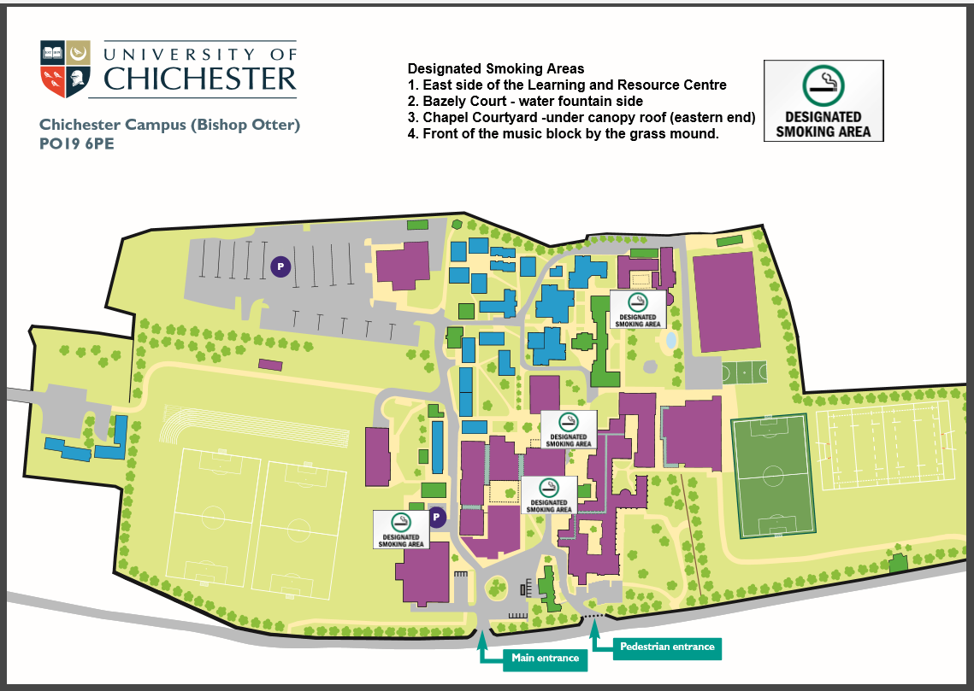
Appendix 1 Chichester Campus - Black stars showing designated areas
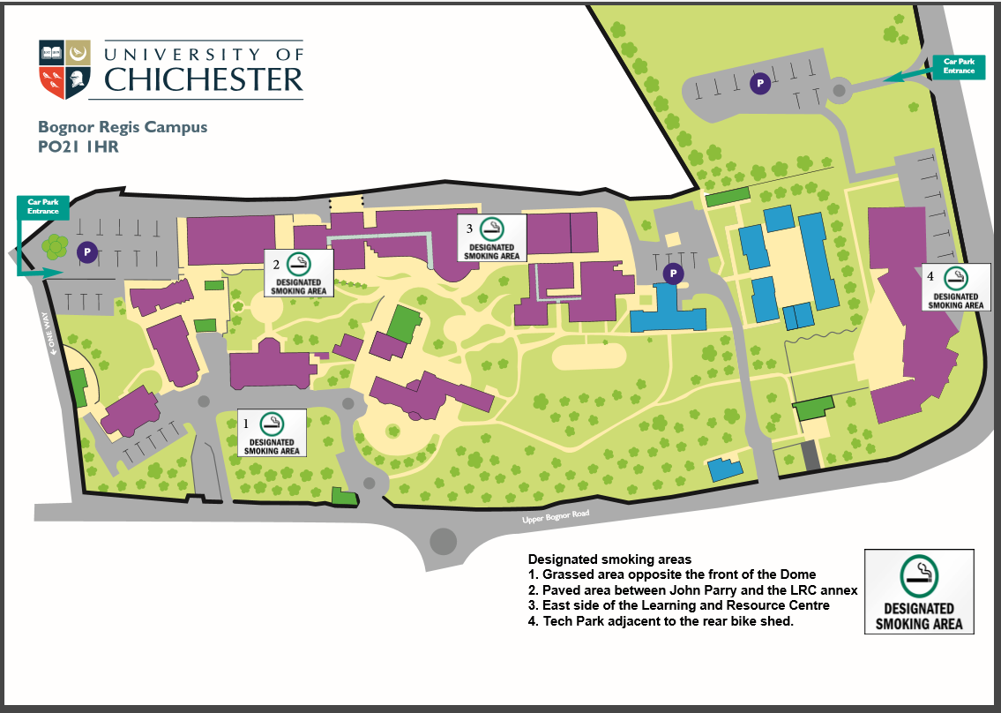
Appendix 2 Bognor Campus- Black stars showing designated areas

