Experiencing financial difficulties?
What is the University of Chichester Support Fund (UoC SF)?
The UoC Support Fund is a University financed scheme which aims to help students who are at risk of leaving their course due to financial difficulty. Any award you receive from the Fund is usually non-repayable.

Who can apply?
Any ‘home’ student (part-time, full-time, undergraduate, postgraduate) can apply although we do have priority groups (e.g. those from a ‘low-income’ background.)

How can I apply?
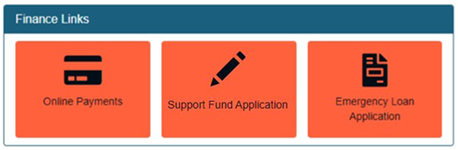
You can apply for the Support Fund from your ChiView page in the 'Finance Links' section which has a tile called ‘Support Fund Application':
Alternatively, you can download a .doc version of the form from our help page:
https://help.chi.ac.uk/money-advice-money-worries#supportfund

How is my application assessed?
We combine the information you give us about your finances with some standard figures (based on government guidelines) to do a set of calculations. We look at your income and your expenditure to assess whether or not you will qualify for an award. A more detailed explanation is provided in the Guidance Notes that accompany the application form.

How long does it take to process?
During Semester 1, we aim to process completed applications within 4 weeks of submission. During Semester 2, we aim to process completed applications within 3 weeks of submission.

How much are the awards?
The size of the award varies according to each student’s circumstances. However, the average award (for full-time students) is around £400.

How often (and when) can I apply?
You can apply once in an academic year. If, after you have applied, your circumstances change, you can supply new information and evidence and we will review our decision. Applications are accepted during the academic year (and not during the summer vacation).

What if I’m not happy with the outcome?
You can contact the Student Money Advice Service for our Review & Appeal Procedure information.

Queries?
Contact the Student Money Advice Service at stumoneyadv@chi.ac.uk or book an appointment through the SIZ.

