Control of Contractors Protocol
Sign, Action, Report

Version History
Date | Editor | Version | Status | Reason for change
16 November 2021 | NB/KH | 1 | Agreed | SEMT –  16 November 2021  Noted by H&S Committee on 9 December 2021

Contents
01 - Forward from Director of Estates and Facilities 1
02 - Introduction 2
03 – Sign, Action, Report 2
04 – Site Hazards 3
05 – SIGN: Sign in protocols 3
06 – ACTION: Action Safely 3
07 – REPORT 4
08 - Fire Action 4
09 – Site Management 5
10 – Personal Protective Equipment (PPE) 5
11 – Welfare facilities 5
12 – Training and training records 5
13 – Completion of works and auditing 5
14 – Acknowledgement 7
Appendix 1: Contacts 7
Appendix 2: Hazard maps 8
Appendix 3: Fire Assembly Points 9
Appendix 4: Emergency Information 10
Appendix 5: Fire Action Notice 10
Appendix 6: Health and Safety Induction 11

01 - Forward from Director of Estates and Facilities
The purpose of this document is to ensure best practice is met and exceeded in terms of Health & Safety protocols by University employed contractors, sub-contractors, suppliers, visitors and those working in University owned and managed properties.
The University has a zero-tolerance approach to Health & Safety breaches and failure to comply with the protocols set out in this document will result in removal from site.
The University also has a very robust Health and Safety policy and all contractors, sub-contractors, suppliers and visitors should make it their job to understand what this policy says and ensure it is adhered to at all times.
It is important to ensure that you become familiar with this document and that you understand its contents fully – if you are in any doubt, please ask and NEVER work unsafely.
This protocol should help you understand what you need to do and it provides practical advice to action – you must familiarise yourself with the contents of this document and embrace the culture of the University in terms of working safely, it is our number one priority.
Always remember to embrace Sign in and out, Action any Health and Safety issues and Report any Health and Safety concerns.

02 - Introduction
All contractors on site must comply with all relevant health, safety and fire legislation and the Health and Safety at Work etc. Act 1974 and the Regulatory Reform (Fire safety) Order 2005 including any specific legislation relating to the Contractor’s activities. All contractors should pre-arrange their visit with the relevant Estate Management contact in advance.

The University’s Health and Safety Policy states that while recognising its own legal responsibilities in the matter of health and safety at work, the Board of Governors requires all members, staff, students, and visitors to act safely and to co-operate with the University in meeting these obligations. The Board of Governors believes that health and safety at work is the responsibility of all. It will encourage employees to take an active role in ensuring that a safe working environment is maintained.

03 – Sign, Action, Report
The University takes its health and safety responsibilities seriously and have a zero tolerance approach to any health and safety breaches. Any breaches evidenced will mean your immediate removal from site.

As well as complying with all relevant health, safety and fire legislation all contractors need to adhere to the principles of Sign, Action, Report:

- Sign in and sign out ensuring Estate Management are aware of your presence on site. The sign in register is located at each campus as outlined below.
- Action any Health & Safety issues,
- Report any Health & Safety concerns.

On arrival onto campus you must:
  - Park in a designated location or car park space and have your vehicle permit displayed.
  - Sign in and out at the Estate Management Office at Chichester and Bognor or the main receptions at Stockbridge Student Village and Fishbourne East halls.
  - Ensure you have received the H&S induction (a copy of which is included in Appendix 6).
  - You must check the Asbestos Register and collect any access cards or keys applicable to your proposed work area.
  - Follow any local rules given to you including fire evacuation from the building on hearing the sound of the fire alarm.
  - You are responsible for taking away any waste that is generated.
  - On completion of works, or at the end of the day, hand back any access cards/keys and where possible ensure works undertaken are checked by a member of the Estate Management Team.
  - If a contractor has their own site compound, one member should still sign in and out of the University daily stating the amount of staff on site at the compound.
  - Ensure you have completed your Risk Assessment and Method Statement (RAMS) before any works are commenced.

Ensure you:
- Do not arrive on site outside of any agreed arrival time.
- You do not undertake any works without a relevant approved Risk Assessment and Method Statement.
- Have provided the University with a copy of your Public Liability Insurance.
- Do not override the University’s fire provision without consultation with a member of the Senior Estate Management Team.
- You do not use any University equipment or PPE owned by the University.
- Are aware of the University emergency number – 01243 816363.

04 – Site Hazards
- Our key hazards are:
- Asbestos
- Gas cylinders
- Confined Spaces
- Converged pedestrian/traffic routes
See appendix 2 for a copy of our hazard map.

05 – SIGN: Sign in protocols
You MUST sign in and out daily in order to collect or return keys/access cards. You will receive a safety induction on the first day of your contract from the relevant University representative.

06 – ACTION: Action Safely
Fire and Fire detection Provision - All buildings have dedicated fire detection and alarm systems. Where dust and/or hot works are expected from your work activity, you must get authorisation from a member of the Senior Estate Management Team to turn off any fire detection before works commences.
Asbestos – Any building built pre-2000, should be regarded as having potential asbestos in its building fabric. The Asbestos Register will confirm where and in what condition, if any, is in the building. You must ensure you check with Estate Management if you are in any doubt or have any queries.
A Permit to Work system is used and must be requested before work commences when under taking any of the following work activities. A Permit will identify the risks and consider the control measures that must be adhered to. You must have an authorised Permit to Work signed by Estate Management prior to starting any work.
- Confined spaces – A small number of buildings have confined space areas such as attic spaces, these areas need to be controlled to ensure safe exiting in case of an emergency. Do not enter a confined space unless you are appropriately qualified and trained to do so.
- Excavation and ground works – such works can be potentially dangerous to both workers and the general public. Suitable measures must be in place to prevent injury from falling in, from potential landslide or oxygen depletion.
- Hot works must be controlled throughout the activity and there must be a means of monitoring the area at least an hour after the hot work is finished.
- Lone working – You must be able to demonstrate that you have a communication link that can be used to confirm that you are regularly checked on to ensure your continued safety.
- Working at height - Any working at height will require you to use the most appropriate equipment to complete the work safely. This may require the use of scaffolding, ladders or other safety equipment such as harnesses for the individual.
- High Voltage works require controls against the potential of electrocution, burns or fatality. Only qualified personnel can enter any High Voltage area.

07 – REPORT
In the first instance, if you see a hazard or risk that requires immediate rectification you must report this to a member of Estate Management. Do not attempt any unsafe work.

08 - Fire Action

ON SEEING A FIRE
- Shout Fire and make your way to the nearest fire exit.
- On your way out press an available call point, (red box found at every exit) to raise the alarm.
- Make your way to the assembly point and await further instruction. A map of our assembly points is shown at appendix 3.
- If you have a contractor compound, all contractor staff should make their way to their own agreed assembly point, one person should then go to the front entrance to meet the fire brigade to direct them to the compound and declare if all staff are present.

ON HEARING THE ALARM

- Stop what you are doing, and make your way to the nearest escape route.
- Do not stop to collect valuables, do not panic.
- If you know of a person waiting in a refuge area please inform the person in charge (Fire Incident Coordinator, identified by a fluorescent jacket).
- Do not re-enter the building until you are told by the Fire Incident Coordinator or the Fire and Rescue Services.
Fire Alarms are tested weekly and will be heard for a length of no more than 15 seconds. Should an alarm bell sound for longer, then treat this as an actual fire evacuation and act accordingly.
Many larger buildings will have more than one exit route. Familiarise yourself with other emergency routes and follow the green running man signage which will take you out to a safe area.
Fire doors are designed to stop the spread of smoke and retain a fire for at least 30 minutes. This is why we require all fire doors to remain closed. Wedged fire doors do not protect anyone and if you see a wedged fire door, please un-wedge and close the door properly.
Most buildings will have a fire action notice similar to the example in appendix 5. This will reiterate the advice and indicate the assembly point.
If you require first aid and you are unable to deal with this yourself or within your team, you need to phone 01243 816363. Give your location and whether an ambulance is needed. See appendix 4.

09 – Site Management
- Fences, hoardings and barriers should be firmly attached to the ground and any waste left overnight placed within the barriers.
- Noise should be kept to a minimum. Where equipment use involves noise, please liaise with the Estate Management Team to help manage any disruption to staff/students.
- All traffic is limited to 5mph, you must park in designated car parking space and ensure a banksman is available should you need to reverse. Always be aware when driving that pedestrians and vehicle routes may interchange.
- It is expected that a good standard of behaviour is upheld at all times and to respect our staff, students and visitors. Behaviour also includes suitable clothing and the wearing of the correct PPE at all times.
- As a contractor and expert in your field of work, you are expected to provide your own equipment and not use any University equipment.

10 – Personal Protective Equipment (PPE)
Personal Protection must always be worn and noted on your risk assessment. Any breach will be taken seriously, and you will be requested to leave the site.

11 – Welfare facilities
Contractors are permitted to use on site facilities such as toilets, cafes and restaurants if they do not have facilities in a site compound. Muddy boots and clothing should be removed.

12 – Training and training records
You should have evidence of any particular training that is essential to carry out your work. Should training certification not be available for inspection on site, you will be requested to leave the site.

13 – Completion of works and auditing
On completion of works, hand back any access cards/keys and where possible ensure works undertaken are checked by a member of the Estate Management Team before leaving. Where this is not possible, perhaps due to finishing in the evening, then arrangements for signing off the work must be arranged for the following day. This may mean coming back on site to complete the process.

The Health and Safety Team have full the authority of the Director of Estate Management to spot check any contractor who is working on site. They will check to ensure the following is in order:
- The correct signing in procedure was followed.
- Risk Assessments, Method Statement and Public Liability Insurance is current and suitable for the work undertaken.
- RAMS are followed.
- PPE is being worn when required under risk assessment.
- A Permit to Work, if being used; is properly completed and countersigned.
- The workspace is barriered off and where necessary correct signage displayed.
- Waste is appropriately managed.
- All health and safety protocols are being adhered to.

Contractors who do not maintain the University requirements as laid out above will be required to leave the site immediately.

14 – Acknowledgement
I/We acknowledge that I/We have read and are aware of the foregoing Control of Contractors Protocol and undertake and agree that I/We and my/our employees and my/our Sub-Contractors and their employees shall at all times observe and confirm with each and every provision of the said Code of Practice, and agree to do everything possible to protect myself and others from danger when working at the University. I/We acknowledge that the said Control of Contractors Protocol is incorporated into and forms part of the contract between the University and the Contractor. If any of the terms of this Control of Contractors Protocol are inconsistent with the said Contract, the terms of this Control of Contractors Protocol shall prevail.

Contractors must ensure that all of their staff, and Sub Contractors, suppliers and visitors to site are made aware of the content of these protocols during their recorded induction to site when working on the University of Chichester premises.
Company
Address

Telephone
Name
Position
Signature |  | Date
Please forward a signed copy as acknowledgement that you have read and understood the terms of this protocol to:
Estate Management
University of Chichester
College Lane
Chichester
West Sussex
PO19 6PE

Appendix 1: Contacts
Telephone numbers:
Estates Office Bishop Otter Campus: 01243 816123
Estates Office Bognor Regis Campus: 01243 8162088
Stockbridge Student Village Reception: 01243 533356
Fishbourne Road East Reception: 01243 839466

Appendix 2: Hazard maps
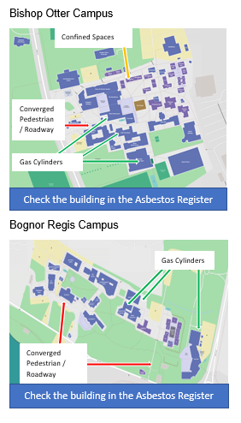

Appendix 3: Fire Assembly Points
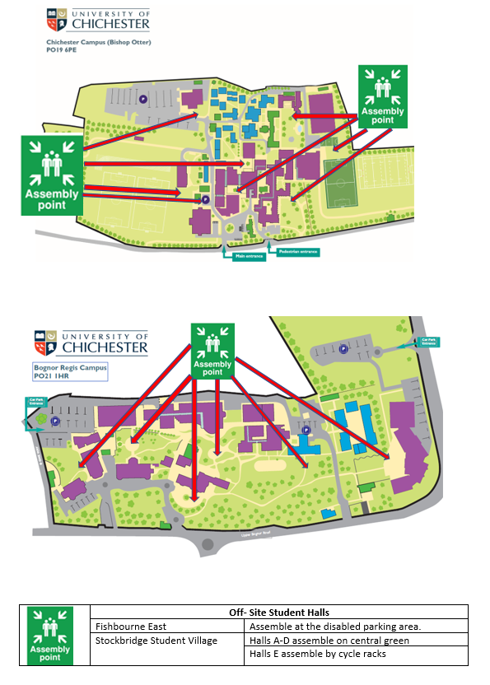

Appendix 4: Emergency Information
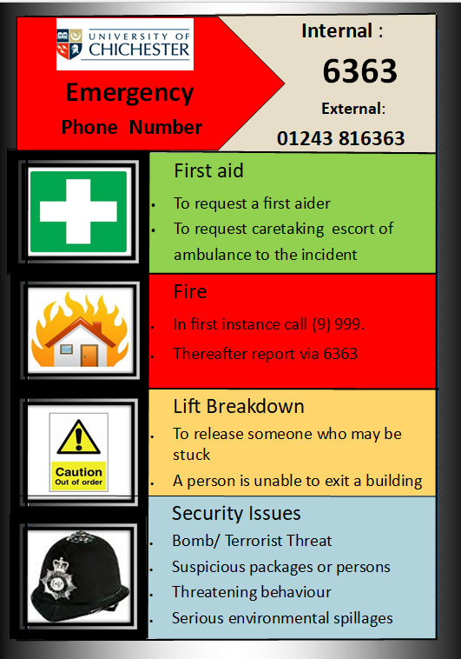

Appendix 5: Fire Action Notice
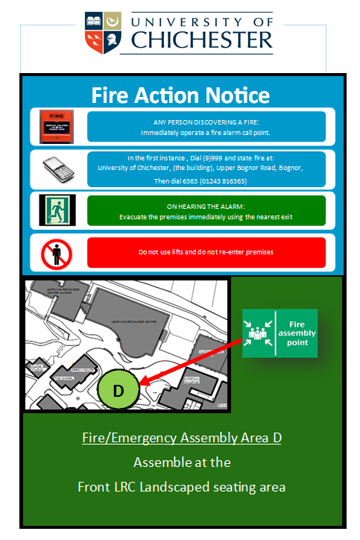

Appendix 6: Health and Safety Induction

