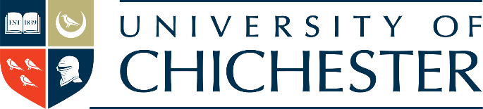

From Adversity to University

Homelessness is a societal problem, this toolkit by UPP and the University of Chichester demonstrates how higher education can be part of an innovative solution

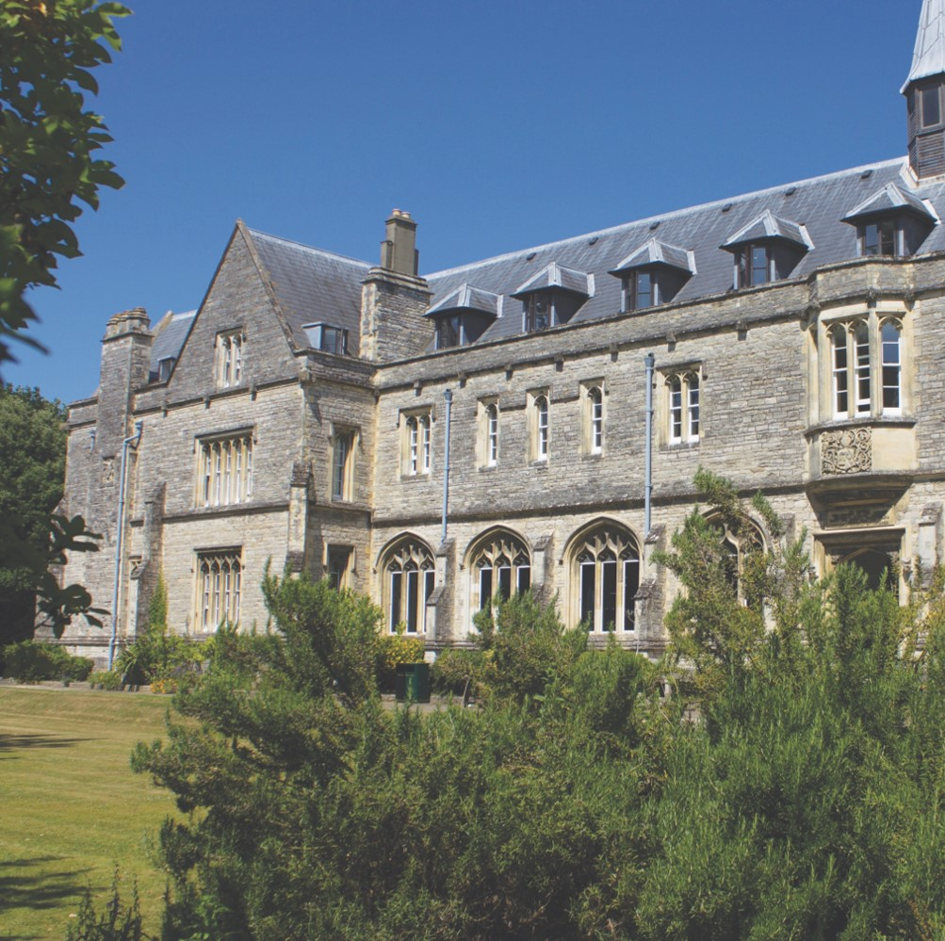

**Get in touch**

If you have any questions please contact:

* Becky Edwards: b.edwards@chi.ac.uk
* Richard Brabner: richard.brabner@upp-ltd.com

1. Foreword

**PROFESSOR JANE LONGMORE, VICE-CHANCELLOR OF THE UNIVERSITY OF CHICHESTER**

I am delighted to have been invited to write a foreword for this toolkit for the widening participation project, *From Adversity to University*. Service to the community has always been a fundamental aspect of the mission of this university; this project embodies that core purpose.

For many students, progression from secondary education to a degree programme is a straightforward road with the support of teachers, family or friends but, for anyone who has struggled with adversity such as homelessness or addictions, there are hurdles every step of the way. This project dismantles the hurdles by providing a route to academic study without judging the individual. It is a simple and elegant solution to some of our most deeply-rooted societal challenges. I hope you will use the toolkit and be as inspired as I have been by the transformational impact of this wonderful initiative.

**Professor Jane Longmore**

Vice-Chancellor

University of Chichester

**RICHARD BRABNER, DIRECTOR OF THE UPP FOUNDATION**

Since the UPP Foundation was established in 2016 we have prioritised our funding towards innovative pilot schemes which offer pracical ways to transform the lives of those who could benefit from higher education. In that vein, supporting the *Adversity to University* bridging module was a no-brainer. The partnership between the University of Chichester and Stonepillow is unique. It offers a second chance in education for those who have faced the most challenging personal and economic circumstances. And is already demonstrating significant impact.

Homelessness is one of societies great ills, but imagine if every university in the country developed a similar scheme where a handful of people went through a short course before embarking on a degree? We’d make a huge dent in tackling this problem. I hope universities and charities are inspired then by this project and use the toolkit as a guide to create their own local schemes. As the toolkit demsontrates, embarking on such a scheme is not easy. It requires sustainable partnerhips, a dedicated team and great care. But the University is proving what a difference can be made, with a relatiely small amount of resource. With the Government’s plans for a Lifetime Loan Entitlement and the revitilisation of the civic university agenda in recent years, there’s no better time to do this than now.

**CHRIS SMETHURST, CO-DIRECTOR OF THE INSTITUTE OF EDUCATION, HEALTH AND SOCIAL SCIENCES**

Those of us who work in the sector will have witnessed the transformative power of education. We will have seen first-hand, dreams that have been realised and doors of opportunity and possibility that have been opened. The prior experience for many of those who have participated in this project has been very different. They have often been failed, denied or demeaned by our education system. For many participants, particularly the first cohorts, it took courage to risk trying again when it would have been so much easier not to. I, for one, am immensely proud that they took a chance on us at the University. They helped to create this project and nothing that has been achieved since would have been possible without them.

**BECKY EDWARDS, CO-ORDINATOR, FROM ADVERSITY TO UNIVERSITY**

*From Adversity to University* offers a widening participation route into higher education for those who have previously disengaged from formal learning. Based on the premise that ability and education are not synonymous and that it is often aspirational rather than economic poverty that is a barrier to success, the course aims to build academic skills and to rebuild self-belief and self-esteem.

Homelessness is a pervasive societal issue that demands innovative, long- term solutions. The re-housing of many rough sleepers during the pandemic is a positive step but will only be sustainable if the tenants have concrete futures. This module offers the potential to transform lives, one person at a time.

The course is a collaboration between local homelessness charities and the University of Chichester, with content that is shaped by the participants. The course develops academic and critical thinking skills based on the lived experience of the students. Those who successfully pass the module, gain 20 academic credits at Level 4. This has been accepted by the University of Chichester as a non-traditional pathway onto degree courses. Students from this module are currently completing degrees in: Teaching, Adventure Education, Fine Art, Sociology and Games Design.

With funding support from the UPP Foundation, longitudinal research is being carried out in order to follow the students as they progress through Higher Education and into a re-imagined future. It is hoped that the success of this project will encourage other universities to do the same. This toolkit is designed to help your university make that possible.

**WHO IS THIS TOOLKIT FOR?**

This toolkit is designed for Higher Education Institutions who are interested in setting up their own “From Adversity to University,” project.

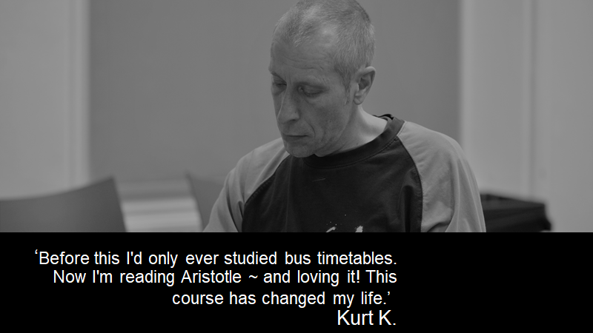

1. Project Overview

**AIM**

The aim of the widening participation *From Adversity to University* Project is to provide non-traditional access to Higher Education for students who have had to overcome adversity in its various forms, with a particular focus on homelessness and addiction.

The project is based on the premise that education and ability are not synonymous, that the level of acumen, knowledge and “quick wittedness,” necessary to survive on the streets, can also be used to develop academic and critical thinking skills.

Homelessness is a societal problem; the bridging module allows Higher Education to be part of an innovative solution.

The module was created in 2018 as a partnership between the University of Chichester and local homeless shelter Stonepillow. It received funding in 2019-20 from the UPP Foundation to support its development and growth. Over the last three years, 25 people have accessed the module, with six students then taking a qualification in maths or English to further their skills, and 5 others undertaking a full degree.

**BENEFITS OF RUNNING THIS COURSE TO THE UNIVERSITY**

* Build links and become actively involved with local charities and community groups by catering for the homeless and other key vulnerable groups
* Increase widening participation and breaks down the traditional ‘barriers’ to accessing higher education
* Supports the development of cross-institutional working. This is created through whole university acceptance of the project, with entry requirement recognition for any subject level degree
* Develops non-judgemental, trusting relationships between participants, staff and students
* Develops in-depth understanding of the varied challenges facing those who have experienced homelessness and addiction

**BENEFITS TO PARTICIPATING STUDENTS**

* Proved to provide students who complete the course with the skills and confidence to succeed on degree courses
* A route to academic study without judgement
* Support to overcome traditional barriers, to accessing Higher Education, including the removal of stereotypical perceptions of homelessness and addiction
* Opportunities for students to become involved as peer-to-peer mentors
* The development of a range of skills from self-esteem, critical thinking, networking, academic learning
* Access to all of the university student support services
* Individual students can expect accommodation availability at the university year round

**CURRENT RESEARCH ON THE ‘FROM ADVERSITY TO UNIVERSITY’ PROJECT**

Lyndon, S. and Edwards, B. (2021) Beyond listening - the value of co-research in the co-construction of narratives. *Qualitative Research.* March 2021. doi: [10.1177/1468794121999600](https://doi.org/10.1177/1468794121999600)

Edwards, B. and Lyndon, S. (2021) From adversity to university – the transformational power of a bespoke bridging module to support those affected by homelessness into higher education. [*Widening Participation and Lifelong Learning Journal*](http://www.open.ac.uk/about/wideningparticipation/about/england/wpll-journal) (accepted for publication).

1. Setting up the Project

**BUILD LINKS WITH LOCAL CHARITIES**

* Links need to be made with local community groups, including homeless charities to establish course interest.
* Joint discussions with the charities to explore funding options and to identify potential students.
* The course facilitator to meet individually with potential participants - it is important that initial meetings take place wherever participants feel most comfortable (university, café, hostel).

**CONFIRM STAFFING**

* The project needs a dedicated course leader who is open-minded, flexible and able to offer individual tutorial support as well as group teaching.
* Peer mentoring from previous students enhances the quality of delivery and understanding of individual needs.
* Asking current students from a variety of programmes to co-facilitate helps to develop a sense of belonging and inclusion for participants.

**ALLOCATE TIME**

* The course runs once a week as a lecture – a convenient time to be agreed with participants and lecturer.
* As the assignments approach, students will need additional time for 1:1 tutorials.
* The course includes one whole research day (normally 10am to 3.30pm).

**REGISTRATION ON THE COURSE**

* Participants are registered as students while they are on the course and can therefore access all the facilities available to all students at the university.
* Gaining a student card is an important part of the journey towards acceptance and a sense of belonging.

**GROUP SIZE**

* Groups should be small – 8 to 10 (maximum)- this allows for relationships to be built and individual support in a trusting and safe environment.
* All participants in the group should have experienced similar challenges e.g. all have been held back academically, have had life issues to contend with, have been affected by homelessness and/or addictions. This supports honest non-judgmental discussion, the development of emotional safety and a group support network.

**INVITING OTHER LECTURERS TO SPEAK**

* Once the group has gained a sense of identity, it is good to ask guest lecturers to talk on specific topics related to their degree courses. This ensures that students are aware of their higher education options based on their individual passions and interests proves to students that they are supported by the whole university.

**COSTS FOR STUDENTS (FUNDRAISED WITH CHARITIES)**

* It is a flat rate fee of £200 per student for the full 12-week course.

**COSTS FOR UNIVERSITY**

* Lecturers allocate 3 hours per week face-to-face, lectures plus individual tutorial time depending on the needs of the students.
* Admissions administration and processing costs.
* Time for marking, as well as moderator and external examiner.
* Creation of course completion certificates.

**TOP TIPS**

* Take time to build relationships with charities
* Get to know your individual students to build trust and confidence
* Make links with university support services while students are still on the Bridging Course
* Ensure there is inter-departmental understanding and acceptance of the aims of the module
* Access training from homelessness charities

**STUDENT QUOTE - LUCY**

*“The bridging course gave me something to focus on, it gave structure and meaning in my life that I had lost altogether. I discovered the joys of research, essay writing and academia. The course gave so much more than that too, it gave companionship of likeminded individuals, the drive and belief that I could do anything I put my mind to and hope for the future. It, quite literally, transformed my life.”*

**BA (Hons) Fine Art**

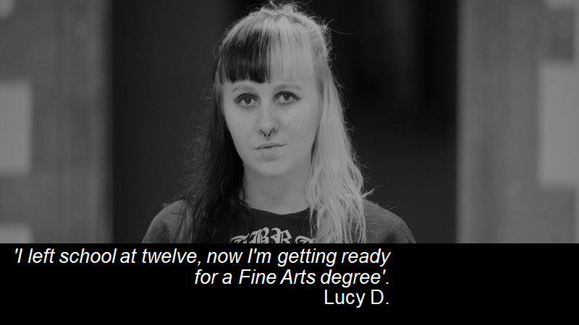

**STUDENT QUOTE - ANNETTE**

*“It built my confidence and made me realise that I do have staying power.”*

**PGCE Primary Education**

**STUDENT QUOTE - SAUL**

*“Coming to Uni has helped my recovery and given me ambitions. That’s a confidence booster. It’s made me realize that I can do something with my life.”*

**BA(Hons) Outdoor and Adventure Education**

**STUDENT QUOTE - DAVID**

*“It has given us hope. Before, the only thing we had in common was our addiction. Now we have education. It’s helping with our recovery.”*

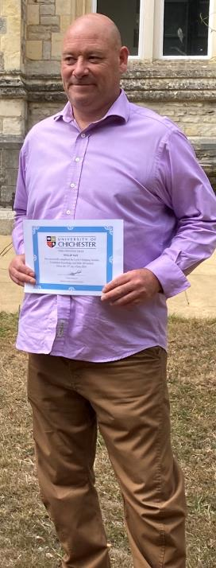**STUDENT QUOTE - PHIL**

*“It's massive for me to actually finish anything I've started, especially anything to do with education in an environment which I consider to be hostile. I've painful memories from my school days which are still as potent now as they were then, along with historical childhood trauma. Barriers and beliefs which I had in place are being exchanged with determination perseverance and a strong conviction that my limitations are imaginary.”*

**BA(Hons) Sociology**

4. Module Content and Structure

**THE CHALLENGE**

The fundamental aim of the course is to provide a foundation in the knowledge and skills necessary for both an academic and professional setting.

It is taught at Level 4 and can be either a 15 or 20 credit module. The course content has been created collaboratively with the students based on a “bottom up,” approach.

Development of academic skills and critical thinking concepts are based on the lived experience of the participants. Sessions run once a week and continue throughout the semester, including reading weeks.

Some of the degree routes chosen by students from the course: BA (Hons) Fine Art, BA (Hons) Outdoor and Adventure Education, PGCE Primary Education, BA (Hons) Sociology, BA (Hons) Games, Design and Development.

**ASSESSMENTS**

**1500-word research essay based on area of** **interest** - this is supported through a whole day session where students are supported to choose topic and begin research.

**1500-word reflective account** - this is to explore how the module or a particular session from the module have impacted upon the individual student (20 credits).

**Mid-way written assignment** - small assignments to hand in e.g. short reflective accounts, will help students to gain insight into whether or not they are ready to commit to the course and assignments

**Example of content:**

- Resilience

- Emotional intelligence

- Critical thinking and decision-making

- Why we sleep

- Communication skills

- Ethics - what are they and why do they matter?

- An exploration of bias

- How to make sense of statistics

- Academic writing skills

- Reflective practice and writing

- Developing research skills

- Guest lectures from other lecturers based on interests of participants

**Example essay titles (created by students based on interests)**

* *“Why do people procrastinate?”*
* *“What is Fusion Energy?”*
* *“Can adventure be used to develop resilience in children and young people?”*
* *“Should cannabis be used for medicinal purposes in the UK?”*
* *“How could a Holocaust survivors philosophical outlook enable them to find meaning amidst their suffering?”*
* *“Have changes in educational policy and practices in the last two decades created a climate within schools in which the fear of academic failure by pupils and resulting negative emotion and behaviour become common place?”*

**Expectations of participants**

* Regular attendance - generally only one session can be missed
* Complete small tasks during the week
* Ask for help from tutor when needed
* Confidentiality

**Expectations of facilitator**

* Clear communication
* Understanding of potential challenges to engagement
* Commitment to the project
* Capacity to offer intense support where necessary – especially close to assignment hand-in dates

5. Challenges

**LACK OF ID**

A majority of those who have been affected by homelessness do not have any form of ID or proof of address.

**Solution:** The university have worked closely with the local charities and accept “Citizen Cards” as photo ID. Charities have also used the funding gained to pay for replacement birth certificates (£11) for students.

**LOSS OF BENEFITS**

As soon as they become official students on a full-time degree course benefits are stopped immediately but their loan is often not paid in their account for 6 weeks.

**Solution:** Make links with student support before the course ends and explain how to apply for a hardship loan; this way students will feel empowered to ask for hardship loan to bridge the gap

**ACCESS TO IT**

Often students do not have laptops or Wifi where they are living.

**Solution:** Once they are registered on the course, they have access to library facilities and can use the computers and borrow university laptops.

**COST OF UCAS**

The cost of completing a UCAS form can be a permanent barrier to students applying for courses, typically £20 if applying to one university or £25 if applying to five universities.

**Solution:** Work with charities to include this as part of initial fundraising for the project.

**RELAPSE**

Students who are recovering from addiction may relapse. Evidence from exit interviews shows participation on the course often helps to prevent the relapse from becoming permanent.

**Solution:** Honest discussion is needed to explore how these students are coping and whether or not they should continue as “attendance only” or re-engage when the course next runs.

**DROPOUT**

Dropout rates tend to be low but can always occur due to difficulties with commitment, transient lifestyles, relapse or a sense that the course is not right for them.

**Solution:** develop ‘pre-course sessions’ with informal discussions so that students can gauge expectations and interest.

6. Share your Stories

**PR, COMMS AND MARKETING:**

Announcing the launch of any innovative course which pledges to help those most vulnerable will almost always make headlines, however, in our experience, the best stories are from the students themselves – many of whom have overcome extremely challenging situations in their lives.

The below checklist covers the basics for all PR and comms around the project’s first year:

**(a)** **Publicity**

* Press release announcing the project – covering how the course will help people from disadvantaged backgrounds, content, and progression onto university. We recommend creating a list of national journalists and publications specialising in homelessness and disadvantaged members of society (tip: there’s not that many).
* Case studies – of individual students and their stories. To be run on your website and linked to your social media channels. These can be run across the year.
* Blog piece – from academic/tutor outlining the progress of the project across the past year and/or outlining their findings.

**(b)** **Legalities**

* A basic GDPR consent form detailing how the students’ images (including videos) and quotes will be used to promote the course in the media, on social media, and additional marketing literature.

**(c)** **Imagery and videography**

* Photos of individual students and cohort in classroom and outside. Consider social distancing in shots and students and lecturers with/without facemasks on (should Covid restrictions remain in place).
* Short 20-second clips of students and academics talking about the impact of the course for purpose of running on social media (don’t forget to add subtitles).

**(d)** **Make your content accessible**

* Set up an online sharing folder (e.g. Google Docs or Dropbox) and make it public.
* Add the link to the folder to all press releases/media pitching.

**(e)** **Wider campaign activities**

•

***World Homeless Day – October***

* The lives and stories of homeless people around the world are celebrated in October.
* This is an excellent opportunity to run case studies and features on your students.
* Remember to start pitching your stories to the press two/three weeks beforehand (mid-September) to ensure maximum.

• ***Hunger and Homelessness Awareness Week – November***

* Another worldwide event but differs from World Homeless Day as it focuses more on community events in your region that are supporting homelessness.

•

***Any other local awareness campaigns***

* Be sure to check out any upcoming local initiatives that you could further promote and raise awareness of the valuable work you are doing.

7. Key Takeaways

**The course offers:**

* the chance to remove barriers to Higher Education and to fundamentally change lives
* the potential for universities and community groups to be part of the movement towards social change
* the chance for universities to create true civic partnerships with benefits to all parties involved
* proof of the transformational power of education

Appendix - Example Case Statement to Support Funding Bids

**BRIDGING MODULE: PROPOSAL TO THE VICE CHANCELLOR’S OFFICE, UNIVERSITY OF CHICHESTER**

**THE NEED WE MEET**

Widening participation in UK universities has been a government objective for decades (Connell-Smith & Hubble, 2018, p. 3). The benefit in terms of personal progression and wider social wellbeing are widely recognised, however the focus has been on disadvantaged youth and BME communities. In parallel, there is universal recognition that “everyone deserves a decent, affordable and secure place to call home. Yet too many people live without the comfort of a home” (Gov.UK, 2019, p. 7), in fact over 550,000 households in the UK are recognised by the Government as eligible for support with housing (C. L. G. Ministry of Housing, 2020).

It comes as a surprise to us, therefore that we are unable to find evidence of a Government strategy to harness the power of higher education to support homeless people in progressing. Beyond recognising universities as a potential safety net for existing young students, (C. L. G. Ministry of Housing, 2018) Government guidance makes no mention of the transformative power of further and higher education, nor is it mentioned in recent consultations. As provision and intervention so often follows policy we find this omission both striking and saddening.

**OUR ABILITY TO DELIVER**

The University of Chichester has a long history of supporting widening participation, and data submitted to the Office for Students demonstrates that “there is now almost no overall household income or socio-economic barrier to access at our institution” (Harper, 2019). We achieve this through a combination of a small campus environment, a supportive culture of teaching, and proactive student support services. Students comment that they feel known and that staff care about them.

It is in this context that the Bridging Module project launched in 2018, offering a fully credited level 4 module (1st year undergraduate) to mature students from a range of backgrounds. From its inception, the programme developed a partnership with local homelessness support charity, Stonepillow. Together we have supported 24 homeless people in exploring the opportunity that higher education offers, and we have enjoyed a 68% rate of completion, with 4 students going on to start an undergraduate degree and 1 student completing a Postgraduate Certificate in Primary Education and gaining employment as a teacher. Of the 7 participants who did not complete the course, 4 moved into employment. 5 of the students who completed the course but did not choose to enter Higher Education, continued with their education by completing GCSEs in Maths and/or English.

**PROJECT GOAL AND OBJECTIVES**

The goal of the Bridging Module is:

*To offer an inspiring and supportive introduction to higher education for individuals who may feel uncertain about the opportunity it offers them and who have previously disengaged with education.*

Our objectives over the next year are to:

* Deliver 2 iterations of the module, helping a least a further 35 students to explore and access higher education
* Maintain our partnership with Stonepillow to ensure with offer opportunity to local homeless people
* Engage with other local homeless charities
* Support other universities in adoption a similar module through publication of a toolkit, and promotion at conferences

**DELIVERING SUPPORT**

The module was co-produced with the initial students and consequently introduces students to academic skills and learning at degree level through a learning and assessment programme that can be tailored to their interests and lived experience. Sessions include both traditional academic skills, such as research, critical thinking and academic writing, but also core skills which support student success, such as resilience and reflective practice.

It is delivered by a team of lecturers, giving students the chance to experience a range of teaching styles, but is led by one key member of staff who is the support tutor to the students. Graduates of the module have also joined the teaching team to offer peer support to other students emerging from homelessness and often addiction, as they progress through the sessions.

Sessions are often taught in the evenings and weekends, to accommodate the needs of mature learners. By bringing students onto campus, and offering a real university learning experience, they are able to judge for themselves whether higher education is a suitable option and to challenge assumptions they may have developed about their own suitability to study at this level.

**CASE STUDY**

Lucy completed the Bridging module in 2019, is 30 years old and has just finished her second year as a student of Fine Art. She believes that the Bridging Module transformed her life.

She has been homeless several times, the first time when she was 16 when she lived alone in a van. She has been involved in several abusive relationships which have led her to flee to different parts of the country and caused the loss of the property she owned and an accumulation of debt. She describes herself as “a loner, a recluse,” someone who has never really “understood other people.” She was home-educated from the age of 12 to 15 and when she returned to college, she was bullied, “it was hell.” She did not engage with education and was “kicked” out of college and home but joining the Bridging module and embarking on a degree in Fine Art has made her realise how much she enjoys learning. She likes the constructive criticism she receives. She believes that barriers are often “within yourself” and feels that the bridging module has given her life “purpose”.

She has overcome her “introversion” to appear on local radio and Russian Television to talk about the module.

**MONITORING AND EVALUATION**

Monitoring of the programme is consistent with all of our undergraduate modules. We seek anonymous student feedback, review grades and moderate marking, both internally and through an external examiner. In addition, we seek feedback from our partner organisations, including Stonepillow. Annual evaluation then allows us to develop and improve the module, as well as our approach to our partnerships. In addition, key staff maintain contact with students who have progressed to a full undergraduate degree.

**SUSTAINABILITY**

The Bridging Module is delivered at below cost, with a reduced charge of £200 per student being made to our partner organisations (compared with the market rate of around £1,187 per module). To date, Stonepillow has successfully secured income to meet homeless participant costs from both a Just Giving Page and unrestricted funding. While the temptation may be to seek free access for some participants, such as those emerging from homelessness, we believe this has a negative impact on the student’s perception of the learning experience.

Low costs are maintained through gift-in-kind from the University, including staff hours and facilities. We believe that the gift-in-kind reflects excellent value in terms of delivering our ongoing, and pioneering, commitment to widening participation.

**REQUEST FOR SUPPORT**

This proposal is seeking an ongoing commitment from the University to deliver to the Bridging Module, to 20 students, across two modules, at below cost for the year 2021-22.

**CITATIONS**

Bates, M. A., Glennerster, R., Gumede, K., & Duflo, E. (2012). The price is wrong. Field Actions Science Reports. The Journal of Field Actions (Special Issue 4)

Connell-Smith, A., & Hubble, S. (2018). Widening participation strategy in higher education in England

Gov.UK. (2019). Tackling Homelessness Together: A consultation on structures that support partnership working and accountability in homelessness. <https://assets.publishing.service.gov.uk/government/uploads/system/uploads/attachment_data/file/780537/Tackling_homelessness_together.pdf> Retrieved from: <https://assets.publishing.service.gov.uk/government/uploads/system/uploads/attachment_data/file/780537/Tackling_homelessness_together.pdf>

Harper, C. (2019). Access and Participation Plan, 2020-21 to 2024-25. Retrieved from: <https://d3mcbia3evjswv.cloudfront.net/files/UniversityOfChichester_APP_2020-21_V1_10007137.pdf>

Ministry of Housing, C. a. L. G., ,. (2020). Statutory Homelessness Annual Report, 2019-20, England. <https://assets.publishing.service.gov.uk/> Gov.UK. Retrieved from: <https://assets.publishing.service.gov.uk/government/uploads/system/uploads/attachment_data/file/923123/Annual_Statutory_Homelessness_Release_2019-20.pdf>

Ministry of Housing, C. L. G., ,. (2018). Homelessness code of guidance for local authorities. <https://www.gov.uk/guidance/homelessness-code-of-guidance-for-local-authorities/chapter-8-priority-need> Gov.UK

Shampanier, K., Mazar, N., & Ariely, D. (2007). Zero as a special price: The true value of free products. Marketing science, 26(6), 742-757

* ng 