Version number: | 01 | 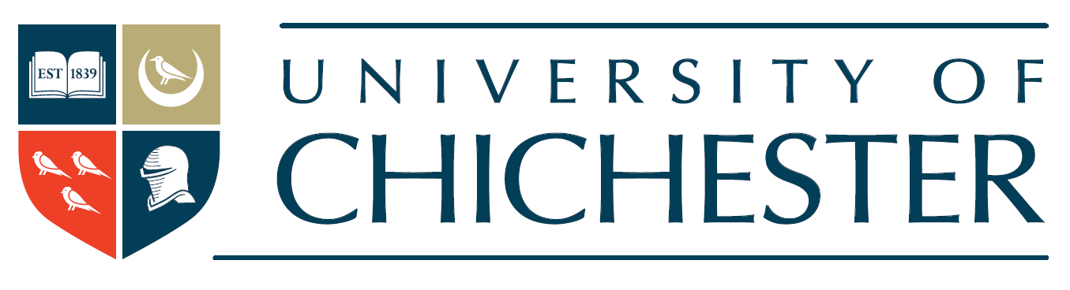
Policy owner: | Chief Human Resources Officer
Effective date: | 01/11/2020
Review date: | 01/11/2023

Procedure for Collective Negotiations and the Resolution of Disputes 2020-2023

Introduction

This agreement outlines the process by which the University of Chichester (“University”) will negotiate collectively on issues that are not connected with individual matters.

Procedures for negotiation and for the handling of disputes have been designed to ensure that informal ways of reaching agreements are fully exploited before recourse is made to more formal mechanisms.

Under the provision the Recognition and Procedural Agreement, the first stages of negotiation are to be conducted within or under the auspices of the Joint Consultative Group. This arrangement ensures that the interests of all groups of employees are given proper consideration, and that agreements are properly documented.

The role of the Joint Consultative Group is reflected in the procedures for negotiation. The outcome of negotiations conducted outside meetings of the Joint Consultative Group will be reported to and ratified by the Group.

Negotiation

A matter for negotiation is defined as:

An issue which is directly related to the contractual arrangements between the Board of Governors and members of staff; or

An issue that is within the jurisdiction of the Board of Governors.

Exclusions

Matters that are:

Within the remit of negotiating bodies established under the National Recognition Agreement between the Universities and Colleges Employers’ Association and the recognised trade unions; and/or

The subject of individual grievance or disciplinary procedures, except where they lead to a collective issue.

Representatives of Recognised Trade Unions

A representative of a recognised trade union may be a local official or a full-time official, as may be decided by the local branch.

The Negotiation Process

There are two types of negotiation:

Informal negotiations under the auspices of the Joint Consultative Group. Matters on which management or a recognised trade union wish to consult or negotiate should first be raised in informal discussion; and

Formal negotiation in a committee of the Joint Consultative Group.

Informal Negotiations

The practice of regular informal meetings between the local representatives of the recognised trade unions and the appropriate representative(s) of senior management, normally including the Vice-Chancellor, is seen to be the most important element of the negotiating process.

Either management or a union may request an informal meeting, which should:

be held within five working days of the request being made;

normally be attended only by members of staff of the University;

be unrestricted in the scope of its discussions;

not be formally minuted.

At the conclusion of a meeting, a note will be made of any agreements reached. A copy of this note will be passed to the Clerk of the Joint Consultative Group. Agreements will be ratified at the next meeting of the JCG.

Formal Negotiations

Normally, formal negotiations will be carried out by a sub-committee of the Joint Consultative Group which may be called by either management or the recognised trade union(s). A written request will be made to the Clerk to the Joint Consultative Group, who will issue a notice to the relevant parties. The notice will include:

The issue that is to be the subject of the negotiations.

The constitution of the negotiating committee, which will invariably include:

representatives of management as determined by the Vice-Chancellor

representatives of the union(s) principally affected by the issue to be negotiated.

An invitation to other recognised unions, i.e. UCU or Unison, to attend meetings as observers if they believe that the interests of their members could be affected by the outcome of the negotiations.

The time and place of the meeting.

The convening notice will be distributed to members of the Joint Consultative Group without delay. They are expected to respond to the notice immediately upon receipt if they require the negotiations to be conducted at a full meeting of the Group rather than in a negotiating committee.

Once a negotiating committee (or sub-group) of the Joint Consultative Group has assembled, it will arrange its own programme of meetings. The objective must be to complete the negotiations as quickly as possible. For this reason, normally an interval of no more than five working days should elapse between meetings.

An agreed statement of the outcome of the negotiations will be prepared by an appointed member or members of the negotiating committee. Copies will be distributed to members of the negotiating committee and all other members of the Joint Consultative Group.

Resolution of Disputes

If discussions in a negotiating committee do not conclude in an agreement, an Extraordinary Meeting of the Joint Consultative Group will be convened. At this meeting the Group will consider and discuss the position reached in the negotiating committee. The Group will then decide to adopt one of the following options:

If scope for agreement is identified, negotiations may be continued in the Joint Consultative Group or, the Group may decide to invite the Negotiating Committee to reassemble for further discussion.

If a successful conclusion to negotiations is seen to be remote, by joint agreement, the national representative bodies may be approached for assistance in dealing with the dispute.

Should this approach not be agreed, or be impractical, or if it fails to resolve the matter, then reference may be made to ACAS for conciliation and arbitration, if appropriate:

by either party to the dispute for conciliation, or

by agreement of both parties to the dispute for arbitration on jointly agreed terms of reference.

Until the procedures within this agreement are exhausted, management and the recognised trade unions agree that no change in the conditions of employment of members of staff will be imposed, nor will industrial action be initiated.

Variation and amendment

Nothing within this agreement is intended to prevent its variation by joint agreement between management and the recognised trade union(s) in the course of dealing with a particular dispute.

The Procedure for Collective Negotiations is applicable for the timeframe 2020 to 2023. The Procedure will be reviewed again in November 2023. Either party may propose amendments to this agreement by giving three months’ notice in writing.

