Fairtrade Impact Report
September 2020 to August 2021

Sales of Fairtrade products have reduced compared to previous years, due to impact of Covid 19 on student and staff numbers on campus.

However, activities and events have continued to be held throughout the year, albeit with some on-line.
Over 100 Fairtrade stickers and sachets of tea, coffee and biscuits were given out to students at Freshers’ Fair in September 2020 to highlight that we are a Fairtrade University.
Fairtrade was the subject of one of our “bite size sustainability” sessions held as part of our professional development programme in December 2020. A Fairtrade chocolate quiz competition was held on-line in January 2021, using the quiz on the Fairtrade website. The prize of course was based on Fairtrade chocolate and attracted 23 participants. Fairtrade products and activities were promoted on our Jump scheme between March and June 2021 with 455 Fairtrade actions, such as buying Fairtrade products, being completed. Sixty bars of Divine chocolate were also given away in March 2021, as part of a promotion with a Fairtrade hot drink.
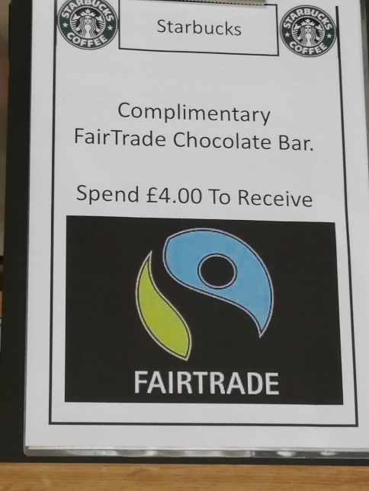
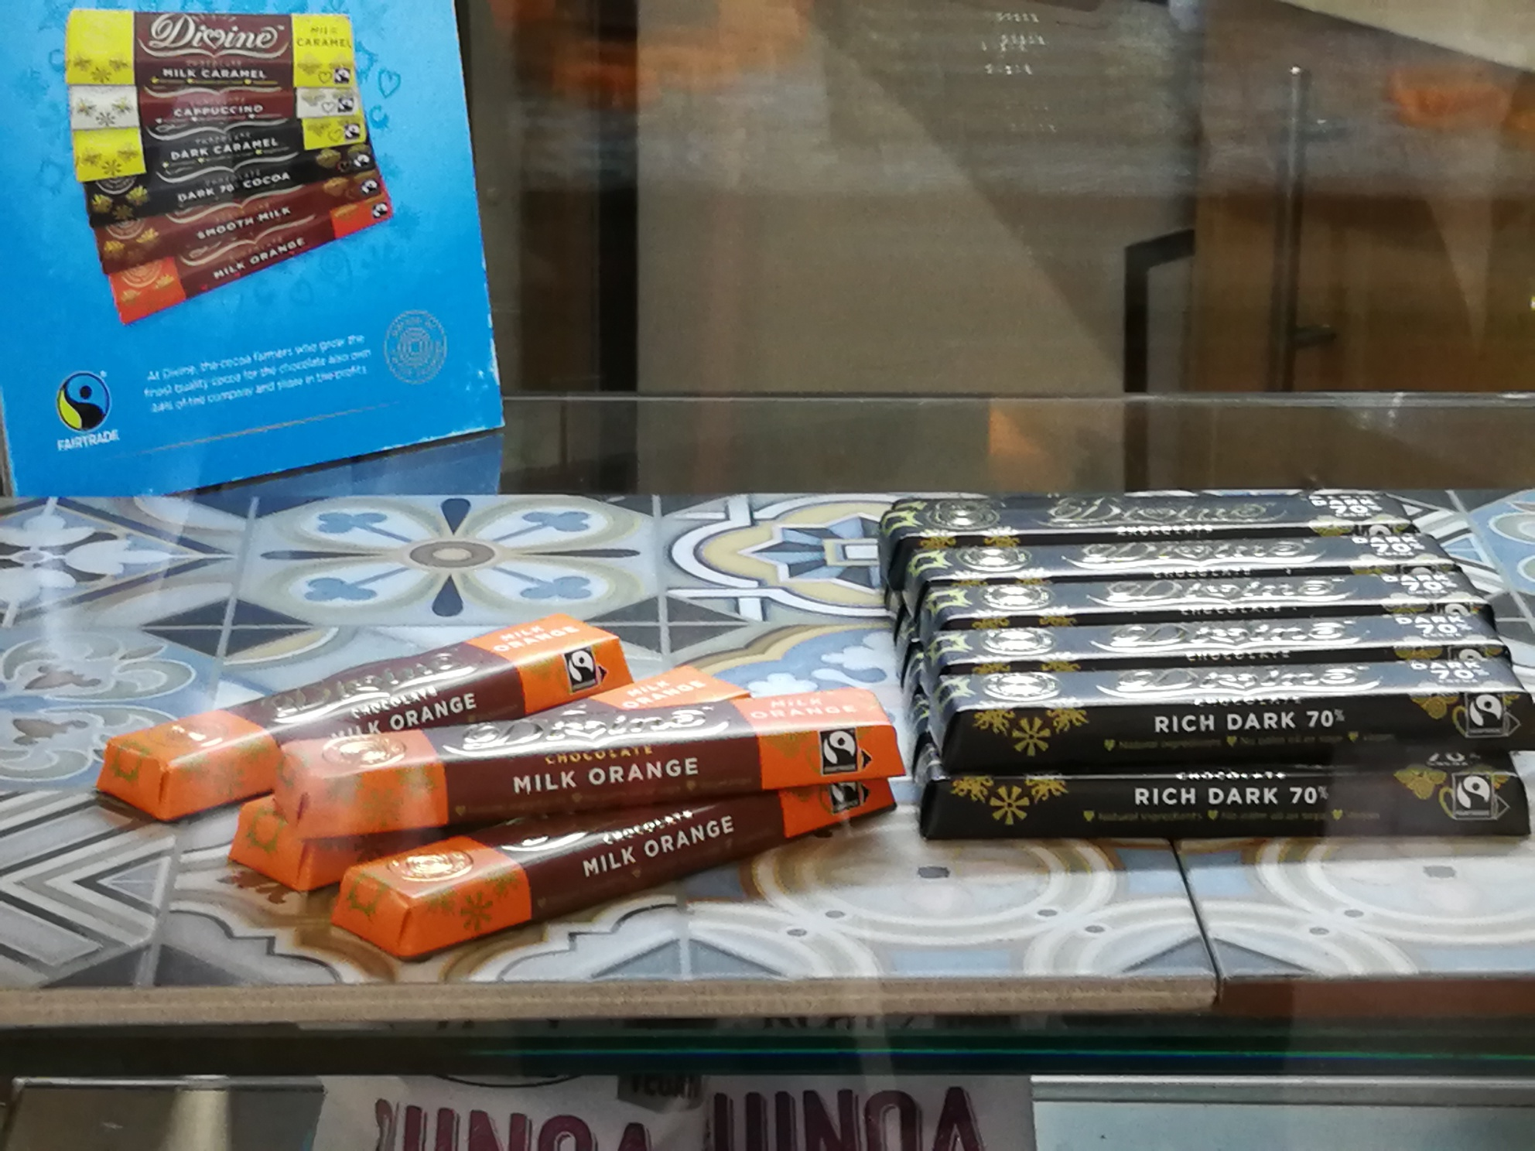

These activities were of course in addition to the usual Fairtrade Fortnight events. This year we teamed up with other universities in our Fairtrade network to offer on-line events hosted by different universities. These included a debate and speaker hosted by Middlesex University and speaker from the Fairtrade foundation hosted by Bournemouth University. These events attracted 115 attendees from the Fairtrade network group. Fairtrade Festival events were also advertised to our students and staff. A Fairtrade and the climate crisis quiz was hosted on Jump, attracting 27 participants and 127 purchases of Fairtrade products were recorded on the Jump platform, throughout the fortnight. Despite the lower numbers of staff and students on campus due to the pandemic, the coffee and cookie promotion held in Otters, also attracted 28 purchases.
Every opportunity has been taken to promote Fairtrade by the offering of Fairtrade products as prizes for events throughout the year. These included the prize for entering a hedgehog poster competition to highlight the issues of bonfires and hedgehogs in October 2020.

Further promotion of Fairtrade was planned at the annual Spring Fair, organised by our second year Event Management students. Due to Coronavirus, the event had to be held on line. However, Fairtrade was promoted through the video produced by the students and 50% of the profits from the Spring Fair were donated to the Fairtrade foundation.
The University has continued to liaise with the University of Middlesex and other members of the Fairtrade Network Group to share ideas and best practice. One of the ideas originating from this group, was to combine online events organised by different members of the group and offer them to all universities in the group. This not only enabled students and staff from all organisations to become involved in more events, but also increased the audience and participation levels.
Progress to all tasks set during the 2020/21 academic year are included on the Action Plan below.

Fairtrade Action Plan V3 2020-2021
Task and appropriateness | Actions | Support/budget required | Measure of success | Responsibility | Timescale |  | Task achieved?
Ensure working group continues with BaxterStorey representatives.  Mandatory criteria MN001 | Set up new working group with BaxterStorey, SU and university representatives. | Support required from campus services manager | Quarterly meetings held | Environmental Coordinator | September 2020 to July 2021 |  | Working group meeting held November 5th and 25th 2020 and 27th Jan 2021.
Use action plan to monitor progress.  Mandatory criteria MN002 | Update action plan and review at working group meetings. | None | Tasks completed in action plan on time. | Environmental Coordinator | September 2020 to July 2021 |  | Action plan to be discussed at meeting on 5th November 2020.
Ensure public commitment to support Fairtrade is maintained.  Mandatory criteria MN003 | Update and agree food charter targets for 2020/21 | Support required from BaxterStorey, SU and University | Signed food charter available on website. | Environmental Coordinator | November 2020 |  | Food charter available on website 15th October 2020.
Ensure all students are aware of our Fairtrade status | Include Fairtrade in student’s on-line induction information Required for CI001 | None |  | Environmental Coordinator | September 2020 |  | Yes – information updated April 2020
 | Fairtrade products to be used as prizes.  Included as II001 | £5/month | Students continue to engage in sustainability activities. New students win prizes. | Environmental Coordinator | October 2020 to June 2021 |  | Fairtrade products included in hedgehog poster prize October 2020 and Fairtrade quiz prize Jan 2021.
Ensure new staff are aware of our Fairtrade status | Include Fairtrade in staff induction sessions  Required for CI001 | None | Staff induction sessions carried out at least bimonthly | Environmental Coordinator | September 2020 to July 2021 |  | Fairtrade included in staff induction 21st October 2020 and 21st Jan 2021.
Task and appropriateness | Actions | Support/budget required | Measure of success | Responsibility | Timescale |  | Task achieved?
Promote Fairtrade at Fresher's Fair if possible  Required for CI010 | Fairtrade stickers and sachets of tea, coffee and biscuits to be given out to students to highlight that we are a Fairtrade University. | None stickers and products already obtained | Greater than 30 stickers, sachets and biscuits given out. | Environmental Coordinator | September 16th 2020 |  | Yes – over 100 Fairtrade products given out.
Ensure any retail, catering or other commercial outlets stock at least one Fairtrade certified line in at least 2 of the following  • Soft drinks  • Wine or Beer  • Health & Beauty  • Savoury snacks & nuts  • Fruit  Mandatory criteria MN007 | Check availability of products offered by BaxterStorey and the SU.  Audit of products available to be produced by Baxterstorey by beginning of November. | Support required from Baxterstorey and the SU | At least one Fairtrade certified line available in The Shop, Otters and the SU bars in at least 2 of the following  • Soft drinks  • Wine or Beer  • Health & Beauty  • Savoury snacks & nuts  • Fruit | BaxterStorey  The Shop manager  SU bars manager | August 2021 |  | Yes – Fairtrade fruit juices sold on both campuses. Fairtrade bananas sold when fruit option offered.
Continually increase Fairtrade certified products in retail and catering outlets  Mandatory criteria MN006  Data on sales required for PL003 and PL011. | Ensure Fairtrade certified products in the following categories are stocked in The Shop and catering outlets and work to increase either the number of lines OR number of items sold year on year:  • Tea  • Coffee  • Sugar  • Hot chocolate and cocoa  • Chocolate, confectionary or snacks | Data required from BaxterStorey and The Shop Manager | Data provided by the SU and BaxterStorey on the number or sales value of Fairtrade items sold show an increase. | The Shop manager and BaxterStorey | Data to be provided for academic year  2019/20 if possible and 2020/21 at the end of August 2021. |  | Data provided by BaxterStorey for the year 2020 to end of March 2021. Data for the year 2019/20 was lost use to the change of contractor in lockdown. Baxterstorey are continually looking at increasing the number of lines, where possible. New coffee supplier Down to Earth is Fairtrade.
Task and appropriateness | Actions | Support/budget required | Measure of success | Responsibility | Timescale |  | Task achieved?
Re-introduce some Fairtrade cotton clothing lines for sale on campus  Part of mandatory criteria MN006  Record sales of clothing  Required for PL003 and PL011 | Re-introduce some SU branded clothing in The Shop. Encourage SU societies to use the Fairtrade clothing. Advertise Fairtrade clothing on University and SU websites. |  | Fairtrade branded clothing available in The Shop. | The Shop manager | June 2021 |  | Some Epona products still available. Source of new Fairtrade lines from Kool Skools delayed due to Coronavirus.
Ensure there is up to date and effective Point of Sale (POS) material in all relevant outlets, highlighting Fairtrade products and providing information on the benefits of Fairtrade to growing communities. Mandatory criteria MN008 | POS material to be displayed in The Shop and catering outlets. This must be placed next to products to avoid confusion, and it should be dated and refreshed periodically. |  | POS material displayed in The Shop and catering outlets with relevant dates. | The Shop manager and BaxterStorey | June 2021 |  | Photos of POS material available from Otters. The Shop remains closed.
Promote Fairtrade in activities/campaigns outside of Fairtrade Fortnight  Mandatory criteria MN005 | Run Fairtrade campaign on social media. |  |  | Environmental Coordinator
 | Fairtrade chocolate quiz competition held using quiz on Fairtrade website. | £20 for prizes | Greater than 20 participants | Environmental Coordinator | January 2021 |  | 24 participants, both students and staff.
 | Fairtrade products and activities promotion on Jump. |  | Greater than 10 participants | Environmental Coordinator | March to June 2021 |  | 455 Fairtrade actions complete
 | Fairtrade used as a subject of one of the “bite size sustainability” sessions. | None | At least 3 attendees at presentation | Environmental Coordinator | 2nd December 2020 |  | 3 participants.
 | Divine chocolate give away. | Baxterstorey to run give away. | At least 40 bars of given away. | Environmental Coordinator | March 2021 |  | All bars given away within 3 days.
Task and appropriateness | Actions | Support/budget required | Measure of success | Responsibility | Timescale | Task achieved?
Partner with a local off-campus Fairtrade group, and work together on at least one project or campaign over the year.
Required for CI004
Proactively share one or more learning or best practice examples from their Fairtrade activities with the wider sector  Required for CI009  Included as II002 | Continue to liaise with University of Middlesex and other members of the Fairtrade Network Group to share ideas and best practice. | None | Ideas generated by the group implemented by the University and/or ideas from the University shared with others. | Environmental Coordinator | Ongoing
Provide and publicise opportunities for students to investigate Fairtrade, trade justice or ethical consumption issues on or off-campus within their course work or dissertations.  Mandatory criteria MN010 | Make opportunities visible and available to students from any discipline to integrate issues of Fairtrade, trade justice or ethical consumption into their coursework. List topics or research questions on website or provide examples of how specific tutors embed these issues into their promotion of project ideas for students to undertake. Publicise opportunities through a variety of channels. | Support required from academic staff. | At least one piece of coursework or dissertation carried out by a student each academic year. |  |  | Global Citizenship offered as part of BA(Hons) primary teaching course.  https://www.chi.ac.uk/teacher-training-and-education/education-and-teaching-courses/undergraduate/ba-hons-primary-teaching-qts  Ethical consumption suggested topic for business school dissertations.

Task | Actions | Support/budget required | Measure of success | Responsibility | Timescale | Task achieved?
Fairtrade Fortnight activities  Mandatory criteria MN004 | The Shop to offer Fairtrade promotions and/or prominently display Fairtrade products with Fairtrade information. |  | At least one promotion offered or display in place. | The Shop Manager | 22nd February to 7th March 2021 | No shop closed due to Covid19
 | Baxterstorey to offer Fairtrade promotions, promote the use of Fairtrade ingredients in menu offerings, offer Fairtrade activities and/or prominently display Fairtrade products with Fairtrade information. |  | At least one promotion or activity offered or display in place. | Baxterstorey | 22nd February to 7th March 2021 | Cookie and coffee offer included in both Otters Restaurants 128 sold.
 | Use University and SU websites to advertise activities | Support from marketing and SU | Info on websites accessed by students and staff | Environmental Coordinator | 22nd February to 7th March 2021 | SU website, Jump and Estate Management newsletter used.
 | Monthly Jump activities to be based on Fairtrade in February. | Info to be included by Green Rewards. | At least 20 participants | Environmental Coordinator | February 2021 | Information included Feb 2021.
 | Advertise Fairtrade Festival and speaker events. |  | At least 5 participants | Environmental Coordinator | 22nd February to 7th March 2021 | Events included in list.
 | Advertise activities via social media Required for CI008 | Support from digital marketing | Info advertised on social media | Environmental Coordinator | February 2021 | Activities advertised on Twitter.
Promote Fairtrade at the virtual Spring Fair  Mandatory criteria MN005 | Work with students producing the virtual Spring Fair to promote Fairtrade. Encourage students to donate some of the profits to Fairtrade Required for CI012 |  | Fairtrade promoted at the virtual fair.  Funds donated to Fairtrade | Environmental Coordinator | April 2021 | Fairtrade promoted through video. Students happy to donate 50% of profits to Fairtrade.
Task | Actions | Support/budget required | Measure of success | Responsibility | Timescale | Task achieved?
Publish an annual progress report on our actions on Fairtrade, trade justice and ethical consumption. Refer to the tasks and progress made through this SMART action plan and make publicly available. This can be part of a wider sustainability report. Mandatory criteria MN011 | Produce report on Fairtrade actions and the impact this has had on staff and students. Or this could be an informal display of outcomes on the website. |  | Report or display of outcomes published on the website. | Environmental Coordinator | August 2021
Include Fairtrade in our hospitality offering.  Required for PL006 | Ensure Fairtrade is served as standard in hospitality across all products with a Fairtrade option such as tea, coffee, sugar etc. or demonstrate progress has been made over the last two years to put this into practice. |  | Fairtrade items included in hospitality offering | Baxterstorey | Ongoing until June 2021
Include up to date information on Fairtrade activities on the website/Intranet/Moodle which can be easily found and well used.  Required for CI007 | Use the Intranet, Moodle and University newsletter to promote and report on Fairtrade activities. | Help from IT and marketing. | Items can be found on various communication channels and information is kept up to date. | Environmental Coordinator | Ongoing until August 2021 | Yes information on website, intranet and Moodle

