Version number: | 2.0
Policy owner: | Director of Students, Support and Information Services and Chief Human Resources Officer
Effective date: | 01/07/2022
Review date: | 30/06/2025

POLICY FOR SUPPORTING TRANSGENDER AND GENDER NON-CONFORMING INDIVIDUALS

Introduction

The University of Chichester (“University”) recognises and values the diversity of its students and staff members’ gender, gender identity and gender expression. The University therefore undertakes not to discriminate against transgender, transfeminine, transmasculine, gender non-binary and gender non-conforming students. It commits to creating an inclusive trans-friendly culture and learning environment, free from discrimination, harassment or victimisation, where all transgender and gender non-conforming students and members of staff are treated with dignity and respect in the gender in which they choose to present themselves.

There is a wide variety of terms used by trans people to describe themselves including (but not limited to) transgender, transsexual, gender-queer, gender-fluid, non-binary, gender non-conforming, gender-variant, crossdresser, genderless, agender, third gender, two-spirit, bi-gender, trans man, trans woman, trans masculine, trans feminine and neutrois. Throughout this policy trans is used as an umbrella term to describe people whose gender does not align with, or is not affirmed by, their sex at birth. It covers a diversity of gender identities and expressions including non-binary people.

Please see the Glossary of Terms (Appendix A) for a comprehensive list of definitions.

The aim of this policy is to set a framework for how the University will support students and members of staff who express their gender identity differently to their sex at birth or have commenced and/or undergone the process of gender reassignment at any stage of the student or employment lifecycle. The policy will give more detail on how the University’s strategic commitment is applied to and how it will provide support to members of the University in meeting their legislative duties.

As part of the equality and diversity commitment, the University is committed to the development of a culture where all members of the community may live, study and work without encountering prejudice or discrimination because of any of the nine “protected characteristics” as defined by the Equality Act 2010.

The University aims to be supportive and understanding of the needs of those students and members of staff who wish to take, or have taken steps, to identify as a gender different to their sex at birth.

Scope

This policy is to ensure that no member of the University community will be treated less favourably than any other, on the grounds of gender identity or expression. This policy will apply at any time before, during or after a student’s programme of study, or before, during or after a member of staff’s contract of employment, and at any point in any process of transition, expression or any change (including reversion) of gender identity.

This policy applies to students and members of staff who express their gender identify differently to their sex at birth (whether or not medical supervision or surgery is involved or contemplated). The policy serves students and members of staff at all stages of gender reassignment, identity or expression, begun or complete throughout the student or employment lifecycle. This encompasses application to the University to study or work, registration, and every stage of study, research or employment.

It may be beneficial to read this policy in conjunction with other policies, which can be found on the University’s website (Academic, Admissions and Student Support Policies and Employment Policies).

Policy Statement

The University is committed to undertaking the following, whether applicable to students, staff or both:

No student or prospective student will be denied access or progression to admission, registration, teaching, learning and research, or treated unfairly on the grounds of their gender identity or expression, or their participation or non-participation in any gender reassignment process.

No member of staff or prospective member of staff will be denied access or progression to teaching, learning and research, or treated unfairly on the grounds of their gender identity or expression, or their participation or non-participation in any gender reassignment process.

No student will be treated unfairly in relation to the awarding of scholarships, grants and other awards under the University’s control or the provision of student support.

No student or member of staff will be disadvantaged through any of the University systems including but not limited to health and safety, personal conduct, complaints or disciplinary procedures.

In the provision of accommodation and other facilities by the University, everyone will be treated as an individual and their needs will be met as required*, appropriately, sensitively and in a timely manner. (* This will be based upon a judgement of ‘reasonableness’.)

The current curriculum, reading lists and contemporary content examples should neither rely on stereotypical assumptions nor contain any transphobic material. Any historical content or comparative content containing what is now recognised as transphobic material needs to be clearly labelled with a content warning.

The University respects the confidentiality of each individual and no information will be shared without the prior explicit agreement of the individual.

The University recognises the right of every individual to choose whether to be open about their gender identity and history. To “out” someone without their express permission may amount to a form of harassment and a criminal offence.

The University recognises each person’s right to their individual gender identity and expression, and commits to respecting their privacy and treating their status confidentially and sensitively.

The University will not tolerate harassment and bullying. Transphobic abuse, harassment or bullying is treated as a serious disciplinary offence and will be dealt with under the Addressing Bullying and Harassment of Students Policy or, in the case of members of staff, the Dignity at Work and Anti-Bullying and Harassment Policy. Support will be provided to any student or member of staff who experiences such behaviour.

Trans issues will be addressed in University equality and diversity training. Trans Awareness and Inclusivity training should be delivered to those working with and supporting trans students and/or trans colleagues.

Any person undergoing medical and/or surgical procedures related to gender reassignment, based upon discussion, will receive proactive support from the University to meet any evolving needs during this period and all reasonable adjustments will be made as required and as far as possible.

The University aims to anticipate and respond positively to the needs of each trans person, providing a professional and consistent service so that all individuals feel welcome, safe, valued and supported in achieving their individual potential.

The University commits to create and maintain an inclusive environment which demonstrates respect for all trans individuals. The University aims to ensure equality across the whole University community with regard to the right to study and work with dignity, to use University facilities, and to preserve the name and personal identity of each trans individual. The inclusive and respectful environment will apply equally to associations (e.g. partner, spouse, family member or ally), of a trans student or member of staff, and to an associate of any student or member of staff who forms a part of, or identifies with, the wider trans community.

The University commits to facilitating where possible that trans individuals are able to access appropriate facilities on campus, for example, toilets in line with their gender identity and/or gender-neutral facilities and associated hygiene products matched to current and previous gender identity.

How to support transgender and gender non-conforming individuals

Protection from discrimination and harassment: The University recognises everyone’s right to choose whether to express their gender identity and history. Bullying, harassment and discrimination are unlawful and will not be tolerated. Our policies protect the rights of trans people to dignity at work and in their studies.

Actions that can be taken to prevent harassment include:

Creating effective and well communicated policies to promote gender equality that explicitly cover gender identity;

Monitoring the policies and their impact regularly;

Developing clear procedures for investigating complaints;

Training staff involved in investigating complaints;

Collaborative working with the Students’ Union.

The following are informal guidelines on how to be a good ally to people who are trans or gender non-conforming:

Respect the person’s gender identity.

Use the name and pronouns that the person asks you to. If you aren’t sure what the right pronouns are, ask. However, recognise that in some situations it is not appropriate to ask, e.g. during a lecture which will out a person to a large audience. If you make a mistake with pronouns, correct yourself and move on.

Respect people’s privacy. Do not ask what their deadname is. Do not tell others about a person’s gender identity without their permission. Documents that have the person’s previous name and gender on them are legally required to be kept confidential. Avoid personal/intrusive questioning, such as asking trans people what their ‘real’ or ‘birth’ name is. In general, do not ask questions that you would not ask any other person.

Listen to the person, and ask how they want to be treated and referred to.

When chairing meetings and making introductions, offer the opportunity for people to present their pronouns in conjunction with their name. As well as this, give your pronouns if you feel comfortable to. For example, “I would like everyone to introduce themselves, please say your name, your position and your pronouns if you would like”. You can also include your pronouns in your email signature.

Use gender-neutral language. For example, don’t gender things unnecessarily, e.g. using ‘if he/she wants’, which can easily be substituted for ‘if they want’. Also, don’t gender professions, e.g. ‘fireman’ can be substituted for ‘firefighter’, ‘policeman’ can be substituted for ‘police officer’, etc.

Wear something or put something in your room/office which is a symbol of support, e.g. a rainbow lanyard.

Appendix A: Glossary of Terms

This glossary of terms aims to be as comprehensive as possible and therefore contains terms beyond trans-specific terminology.

Language is evolving and therefore this glossary will not be fully exhaustive and will need further amendments in future iterations.
Trans
An inclusive term for those who identify themselves as transgender, non-binary or gender non-conforming. The term ‘trans’ can be used without offence but should only be used as an adjective, for example ‘a trans person’. Following gender transition, some people prefer to be referred to as men and women without reference to their historical transition status.

Affirmed Gender
The new gender of a person who has had their gender reassigned and/or legally recognised. It is possible for an individual to transition fully without surgical intervention.

Agender
Denoting or relating to a person who does not identify themselves as having a particular gender.

Bi-gender
Denoting or relating to a person whose sense of personal identity encompasses two genders.

Cisgender
Denoting or relating to a person whose sense of personal identity and gender corresponds with their birth sex. A cis man is a person who was assigned male at birth, and whose gender identity is a man. A cis woman is an individual who was assigned female are birth, whose gender identity is a woman

Closeted
Denoting or relating to a person who is concealing their sexual identity.

Coming Out
The process when someone discloses their gender identity (and/or sexual orientation) to others. It is also important to note that coming out is a continuous process, and not a one-time event.

Crossdresser
A person who dresses in clothing (stereo)typically worn by members of a different sex. A crossdresser is unlikely to have a full-time identity as a member of their cross-dressed gender and typically does not seek medical intervention.

Deadname
The birth name of someone who has since changed it.

Disclosure
The act of a person making known that they have taken or wish to take steps to express their gender identity differently to their sex at birth.

Gender
Gender consists of two related aspects: gender identity, which is the person’s internal perception and experience of their gender; and gender role or expression, which is the way the person lives in society and interacts with others based on their gender identity. Gender is less clearly defined than anatomical sex and does not necessarily represent a simple binary choice; some people have a gender identity that is neither clearly male nor female.

Gender Dysphoria / Gender Identity Disorder
The medical term for the condition in which a person has been assigned one gender (usually at birth on the basis of their sex), but identifies as belonging to another gender, or does not conform to the gender role society ascribes to them. Gender Dysphoria is not a form of sexual deviancy or a sexual orientation. Gender Dysphoria is a highly personal and complex condition.

Gender Expression
How a person presents their gender, for example, through dress, demeanour and actions. Such expression is usually culturally determined and interpreted through gender norms. Typically, trans people seek to make their gender expression match their gender identity, rather than their assigned sex at birth.

Gender-fluid
Denoting or relating to a person who does not identify themselves as having a fixed gender.

Gender Identity
How a person perceives their gender, for example male, female, gender-fluid, gender-queer, etc.

Genderless
Denoting or relating to a person who does not identify as, or consider themselves to have, a particular gender.

Gender Neutral (identity)
Neutral gender identity or expression, may identify with the preference for gender neutral language and pronouns. It is similar to and often overlaps with the experience of being agender, genderless or having no gender identity.

Gender Neutrality
The rejection of gendered norms, language (e.g. Fireman), and cultural associations (e.g. pink is for girls). One can identify with gender neutrality but still align with a gender identity.

Gender Non-conforming
Denoting or relating to a person whose behaviour or appearance does not conform to prevailing cultural and social expectations about what is appropriate to their gender.

Gender Presentation / Gender Expression
While gender identity is subjective and internal to the individual, the presentation of one’s self, either through personality or clothing, is what is perceived by others. Typically, trans people seek to make their gender expression or presentation match their gender identity, rather than the sex assigned at birth.

Gender-queer
Denoting or relating to a person who does not subscribe to conventional gender distinctions but identifies with neither, both, or a combination of male and female genders.

Gender Reassignment/Transitioning
A process that is undertaken under medical supervision for the purpose of reassigning a person’s sex by changing physiological or other characteristics of sex and includes any part of such a process.

Gender Recognition Certificate (GRC)
A certificate issued by a Gender Recognition Panel under the Gender Recognition Act 2004 means that a holder of a full Gender Recognition Certificate (GRC) is legally recognised in their affirmed gender for all purposes. Although defined here, this cannot legally be asked for.

Genuine Occupational Requirement (GOR)
In UK employment discrimination law, a GOR exists when the nature of a particular job causes the sex or gender of an applicant to become a reasonable cause for choosing one applicant over another. For example, physiology or authenticity (for example, in choosing actors to play a role) or privacy and decency of people the employee would be dealing with (for example, staff in a care home).

Gender-variant
Denoting or relating to a person who feels that their gender identity does not fit within society’s gender binary norm of being exclusively male or female. They may embrace aspects of binary genders or may identify with neither.

Intersex
A general term used for a variety of conditions in which a person is born with a reproductive or sexual anatomy that doesn’t fit the typical medical or social definitions of female or male.

Medical Transition
The process which is undertaken through medical supervision to change a person's physical and sexual characteristics to match their gender. Medical transition can include hormone therapy; voice therapy and possibly (although not always) chest and bottom surgery. However, this is not an exhaustive list. This process is also referred to as 'gender reassignment' in equality legislation.

Non-binary
Denoting or relating to a person who does not subscribe to the customary binary approach to gender, and who may regard themselves as neither male nor female, or both male and female, or take another approach to gender entirely.

Neutrois
Denoting or relating to a person who has a neutral gender identity or who lacks a specific gender identity.

Outed
When a person's gender identity (or history) is disclosed to someone else without their consent. The term ‘outing’ is also used in terms of revealing an individual's sexual orientation without their permission.

Passing
A term that often refers to a transgender person, where they are widely perceived as the gender that they wish to present themselves as.

Pronoun
A word that is used in place of a noun; personal pronouns replace a person’s name. Using a person’s correct pronouns fosters an inclusive environment and affirms a person’s gender identity. It is best practice to ask someone for their pronouns if unknown.
Students can select from the following pronouns on ChiView:

- Any pronouns
- He/him
- He/they
- It
- Just use my name
- She/her
- She/they
- She/he/they
- They/he
- They/she
- They/them
- Xe/xem
- Ze/zem.

Staff also have a range of options to select from.

Real Life Experience
This refers to the phase during gender reassignment in which the individual must live and work in their affirmed gender; this is usually a requirement before certain medical procedures will be carried out.

Self-identification
Where a person uses a specific trans self-descriptor the University will attempt to work with this definition.

Social Transition
Can involve social, cosmetic, and legal changes, without regard to medical interventions. People who have socially transitioned may ask others to refer to them by their preferred name and pronouns, and some may legally change their name.

Third Gender
Denoting or relating to a person who does not identify as male or female, but rather as neither, both, or a combination of male and female genders.

Trans
An inclusive term for those who identify themselves as transgender, non-binary or gender non-conforming. The term ‘trans’ should only be used as an adjective, for example, ‘a trans person’. Following gender transition, some people prefer to be referred to as men and women without reference to their historical transition status.

Transgender
An umbrella term for people whose gender identity and/or gender expression differs from their sex assigned at birth. Transgender people may or may not seek medical transition, this is unique to the individual. The term transgender should only be used as an adjective, for example, 'transgender people'.

Trans Feminine
A broader term for all trans individuals with predominantly feminine identities or gender expression, and includes trans women as well as non-binary individuals who were assigned male at birth and may have an identity that is partially feminine but not entirely female.

Trans Masculine
A broader term for all trans individuals with predominantly masculine identities or gender expression, and includes trans men as well as non-binary individuals who were assigned female at birth and may have an identity that is partially masculine but not entirely male.

Transphobia
A term used to describe discrimination that can be experienced by trans people, which arises as a result of their expression of their gender identity.

Transitioning
A term used to describe the process someone goes through to change from one gender to another, with or without medical intervention.

Transsexual Person
A person who feels a consistent and overwhelming desire to transition and fulfil their life as a member of the opposite gender. This is an outdated term and could be considered offensive.

Transvestite
A person who dresses in the clothing typically worn by the opposite gender. Generally, transvestites do not wish to alter their body and do not necessarily experience Gender Dysphoria.

Two-spirit
Denoting or relating to a person who identifies as having both a masculine and a feminine spirit. Used by some Indigenous people to describe their sexual, gender and/or spiritual identity.

Appendix B: The Transition Process
The following information is intended to illustrate some people’s transition journey; not all trans people will want to, or be able to, take all of the steps outlined. Each individual’s situation will vary depending on a range of factors, including whether or not a person opts for medical procedures, and whether they are receiving medical assistance privately or on the NHS. There are helpful online resources such as https://genderkit.org.uk/ that will provide information on the transition process.
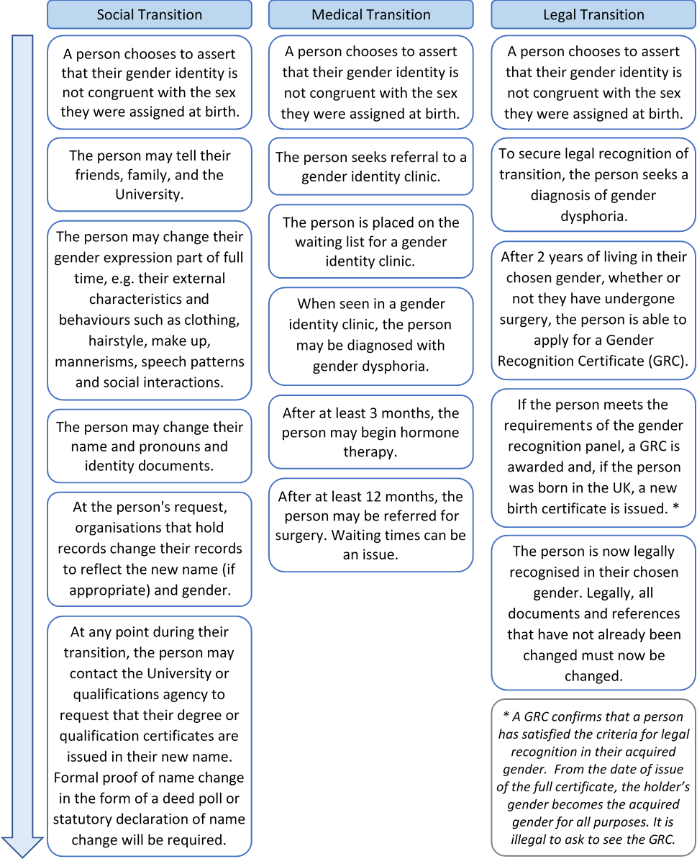

Appendix C: The Law
The process of gender reassignment can take several years to complete and there are different legislative protections at each stage of the process:

The Equality Act 2010
Gender reassignment is one of nine protected characteristics within the act, and it is also included in the Public Sector Equality Duty. The definition of gender reassignment within the act gives protection from discrimination to a person who has proposed, started or completed a process to change their sex.
The act offers far-reaching protection from discrimination on the grounds of gender reassignment as it protects:
- trans people who are not under medical supervision;
- people who experience discrimination because they are perceived to be trans;
- from discrimination by association because of gender reassignment. For example, it would protect the parents of a trans person from being discriminated against because their child is transitioning.

The Gender Recognition Act 2004
The legal position for a person who has fully transitioned is clear and unequivocal. The Gender Recognition Act 2004 allows trans people who are able to satisfy the Act’s evidence requirements, to apply to a Gender Recognition Panel to seek full legal recognition. If a Gender Recognition Certificate is issued, and the person’s birth was registered in the UK, they will be able to obtain a new birth certificate which does not disclose the fact that they have changed gender. Applying for a GRC is not a legal requirement and is not necessarily the end goal of a transition process. Not all transgender people will choose to apply for a GRC and having or not having a GRC should not necessarily be used as a ‘marker’ of a person’s gender or of the completeness of a transition process. Anyone who acquires information about someone’s trans status is liable to criminal proceedings if they pass that information to a third party without the permission of the individual.

The Human Rights Act 1998
The Human Rights Act provides protection to trans people, principally under the right to a private life. This includes, amongst other things, the right to choose a sexual identity, lifestyle and the way a person looks and dresses.

Data Protection Legislation
Under data protection legislation, trans identity and gender reassignment constitute ‘special category data’. It is important to note, therefore, that information relating to a person’s trans status cannot be recorded or passed to another person unless an appropriate condition for processing special category data, in accordance with data protection legislation, has been met.

