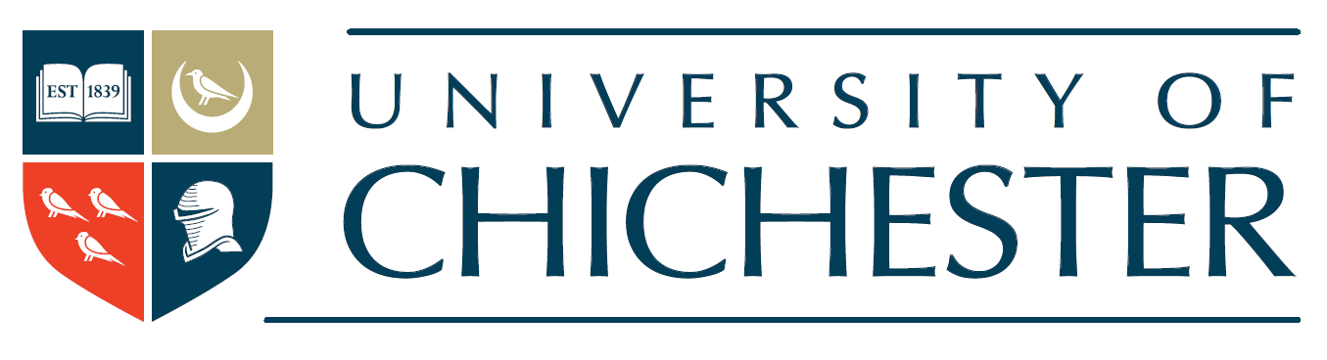

Statement on Modern Slavery 2018-19

Introduction

This statement is made pursuant to Section 54 part 6 of the Modern Slavery Act 2015 and sets out the steps that the University of Chichester has taken in the financial year ending 31 July 2019 to ensure that slavery and human traff icking are not taking place in any part of our business or our supply chains.

Modern slavery is a crime and a violation of fundamental human rights. We are committed to acting ethically and with integrity in all our business dealings and relationships and to implementing and enforcing effective systems and controls in our business to support the eradication of modern slavery globally.

Organisation structure

We are a university and a charity, established under the laws of the UK, with our administrative offices at our Bishop Otter Campus, College Lane, Chichester PO19 6PE. We have nearly 1000 employees and over 5000 students at any one t ime. Our annual turnover is in excess of £50 million, and while our key expenditure is on our academic and administrative staff, we engage with a large number of suppliers nationally and globally to enable us to provide our services.
The University is organised into multiple academic institutions and departments, which are supported by our professional service departments. Our key supply chains include the purchasing of IT equipment and services, building works, printing and design work, catering and accommodation­ related services, security services and medical support services.

Our policies on slavery and human trafficking

We are committed to ensuring that there is no modern slavery or human trafficking in our supply chains or in any part of our business. Our Anti-Slavery and Human Trafficking Policy reflects our commitment to acting ethically and with integrity in all our business relationships and to implementing and enforcing effective systems and controls to ensure slavery and human traff icking is not taking place anywhere in our supply chains. The policy is binding on all of our employees and is incorporated into our standard terms of purchase with our suppliers.

What we have done this year

In our financial year 1 August 2018 - 31 July 2019, we have continued to improve our management of the risks of slavery in our business and our supply chains.

We have:

- reviewed the provision of procurement expertise within the organisation and expanded centralised oversight and co-ordination;
- formalised the University's Procurement Working Group, to share best practice between departments and monitor ongoing procurements, pipeline and spend by category;
- made 'Modern Slavery' a topic to be discussed at every Procurement Working Group;
- welcomed external speakers to review our procurement practices and provide recommendations;
- participated in a benchmarking report on responses to modern slavery across the HE sector;
- rolled out an e-learning module on modern slavery, which was made in-house, to members of the Procurement Working Group;
- begun the re-tender process for our catering services with modern slavery due diligence highlighted throughout as we recognise that this is a high-risk area;
- continued to monitor our major suppliers and any significant developments in our supply chains for risk and respond accordingly.

What we will do next year

Following a review of the effectiveness of the steps we have taken this year, in the coming year, we will:

- conclude the re-tender process for our catering services, with under the supervision of the Procurement Working Group and the University Solicitor at all stages;
- roll out the modern slavery e-learning module to more staff members;
- promote our actions on modern slavery as part of our community focus;
- implement sector benchmarking recommendations as appropriate;
- continue to monitor our major suppliers and any significant developments in our supply chains for risk and respond accordingly.

We welcome feedback on our progress to date and suggestions for further improvement.

·
Professor Jane Longmore, Vice-Chancellor University of Chichester

Date: 18.11.2019

