Fairtrade Impact Report
September 2021 to August 2022

Sales of Fairtrade products have increased again compared to 2019/20 and 2020/21, when Covid 19 restricted the number of students and staff on campus (Figure 1).
Figure 1 Sales of Fairtrade products have increased post Covid

However, sales are not as high as those in the years immediately prior to Covid due to the decision by Starbucks to transition away from Fairtrade coffee in place of its’ own supplier scheme, Coffee and Farmer Equity (C.A.F.E). As we have not been able to confirm how this transition has affected our supply of Fairtrade coffee, we have used data for the worse case scenario assuming none of the Starbucks coffee we have used is Fairtrade.
Activities and events have continued to be held throughout the year, to promote Fairtrade.
On October 2021, we launched a social media campaign to encourage students to use university branded reusable cups. The prize for the competition associated with this campaign comprised of Fairtrade goodies (Figure 2) as well of course as a reusable cup!
Figure 2 Fairtrade goodies provided a great prize for the reusable cup competition
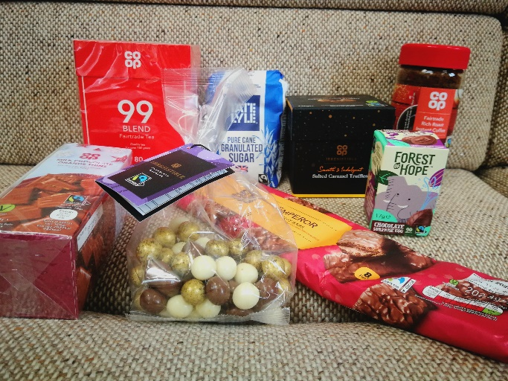

In November 2021, the University and Students’ Union held its annual Green Week.
Green fairs were held at both campuses which were attended by about 80 students and a few members of staff. A stall displaying Fairtrade information was set up at both fairs, with Fairtrade coffee, tea and stickers given away (Figure 3). Another stall run by our waste contractor encouraged students to determine which waste types can be recycled on our campuses. All participants were entered into a draw to win a selection of Fairtrade goodies (Figure 4). A clothes haul was also held during Green Week, with Fairtrade tea and coffee made available to all attendees as refreshments (Figure 5).

Figure 3 Fairtrade stall | Figure 4 Fairtrade goodies make a great prize for the waste competition | Figure 5 Fairtrade refreshments at the clothes haul

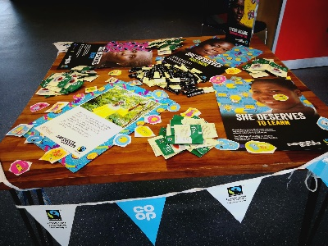
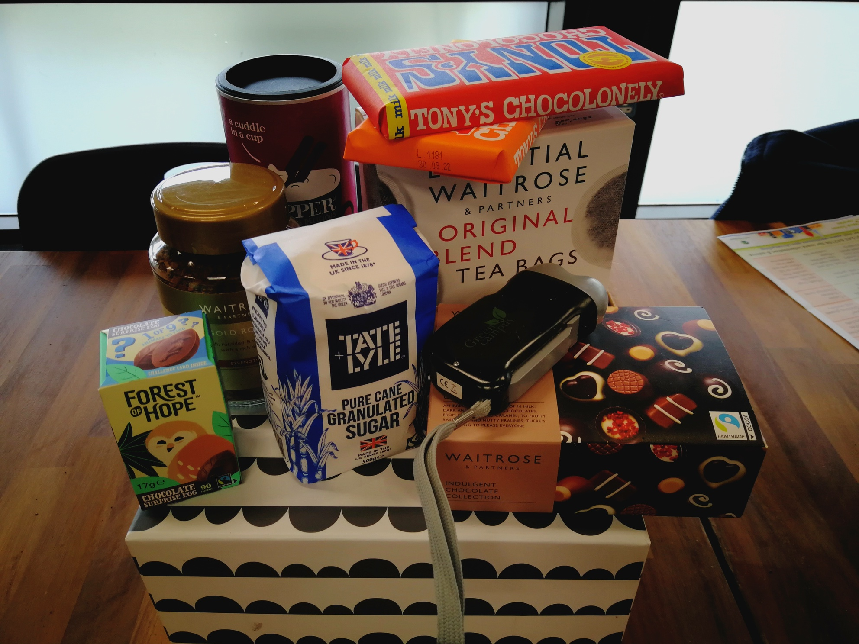
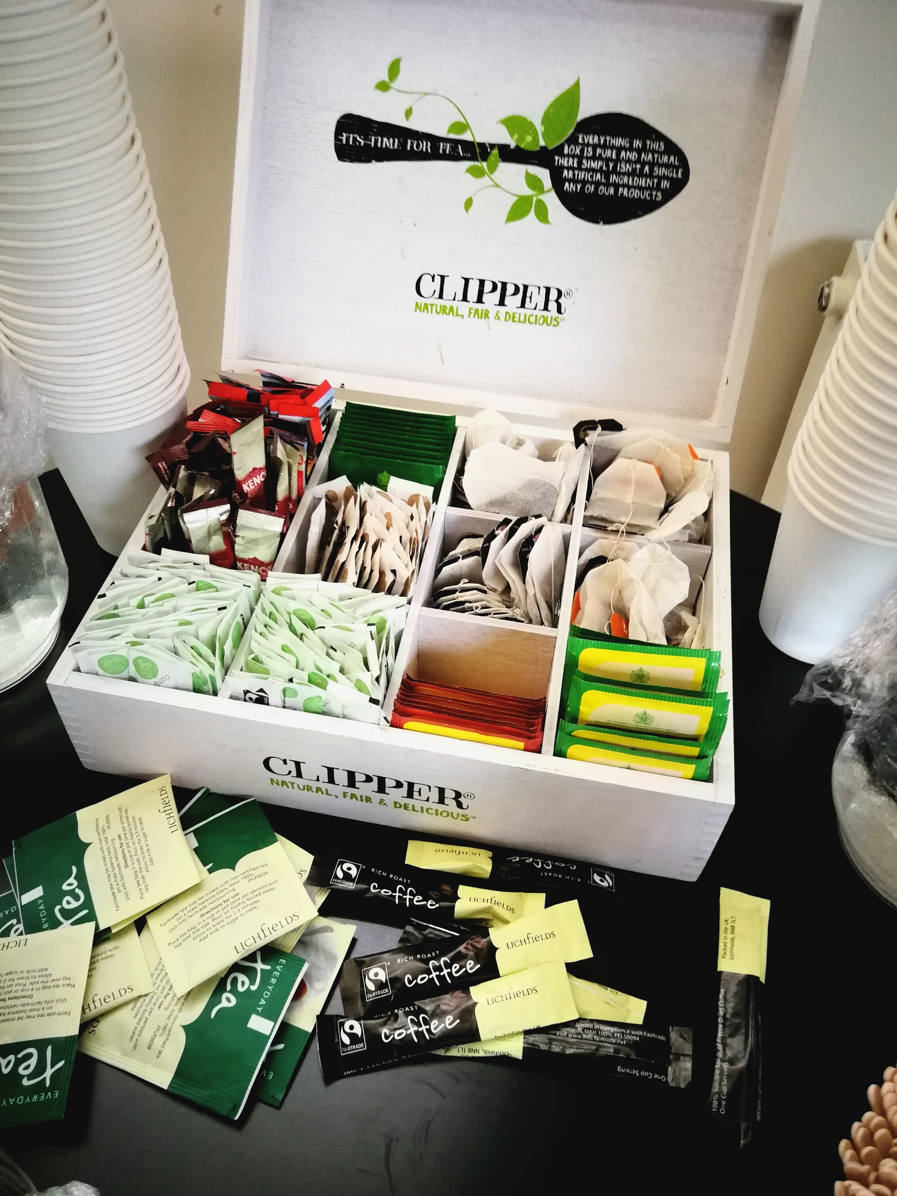

Fairtrade products and activities have continued to be promoted through our Jump scheme. In the last year, 139 Fairtrade purchases have been logged and 1,043 positive food purchases made. This includes Fairtrade and other certified products such as MSC fish, local products, seasonal fruit and vegetables and sustainable products, such as those with no palm oil. In addition, in December, 29 actions relating to the giving of ethical Christmas gifts, including Fairtrade, were logged

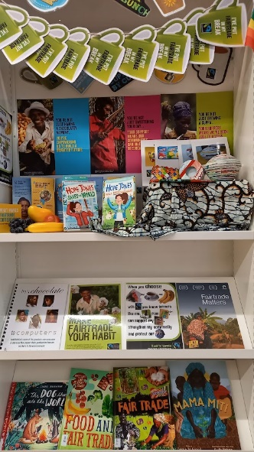
These activities were of course in addition to the usual Fairtrade Fortnight events. This year we again advertised Fairtrade Festival events to our students and staff, in addition to holding our own events and activities. In order to promote the importance of Fairtrade to farmers producing the products we all love, such as chocolate coffee and cotton, an exhibition was held in the LRC at our Bognor campus. The exhibition, produced by our library staff, included books, leaflets and posters about Fairtrade (Figure 6). A Fairtrade and the climate crisis quiz was hosted on Jump, attracting 16 participants and 125 purchases of Fairtrade products were recorded on the Jump platform, throughout the fortnight. Our catering contractor ran a promotion on Fairtrade coffee, juice and cookies in our Otters restaurants attracting 115 purchases.

Figure 6 Fairtrade exhibition

The University has continued to liaise with the University of Middlesex and other members of the Fairtrade Network Group to share ideas and best practice. One of the issues discussed by the group this year was the problem of obtaining Fairtrade products through suppliers affiliated by NUS Services. Through this collaboration, NUS Services have now produced an ethical trading brochure which covers their Fairtrade-certified ranges.
Progress to all tasks set during the 2021/22 academic year are included on the Action Plan below.

Fairtrade Action Plan V4 2021-2022
Task and appropriateness | Actions | Support/budget required | Measure of success | Responsibility | Timescale | Task achieved?
Ensure working group continues with BaxterStorey representatives.  Mandatory criteria MN001 | Set up new working group with BaxterStorey, SU and university representatives. | Support required from campus services manager | Quarterly meetings held | Environmental Coordinator | September 2021 to July 2022 | Working group meeting held November 10th 2021, 3rd/10th February 2022 and 12th May 2022.
Use action plan to monitor progress.  Mandatory criteria MN002 | Update action plan and review at working group meetings. | None | Tasks completed in action plan on time. | Environmental Coordinator | September 2021 to July 2022 | Action plan discussed at meetings.
Ensure public commitment to support Fairtrade is maintained.  Mandatory criteria MN003 | Update and agree food charter targets for 2021/22 | Support required from BaxterStorey, SU and University | Signed food charter available on website. | Environmental Coordinator | November 2021 | Food charter available on website October 2021.
Ensure all students are aware of our Fairtrade status | Include Fairtrade in student’s on-line induction information Required for CI001 | None |  | Environmental Coordinator | September 2021 | Yes – information updated July 2021
 | Fairtrade products to be used as prizes.  Included as II001 | £5/month | Students continue to engage in sustainability activities. New students win prizes. | Environmental Coordinator | October 2021 to June 2022 | Fairtrade products used for reusable cup launch prize October 2021 and Green Week prizes November 2021.
Ensure new staff are aware of our Fairtrade status | Include Fairtrade in staff induction sessions  Required for CI001 | None | Staff induction sessions carried out at least bimonthly | Environmental Coordinator | September 2021 to July 2022 | Fairtrade included in all staff inductions

Task and appropriateness | Actions | Support/budget required | Measure of success | Responsibility | Timescale | Task achieved?
Promote Fairtrade at Fresher's Fair if possible Required for CI010 | Fairtrade stickers and sachets of tea and coffee to be given out to students to highlight that we are a Fairtrade University. | None stickers and products already obtained | Greater than 30 stickers and sachets given out. | Environmental Coordinator | September 2021 | Yes – Fairtrade promoted by the SU Environment Society
Ensure any retail, catering or other commercial outlets stock at least one Fairtrade certified line in at least 2 of the following  • Soft drinks  • Wine or Beer  • Health & Beauty  • Savoury snacks & nuts  • Fruit  Mandatory criteria MN007 | Check availability of products offered by BaxterStorey and the SU.  Audit of products available to be produced by Baxterstorey by beginning of November. | Support required from Baxterstorey and the SU | At least one Fairtrade certified line available in The Shop, Otters and the SU bars in at least 2 of the following  • Soft drinks  • Wine or Beer  • Health & Beauty  • Savoury snacks & nuts  • Fruit | BaxterStorey  The Shop manager  SU bars manager | August 2022 | Yes – Fairtrade fruit juices sold on both campuses. Proper Corn introduced in Otters at both campuses as savoury snack.
Continually increase Fairtrade certified products in retail and catering outlets  Mandatory criteria MN006  Data on sales required for PL003 and PL011. | Ensure Fairtrade certified products in the following categories are stocked in The Shop and catering outlets and work to increase either the number of lines OR number of items sold year on year:  • Tea  • Coffee  • Sugar  • Hot chocolate and cocoa  • Chocolate, confectionary or snacks | Data required from BaxterStorey and The Shop Manager | Data provided by the SU and BaxterStorey on the number or sales value of Fairtrade items sold show an increase. | The Shop manager and BaxterStorey | Data to be provided for academic year  2020/21 in September 2021 and 2021/22 at the end of August 2022. | Data provided for academic year 2021/22.  Divine chocolate introduced in Costas.  Problem with The Shop obtaining Fairtrade products from Blakemore.
Task and appropriateness | Actions | Support/budget required | Measure of success | Responsibility | Timescale | Task achieved?
Re-introduce some Fairtrade cotton clothing lines for sale on campus  Part of mandatory criteria MN006  Record sales of clothing  Required for PL003 and PL011 | Re-introduce some SU branded clothing in The Shop. Encourage SU societies to use the Fairtrade clothing. Advertise Fairtrade clothing on University and SU websites. |  | Fairtrade branded clothing available in The Shop. | The Shop manager | June 2022 | Some Epona products still available. Source of new Fairtrade lines from Kool Skools delayed due to Coronavirus.
Ensure there is up to date and effective Point of Sale (POS) material in all relevant outlets, highlighting Fairtrade products and providing information on the benefits of Fairtrade to growing communities. Mandatory criteria MN008 | POS material to be displayed in The Shop and catering outlets. This must be placed next to products to avoid confusion, and it should be dated and refreshed periodically. |  | POS material displayed in The Shop and catering outlets with relevant dates. | The Shop manager and BaxterStorey | June 2022 | Yes - ongoing
Promote Fairtrade in activities/campaigns outside of Fairtrade Fortnight  Mandatory criteria MN005 | Fairtrade promoted at green fairs during green week. Information provided and stickers, tea and coffee | None | Greater than 20 participants | SU Sustainability Officer and Environmental Coordinator | November 16th and 18th 2021 | Yes – over 80 participants in the fairs.
 | Fairtrade products and activities promotion on Jump. | Green Rewards | Greater than 10 participants | Environmental Coordinator | Ongoing | Yes – 139 participants in Fairtrade activity.
 | Fairtrade used as a subject of one of the “bite size sustainability” sessions. | None | At least 3 attendees at presentation | Environmental Coordinator | 1st December 2021 | No- no participants.

Task and appropriateness | Actions | Support/budget required | Measure of success | Responsibility | Timescale | Task achieved?
Partner with a local off-campus Fairtrade group, and work together on at least one project or campaign over the year.
Required for CI004
Proactively share one or more learning or best practice example from our Fairtrade activities with the wider sector  Required for CI009  Included as II002 | Continue to liaise with University of Middlesex and other members of the Fairtrade Network Group to share ideas and best practice. | None | Ideas generated by the group implemented by the University and/or ideas from the University shared with others. | Environmental Coordinator | Ongoing | Yes, ongoing membership of the Fairtrade Network Group
Provide and publicise opportunities for students to investigate Fairtrade, trade justice or ethical consumption issues on or off-campus within their course work or dissertations.  Mandatory criteria MN010 | Make opportunities visible and available to students from any discipline to integrate issues of Fairtrade, trade justice or ethical consumption into their coursework. List topics or research questions on website or provide examples of how specific tutors embed these issues into their promotion of project ideas for students to undertake. Publicise opportunities through a variety of channels. | Support required from academic staff.  Use Responsible Futures framework. | At least one piece of coursework or dissertation carried out by a student each academic year. |  | Ongoing | Yes. Student citizenship taught as part of citizen and changemaker modules.  Fairtrade included in Entrepreneurial Mindset Module as a project to encourage further student participation January to April 2022.

Task | Actions | Support/budget required |  | Measure of success | Responsibility | Timescale |  |  | Task achieved?
Fairtrade Fortnight activities  Mandatory criteria MN004 | The Shop to offer Fairtrade promotions and/or prominently display Fairtrade products with Fairtrade information. |  |  | At least one promotion offered or display in place. | The Shop Manager | 21st February to 6th March 2022 |  |  | No -The Shop struggling to obtain FT products from Blakemore.
 | Baxterstorey to offer Fairtrade promotions, promote the use of Fairtrade ingredients in menu offerings, offer Fairtrade activities and/or prominently display Fairtrade products with Fairtrade information. |  |  | At least one promotion or activity offered or display in place. | Baxterstorey | 21st February to 6th March 2022 |  |  | Cookie and coffee/juice offered for £3 in both Otters from beginning of February.
 | On-line quiz produced with questions based on Fairtrade video. Fairtrade products given as prize. |  |  | At least 10 participants | Environmental Coordinator | 21st February to 16th March 2022 |  |  | Yes – 15 participants
 | Use University and SU websites and newsletter to advertise activities | Support from marketing and SU |  | Info on websites and NL accessed by students and staff | Environmental Coordinator | 21st February to 6th March 2022 |  |  | Events publicised in NL 11th and 18th February.
 | Monthly Jump activities to be based on Fairtrade in February. | Info to be included by Green Rewards. |  | At least 20 participants | Environmental Coordinator | February 2022
 | Exhibition to be held in LRC at BRC. | Support from LRC staff |  | Exhibition in place | LRC staff | 21st February to 6th March 2022 |  |  | Yes, exhibition held.
 | Advertise Fairtrade Festival and speaker events. |  |  | At least 5 participants | Environmental Coordinator | 21st February to 6th March 2022 |  |  | Events publicised in NL 11th and 18th February.
 | Advertise activities via social media Required for CI008 | Support from digital marketing |  | Info advertised on social media | Environmental Coordinator | February 2022 |  |  | SU advertised activities on social media
Task | Actions | Support/budget required | Measure of success |  | Responsibility |  | Timescale | Task achieved?
Promote Fairtrade at the Spring Fair  Mandatory criteria MN005 | Work with students producing the Spring Fair to promote Fairtrade. Encourage students to donate some of the profits to Fairtrade Required for CI012 |  | Fairtrade promoted at the fair.  Funds donated to Fairtrade |  | Environmental Coordinator |  | April/May 2022 | No- no Spring Fair this year
Publish an annual progress report on our actions on Fairtrade, trade justice and ethical consumption. Refer to the tasks and progress made through this SMART action plan and make publicly available. This can be part of a wider sustainability report. Mandatory criteria MN011 | Produce report on Fairtrade actions and the impact this has had on staff and students. Or this could be an informal display of outcomes on the website. |  | Report or display of outcomes published on the website. |  | Environmental Coordinator |  | August 2022 | Fairtrade Impact report produced and added to website.
Include Fairtrade in our hospitality offering.  Required for PL006 | Ensure Fairtrade is served as standard in hospitality across all products with a Fairtrade option such as tea, coffee, sugar etc. or demonstrate progress has been made over the last two years to put this into practice. | Support needed from Baxterstorey | Fairtrade items included in hospitality offering. Issues with coffee sachet supplier resolved. |  | Baxterstorey |  | Ongoing until June 2022 | Yes, Fairtrade tea, coffee and sugar available in hospitality.
Include up to date information on Fairtrade activities on the website/Intranet/Moodle which can be easily found and well used.  Required for CI007 | Use the Intranet, Moodle and University newsletter to promote and report on Fairtrade activities. | Help from IT and marketing. | Items can be found on various communication channels and information is kept up to date. |  | Environmental Coordinator |  | Ongoing until August 2022 | Information included on the website. News item about One star award added to website on 14th September 2022.
Task | Actions | Support/budget required | Measure of success |  | Responsibility |  | Timescale | Task achieved?
Provide sales promotions, discounts or competitions on Fairtrade products throughout the year.  Required for PL010 | Fairtrade promotion of cookies/chocolate and coffee/juice during green week in Otters | Baxterstorey | Greater than 30 promotion combinations sold. |  | Baxterstorey |  | November 15th to 19th 2021 | Yes
 | Fairtrade products and activities promotion on Jump. | Green Rewards | Greater than 10 participants |  | Environmental Coordinator |  | Ongoing | Yes
Carry out baseline curriculum review or audit for Fairtrade, trade justice or ethical consumption themes and make findings publicly available.  Required for RC005 | Include as part of curriculum review for Responsible Futures. | Support required from academic staff | Review carried out. Report on website |  |  |  | Spring 2022
Repeat scoping exercise/survey carried out in March 2020 to ascertain what students and staff understand about Fairtrade and how they rate its significance.  Mandatory criteria for MN009  Compare results with those obtained in March 2020.  Required for RC002 | Carry our survey possibly during Green Week 2022. |  | Review and comparison carried out. Report on website |  | Environmental Coordinator |  | November 2022

