University of Chichester

Waste Management Information and Guidelines

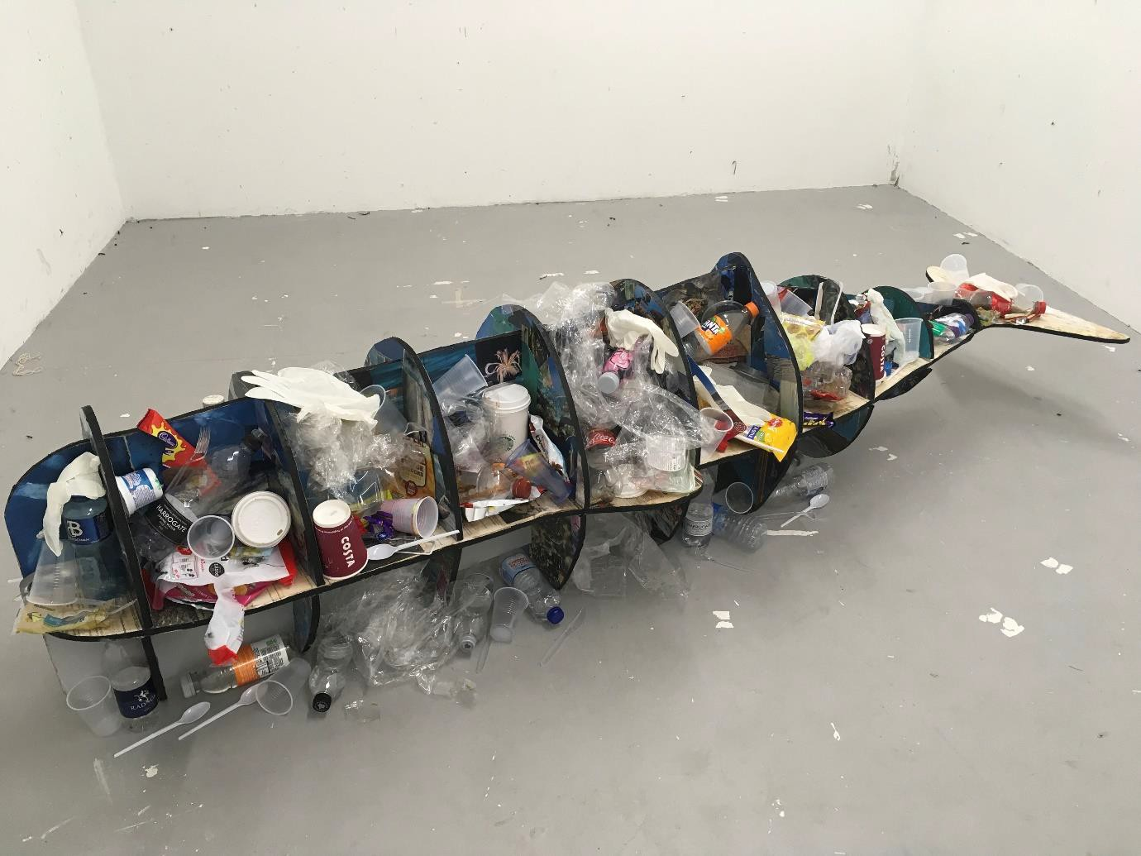

Artwork produced by Elle Tarr to depict the impact of plastic waste on ocean life as partial fulfilment of her degree in Fine Art, April 2018.

Introduction
As a society we are consuming natural resources at an unprecedented rate creating mountains of waste that requires disposal. More sustainable approaches to the use of resources and the management of waste are urgently needed using the waste hierarchy as depicted below in Figure 1.
Figure 1 The waste hierarchy
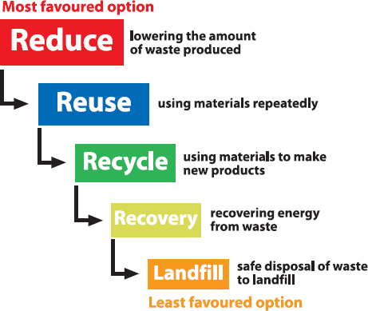

As an organisation we consume resources and produce large quantities of waste from our student accommodation, catering facilities, offices, and teaching departments. With public environmental consciousness rising, it is important that we demonstrate leadership and reduce the impacts we have on the environment. We have identified the need to create and maintain a sustainable environment for our students, staff and local neighbours to enjoy.
Developing sustainable approaches to managing our waste is a key component of this goal.

This document has been developed to provide the University community with a clear understanding of sustainable waste management and the roles and responsibilities that we all have in implementing this.

Adopting a sustainable approach to managing waste will bring us many benefits including:

Environmental: Transportation and treatment of waste creates emissions. Although the University and its waste management contractors have worked hard to reduce the impact of waste disposal, there is still an environmental consequence of waste production. Managing our waste effectively will reduce the carbon emissions of the University.

Reputation: Environmental issues are important to our staff, students and local community. The environmental performance of Higher Education Institutes is becoming more important with the acknowledgment of the vital role they play in sustainability education. Publicly available statistics on many aspects of sustainability are produced by all institutions enabling comparison of performance.

Financial: A number of waste streams produced by the University will have a market value if processed and managed properly. Metal in particular has considerable value when recycled. It costs roughly double the amount of money for the University to dispose of general waste compared to mixed recyclable waste. Obviously increasing our recycling rate will therefore substantially reduce our waste disposal costs.

Legal: If the University fails to manage its waste properly we are at risk of prosecution and fines, which damages our reputation with students, staff and the local community.

The University produced 592 tonnes of operational waste in the academic year 2016/2017. This is equivalent to about 62 double decker buses!

The University’s recycling rate is approximately 42%. This has remained largely unchanged for the past five years.

Best practice in the HE sector is around 60%

Waste Management Purposes

- To ensure the safe handling, storage and disposal of waste on campus to protect human health and the environment.

- To ensure the segregation of waste streams maximising the potential for recycling and reducing waste to landfill to a minimum.

- To comply with all waste legislation, including duty of care responsibilities and promote waste management best practise.

- To reduce the amount of waste we produce by adopting a waste hierarchy (see Figure 1).

- To promote environmental awareness and training to staff, students and other stakeholders in order to increase and encourage waste minimisation, reuse and recycling.

Specific objectives and targets for waste reduction and management are included in the University’s Environment and Sustainable Development Plan 2017 to 2022.

Waste management at the University
Veolia Environmental Services are our current waste management contractor. Veolia are responsible for removing operational waste from our campuses. This is defined as waste from offices, accommodation, teaching areas and our catering outlets. In all areas except accommodation, the waste is collected as either recyclable or non-recyclable in a two bin system. Recyclable waste is generally collected in green bins and non-recyclable waste in black bins. Each is clearly labelled with the types of waste which can be placed in each bin, as shown below in Figures 2 and 3. In our on campus accommodation, extra glass bins are also provided.

Figure 2 Signage for recyclable waste Figure 3 Signage for non-recyclable waste
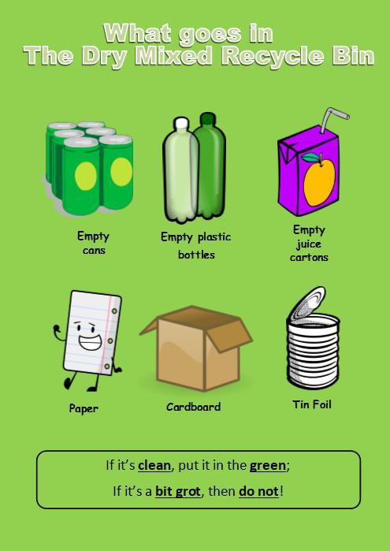
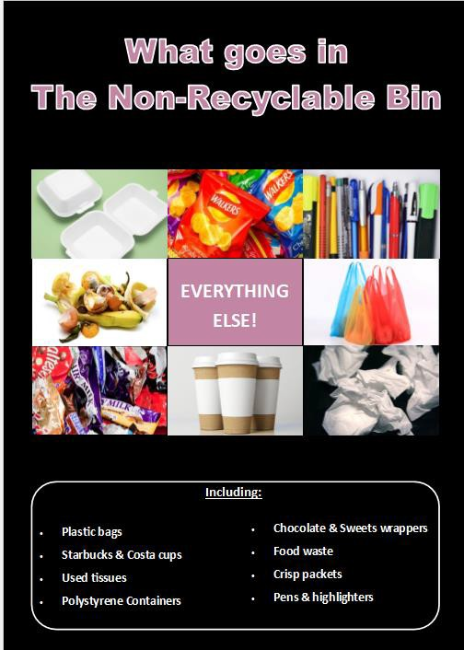

It is important that the correct waste types are placed in each bin because;
- Once recyclable waste is mixed with non-recyclable waste this can no longer be recycled.
- It costs the University about half as much to recycle waste.

Once both types of waste have been collected from our campuses they are taken to Veolia’s site in Portsmouth. The mixed recyclable waste is sorted in a materials recycling facility (Figure 4). Different types of waste generated from the facility are baled and sent off to processing plants where the material is recycled into new products.
Figure 4 Materials Recycling Facility
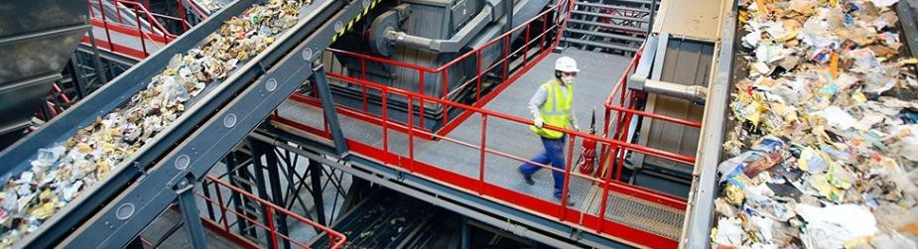
Waste collected in our black bins is converted into electricity in Veolia’s waste to energy plant in Portsmouth. This plant produces enough energy to power 22,000 homes.
Waste arrangements for our off campus accommodation are different. For example, waste from Havenstoke and Pinewood is collected by Chichester District Council. Signage is provided to enable correct waste segregation.

During student arrivals (September) and departures (May/June) the University provides additional services to ensure that the increased level of waste during this time is handled correctly and we maximise the waste recycled.
To encourage recycling, the University has produced an A – Z of Recycling with details of what can be recycled and where (Appendix 1).

Responsibilities for waste management and recycling

Estate Management has the responsibility for waste services and ensuring the University is legally compliant. Departments are not responsible for removing their own waste off site and should contact Estate Management for advice on disposal or additional services if required. Everyone in the University, staff, students, visitors and conference guests, have a role to play in reducing and managing waste. The tables below provide more information on individual roles and responsibilities:

Students
- Take reasonable steps to minimise waste produced.
- Treat waste responsibly, identifying the type of waste and disposing of it in the appropriate container.
- Report any problems with waste collection to the University through the ‘Request a Service’ tab on Moodle.
- Do not bring personal household waste on campus for the purposes of fly tipping.
- Abide by agreements with University departments for specific project activities, such as art installations and dance performances.

Staff
- Take reasonable steps to minimise waste produced.
- Treat waste responsibly, identifying the type of waste and disposing of it in the appropriate container.
- Report any problems with waste collection to the University through the ‘Request a Service’ tab on the Intranet.
- Do not bring personal household waste on campus for the purposes of fly tipping.

Directors and Departmental Heads
- Ensure that all staff implement this policy in their day to day duties and that they are encouraged to co-operate with waste management and recycling.
- Ensure that students abide by this policy and are encouraged to co-operate with waste management and recycling.
- Identify training needs for staff in waste management.
- Ensure that all departmental purchases consider environmental impacts such as end or life of a product.
- Ensure that any departmental waste to be taken off-site is not disposed of through Household Recycling Centres.
- If it is necessary to procure additional waste services, do this through Estate Management.
- Ensure that non-hazardous waste (general and recycling) is disposed in the correct containers.
- Ensure that no hazardous waste is disposed of through the general waste or recycling bins. Ensure no hazardous liquids are emptied into drains. For advice, contact Health & Safety.
- Encourage staff, students and visitors to co-operate with waste campaigns, projects and initiatives.

Estate Management
- Manage the waste and recycling service for the University.
- Control all waste records and documentation including Waste Transfer Notes, Consignment notes and Exemptions for the University.
- Ensure that contractors are advised that they must comply with the Contractors Code of Practice.
- Investigate any incidents or accidents relating to waste management.
- Undertake external and internal auditing and monitoring of procedures for all waste to ensure legal compliance.
- Compile waste data and statistics to enable annual benchmarking against established Environmental Performance Indicators.
- Maintain registration with the appropriate enforcement agencies as a producer of waste or as a waste carrier.

Environment and Sustainable Development Co-ordinator
- Provide guidance to the University on waste management.
- Help to establish environmental objectives and targets for waste management.
- Report annually to the Environmental and Sustainability Group (ESG) on progress on waste objectives and targets.
- Help to identify and provide appropriate training to ensure staff and students are competent to fulfil their responsibilities for waste management.
- Ensure progress to waste objectives and targets through organisation of the waste working group.
- Develop communication strategies/campaigns to encourage adherence to this policy.

Contractors and Suppliers
- Dispose of waste responsibly in accordance with the Contractors’ Operating Guidelines.
- Report any incidents, breaches of and non-conformance with waste collections to your Contract Manager and Estate Management.
- Supply all appropriate documentation including Waste Transfer Notes, Health and Safety Policy, Environmental Policy, Risk Assessments, Method Statements and Duty of Care within tender submissions to the University.

Appendix 1 A-Z of Recycling

We have two main streams of waste at both of our campuses; recyclable waste and non-recyclable waste.
In our buildings on both campuses, green bins are generally used to collect mixed recyclable waste and black bins are generally used to collect non-recyclable (general) waste. Signs are present on both types of bins clearly indicating the types of waste which can be placed in these bins. Outside of the buildings on both campuses we have split bins for recyclable and non-recyclable (labelled as general) waste. The same types of materials can be placed in these bins as the inside bins. It is important that the correct types of waste materials are placed in the bins as they are treated differently once they leave our campuses.

  - Recyclable waste is sorted at a dedicated Materials Recycling Facility. The different waste materials such as bottles, paper and cans are then baled and sent off to be recycled into respective products.

  - General waste and glass is taken to an Energy Recovery Facility, where the waste is processed into energy which supplies the national grid and powers 22,000 homes in Hampshire. The residue from this energy process is used in road asphalt and the glass residue helps to bind the asphalt.

A-Z | Waste | How to recycle, generate energy or dispose of:
A | Aerosols | If these are empty they can be recycled along with drinks cans etc. Please place in the mixed recycling bins. Although aerosols in the UK no longer contain CFCs, they do contain other ozone depleting propellants, so where possible try to choose alternatives such as pump action sprays.
 | Aluminium cans | Please see cans.
 | Aluminium Foil | Please place clean foil in the mixed recycling bins, dirty foil should be placed in the non-recyclable (general) waste bins.
B | Batteries | Battery Recycling Tubes are located at each campus reception, where students and staff can dispose of batteries. When full, these tubes are emptied and collected by our waste contractor. If you have a battery that is too large to fit in the containers please use the “Support Me” link on the Intranet or on Moodle (orange and white life ring) and ask for it to be taken to be disposed of.
 | Books | Books and journals from your department or faculty should either be reused or recycled.  Unwanted non-fiction books are collected from the LRC from time to time. Contact Julie Peachey on extension 6094 for details.  Alternatively please use the British Heart Foundation Charity Donation banks in each campus recycling compound.
 | Bulbs | If you have a bulb, fluorescent tube or lamp that needs changing, please use the “Support Me” link on the Intranet or Moodle (orange and white life ring) to report the problem. To dispose of a specialist bulb, i.e. from projectors, use the  “Support Me” link on the Intranet or Moodle (orange and white life ring) and ask for this to be collected.
C | Cans | Please place drinks cans or tin cans in the mixed recycling bins.
 | Cables | Do not place in the recycling or general waste bins. Use the “Support Me” link on the Intranet or Moodle (orange and white life ring) and request these to be collected.

 | Cardboard | Please FLAT-PACK all boxes and take to a mixed recycling bin situated around campus.
 | Carrier Bags | Carrier bags cannot be recycled unless they are made of paper. Please consider using a reusable carrier bag when you go shopping. Remember you will now be charged 5p for each plastic bag. You are able to return unwanted carrier bags to your local supermarkets for recycling.  If you need to dispose of plastic carrier bags on campus, please place in the non-recyclable (general waste) bins.
 | Cartridges | Forward to either BOC or BRC Reprographics.
 | CDs | Please forward to IT for shredding.  Music and non-data CDs can be placed in the British Heart Foundation charity donation banks in each campus waste compound.
 | Christmas Cards | Christmas cards generate a lot of waste, so please recycle them or consider sending them electronically. Many local shops and supermarkets provide recycling containers specifically for cards after the Christmas period.  Alternatively please place them in the mixed recycling bins.
 | Cling Film | This cannot be recycled and should be placed in the non-recyclable (general waste) bins.
 | Clinical Waste | Please see Hazardous Waste.
 | Clothing | Please see textiles.
 | Computer Equipment | Please see IT.
 | Confidential Waste | Smaller quantities of confidential waste can be shredded. Larger quantities of confidential waste can be disposed of through the Confidential Waste Bins/Bags located in most office areas. Use the “Support Me” link on the Intranet or Moodle (orange and white life ring) when your confidential waste bag is full.
 | Crisp  packets/snack food packs | Please place in the non-recyclable (general waste) bins.
D | Drinks cartons (cardboard based) | Please place in the mixed recycling bins.
E | Electronic and electrical equipment (WEEE) | Please DO NOT put electronic or electrical waste into the general waste bins. Some of this waste is classed as hazardous and all electronic and electrical equipment disposal is covered by legislation.  Please use the “Support Me” link on the Intranet or Moodle (orange and white life ring) when you have any electronic or electrical waste for disposal. This includes:  - Fridges & freezers  - Telecoms & computer equipment  - Small appliances  - Large appliances  - Cables, leads and plugs  - E-Cigarettes  (Don’t forget that all electrical equipment still in use needs to be PAT tested annually. Contact the H&S Manager on extension 6480 for details).
 | Envelopes | Where possible reuse these internally; otherwise they can be recycled. Please place in the mixed recycling bins. If possible remove any plastic film or  windows.

F | Fluorescent Lamps | See bulbs.  Please DO NOT put fluorescent tubes in the non-recyclable (general waste) bins.  Fluorescent tubes are classed as hazardous waste and must be disposed of via a specialist contractor. Please use the “Support Me” link on the Intranet or Moodle (orange and white life ring) when you have any to dispose of.
 | Food Waste | Please place in the non-recyclable “general waste” bins. Composting facilities will be investigated in the future.
 | Food Tins | Please clean and place in the mixed recycling bins.
 | Furniture | Where possible furniture is reused on campus. Otherwise it should be collected by the supplier of new furniture for onward recycling.  Please use the “Support Me” link on the Intranet or Moodle (orange and white life ring) if you have unwanted University furniture for removal.
G | Glass | Bishop Otter Campus:  STAFF: Take unbroken glass to the glass bins located at the Springfield Recycling compound.  STUDENTS: Place unbroken glass in dedicated glass bins in your accommodation blocks.  Bognor Regis Campus:  STAFF: Take unbroken glass to the glass bins in the Longbrook recycling compound.  STUDENTS: Place glass in dedicated glass bins in your accommodation blocks.  Our contractor at both main campuses sends general waste and glass to an Energy Recovery Centre, where the waste is processed into energy which supplies the national grid and powers 22,000 homes in Hampshire. The residue from this energy process is used in road asphalt and the glass residue helps to bind the asphalt.  Operationally however, for health and safety reasons, we continue to separate glass at source, i.e. in accommodation. Staff will still need to take their glass to the Longbrook and Springfield compounds themselves.  Broken glass: Please use the “Support Me” link on the Intranet (orange and white life ring) to have it collected and disposed of safely.  Pinewood, Mainline, Bognor Road and Havenstoke Residents: Due to  different contractual arrangements, please continue to place glass in recycling bins.

H | Hazardous Waste | Please DO NOT put hazardous waste in ANY bins. It must be disposed of separately in accordance with hazardous waste legislation.  Please use the “Support Me” link on the Intranet or Moodle (orange and white life ring) to arrange for disposal.  This includes:  - Chemicals  - Laboratory waste  - Clinical waste  - Paints  - Bulbs and fluorescent tubes  - Batteries  - Fridges and Freezers  - Feminine hygiene.
I | IT & computer equipment | Please DO NOT put IT waste in any non-recyclable (general waste) or mixed recycling bins.  Please contact the IT department for advice on extension 6222 or use the “Support Me” link on the Intranet or Moodle.
J | Junk Mail | You can take your name off mailing lists by visiting the web page of the Mailing Preference Services(www.mpsonline.org.uk).  Any junk mail received should be placed in the mixed recycling bins.
K
L | Laboratory Waste | Please see Hazardous Waste.
 | Laminated paper | Please place in the non-recyclable (general waste) bins.
 | Lever arch files | Unwanted lever arch files can probably be used by other members of staff or students. If you can’t find anyone who wants them, please place in the non- recyclable (general waste) bins.
 | Light Bulbs | These are classed as WEEE. Please use the “Support Me” link on the Intranet or Moodle (orange and white life ring) and ask for the light bulb to be collected for recycling.
M | Magazines and Catalogues | Please place in the mixed recycling bins.
 | Medicines | Medicines/drugs are classed as Hazardous waste and unused, out of date, or no longer required medicines need to be taken back to a pharmacy for safe disposal.
 | Metal | Many metals have an economic value and where we recycle, we can potentially generate some income, which all goes to providing the service. Please break any metal objects down to the smallest unit possible and take to a metals skip. Contact the caretakers to ask them to open the skip.
 | Mobile Phones | Return your phone to the shop of purchase or enquire at your local supermarket which may have a scheme for collecting mobile phones. Alternatively please use the British Heart Foundation donation banks.  Please return work phones to your Manager.

N | Newspaper | Please place in the mixed recycling bins.
O | Organic Waste | Please see food waste.
P | Paper | Please reuse paper first by using both sides. Place in the mixed recycling bins.
 | Paint | Metal empty paint tins can be placed in the metal skips. Please contact the carpenters to ask them to open a skip.  Plastic empty paint tins go in the non-recyclable (general waste).  Paint tins with any paint residue please use the “Support Me” link on the Intranet or Moodle (orange and white life ring) and ask for the tin and paint to be collected for processing.
 | Plastic | Some plastics can be recycled and should be placed in the mixed recycling bins. These include: drinks bottles (fizzy drinks and water), the plastic cups by the water dispensers, milk bottles, cleaning product bottles, shampoo and washing up bottles.  Other plastics such as: plastic toys, plastic bags, bottle lids, yoghurt pots, tubs (e.g. butter containers), cling film or bubble wrap and video cassettes cannot be recycled and should be placed in the non-recyclable (general waste) bins.
 | Plasterboard | Plasterboard (and other items containing Gypsum) has been banned from landfill and must be recycled separately. Normally this waste would only be produced by Estate Management staff but there may be a requirement from staff and students, for example set building and art work, who must contact the Facilities Manager for advice (extension 6131).
 | Polystyrene Cups and Food Trays | Currently these cannot be recycled so need to be disposed of in the non- recyclable (general waste).
 | Printer Cartridges | Please see cartridges.
Q
R
S | Sanitary/feminine hygiene waste | Sanitary waste is classified as hazardous and must be disposed of in the dedicated bins provided. If bins are full, please use the “Support Me” link on the Intranet or Moodle (orange and white life ring)
 | Sharps | Students and staff who need sharp bins for medical reasons must contact Student Services who will arrange for the provision of a sharps bin.
 | Shoes | Shoes in good condition that you no longer want can be collected for charity.  Please place in the British Heart Foundation bins in the campus recycling compounds.
 | Televisions | Consider donating unwanted televisions that are in good working order to a charity or selling them to resale and second hand shops, or dispose of broken televisions at Recycling Centres for Household Waste. It is ultimately your responsibility to dispose of a broken television, either via the above method or you should to take it with you when you leave university accommodation. If discarded and left in university accommodation a charge will be traced back to you.

 | Tetrapak Cartons | Please place in the mixed recycling bins.
 | Textiles/Clothing | Please place in the British Heart Foundation Bins located in the campus recycling compounds.
T | Telephone Directories | Please place in the mixed recycling bins.
 | Toner Cartridges | Please see cartridges.
U
V | Videos | Please place in the non-recyclable (general waste) bins.
W | Wood | Wood is collected in dedicated skips for recycling. Please break any wooden objects down to the smallest unit possible and take to a wood skip. Contact the caretakers to ask them to open the skip.  There is a bin containing offcuts of wood outside the Carpenters’ Workshop at BOC, for staff to take home for personal use.
 | Window envelopes | Detach the plastic film and place the paper in the mixed recycling bins and the plastic in the non-recyclable (general waste).
X
Y
Z

