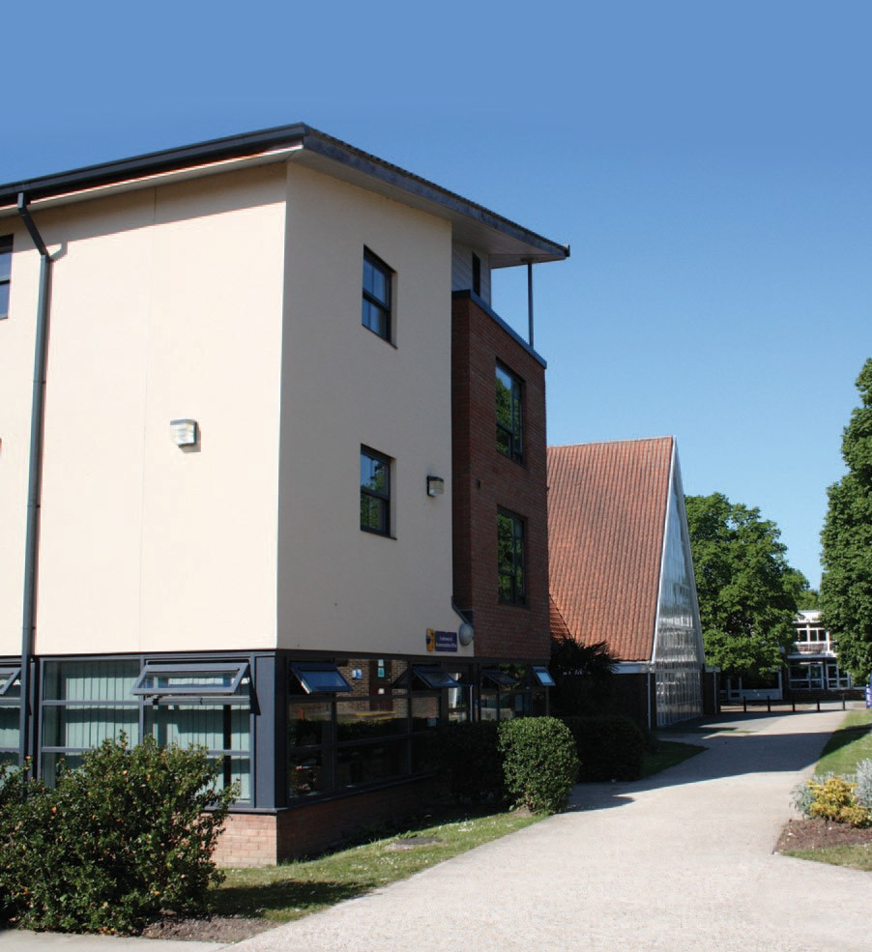
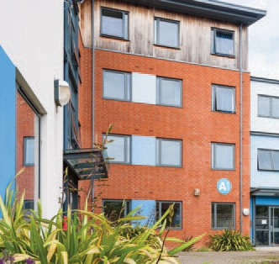
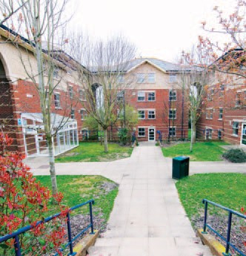
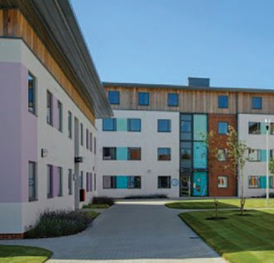
2023/2024
Accommodation
Handbook for Residents

chi.ac.uk/accommodation | Email: accommodation@chi.ac.uk

Contact details

 | Telephone | Internal
Main Switchboard | 01243 816000 | 0
Academic Registry | 01243 816026 | 6026
Accommodation Ofce – Bishop Otter Campus | 01243 793477 | 3477
Accommodation Ofce – Bognor Regis Campus | 01243 793488 | 3488
Admissions | 01243 816002 | 6002
Careers | 01243 816035 | 6035
Catering Manager Chichester Campus | 01243 816072 | 6072
Catering Manager Bognor Campus | 01243 812074 | 2074
Chaplain | 01243 816041 | 6041
Disability and Dyslexia Service | 01243 812076 | 2076
Emergency Number | 01243 816363 | 6363
(both campuses)
Finance Department | 01243 816429 or 816108 | 6429/6108
Nurse Health Advisers | 01243 816111 or mob 07739 983703
Health and Safety | 01243 816488 | 6488
International Student Advice Service | 01243 812146 | 2146
UinMind Mental Health Advice Service | 01243 816402 | 6402
Samaritans | 08457 90 90 90 | N/A
Student Wellbeing Advisor Team | 01243 816238 | 6238
Student Money Advice Service | 01243 816038 | 6038
Students’ Union | 01243 816394 | 6394
Support and Information Zone (SIZ) | 01243 816222 | 6222

Emergencies (Out of hours)
 | Telephone | Internal
Emergency Number (Chichester) | 01243 793477
Emergency Number (Bognor) | 01243 793488
Emergency Number (Stockbridge) | 01243 533356/07824 349543
Emergency Number (Fishbourne Road East) | 01243 790279/07791 692966
Security Patrol Chichester | 01243 816147  07974 829935 (Mobile) | 6147
Security Patrol Bognor | 01243 812184  07974 829936 (Mobile) | 2184
Fire/Police/Medical Emergency | 9-999

Revised February 2023

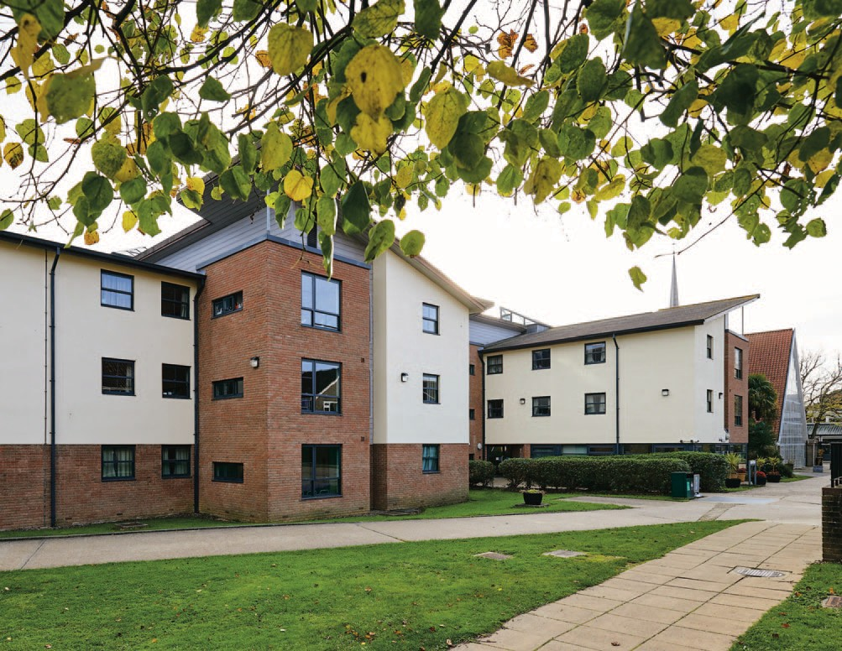

Contents
Contact Details 2
Dear Student 4
Student Residential Licence Agreement 5
Schedule 8
Residential Life 10
Schedule of Damages and Fees 34

Dear Student

We look forward to welcoming you to our accommodation and wish you every success with your studies.
This Handbook is devised to help you with day-to-day residential life and is divided into two sections:-

• Residential Licence and Terms and Conditions
• General Information about Residential Life

Please read it carefully as both sections form part of the Residential Licence Agreement you will need to sign
before arrival at University. Please keep the handbook in a safe place so you can refer to it throughout the year

We pride ourselves on our friendly, supportive and secure accommodation/services. Your Welcome Representative and Block Representative will play an important role in your time in the residences and are the first people to turn to if you require any help or information. The quality of life in our halls is dependent on the members who live in it. Please help us to continue our tradition of caring for our community by caring about and caring f or others in your hall or house. Inevitably, to assist in the smooth running of a community there must be some rules! You will read about the rules as you go through this handbook. Please abide by them. May we particularly draw your attention to the Code of Conduct to which you must adhere to.

If you have any queries concerning your accommodation package, please refer to our Accommodation Brochure, which, if you do not already have a copy, can be downloaded from our website.

We look forward to welcoming you to our accommodation and wish you every success with your studies.

The Accommodation Office team (Tel: 01243 793477)

Student Residential Licence Agreement
This Licence is made on the date it is electronically signed by the Licensee.

Interpretation
  - The particulars set out on the linked accommodation portal sign-up page shall apply to this Licence.
  - If any provision of this Licence is held to be illegal, invalid or unenforceable, the remainder will be unafected.
  - Any obligation on a party under this Licence not to do something includes an obligation not to allow that thing to be done and an obligation to use best endeavours to prevent that thing being done by another person.
  - The parties to this Licence do not intend that any of its terms will be enforceable by virtue of the Contracts (Rights of Third Parties) Act 1999 by any person not a party to it.

Licence
  - The Licensor permits the Licensee to occupy the Property during the License Term on the terms set out in this Licence.
  - It is agreed, and the Licensee acknowledges that:
    - this licence is not intended to confer exclusive possession upon the Licensee or to create the legal relationship of landlord and tenant between the parties;
    - the Licensee shall not be entitled to an assured tenancy or a statutory period tenancy under the Housing Act 1988
or any other statutory security of tenure now or when the licence conferred by this agreement ends;
    - the Licensor retains control, possession and management of the Property and the Licensee has no right to exclude the Licensor from the Property;
    - the Licensor shall be entitled at any time on giving four weeks’ notice (or less in the event of an emergency or due to the outcome of disciplinary action) to require the Licensee to transfer to an alternative space elsewhere within the University and the Licensee shall comply with such a requirement; and
    - the Licensee is not permitted to terminate the Licence prior to the end of the Licence Term unless on the basis of clause 4.3 – 4.4.
  - The licence conferred by this agreement is personal to the Licensee, and is not assignable.
  - The Licensor will consider any reasonable request by the Licensee to move to a room other than the Property but any such move is at the Licensor’s sole discretion. If the Licensee wishes to move room, they must:
    - submit their request in writing to the Accommodation Ofcer with the reasons for their request; and
    - if a change is approved, pay £50 to cover the costs of associated cleaning and additional administration work.

The Licensee’s obligations
  - The Licensee must:
    - pay the Licence Fee payable to the Licensor without any deduction in advance in the amount(s) and on the instalment date(s) set out in the Schedule;
    - use the Property only as a private residence for the Licensee only;
    - use the Property carefully and properly and not to damage the Property (and where damage is caused, pay the Licensor’s reasonable costs of repair on demand);

3.1.4. | keep the Property clean, tidy and clear |  | 3.1.16. pay for any damages caused to the
 | of rubbish, including communal areas; |  |  | Property within 28 days of receipt of
3.1.5. | not do anything at the Property which |  |  | invoice;
 | is illegal or immoral or is a nuisance, |  | 3.1.17. allow access to the room for
 | disturbance or annoyance to the |  |  | inspection and maintenance by the
 | Licensor or to the occupiers of any |  |  | University staf or by duly authorised
 | adjoining premises; |  |  | ofcer of the University at any time;
3.1.6. | not deface, damage or misuse the |  | 3.1.18. report to the Accommodation Ofce
 | fabric or décor of the Property; |  |  | or Residential Advisor as soon as
3.1.7. | not display, afx or hang any objects or notices on the outside of the Property or from or in the windows of the |  |  | reasonably practicable any defects within the Property, including communal spaces;
 | Property; |  | 3.1.19. attend any individual, fat, block, hall or
3.1.8. | not block, or put damaging substances into, the sinks, baths, lavatories, cisterns or pipes in the Property or allow them to overfow; |  |  | general meeting called by the Staf Wardens, Residential Advisers, Welcome Representatives, or any  other member of staf from the Accommodation Ofce;
3.1.9. | not use any electrical equipment in the  Property without frst gaining the approval of the Licensor (approval will not be given for kitchen appliances including mini refrigerators); |  | 3.1.20. follow any instructions or requests, whether written or verbal, from Accommodation Staf relating to the Property;
3.1.10. not allow any sound in the Property to be heard outside the Property between 11.00 pm and 7.00 am; |  |  | 3.1.21. participate fully in fre precautions and other safety measures (including fre evacuation practices and hall induction  processes);
3.1.11. not obstruct fre doors (including  holding them open with a doorstop); |  |  | 3.1.22. carry an identifcation badge whilst on University grounds and, if requested,
3.1.12. not to park a car or similar transport |  |  |  | show this identifcation to
 | on University property (unless |  |  | Accommodation Staf, Campus
 | otherwise agreed in writing with the |  |  | Security, or Duty Manager; and
 | Accommodation Ofce) or park a car  or similar transport in residential roads in the locality if living in University managed property within Chichester or Bognor; |  | 3.1.23. abide by all University of Chichester policies, in particular, the Handbook for Residents, the Residential Code of Conduct, the Disciplinary Code and Procedures for Students in Halls of
3.1.13. not discharge any freworks or light any |  |  |  | Residence, and the Academic
 | fre, barbeques or the like on |  |  | Regulations.
 | University owned or managed
 | property;
3.1.14. not keep any pet or other animal, or |  | 4. | Termination
 | ofensive or dangerous weapon, or large items which would not normally  be stored in accommodation (such as a | 4.1. Unless terminated earlier, this licence shall end automatically on the End Date.
 | bike or canoe) in the Property; | 4.2. The Licensor may terminate the license with
3.1.15. not carry out any profession or trade |  |  | immediate efect if the Licensee:
 | from the Property; |  | 4.2.1. | has not taken up residence within
 |  |  |  | seven days of the start of the Licence
 |  |  |  | Term;

    - defaults on any debt to the University; 5. Insurance
    - as a student of the University of 5.1. The Licensor shall:
Chichester, is subject to disciplinary 5.1.1. insure the Property and any contents procedures; belonging to the Licensor under
    - ceases to be registered as a student at comprehensive insurance policies
the University of Chichester; subject to any exclusions and excesses

    - is in contravention of the license; or
that are usually imposed in residential insurance policies;

    - is or has been convicted of a criminal 5.1.2. arrange basic insurance for the
Licensee’s personal efects and
ofence which, in the opinion of the
Licensor, means they should not be housed in the Property.
equipment; and

  - The Licensee may terminate this Licence on four weeks’ written notice. The Licensee will remain liable to pay the Licence Fee in respect of the remainder of the Licence Term unless
5.1.3. use all reasonable endeavours to arrange for any damage covered by the insurance policies to be remedied as soon as reasonably practicable.

otherwise agreed in writing by the Licensor. 5.2. The Licensee shall not to do anything which The Licensor will normally agree to waive may invalidate the Licensor’s insurance of the liability in the following circumstances: Property, entitle the insurers to refuse to pay

    - where the Licensor is able to recoup its losses by re-licensing the property
out policy monies or to increase the insurance premiums.

to a registered student not already 5.3. The Licensee may upgrade the insurance living in University owned or managed covering their personal efects and equipment accommodation; or for an additional fee.
    - where the Licensee is no longer a student of the University for reasons
beyond the Licensee’s reasonable 6. Repair and maintenance
control. 6.1. The Licensor shall maintain in good condition
  - At the end of this licence the Licensee shall: the outside and main structure of the Property

    - hand to the Licensor all keys to the Property;
and all fxed gas, electrical and heating
appliances forming part of the Property but where such maintenance is as a result of

    - give the Licensor vacant possession of damage caused by the Licensee the Licensor the Property; shall be entitled to recover from the Licensee all

    - ensure that the Property is completely clean and tidy;
    - complete an inventory check;
    - pay the Licensor’s reasonable costs in
costs other than those met by its applicable insurance.

7. Catered accommodation

making good any damage caused to 7.1. Where the Property is catered (see Schedule), the Property. the Licensor will provide the Licensee with

  - If the Licensee has not left by 12.00pm on the last day of the Licence Term, the Licensee must pay an appropriate additional charge for extended occupancy.
  - If the Licensee fails to return their keys, they will be charged £125 for a replacement key and lock.
campus meal credit for use in accordance with its Terms and Conditions for Catered Accommodation, available from the Accommodation Ofce.

PAYMENT INSTALMENT AGREEMENT

(For Accommodation and Catering Fees) 2023/2024

First instalment: 3rd October 2023 Second instalment: 8th January 2024 Third instalment: 8th April 2024
*Adventure Education and QTS Secondary PE’s second and third instalments – Dates to be confrmed
* Institute of Education second and third instalments – Dates to be confrmed

Bishop Otter Campus
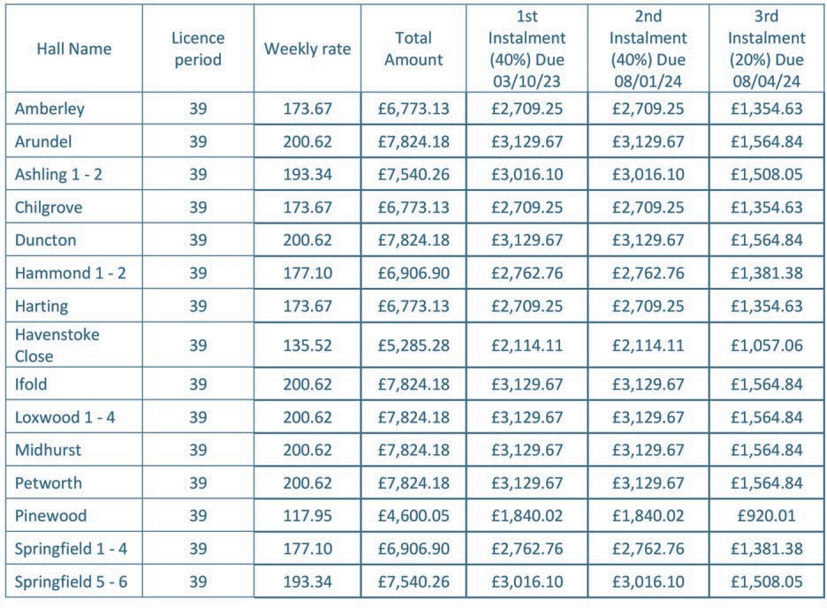
Bognor Regis Campus
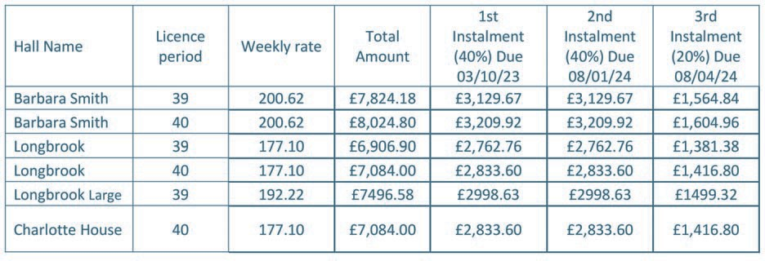

University Managed Properties
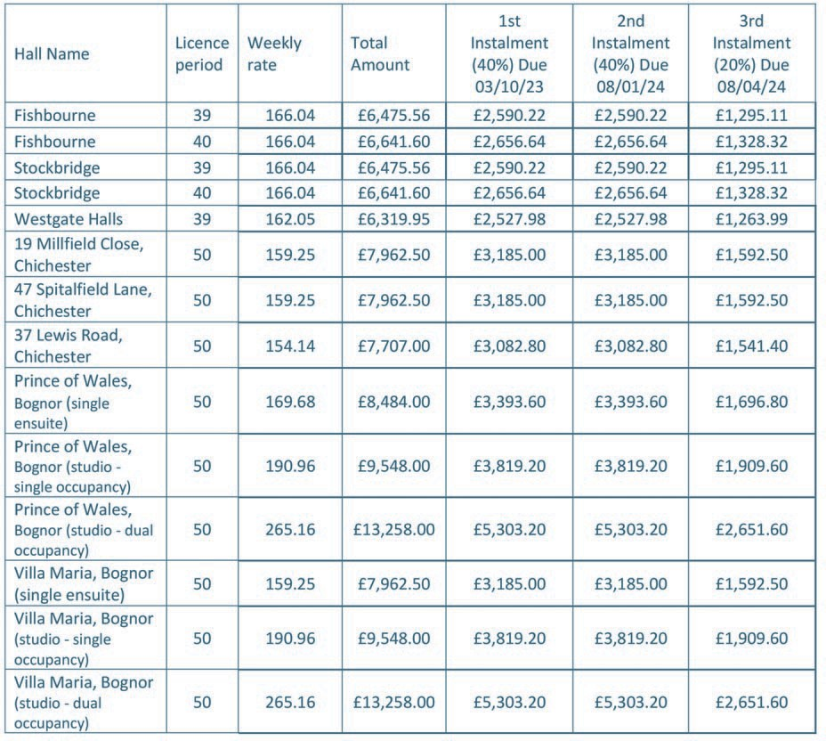
Contract Dates 2023/24
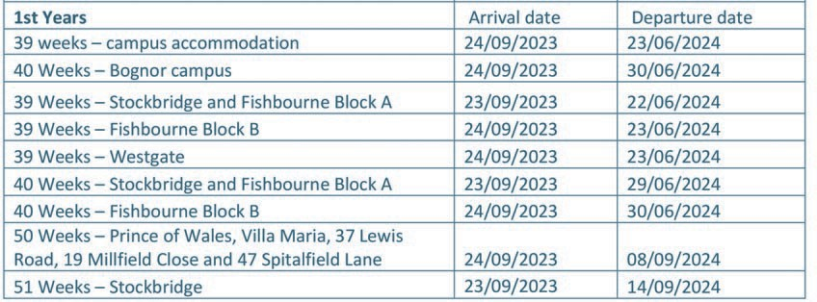
Damages will be billed as they occur and must be paid for within 28 days.
Heating is provided in Amberley, Chilgrove, Harting halls, the Barbara Smith Halls, and Longbrook House using pre-paid meter cards which are available from the Accommodation Ofce free of charge.
The instalments due do not represent a payment for an individual semester/term. The total amount due for accommodation is divided into three instalments: 40% for the frst instalment, 40% for the second instalment and 20% for the third instalment to coincide with the student loans company maintenance loan payment dates, for ease of student budgeting purposes only.
Any student wishing to arrive early will be sent an additional invoice for the period up until the instalment agreement commences. This invoice will need to be paid before arrival in order that access to the room can be authorised.

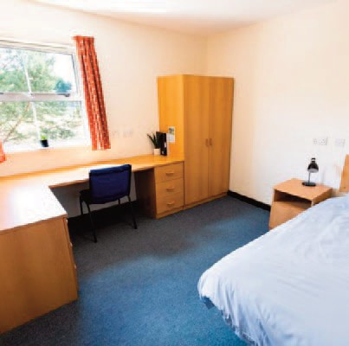
Residential Life
This section is set out alphabetically for ease of reference.

ABSENCE FROM RESIDENCE
If you intend to be away for a period of more than three days, during term time, please let the Accommodation Ofce know, giving details of where you may be contacted. It allows us to contact you if there is an emergency and it assists the staf to check the facilities in the event of an evacuation. Please note refunds of rent cannot be given for periods of absence.

ACCESS TO YOUR ROOM
You MUST allow access to your room by all authorised persons at the published times for inspection at reasonable times. There will be no exception to this rule. The University of Chichester reserves the right to gain access to your room at all times and to invite in external agencies if there is reasonable suspicion that your room may contain illegal substances or you are undertaking illegal activities in the premises.

ACCOMMODATION CHARGES
Payment for accommodation at the University of Chichester is required by the dates published in the Payment Instalment Agreement. If you are in debt at the end of the year external debt collectors will be employed to collect the outstanding monies. If you think you are going to have problems with your payments, seek help from the Money Advice Service based in Student Support Services.

ACCOMMODATION OFFICE
If you have any queries concerning your accommodation the Accommodation Ofce at the Bishop Otter Campus can be found at the bottom of the Amberley Halls of Residence, near the Chapel. The Accommodation Ofce at the Bognor Regis Campus can be found on the ground foor of Barbara Smith Halls, Block 9. The sites of Stockbridge Student Village, Fishbourne Road East Halls and Westgate Halls all have their own dedicated Accommodation Ofce Receptions. Every now and again information will be requested by the Accommodation Ofce e.g. dates you will be staying on campus over the Christmas and Easter holidays etc. It is important that any forms are completed and returned by the required date.

ANUK CODE OF STANDARDS FOR LARGER DEVELOPMENTS
The ANUK National Code is voluntary and was established for both educational establishments and private sector accommodation suppliers. University of Chichester has joined this code as part of their commitment to providing you with a frst-class housing service and facilities.

Those institutions that join the Code must provide students with information, reassurances and procedures that must be followed if a dispute occurs. The Code is fully supported by NUS (National Union of Students) who are a key stakeholder and have representation on the management and complaints procedures of the Code. The Code will act as a student accommodation quality guide. The advantages of living in a building covered by the Code are as follows:-
- Best practice regarding day-to-day accommodation management.
- Your contract is clearly written, stating what you are paying for and how much your rent is, with reasonable terms and no hidden costs.
- Your accommodation should be fully prepared for you when you arrive to take up residence.
- Your accommodation meets with a set of nationally recognised standards in respect of services, furniture and fttings.

- Repairs and maintenance are carried out within agreed timescales.
- The building meets with, and exceeds, related health and safety standards.
- You will be given information to explain what management routines are followed in the buildings.
- There is a set and accountable procedure for dealing with any disputes or complaints.

Full details about the National Code, a copy of the Code, its current membership and the complaints procedures, can be gained from www.anuk.org.uk or by telephoning the National Code Administrator on 0113 243 0169.

BALL GAMES
For health and safety reasons all ball games and similar pastimes are not allowed in halls of residence or on any of the open areas adjacent to the halls or in the communal areas. Playing feld areas should be used if you wish to play ball games or similar. Any damages resulting from unauthorised ball or other games will be charged accordingly.

BEDROOMS
Each room contains a bed, bedside table, desk lamp, wardrobe, desk, drawers, desk chair and curtains. You will be required to provide your own bedding unless you are an international student.

BICYCLES/SURF BOARDS/SIMILAR LARGE ITEMS
Bicycles must be left only in the designated cycle sheds or areas provided. Please ensure a high quality lock is used. You should take reasonable precautions to ensure the security of your cycle, which is brought onto campus entirely at your own risk. You are strongly recommended to insure your cycle. Under no circumstances may cycles be stored in halls since they may impede the evacuation of the building in the event of an emergency and such blockages are prohibited under fre regulations. Any cycles found inside halls will be removed immediately. All other large items should be in a location approved by the Accommodation Ofce staf. The Accommodation Ofce staf reserve the right to refuse to store an item on campus.

DAMAGE FEES
You are responsible for the proper care of the furnishings, fttings and equipment, as well as the decorative state of your room and, along with the others in your hall, for the communal areas. No alterations or repairs should be made to the fabric of the building. You will be asked to check an inventory of your room when you arrive and when you leave, which must be returned to the Accommodation Ofce within 48 hours of occupation. Damages will be billed as they occur. Please refer to the back page of this handbook for a list of charges. Invoiced damage (including extra cleaning) must be paid within 28 days.

BUS SERVICE
An inter campus bus service operates during term time between the two campuses. Inter campus buses are free, timetables on the webpages www.chi.ac.uk/about-us/how-to-fnd-us/#travel-by-bus and on the menu bar of Moodle.
For special events such as Freshers Week the SU arranges an extra bus service.

CARERS
If you have additional requirements and have a helper occupying a separate room, they are expected to adhere to the Licence Agreement and Code of Conduct, sign a residential agreement and make payment (at advertised rates) for the room in accordance with the Payment Instalment Agreement.

CAR PARKING
Havenstoke
Resident students may purchase an annual permit to park at Havenstoke Close. There are limited spaces available and these shall be allocated on a frst come, frst served basis. Contact the Accommodation Ofce for further details. Vehicles parked without the correct validation permit will receive a penalty charge. The cost for the 39 week parking contract is £275.73 (price correct at time of printing).
Stockbridge and Fishbourne Road East Halls
It is a strict condition of occupancy at Stockbridge and Fishbourne Road East Halls that students are prohibited from parking their cars onsite or within the local area. The planning conditions for both sites only allow the University to grant parking permits to those with a registered disability, or in the event of document medical reasons. The University is also able to allow students to park where they are granted permits due to their course requirements (placement students). Halls arrivals and departures will be allowed on site parking for no longer than is necessary.

CHRISTMAS AND EASTER VACATIONS
You are entitled to stay in your room, and/or leave your belongings, over Christmas and Easter if you so wish. The dining room, however, will be closed during these holidays. Please complete forms given out by the Accommodation Ofce staf before each period in order that the University may know who will be staying on campus during the holiday seasons.

CHRISTMAS DECORATIONS
Christmas decorations and other celebration paraphernalia are prohibited in all communal areas which are fre escape routes.

CLEANING OF YOUR ROOM AND COMMUNAL AREAS
Residents are responsible for keeping their bedroom, ensuite bathroom or communal bathrooms and other associated communal areas of their fat/foor clean, tidy and in a ft and livable state. The Housekeeper will be conducting regular bedroom and communal area inspections to ensure these areas meet the standard expected.
The inspection frequency will be published in each hall of residence.

Housekeepers will leave ‘fail notices’ for students whose communal areas/bedrooms fall below the standard expected. Should standards not improve within a specifed timeframe, Housekeepers may decide to charge for a force clean which will be carried out by our contractors. If a force clean occurs, the costs associated with this service will be passed onto the students who bear responsibility over the areas being cleaned.

Should an area be found in a grossly unacceptable state, where it is deemed to be hazardous to health, a force clean may be arranged immediately - again the costs associated with this will be passed onto the applicable residents.

Should bedrooms/communal areas be found in an unacceptable state on a regular basis then the Accommodation Disciplinary Procedures may be invoked. Further subsequent warnings may escalate the disciplinary process to a formal investigation whereby your academic Heads of School will be notifed.
If you are struggling to keep your areas clean and tidy please see your Housekeeper at the earliest opportunity to discuss the options available to you to ensure the upkeep of your accommodation.

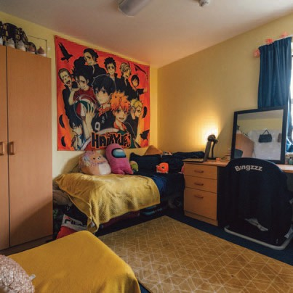
CHAPLAINCY
Our Chaplaincy ofers opportunities for students to explore faith, discuss life and fnd community. The Chaplain is based at Bishop Otter Campus but holds services and provides space for discussion and time for quiet refection on both campuses.

The Chaplain is here for all students: to listen to and support them, and to assist students of all faiths to locate places to worship and pray where they may feel most at home.

More details can be found by visiting the Chaplaincy web pages at: www.chi.ac.uk/chaplaincy or checkout the Facebook page: University of Chichester Chaplain and Twitter: @chiunichaplain"

CODE OF CONDUCT
The quality of life in our residential community is dependent on the members who live in it.Please help us to continue our tradition of being a caring community by caring about and for others in your hall. Inevitably, to assist in the smooth-running of a community there must be some rules which we ask you abide by. Full details of the Halls’ Code of Conduct can be found on the Accommodation Ofce website (www.chi.ac.uk/student-life/accommodation) but a brief summary of pertinent points are listed below:

- Members of University of Chichester are expected to conduct themselves at all times in a manner supportive of an academic community of an institution of higher education.
- Provide consideration for others in the Halls of Residence and University staf and agents.
- Noise should be kept to a minimum. Loud music and other noises which interfere with the well-being of others will not be supported. Particular care should be taken at night, when maintenance of an atmosphere conducive to sleep and late night study is essential. Excessive noise will not be tolerated between midnight and 7.00am.
- Communal areas must be maintained in a clean and ft state for their purpose. In particular kitchens and toilet facilities must be kept clean and tidy.
- Study/bedrooms must be kept clean and in a ft and habitable state by all students.
- Due attention should be given to the safety of other residents and oneself, particularly through the adherence to the Fire Regulations.
- Security precautions must be followed and doors to halls must be kept locked at all times. Entrance codes to residences and/or keys should not be given out to other parties.
Students in breach of the Code of Conduct risk invoking the Accommodation Disciplinary Procedure (available for viewing on www.chi.ac.uk/student-life/accommodation). In serious breaches of this Code and/or Residential Licence Agreement students risk termination of their licence agreement and may also, via the University’s Disciplinary Procedures, risk expulsion from the University.

COMPLAINTS
The University Accommodation Complaints Procedure can be found on the Accommodation Ofce website (www.chi.ac.uk/student-life/accommodation) and this process must be followed when making
a formal complaint.

CONFIDENTIALITY POLICY
The University of Chichester Accommodation Ofce is committed to providing a confdential advice service. All users of the service have the right to confdentiality to protect their interests. Assuring confdentiality is necessary to maintain the credibility of the service.

Whilst staf and agents of the University of Chichester have a duty of confdentiality under current data protection legislation this confdentiality is limited by the duty of care we have to our students and staf. The duty of care takes precedence where there are serious concerns about the individual’s mental or physical health or for the safety of others exposed to serious risks from that person.

Subject to what follows, no information regarding a student shall
be given directly or indirectly to a third party who is not a member of Accommodation Ofce staf or agent, without that client's expressed consent. No information will be given to any external agency without the client's express consent unless the provision of such information is required by law. The Director of Estate and Facilities Management may, however, decide that information should be disclosed without the client's consent if, in their judgment, there is a risk of immediate physical danger to the student or others.

The University of Chichester recognises that information may need to be shared when Accommodation Ofce staf discuss cases. Staf are expected to ensure that such discussions take place in an appropriate environment - and not normally outside the University, except when seeking additional advice from an external advisor.

It is the responsibility of the Accommodation Ofce staf to ensure that all statistical records given to third parties are produced in an anonymous form, so that individuals cannot be recognised.

It is the responsibility of the Accommodation Ofce staf to ensure that all individual case records are locked securely at the end of each working day. This includes note-books, copies of correspondence and any other sources of information. It is also their responsibility to ensure that all computer records are held secure and are appropriately protected.

If Accommodation Ofce staf wish to correspond with clients, they are responsible for confrming that it is acceptable to call or write to them at home in relation to their case. All staf must ensure they make no reference to the purpose of their call when making telephone contact through third parties. All details of expressed consent must be recorded on fle.

COOKING
You will need to bring crockery, cutlery and any cooking utensils, pans etc you would like to use. All kitchens have microwaves, hobs, ovens, fridges, freezers, toasters and kettles. Please ensure at all times, whilst cooking, that no item is left unattended. The fre alarm systems are directly linked to the Fire Service, who will attend. False alarms may lead to a cost being charged to the block or person involved. Help us to reduce false alarms.

COUNSELLING
There are times in life when it’s easier to talk to someone outside your friends and family about issues that are bothering you. The UTalk Counselling Service ofers you the opportunity to talk through your personal problems and difculties with a qualifed and Registered Counsellor for an average of six sessions. The counsellor will listen to you, be non-judgemental, respect your views and help you fnd your own answers and plan a way forward. To book a counselling assessment please contact the SIZ desk and ask for a UTalk assessment or email UTalk@chi.ac.uk."

DAMAGE TO YOUR ROOM AND OR COMMUNAL AREAS
Should there be any damage to your room you will be charged for repairs, unless someone else admits responsibility and is willing to pay. All residents in a hall are deemed to be collectively responsible for any damage to communal areas. It is in your interest to prevent other residents or visitors from causing any damage. Accounts for any damage must be paid to the Accommodation Ofce within 28 days of invoice; otherwise a student risks the licence agreement being terminated. Any damages found in communal areas will be invoiced to all residents who bear joint responsibility for the area concerned. It is the residents responsibility to provide the Accommodation Ofce with the name(s) of persons responsible for the damage.

DAMP, CONDENSATION, AND MOULD
A common problem in student accommodation is condensation and mould. Condensation is caused by normal everyday moisture producing activities such as cooking, showering, drying clothes, and even just breathing! If this excess moisture is not properly ventilated, it can lead to mould and mildew growing in the coldest parts of a property or a room (in window voids, behind furniture, etc.).
Tips for reducing moisture in halls:

Heating
Do not place wet clothes over heaters, this will stop heat circulating in your bedroom and place excess moisture in the air.

Drying Clothes
It’s always best to dry clothes in well ventilated rooms. Clothes airers should be placed ensuites or bathrooms – close the door and make sure the extractor fan is turned on to remove the excess moisture.

Ventilation
Letting fresh air to fow through your bedroom is good for lots of diferent reasons, including your own health, comfort, wellbeing, and also to help reduce the likelihood of experiencing condensation and mould.

It’s key to purge the air in your bedroom twice a day, you do this by opening your window as wide as possible in the morning when you wake up and in the evenings. The window doesn't need to stay open all day long, just long enough to allow a changeover of air (15-20 minutes will do). It’s also good to open your curtains regularly to let natural light in and to allow greater airfow around your bedroom, particularly when your window is open.

Condensation
If you wake up in the mornings to condensation on your window, wipe it down with a cloth and wring the cloth out down a sink.

When having a bath or shower, ensure the extractor fan is on so the steam created can be removed from the building – this will greatly reduce any build-up of condensation within the bathroom/ensuite. Extractor fans should run for up to 30 minutes after you have turned the light of - please do not use the isolator switch to turn the fan of because this will likely lead to growth of mould and mildew.

When cooking, ensure you have the kitchen extractor fan/cooker hood switched on – also, try to keep lids on pans as much as possible to keep the moisture produced from cooking within the pan.

Mould
Mould grows in rooms/areas where there is prolonged exposure to excess moisture connected to poor ventilation or high moisture producing activities (or both). Inadequate heating could also play a factor in mould growth. Mould grows from mould spores which are naturally present in the air both indoors and outdoors.
Mould requires oxygen, a food source and moisture to grow. In terms of food sources, and apart from the obvious human food that you might expect to see mould grow on, mould can also thrive on substances such as wood and paper products to dust containing dead skin cells, it will also grow on some synthetic materials like paints, adhesives, and textiles as well which is why you will see mould grow on walls and windows.

DENTISTS
It is extremely difcult to locate an NHS dentist in this area so we strongly recommend you remain registered with your dentist at home.

DISABILITY AND DYSLEXIA ADVICE AND SUPPORT
The Disability and Dyslexia Service provides a range of support services to students with disabilities, continuing health conditions, specifc learning difculties and any additional needs that require support or adjustment in teaching, learning and exams.

The team also includes a Sensory Adviser who assists students with vision and/or hearing impairments to access course materials in alternative formats and to make the most of assistive technology.

Our Dyslexia Advisers are able to assist with assessing and arranging appropriate support for students with a range of specifc learning difculties including dyslexia, dyspraxia and dysgraphia. Even if you have previously not been assessed as having had difculties it is not too late to recognise the issue and deal with it now. The service can also advise the Accommodation Ofce if applicants require prioritisation for particular types of accommodation because of their disability or medical condition. Applicants requesting special, prioritised or adapted accommodation on campus because of a disability or medical condition must contact this service to discuss their needs as early as possible in the application process, and by 30th April in the year of application.

Students who feel their condition means they will need to live on campus after their frst year must contact the Disability Team by 30th April in their frst year, who will explain the applications process. You can book an appointment with an advisor through the SIZ desk in the Learning Resource Centre on either campus, or by ringing 01243 816222. You can also e-mail the service direct through disability@chi.ac.uk. For more information see the webpages: www.chi.ac.uk/disabilityservice

DISCIPLINARY PROCEDURE
If students do not adhere to the Code of Conduct, or contravene the Licence Agreement, they may be asked to meet with a member of the Accommodation Team and following this, written warnings may be issued.
The frst of the two stages of the disciplinary process are informal. Thereafter, the matter will be escalated to the Accommodation Manager (or nominee in their absence). Where serious misconduct is suspected then matters may be escalated or go directly to the Head of Campus and Residential Services for consideration and may result in you being required to leave your accommodation. For further details on the disciplinary procedures please visit our website at: www.chi.ac.uk/student-life/accommodation

DOCTORS
We strongly recommend that all students register with a GP local to the University Campus; it will still be possible for you to see your ‘home’ GP during holidays as a temporary patient. The nurse health advisers will help you through the registration process.
We maintain close links with three local surgeries:

Lavant Road Surgery – within walking distance of Bishop Otter Campus and Havenstoke Halls of Residence. They also have an on-site Pharmacy. www.lavantsurgery.co.uk; 01243 527264.

Cathedral Medical Practice is also within walking distance of Bishop Otter Campus, and within walking distance of University–managed accommodation at Stockbridge Halls and Fishbourne Road East Halls. www.cathedralmedicalgroup.nhs.uk; 01234 813450.
Maywood Surgery is within walking distance of Bognor Regis Campus.
cwsccg.maywood-surgery@nhs.net 01243 829141.

ELECTRICAL APPARATUS AND PORTABLE APPLIANCE TESTING
Residents are responsible for ensuring that any equipment they bring to the University is electrically safe and suitable for UK electrical systems.Electrical equipment must not overload the University’s electrical supply. Individual electrical items shall not be rated above 1kw.

One CE approved fused multi-adaptor (rated at 10 amp with a maximum four ways) for use with low wattage equipment only, such as PC and printer is permitted in each room. All plugs and adaptor must comply with BS1363.

Non UK equipment and associated Non-UK to UK adaptors may not be used unless they have been inspected and approved by the University. Contact the Accommodation Ofce to arrange a portable appliance test. If you are in any doubt about the suitability of your electrical appliances contact the Accommodation Ofce. The University will undertake an electrical test for all appliances, if deemed necessary. Arrangements for items to be tested must be made on the day of arrival. Electrical items belonging to students which are placing an excessive load on the electrical system, or which, in our view are unsafe or unft for use will be removed and stored until the end of year. Power supplied is 240v and 3 pin plugs must
be utilised.
Items that should not be brought onto the University include:
- Cubed adapters
- Rice cookers
- Items requiring a continental electrical adapter in order to work.
- Individual fridges/coolers
- Electrical room heaters
- Electric blankets
- Deep fat fryers
- Grills and sandwich makers
- 3D Printers
- Crypto-currency mining equipment (or any other equipment which is specifcally use for, or used to support, this activity)
- Any Personal Transportation Device which requires the charging of a lithum-ion battery

(Past experience dictates that deep fat fryers and grills/sandwich makers are inherently dangerous due to a combination of an accumulation of fat, poor washing up practices and late night high spirited food binges). If you have a query regarding a piece of electrical equipment that you are not sure whether it needs testing, please email healthandsafety@chi.ac.uk.

EMERGENCY ACTION IN THE EVENT OF A FIRE
On discovering a fre:
- Operate the nearest fre alarm ‘break glass’ which will result in the fre services automatically being called.

- Contact the University emergency number on extension 6363 (both campuses). They will direct the fre services vehicles.

- Do not attempt to tackle the fre unless you have been trained to do so - and then without putting your personal safety at risk.

- Evacuate the building by the nearest signed exit and assemble at the point which is indicated on the building emergency procedures.

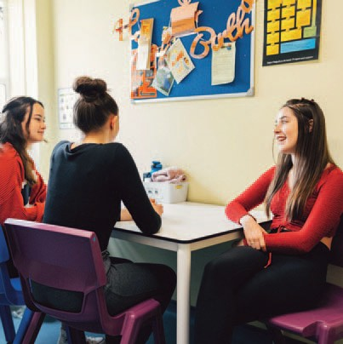
On hearing the fre alarm:
- Evacuate the building by the nearest available signed exit route.

- Assemble at the point which is indicated on the building emergency procedures.

- You must leave when requested, even at a practice – it is a disciplinary matter if you refuse.
DO NOT:
STOP IN THE BUILDING TO COLLECT PERSONAL POSSESSIONS OR
RE-ENTER THE BUILDING UNTIL THE FIRE SERVICE HAS GIVEN PERMISSION

EMERGENCY ACTION IN THE EVENT OF A MEDICAL INCIDENT
If you discover a situation in ofce hours where frst aid or emergency medical treatment is necessary call the University emergency number 01243 816363 for a First Aider.

Out of hours urgent medical treatment can be dealt with by telephoning the NHS 111 service or follow the emergency medical procedure fow chart that can be found on all notice boards in each Hall of Residence. The Campus Wardens can be contacted by internal telephone.

If an ambulance is needed, dial 999 (9-999 on an internal phone) and ask for Ambulance Service and contact the University emergency number 01243 816363 immediately after the ambulance has been called so that the ambulance can be directed to the correct location.

St. Richard’s Hospital Accident and Emergency Department is open 24 hours a day; the Bognor War Memorial Hospital Minor Injuries Unit is open Monday to Friday 9.00am – 5.00pm.

An accident on campus must be reported to the Health and Safety Ofcer on Extension 6488 as soon as is practicable.

24 HOURS SUPPORT AND ASSISTANCE
All residents living at our main accommodation sites can access 24 hours support and assistance provided by a range of teams such as the Accommodation Ofce, Security, Staf Wardens and Duty Managers. Each site has its own 24hr contact number which will divert to the relevant staf when on duty.

You can call for assistance for anything, whether it’s because you’ve locked yourself out of your room, for a noise complaint, an urgent repair such as no heating/hot water or electricity, for medical assistance, or if you’re mental health or wellbeing is not at its best. Regardless of the reason why you are calling, our trained and experienced staf will be more than happy to assist you. Please call the following number(s) for your site if assistance or support is required:

Bishop Otter Campus (including Havenstoke and Pinewood) – 01243 793477 Stockbridge Student Village – 01243 533356 / 07824-349-543
Fishbourne Road East Halls – 01243 790279 / 07791-692-966
Westgate Halls – 01243 812931 / 07795257068
Bognor Regis Campus – 01243 793488
Chichester HMOs (Spitalfeld Ln, Millfeld Cl, Lewis Rd) – 01243 793477 Bognor HMOs (Prince of Wales, Villa Maria) – 01243 793488

END OF CONTRACT
You are expected to vacate your room by 12.00pm (midday) on the day shown in your Residential Licence Agreement. If you stay after this time, just like a hotel, an additional charge will be made. If you wish to stay beyond the date shown on your residential licence, please speak to the Accommodation Ofce who may be able to extend your booking. Rooms are used for conferences during the summer months so it may not be possible to grant your wish.

When leaving your room to go on summer vacation, please start clearing at least a week before you leave to help the domestic cleaners, who otherwise have an almost impossible task of throwing away tons of rubbish. Last year the University sent 850 tonnes of rubbish to landfll, which is equivalent to 850 minis. It is your duty to help recycle as much as possible.

Please clear all pin boards of posters and clean out cupboards and wardrobes i.e. remove all personal possessions. If rooms and the communal areas are left in an unacceptable state requiring additional cleaning you will be charged for this. It is the student’s responsibility to clean, ovens, microwaves, hobs and fridge/freezers if any of these are left in an unacceptable state you will be charged for this.

You will be expected to agree to a departure appointment to allow the proper processing of paperwork and checking of your inventory. Details of how to book the appointment will be released towards the end of your contracted licence period. Please follow all guidance issued regarding departure.

ENVIRONMENTAL POLICY
The University is fully committed to reducing the impact it has on the environment. This means that we try to be careful about the way we use valuable resources, encouraging recycling and keeping waste to a minimum. Both campuses have recycling centres and we also provide recycling facilities in all halls of residence to enable students to recycle paper, cans, glass, cardboard and packaging.
Help the University to continue to reduce our carbon footprint by:
- Switching of lights when they are not in use
- Turn of the heating before opening the window
- Not leaving electrical equipment on over night

We are continuously trying to improve our environmental performance and if you have any suggestions or comments that could help us then please do contact the environmental team. Further information about the University’s environmental goals and activities can be found on Moodle/Campus Facilities/Environment and Sustainability.

FEES
If you have any queries about the payment of your accommodation fees please speak to our Finance Department on ext 6108 or 6429. Fees are to be paid online. Failure to pay fees in a timely fashion could lead to eviction processes being invoked. If you are in unexpected fnancial crisis contact the Student Money Advice Service: studentmoney@chi.ac.uk

FIRE DOORS
The doors to your bedroom, kitchen, and fats (where applicable) are fre doors and must be kept closed. They are ftted with metal door-closing mechanisms at the top to make sure that they close and prevent the spread of fre and smoke.

There are some kitchen doors and some corridor fre doors which are designed to stay open until the fre alarms are activated, at which point these doors will close. Therefore, it is important that these areas are kept clear of any items which may hinder the closing of these doors.

Propping open a fre door, or preventing the closure of fre door which is on a 'hold-open' system is a disciplinary ofence.

FIRE PRECAUTIONS
You are expected to comply with fre precautions at all times and should familiarise yourself with fre alarm break glass switches, emergency routes and the location of fre fghting equipment in the hall. Fire practices are held at regular intervals; willful failure to participate in these practices is viewed as a serious matter and treated as misconduct. The removal of, or tampering with, the fre fghting equipment, fre/smoke detection installations, or the misuse of any other devices installed to provide protection against fre are criminal ofences under the Regulatory Reform (Fire Safety) Order 2005.
Particular care is necessary in residences:
- Corridors, staircases and other open areas must NOT be obstructed by furniture or other items, such as bicycles.
These will be removed and persistent breaches may result in disciplinary actions being invoked.
- Fire doors must NOT be wedged open or a fne may be issued.
- As the heat and smoke sensors are sensitive, they are easily triggered. For this reason cookers and grills must NOT be left unattended, kitchen doors must be kept shut at all times and candles/joss sticks must not be used in halls. Even accidental initiation of an alarm requires the building to be evacuated and the Fire Service called. The costs incurred in handling careless or malicious false alarms will be charged to the person(s) responsible.

FURNISHINGS AND FITTINGS IN YOUR ROOM
Since your room has been furnished for a specifc purpose, you are not allowed to bring additional items of furniture onto campus. You are responsible for laundering your own bed linen, towels, tea towels, and your personal clothing.

HEALTH AND SAFETY
In the interest of your own and other students’ safety you are not allowed to burn candles or joss sticks or store any fammable liquids such as kerosene, lighter fuel, petrol, BBQ lighting fuid, methylated spirit, parafn etc in the student residences. (This is not an exhaustive list and refers to any substance with fammable properties.) For this reason we insist that aerosol products are kept to a minimum and away from heat sources. Please note that storage of ofensive weapons/objects that can endanger a persons health and safety will not be permitted. If found, these items will be held until the end of the licence agreement.

HEATING
Please note the information below only relates to those residences where central heating is present in the block (rather than room specifc heating). Please see published information by the Estate Management Department regarding the dates when the central heating is in operation.
Central heating times throughout residences and the target temperature for each period.

Heating times (Weekdays) | Temp | Heating times (Weekends) | Temp
6.30am – 10.00am | 20 deg | 6.30am – 10.00pm | 20 deg
10.00am – 4.00pm | 16 deg *
4.00pm – 10.00pm | 20 deg
10.00pm – 6.30am | 13 deg *

Times and temperature set points must NOT be altered. Any evidence of alteration will lead to an investigation and could lead to disciplinary action being invoked if a student is found guilty of tampering with University property.

The heating season shall normally operate between 1st October and 1st May (inclusive). During exceptional weather conditions these dates may be varied. Residents will be notifed of any changes to the heating period.

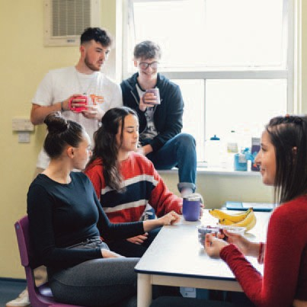
HOMESICKNESS
Many students sufer from homesickness at some point when at University. For the majority of students this passes very quickly when they make new friends and ‘fnd their feet’ on their course. It is important to remember that studying at University is not a period of isolation. Living in halls often teaches students how to live away from home for the frst time. You may learn much more than you had originally thought you would!
You will discover how to manage your money and laundry, whilst interacting with a community of people from a variety of backgrounds.

It is important to remember that everyone is in the same situation and however daunting it may seem, in a few short weeks after arrival you will have made friends with people who may be in your life for longer than the duration of your course.
If you are struggling with being away from family and friends please talk to someone, for example your friends within your Halls, study circle or staf from the Accommodation Ofce. Please allow yourself time to put down roots at University. If you do need more support, ask the Support and Information Zone about Wellbeing Pop-ups or email the Student Wellbeing Adviser Team on AdviseU@chi.ac.uk.

INCIDENTS
Accidents and incidents that occur in University owned or managed accommodation must be reported to the Accommodation Ofce as soon as possible, and an incident report completed by those involved. Contact Security if out of ofce hours.

INSPECTION OF ROOMS
Regular routine inspections of halls and rooms will take place for health and safety purposes and to ensure that the terms and conditions of the licence are adhered to. Adequate notice of the inspection will be given by the Accommodation Ofce via email. Any information or guidance that is required to imparted to students following an inspection will likely be given via ofcial notices left in the appropriate areas, a follow up email may also be sent for recurring issues. Inspection notices will be posted on notice boards to highlight when rooms will be entered.

It is your responsibility to clean your bedroom at least once every week. Housekeepers will inspect your room and if it fails to meet the required standards you will be issued with a Cleaning Warning. If you receive 3 Cleaning Warnings in a Semester you will also receive a Formal Disciplinary. In the event that your room is consistently not to standard the Housekeeper will instruct the Cleaning Contractor to clean the room and you will be charged for this work. The Housekeeper may charge for every time they have to revisit.
Housekeepers will inspect the following items-:
- Your carpet should be vacuumed and clear of belongings to allow Housekeepers to view it.
- Surfaces should be tidied and dusted.
- Rubbish should be in your bin – which can be emptied into the kitchen bin or placed in the bins provided in the main waste and recycling compound for your site.
- Recycling should not be stored in your room – please ensure this is placed in the appropriate bins in your kitchen.
- En-suites should be cleaned using an appropriate product – shower cubicles should be free from lime scale and soap residue and sinks and WC’s should be clean and free of stains and marks. The foor should be clean and washed regularly.

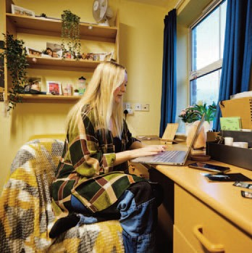
INSURANCE
A block contents policy has been arranged for all resident students. It is a condition of residence that you subscribe to this policy. The cost is included in your accommodation charge. Please note that if your bedroom door is left unlocked, even if you are in the bathroom or kitchen, and something is taken, any claim will be invalid. You must activate the above insurance by following the publications given to you on arrivals day. You can upgrade the policy to cover high risk/expensive items such as laptops and mobile phones at an extra charge which is paid direct to the Insurance Company.

INTERNET CONNECTION
Internet services for halls of residence at the Bishop Otter Campus,
Bognor Regis Campus, Stockbridge, Fishbourne and Westage, are
provided by Glide Student. The service provision includes wired and WiFi connectivity.

If you feel your internet connection is slow or faulty, please ensure you test your connection speeds using online speed checkers such as http://www.speedtest.net a few times before making a report. Those on the Glide service can download the Glide app to report connection issues directly. You can also contact Glide direct by sending an email to glide@glide.uk.com or calling their helpdesk on 0333 666 5555.

Students living in University Managed HMOs will have their internet service provided by diferent service providers (BT, Virgin Media, etc). Should there be any issues with your internet service, please follow your standard maintenance reporting procedures to report the fault service.

KEYS
Keys for the entrance doors and your own room are issued on your arrival. Keys must be returned when you leave, following your Inventory Check. They should not be handed into the Accommodation Ofce without having had the bedroom and associated communal areas checked, unless previously arranged with an appropriate member of staf of Accommodation Ofce. If you lose or damage a key you will be charged the full cost of a replacement key and lock (£125). (The replacement charge for key cards is £5.) Keep your room door and hall doors locked for security. Keys should not be copied and nor can they be passed onto third Parties for use.

KITCHENS
All residents have access to a kitchen, either shared between others in your fat or on your foor, or within your own bedroom as studio accommodation. For those with shared kitchens, please note that it is a joint responsibility of all students to keep kitchens clean and tidy for others to use. If kitchens are persistently found in an unacceptable state, the University may enact a 'forced clean' and charge all applicable residents for the service. The responsible students also risk invoking the Accommodation Disciplinary Procedures.

Please avoid using the kitchens to prepare food at unsociable hours, for example the early hours of the morning, unless necessary on religious grounds. Cooking should never be left unattended and use of extractor fans/cooker hoods is required at all times.

Students are required to utilise the recycling bins and participate fully with the University’s Environmental Policy. Further information on what is provided in each kitchen can be found on the University website at: www.chi.ac.uk/student-life/accommodation

LAUNDERETTES
Launderettes are located:-
- at the side of the Chilgrove Halls of Residence, Bishop Otter Campus.
- in Havenstoke Close, adjacent to the Bishop Otter Campus.
- behind Block 9, Barbara Smith Halls, Bognor Regis Campus.
- at both Stockbridge and Fishbourne Road East Halls

The machines at BOC, BRC and Stockbridge are operated via the relevant app that can be downloaded; Fishbourne and Westgate machines are coin operated. Any problems connected with the machines or any damage should be reported to telephone extension 3477 or 3488. Please note that University of Chichester cannot be held responsible for damage caused to washing while using the laundry facilities. Students are responsible for laundering of all personal items.

LINEN AND BEDDING
If you are an international student you can request to be provided with bedding (duvet and sheets) and towels. Please be aware that you are responsible for keeping the items clean. We recommend you wash these on a weekly basis to keep them in good condition. You will be charged for any bedding or towels that have been stained or damaged.

LOCK-OUTS
If you lock yourself out of your accommodation you will need to go to the Accommodation Ofce during ofce hours so they can identify you by checking your records before letting you in. There will be a £5 charge for every lockout, following your third request to be let back into your room, as an administration charge.
After ofce hours please use the advertised number for lockouts which can be found on the notice board in your Hall of Residence.

MAIL
Your incoming mail is distributed from your local Accommodation Ofce Reception (with the exception of the Havenstoke Houses, Pinewood and University managed HMOs in Bognor and Chichester).

Mail is managed following approved procedures. All parcels and registered packages are to be signed for by the students. Students are asked to collect credit cards and cheque books from their banks and not ask for them to be sent to the campus. You may post items for internal staf at the Accommodation Ofce reception.

There is a post box for external mail at the main University Receptions, which is emptied by the Post Ofce each weekday evening. Mail can be sent directly to Pinewood, Havenstoke, Westgate Halls, Stockbridge Student Village, Fishbourne Road East Halls, and the University managed HMOs within Bognor and Chichester. The postal addresses for all accommodation is listed below:

BISHOP OTTER CAMPUS
Room number, block, University of Chichester, College Lane, Chichester, West Sussex, PO19 6PE

HAVENSTOKE
Room Number, House Number, Havenstoke Close, Chichester, West Sussex. PO19 6RR

PINEWOOD HOUSE
Room Number, Pinewood House, Pinewood Close, Chichester, West Sussex. PO19 6YS

FISHBOURNE ROAD EAST HALLS
Room Number, Fishbourne Road East Halls, Fishbourne Road East, Chichester, West Sussex. PO19 3FH

STOCKBRIDGE HALLS
Stockbridge Road, Chichester, West Sussex. PO19 8FG

LEWIS ROAD
37 Lewis Road, Chichester, West Sussex. PO19 7LZ

MILLFIELD CLOSE
19 Millfeld Close, Chichester, West Sussex. PO19 6UR

SPITALFIELD LANE
47 Spitalfeld Lane, Chichester, West Sussex. PO19 6SG

WESTGATE HALLS
Westgate Fields, Chichester, PO19 1SB

BOGNOR REGIS CAMPUS
Room Number, Block, University of Chichester, Upper Bognor Road, Bognor Regis, West Sussex, PO21 1HR

PRINCE OF WALES
Studio/Apartment Number, 1 Highfeld Road, Bognor Regis, West Sussex, PO22 8BQ

VILLA MARIA
Studio/Apartment Number, Villa Maria, Campbell Road, Bognor Regis, West Sussex. PO21 1NW

After you leave University-owned accommodation it is your responsibility to ensure you have let the relevant companies and individuals know your new address details. Students' post can be collected at the published times from the Accommodation Ofces on the Chichester and Bognor campuses and from the Reception areas at Stockbridge and Fishbourne Road East Halls.

MEALS FOR RESIDENTS STAYING IN CATERED ACCOMMODATION
Resident students staying in catered accommodation are provided will receive a daily allowance which can be spent in the Restaurants at either campus. This allowance is loaded on to catered students’ campus cards each day, however any amount not used will expire at the end of each day.

Please note that some items, such as confectionery, cannot be purchased using the daily allowance, however you can pay for additional items not covered under the allowance. Students living in self-catered accommodation can purchase a catering package if they wish.

If you lose your student card you must go to the Support & Information Zone (SIZ) immediately to arrange a replacement card, any lost or damaged cards will cost up to £20 to replace. Please keep in mind the importance of replacing your card as soon as possible as you will be charged for meals without one.

You MUST NOT take cutlery and crockery from the dining room. If you do it will be viewed as theft and you will be subject to disciplinary procedures. Please ensure your dress is appropriate when eating in the dining hall – no pyjamas permitted, and shoes must always be worn.

If you have any specifc dietary requirements, suggestions or problems regarding your meals or service please speak with the Catering Manager at either campus.
Examination and Assessment Weeks
During the main examination and assessments weeks for Semester 1 and Semester 2, catered residents will receive the normal catering allowance.
Student Directed Study Weeks/Reading Weeks
Student Directed Study Weeks are weeks when there is no scheduled teaching. These weeks are also referred to as Reading Weeks. During these times, catered residents will only receive the brunch allowance for each day during that week. Service times may be subject to alteration – which will be advertised in advance.

Inter-Semester Weeks
Inter-semester weeks, including Wellbeing/Employability weeks, operate the same as Reading Weeks – see above.
Christmas and Easter Vacations
There is no catering provided during the Christmas and Easter breaks, this is factored into the annual cost of your accommodation fees.
Claims for meals not taken
Rebates for any missed meals can only be given in very exceptional circumstances (for example when a student is absent on medical or compassionate grounds, not due to study commitments). In these circumstances a student should apply in writing, in advance where possible, to the Accommodation Ofce.
Placement Students
Student who go on placement, primarily Teaching students based at Bognor, should speak with the catering staf as to what ofers are available to them to ensure that they can still access their catering entitlement despite being of-campus for the majority of the day.
Food Allergies
If you sufer from a food allergy it is important that you contact the catering manager on campus within your frst week on site.
Feedback
There will be times during the year when you may wish to make comments/suggestions about your catering service. Questionnaires will be issued periodically and Comments Boards are available in the Dining Rooms where we welcome constructive feedback.
Vending Machines
Vending machines, with all-day access are provided in the Sports Activity Research Centre (SARC), in The ShowRoom foyer at Bishop Otter Campus and in The Dome entrance at the Bognor Regis Campus.
Contact Details
General Manager – BOC/BRC: Extension 6210 Catering Manager Bishop Otter Campus: Extension 6072 Catering Manager Bognor Regis Campus: Extension 2074

MEDICATION
If, for medical reasons, you require a personal fridge to store medicine, please contact the Accommodation Ofce by 1 August on extension 3477 or 3488 who will be able to arrange this for you. It is the student’s responsibility to ensure that any needles are disposed of correctly in sharps boxes. These are available from your own personal doctor.

MENINGITIS, MEASLES AND MUMPS
Meningitis, measles and mumps and are serious infectious illnesses that can spread easily when groups of people are gathered together such as at university, so it is important that you are fully protected before you start your studies.

We highly recommend that, if you haven’t already done so, you go to your doctor and get the new ‘Men ACWY’ vaccine (which ofers protection against the new ‘Meningitis W’ strain as well as the other three groups of meningococcal bacteria A, C and Y) and check your MMR vaccination status.
We do also strongly advise that you get the recommended two MMR (mumps, measles and rubella) vaccinations if you have not previously been immunised. (You can also get these vaccinations when you register at a GP surgery local to the University).

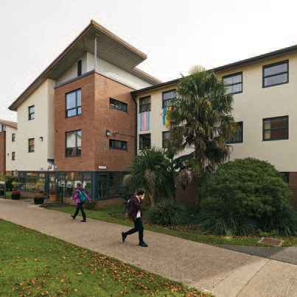
Meningitis
Meningitis and meningococcal septicaemia (blood poisoning) are serious diseases that can strike rapidly with little warning and if left untreated could be fatal. Outbreaks of meningitis tend to occur where people live or work closely together, such as university, living in halls of residence, living in shared student accommodation.

Meningitis is an infection of the meninges (the protective membranes that surround the brain and spinal cord). The infection can be caused by bacteria or a virus, and it leads to the meninges becoming infamed. This can damage the nerves and brain.

Early treatment of meningitis is essential to save lives, so it is important to KNOW THE SIGNS AND SYMPTOMS!

The following are common symptoms and signs of Meningitis and Septicaemia (blood poisoning) however, remember that NOT EVERYONE getsALL these symptoms:
- Fever/High temperature (with cold hands and feet)
- Vomiting
- Headache
- Stif neck
- Dislike of bright lights
- Joint or muscle aches and pains
- Drowsy, difcult to wake
- Confusion
- Septicaemia signs = stomach cramp, diarrhoea, rash

The rash that shows Septicaemia (blood poisoning) will not fade under pressure - use the GLASS test: push a glass on to the rash and if it does not disappear under pressure it is a Meningococcal Septicaemia rash.

Early signs and symptoms can be confused with fu or a bad hangover. Trust your instincts - get medical help immediately, dial 999, this could be a medical EMERGENCY!
For more information on meningitis please see the Meningitis Now website
https://www.meningitisnow.org/

MENTAL HEALTH
UinMind is our mental health advice and support service supporting students with diagnosed mental health conditions as well as those experiencing problems such as stress, low mood, anxiety and difculty coping. They work to equip students with the tools necessary to cope with the emotional demands of University life and as such run skills training interventions for students who wish to develop skills to deal with their mental health. Look out for the MOODft and CALM emails.

If you have not accessed the UinMind service before you should attend a Wellbeing pop-up session in the frst instance. These run throughout the week in the LRC on both campuses when students can come down and meet 1:1 with a wellbeing adviser without needing an appointment. The timetable is available from the Support and Information Zone and can also be found on the University help pages: https://help.chi.ac.uk/wellbeing- pop-ups. This is a chance to talk about your mental wellbeing and to think about what support might be most helpful. If necessary, the wellbeing adviser can book you in for a further session with a member of the UinMind team where your needs can be discussed further.

MENTAL HEALTH CRISIS
When someone’s mental or emotional state deteriorates quickly and this places them or someone else at risk, this is often called a mental health crisis. In this situation it is important to get help quickly from an appropriate service. You can:-
- Make an emergency appointment with your GP
- Go to your nearest Accident and Emergency department (locally St. Richards Hospital, Chichester 01243 788122)
- Out of Hours: Call the NHS Sussex Mental Healthline: 0300 5000 101.
- If you feel someone is an immediate danger to themselves or others call for an ambulance and/or the police on 999.

Please also get in touch with UinMind as soon as possible UinMind@chi.ac.uk so they can support you – we cannot provide out of hours or crisis support so do not delay accessing urgent help.

MISCONDUCT
Students may be subject to the University of Chichester Accommodation Disciplinary Procedures for conduct incompatible with the Licence Agreement. Misuse of fre protection systems, persistent noise, petty theft (e.g. of food/milk), unsatisfactory care of rooms, unauthorised overnight guests, disrespect shown to Wardens and University Staf are all instances of unacceptable social behaviour. Drunkenness and disorderly behaviour, together with any acts of vandalism are not tolerated at University of Chichester. Any student held responsible for misconduct will be subject to the disciplinary procedure and invoiced, where damage has occurred. For very serious cases of misconduct a student may be suspended from their University owned/ managed accommodation. Misconduct concerned with theft, weapons or the possession, use and/or supply of drugs automatically become matters where we notify the police, we may also conduct an immediate search of your bedroom and associated communal areas and handover any evidence found to the appropriate authorities. Please see the Disciplinary Procedures on the Accommodation website for further information: www.chi.ac.uk/student-life/accommodation.

MOVING ROOMS
If you wish to move rooms, this may be possible, but there will be an administration charge of £50, which will require immediate payment. (Please see charges grid on the back of this Handbook.) In exceptional circumstances the University reserves the right to ask students to move rooms and possibly even share a room. However, this will be avoided if at all possible and if asked to do so the student will be provided the room at the lower rental charge. Failure to comply with this direction could lead to termination of the licence agreement.

NOISE
All students living in University accommodation, with large amounts of people around you, should expect a reasonable amount of noise. For most students, it will be their frst time away from home, for others it will be the excitement of living with like-minded people. However, overly excessive noise which has the potential to disturb or disrupt the sleep or study of others, regardless of the time of day, will not be tolerated. Excessive noise will not be tolerated between 11.00pm and 7.00am for residences on campus or the main student villages in the City of Chichester (Stockbridge and Fishbourne).

Those students living in Houses of Multiple Occupancy (HMOs) in Chichester and Bognor, i.e. those smaller properties not on the main campus and sited within residential communities, will need to pay extra special attention to the noise they create. Care must be taken to not cause noise disturbances to the residential neighbours – the University works closely with the local authority for noise pollution and antisocial behaviour and Sussex Police, therefore any complaints received from members of the public about University managed HMOs will be taken very seriously.

For further details please see the Code of Conduct. Should you be afected by noise, please contact the Accommodation Ofce or Security if at night using the applicable 24hr contact number for where you live.

NURSE HEALTH ADVISERS
The Nurse Health Advisers provide an approachable and confdential service to all students ofering support and guidance on all aspects of health and wellbeing. They ofer daily drop-in sessions at both campuses, timetables can be obtained from the Support and Information Zone and are also on the University help pages: https://help.chi.ac.uk/student-health-service. The Health Centres are on the ground foor at the centre of New Hall on the Chichester Campus, and in the LRC Annex (past Costa) on the Bognor Regis Campus.To book an appointment outside drop-in sessions call/text 07739 983 703 or 01243 816111 (internal extension
6111); Email: studenthealth@chi.ac.uk."

OPENING HOURS
The Accommodation Ofces at all the main sites (Bishop Otter Campus (BOC), Bognor Regis Campus (BRC), Stockbridge and Fishbourne) operate their own opening hours specifc to the site.

The BOC and BRC ofces are open during working hours only – please check with the site ofces as to the specifc hours that they are open. Security will be on campus outside of these hours to provide help and support as required. The Stockbridge and Fishbourne ofces are open 24/7, with Security staf providing support outside of normal ofce hours.

OPERATING MANUAL
All Kitchens have a copy of the University of Chichester’s Hall of Residence Operating and Maintenance Instruction Manual which details how to correctly use and maintain the electrical equipment supplied in residences. The manual must not be defaced or removed from the kitchen; a fne will be imposed on the person(s) responsible if this occurs.

PARTIES
For safety reasons parties cannot be held in Halls of Residence. You should approach the Students’ Union Ofce to hire facilities. All celebrationary paraphernalia are prohibited in all fre escape routes. This includes fairy lights, Christmas trees and decorations.

PASTORAL CARE OF RESIDENTS
Internal support for students is provided by the Accommodation Ofce team. Please contact them initially if you have any worries (Chichester Ext. 3477 and Bognor Ext. 3488). If you have any concerns or wish to
discuss any medical or health issues, they in turn may refer you to other support teams in the University which may include the Chaplain, Student Support and Wellbeing or a Nurse. Under 18 students will be required to abide by the U18s Accommodation Policy.

PAYMENTS
You must let the Finance Ofce know if you are unable to meet your accommodation instalment payments on time by ringing us on extension 6429 or 6108. You may be asked to make alternative arrangements with a member of the fnance team with regard to the payment schedules.

PERSONAL SAFETY
For your own personal safety students are advised:-
- to avoid walking alone after dark, particularly in poorly lit areas.
- to close/lock all ground foor windows and doors.
- to avoid letting unknown/uninvited people into your Hall/House/Room.
- keep valuables stored in your room and ensure they are out of sight if you are in a ground foor room.
- Not to tamper with fre safety equipment
If you have cause for concern about your safety at any time call Security or the Accommodation Ofce – numbers on the inside cover of this handbook.

PETS
You are not allowed to keep pets of any description in any accommodation area.

POSTERS IN YOUR ROOM
Please confne any posters or similar displays to the pin board area provided. They should not be fxed to other areas of walls, ceilings or doors since this can cause damage to the fabric of the room and create a fre hazard.

RECYCLING
Please collect your recyclable waste in the bins provided and empty the bins, when full, at the appropriate recycling points on both campuses. Please read and familiarise yourself with the instructions. On no condition should you throw plastic carrier bags into recycling bins.

REPAIRS AND MAINTENANCE
It is incumbent upon resident students to report maintenance issues as they arise, so that the University can make efective repairs or replacement. If maintenance issues are not reported then we cannot put things right for you and this may afect your experience and enjoyment of your accommodation.

Maintenance issues such as a dripping tap, fickering light, slow draining bath or shower are all kinds of non- urgent repairs. Non-urgent issues should be reported on-line via “Support Me” on the home page of Moodle. Click on the lifebelt link and follow the procedure under the “Log a request” link. Please ensure you correctly select the area where the repairs are required, and please do give a good description of the issue.

Emergency maintenance, urgent repairs, or loss of power, foods, loss of heating or hot water, should be reported via phone on your site’s 24 hour assistance number or speak to a member of staf:

Bishop Otter Campus (including Havenstoke and Pinewood) - 01243 793477 Stockbridge Student Village - 01243 533356 / 07824-349-543
Fishbourne Road East Halls - 01243 790279 / 07791-692-966
Westgate Halls - 01243 812931 / 07795257068
Bognor Regis Campus - 01243 793488

Students residing in the University managed HMOs within Chichester and Bognor will be given the correct reporting procedures for their property.

SAFETY EQUIPMENT
The taking down, removal, re-sitting or defacing of any safety signage or equipment from within the University or bringing such equipment from outside, on to University property, is a criminal ofence and will be viewed as a serious breach of conduct.

SECOND YEAR AND BEYOND
After your initial year in Halls many students rent private sector houses with friends they have made during their frst year in Halls. Other students prefer to stay in Homestay or Private Home accommodation (renting a room in someone’s home). The University keeps a register of approved private sector landlords and their properties which are accredited through the local District Councils (Chichester and Arun) Accreditation Scheme. Further information can be found at this link

These accredited shared-houses, along with homestay and private home accommodation, are advertised on the University’s ‘StudentPad’ website: www.chichesterstudentpad.co.uk In order to use the search facility on Studentpad you will need to use the correct password, this will be notifed to all students via their @stu.chi.ac.uk email accounts at the time that the housing register goes live or you can request this password from your local Accommodation Ofce. There is a ‘notice board’ facility for students to advertise for housemates on this website – again you will need to use the correct password.

All the accommodation on our Studentpad website has been inspected by the University and either Chichester or Arun District Council and will meet stricter standards for housing as set out in the Accreditation Scheme.

Although the University advertises the accredited properties on our Studentpad website, we cannot accept any responsibility for the landlord’s actions or agreements that you enter into. Please therefore read any agreement very carefully before signing.
There is some general advice on the University’s website which we recommend you read before entering into any legal contracts.

Students requiring extensive adaptations to their accommodation, or for those with exceptional disability related difculties, will be able to stay in halls for their second or third year. If you believe you may require this please contact the Disability and Dyslexia Service on 01243 812076 (internal extension 2076) or email disability@chi.ac.uk before 1 April.

SECURITY
Security is the responsibility of every resident and you should be particularly alert to the securing of your own room and hall. External doors must be locked at all times and you should not let unknown people enter the building. Ground foor windows should not be left unsecured. Access codes should not be given to any non- residents under any circumstances.

SMOKING
Smoking is forbidden in ALL halls of residence. If you wish to smoke please do so outside at least 5 metres from any doors and windows and 2 metres from any other parts of any building. Please dispose of your cigarette butt in an appropriate manner. Smoking of illegal substances is banned and will be treated as serious misconduct (see the University of Chichester’s Drug and Alcohol Policy.) Students are responsible for their guests not to smoke in the Halls. Students who allow this may be subject to disciplinary action.

STAYING ON IN UNIVERSITY ACCOMMODATION DURING THE SUMMER PERIOD
If you wish to stay in University accommodation over the summer please contact the Accommodation Ofce as soon as possible so they can check room availability for you; the accommodation available is usually in the University Managed properties. Please note you will be tied to the Licence terms and conditions and external customers may be in on-campus at this time. Payment for your additional stay must be made in advance to the Finance Ofce.

STUDENT MONEY ADVICE SERVICE
If you have any concerns about your ability to pay for your accommodation at any time whilst you are at the University, please contact the Student Money Advice Service. Appointments can be made through the SIZ, by e-mail studentmoney@chi.ac.uk or by phone 01243 816038. As well as discussing your concerns about paying Accommodation Fees, our Student Money Advisors can check that you are getting all the funding you are eligible for, support you if you are experiencing problems or delays with Student Finance England, provide help with budgeting and discuss your eligibility for hardship funds. To fnd out more, please visit: www.chi.ac.uk/study-us/fees-fnance/funding-full-time-students

SUPPORT AND INFORMATION ZONE
The Support and Information Zone (SIZ) is your frst point of contact for many University services and is available for extended hours, weekdays and weekends, to support and advise you. Being located in both Learning Resource Centres (LRC), but also accessible via telephone, email and self-service, you can always fnd friendly support staf able to assist with many aspects of University life, including: general IT and library support, queries relating to academic registry or fnance, and appointment bookings for a full range of student support services (Careers and Student Support and Wellbeing Services including the daily Wellbeing Pop-ups, the Student Wellbeing Adviser Team, the Disability and Dyslexia Service, Student Money Advice, Student Counselling, the Nurse Health Advisors and the International Student Advisory Service). For more complex IT or library queries, specialist staf are also available to assist and train you in the use of all specialist LRC resources.

VISIT THE SUPPORT AND INFORMATION (SIZ) DESKS
There are service desks located in both Learning Resource Centres that can be visited in person. Bishop Otter Campus: Ground foor, Learning Resource Centre
Bognor Regis Campus: Ground foor, Learning Resource Centre
Semester Opening Hours*:
Monday to Friday: 8:00 to 22:00. | Weekends: 10:00 to 19:00
Non-Semester Opening Hours:
Monday to Friday: 08:00 to 17:00. | Weekends: Closed
CONTACT THE SIZ
There are several ways to contact the SIZ team:
In person: SIZ counter, Learning Resource Centres Telephone: (01243 81) 6222 Email: help@chi.ac.uk Online: Self Service portal on on your ChiView page.
Social Media: Twitter - @SIZ_chiuni Facebook - SIZchiuni
For more information about our service and current opening hours visit our website: www.chi.ac.uk/help

*Please note that the closing down procedure will start 30 minutes before closure when the SIZ telephone service closes.

STUDIO ROOMS
The University has a limited number of studio rooms in Bognor Regis which can occupied as single or couples accommodation. There are diferent rental rates for these rooms in the event of them being occupied by a single person or by couples (dual occupancy). In the event of dual occupancy, and where one person within the couple is a student and the other is not, the student will take on full liability for the licence agreement and rent. If both parties within the couple are students then the room will be licensed to both students, with each liable for one half of the total rent.

Where a room is licensed on a dual occupancy basis, and in the event of a relationship breakdown, the room will continue to be charged at the dual occupancy rate until the Accommodation Ofce has received formal confrmation that it has reverted back to single occupancy and the second set of keys have been returned.

STUDENT SUPPORT AND WELLBEING
The University has a wide range of specialist support services to aid students through challenging times. The services are available at both campuses and are designed to meet the needs of all students at whatever stage in their studies. For details of all the services ofered click the 'Student Wellbeing' button on your Moodle home page or email stusupport@chi.ac.uk. Further information can be found at this link

TELEPHONES
It is not possible to receive direct incoming calls on Hall telephones. They may be used to make external calls with a phone card, which uses an 0800 number or for the Emergency Services (9-999). There are pay phones on campus for students to make external calls.

TELEVISIONS
You need to be covered by a valid TV Licence if you watch or record TV whether it is broadcast live or via a streaming service such as BBC iPlayer. This includes the use of devices such as a computer, laptop, mobile phone or DVD/video recorder. TV Licensing will contact all students to ask them if they have a Licence, please reply as failure to make a declaration could result in legal proceedings being taken against you.
Television aerial sockets are provided in some halls of residence; however, the University accepts no responsibly for signal strength or reliability of signal, particularly where the area falls at the outermost parts of the signal coverage for two main broadcast transmitters in the region.

TERMINATION OF CONTRACT
If you wish to leave your room earlier than the term specifed in your licence agreement you will need to let the Accommodation Ofce know in writing (allocations@chi.ac.uk)) and fnd a suitable alternative student, not already in halls, to take up your contract. Failure to do so will result in you having continuing liability for the rent. If you are leaving your studies at the University and moving out, you will be required to submit four weeks written notice to the Accommodation Ofce for ending the Licence Agreement early.
When you leave your accommodation you will need to:-
- advise the Accommodation Ofce in writing
- return your keys
- return your meal card (if applicable)
- return your internet connection cable
- have your room checked against the inventory you completed when you moved in, with a member of the Accommodation Ofce staf.
Please note that you will continue to be charged for the room until all the above has been carried out. Refer to the Student Residential License agreement for more details

U18’S POLICY
The University has an Accommodation policy to which U18 must comply. This available to view on the accommodation pages of the website at www.chi.ac.uk/student-life/accommodation. It should be noted of-spring of a student cannot be housed in University Accommodation.

VACUUM CLEANERS
All fats are provided with vacuum cleaners to ensure residents can keep their living areas clean and tidy. If the vacuum looses suction, check to see if the bag needs replacing or if there are blockages in the hose/pipes.
Replacement bags can be collected from your local Accommodation Ofce Reception free of charge. Please note that vacuum cleaners cannot be used on liquids. Any damages caused to the vacuum cleaner by either using it on liquids or by not replacing the bag may be chargeable to those who have responsible over the unit.

VISITORS/GUESTS
Residential students are responsible for non resident guests and should ensure their safety. Visitors must behave in a manner acceptable to the hall community and abide by the terms and conditions of the students (who they are visiting). All guests must leave Halls of Residence by midnight for security reasons. Friends visiting occasionally from a distance may stay overnight for no more than two nights and for a maximum of eight visits per year, but must not sleep in communal areas. To comply with Fire Regulations, visitors staying overnight must be approved by the Accommodation Ofce. In exceptional circumstances it may be possible for a friend to stay for more than two nights but prior permission must be sought in writing from the Accommodation Ofce. A charge will be made for such stays. Please note that should your visitor wish to keep a car on campus overnight there will be a nightly charge.

VISITOR BEHAVIOUR
Any visitor may be asked to leave the University premises by an authorised member of the Accommodation Ofce staf, Security or Caretaking teams for any of the following reasons:-
- Where there has been a verbal or physical abuse to another because of their race, sexual orientation or disability.
- Where there is physical damage or any other acts of vandalism to the premises.
- Excessive or persistent noise above which is specifed in the Code of Conduct.
- Drunk and/or disorderly behaviour including overstaying their welcome and refusing to leave when asked to do so.
- Where there has been unacceptable behaviour towards University staf or students.
- Where they are found causing a nuisance in any other building other than the one they are invited into.
- Inappropriate dress which might cause ofence.
- Aggressive behaviour towards staf and students at any time.
- Found in restricted areas of the campus.
- Produces grafti and the use of malicious or abusive words or drawings.

- Failure to accept and comply with any reasonable request by a Staf Warden, Accommodation Ofce Staf, Security or Caretaker.
- Where their acts may endanger others’ safety and security.
- Failure to comply with any fre regulations that may endanger others’ safety.
- Failure to comply with any of the University’s Health and Safety policies and procedures which may lead to injury or accident.
- Where there is any suspicion of anything illegal being carried out by the visitor, then the matter will be put into the hands of the local Police.

WASTE
Students should dispose of waste appropriately. Please see ‘Recycling’. Please do not leave sharp objects, broken glass, electrical items or bodily waste in the bins.

WELLBEING POP-UPS
The University's Student Support and Wellbeing team run semester time weekday pop-ups giving students the chance to chat to someone confdentially about any concerns or worries they may have.

These pop-ups are run every weekday across both campuses and students will be able to chat with a Professional Adviser who can sign post them to services and ofer support there and then.
For the current timetable ask the SIZ or see the University help pages:
https://help.chi.ac.uk/wellbeing-pop-ups

WELCOME REPRESENTATIVES / BLOCK REPRESENTATIVES
Each hall will have a designated Welcome Representative who will be in place for the frst 7 weeks of the academic year. The Welcome Reps are responsible for promoting and enhancing student engagement. They will actively participate and lead ice breaking sessions and visit halls of residence to check on student progress. The rep will help them establish a Block Representative for each hall who will act as a ‘spokesperson’ for that particular house or hall of residence.

WINDOWS
As a general rule if a window is broken, damaged or soiled it is charged to the resident, even when damage is caused by an unknown person from the outside. Some windows are ‘tilt and turn’ and therefore have two ways of opening. For safety reasons we only permit limited opening and you must not interfere with the window mechanism. Please do not try and force them. Many ground foor windows have restrictors which are ftted for security purposes and should therefore not be removed.

WHAT YOU WILL NEED TO BRING WITH YOU FOR YOUR ROOM
Bed Linen (2 sets), duvet/blankets, pillows, towels, tea towels, toilet rolls and iron and ironing board (if required). Cleaning materials; multi-surface, toilet, crockery and washbasin cleaner. Basic cutlery/crockery and cooking utensils, including pans.
PROVIDED IN KITCHENS
All kitchens are provided with an oven, hob, a microwave, a toaster, a kettle, a refrigerator and a freezer. Some kitchens in larger fats may have extra facilities provided.

Schedule of Damages and Fees – 2023/24

APPLIANCES
ITEM | REPLACEMENT
 | CHARGE (inc vat)
Replace Microwave (1.2cf and smaller) | £50.00
Replace Microwave (1.4cf and larger) | £70.00
Replace Refrigerator (6cf ) with Freezer | £120.00
Replace Refrigerator (11.7cf) with Freezer | £190.00
Replace Refrigerator (16cf) with Freezer | £250.00
Replace Cooker (Electric) | £375.00
Replace Cooker (Gas) | £300.00
Appliance Accessories | £10.00 +
Microwave Carousel Ring | £10.00
Microwave Tray | £10.00
Stove Burner Bowl | £40.00
Stove Knob | £5.00
Stove Surface Element | £60.00
Oven Bake/Broiler Element | £60.00
Oven Rack | £25.00
Refrigerator Door Shelf | £20.00
Refrigerator Interior Shelf | £20.00
Refrigerator Vegetable Drawers | £30.00
Replace Kettle | £11.00
Replace Toaster | £16.00
Vacuum Cleaner | £85.00
Replace Iron | £22.00
DOORS AND DOOR FURNITURE
Doors minor repairs | £30.00
Replace Door | £350.00
Repair Split Door | £100.00
Replace Peep Site | £20.00
Refnish Door (one side) | £35.00
Refnish Door (both sides) | £60.00
Replace Lock (Mechanical) | £125.00
Replace Lock (Electronic) | £250.00
Replace Door Frame £45.00

FURNITURE (BUILT IN)

ITEM | REPLACEMENT  CHARGE (inc vat)
Replace Closet Door Replace Closet Rod Replace Closet Towel Rack Replace Closet Mirror Rehang Wall Bookshelves | £30.00  £10.00  £10.00  £25.00  £10.00
Replace Wall Bookshelves £10.00

FURNITURE (STAND ALONE)

Replace Bed Ends (pair) | £50.00
Replace Bed Frame or Base | £65.00
Replace Bed Lofting Pin | £10.00
Replace Bed Stabilizer Bar | £10.00
Replace Bookshelf | £100.00
Replace Chair | £75.00
Replace Cofee Table | £60.00
Replace Couch | £300.00
Replace Counter Stool | £50.00
Replace Desk Chair | £100.00
Replace Desk Chair Seat/Back | £40.00
Repair Desk Drawer | £25.00
Low Chair (Bedroom) | £62.00
Repair Desk Leg | £25.00
Refnish Desk (Staining) | £25.00
Replace Desk | £130.00
Replace Desk Hutch | £30.00
Replace Dresser (3 drawer) | £120.00
Replace Dresser (5 drawer) | £150.00
Replace File Cabinet | £285.00
Replace Mattress | £100.00
Replace Table | £70.00
Replace Wardrobe | £230.00
Replace Wardrobe Door | £40.00
Bedding (University Owned) £20.00

HOUSEKEEPING AND CLEANING

ITEM | REPLACEMENT
 | CHARGE (inc vat)
Deep Clean of Room | £50.00
Housekeeping (30 minutes) | £10.00
Cleaning (30minutes) | £10.00
Large Item Removal (per piece) | £25.00
Reset Room (Furniture Moving) | £25.00
Replace Wastebasket | £7.00
Replace Recycling Bin | £25-£50
Replace Pedal Bin | £25.00
Replace Mop | £5.00
Replace Bucket | £4.50
Replace Broom | £4.00
Replace Dust Pan and Brush | £4.00
Replace Ironing Board | £22.00
Replace Kitchen Manual | £4.00

LOST KEYS & ID CARDS

Letting Into Rooms | £5.00
Lost Temporary ID (Proximity) | £10.00
Replace Key Card | £5.00
Duplicate Metal Key | £15.00
Lost Key (Lock Change) | £125.00
Lost Front Door Key | £25.00
Damaged Key Fobs | £3.00
Replace ONITY lock complete | £250.00

LIGHTING

ITEM | REPLACEMENT
 | CHARGE (inc vat)
Replace Light Fixture | £60.00
Replace Light Switch | £25.00
Replace Bed Side Lamp | £10.00

NETWORK EQUIPMENT

Replace Network Switch and/or ancillary Equipment | Billed at Contractor Cost
Replace Internet router | Billed at Contractor Cost
RJ45 socket and face plate | Billed at Contractor Cost
Internet Cable | £5.00

POWER AND ELECTRICAL FITTINGS

Replace Power Cable Billed at Contractor Cost
Replace Power Supply Billed at Contractor Cost
Replace Socket Outlet £15.00
Reattach Socket Outlet £10.00

DECORATIONS
Bedroom (standard) Redecorate complete room | £350.00
Patch & Plaster Wall (1'x1') | £40.00
Paint Wall – one wall only | £40.00
Paint Ceiling | £40.00
Redecorate Common Room | £500.00

BUILDING FABRIC

ITEM | REPLACEMENT
 | CHARGE (inc vat)
Replace 1'x1' Ceiling Tile (Labour Extra) | £10.00
Replace 2'x4' Ceiling Tile (Labour Extra) | £20.00
Replace Carpet (Square Yard, Labour Extra) | £25.00 per m2
Replace Carpet Square | £20.00
Window – temporary board up | £10.00
Window and reglaze | Billed at contractor cost

WINDOWS AND BLINDS
Replace Blind Curtain track – Refx  Curtain Track – Replace | Billed at contractor cost  £15.00  £30.00

FIXTURES AND FITTINGS

Notice board (pin board) – replace £40.00
Notice board (writing board) £45.00

FIRE EXTINGUSERS AND FIRE BLANKETS

Tampering Or Removal of Security Tag | £25.00
Refll Water | £65.00
Refll CO2 | £85.00
Damage by Vandalism | Up to £75.00
Fire Blanket | £30.00

Activation Due False Alarm
Activation Due Vandalism
Charge from fre service
£75.00
OTHER CHARGES

Improper Checkout
Rubbish Left In Room At Check Out Moving Rooms
Billed at Contractor Cost
£50.00
£50.00
IMPROPER FIRE ALARM ACTIVATION

DAMAGED FIRE ALARM EQUIPMENT
Fire Alarm Panel | Billed at Contractor Cost
Smoke Detector Head | Billed at Contractor Cost
Call Point (Break Glass) | £20.00
Sounder | Billed at Contractor Cost

Housekeeper charges will be published on the notice board in each Hall of Residence.

These charges will be invoiced for payment within 28 days. Non-payment may incur interest charges at current bank rates and incur the disciplinary procedures. All other items not listed will be billed at rates charged by contractors and include an appropriate administration fee. Disciplinary procedures will be instigated upon non-payment of invoices.

Please note that this is not an exhaustive list. (In cases of intentional damage an administration fee of a minimum of £30.00 will be added to these charges as well as the full cost of labour and materials etc).

This handbook contains important information about your time in University owned accommodation, which was correct at the time of compilation but is subject to change. Please retain it during your period of residence.

This handbook is available in alternative formats on request. Please email: sensadvisor@chi.ac.uk

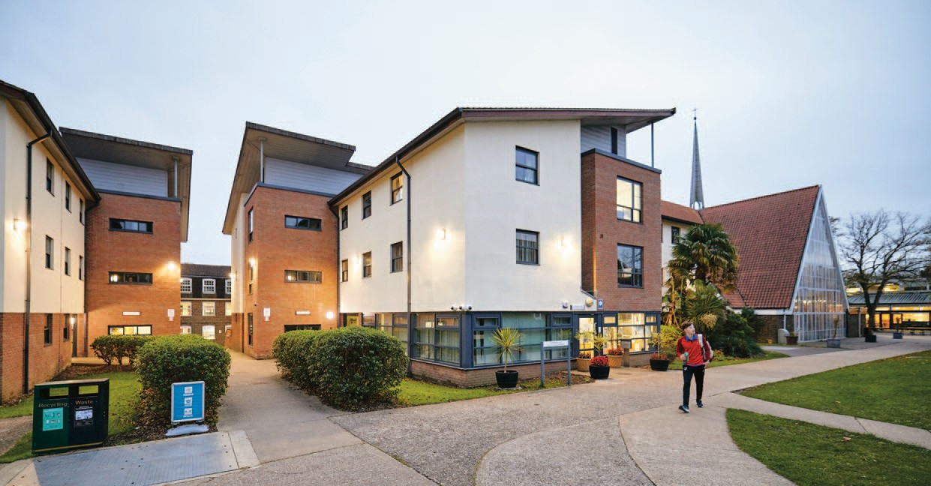

Contact Details:

Accommodation Ofce 01243 816069 accommodation@chi.ac.uk

#chiuni | chi.ac.uk

