•HM Government

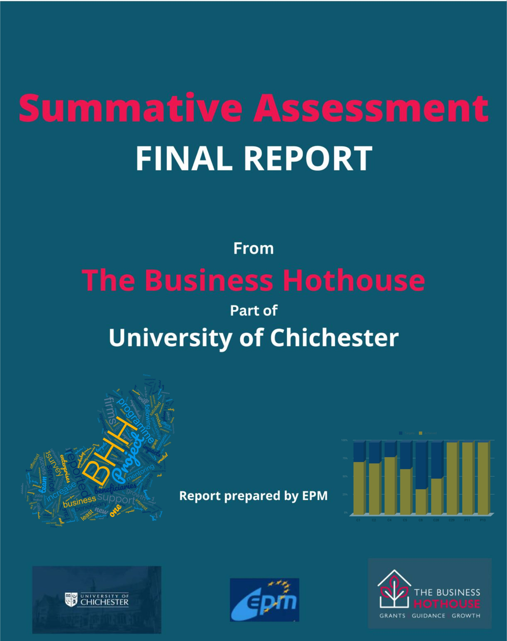

** * * *

* *

* * * **

**European Union**

European Regional Development Fund

*EXECUTIVE SUMMARY*

* The £10.9m Business Hothouse (BHH) project is a University of Chichester project aiming to increase entrepreneurship, particularly in areas with low levels of enterprise activity and amongst under-represented groups, and increase the growth capacity of SMEs.
* The BHH project offers a comprehensive business support programme across the C2C LEP area.

The project offers the following five strands of support:

* + Productivity and Growth
  + Access to Finance and Investment readiness
  + Monetisation of innovation
  + Leadership and management, peer support and mentoring
  + Business start up programme
* The final assessment of the BHH project was conducted at project closure based on a combination of evaluation tools with inputs and analysis from official contracts and claims, survey responses from 78 project beneficiaries, 25 phone calls with beneficiaries, 9 phone calls with Wider Stakeholders, a Management & Governance Team workshop and a Delivery Team Partners workshop.
* The project Team adapted very well to the challenges of the COVID-19 pandemic with the service being pivoted quickly online. The online support and expertise allowed an easier accessibility into the BHH programme achieving a greater reach.
* 46.8% of BHH beneficiaries are pre-start firms, not yet incorporated and 48% are micro-firms with 9 or fewer FTE employees.
* 78 beneficiaries responded to the survey. This equals a 4.74% response rate.
* 14.1% of beneficiary survey respondents classed themselves as rural enterprises and 3.8% as social enterprises.
* 75% of beneficiaries indicated to be very satisfied or satisfied with the service they received from the BHH project.
* The biggest source of referrals into the BHH programme came from the Growth Hub (26.9%), then via the Economic Development Team at Local Authority (14.1%) and Word of mouth (11.5%) and via the Chamber of Commerce (11.5%).
* 32.1% of beneficiaries have secured at least one new contract thanks to the support of BHH
* The services found most useful were grants (32.9%), followed by Workshops/webinars (27.4%) and then 1.2.1 mentoring (13.7%).
* Concrete impacts reported by beneficiaries include: 83.3% improvement in productivity, 36.6% increase in revenue, 36.8% reduced operation costs, 35.9% improved robustness, 35.1% improved sustainability/environmental impact.
* 61.5% of firms reported making progress towards a new-to-firm product or service with an increase in TRL of +3.64 (and 20% due to BHH intervention).
* 46.15% of beneficiary survey respondents created at least one job and 38% safeguarded at least one job. In total, 75.5 new FTE jobs were created across 36 firms and 95.5 jobs were safeguarded across 30 firms.
* 13% of firms reported to be badly or very badly affected by the pandemic. Some positive impacts following COVID-19 were also reported mainly on efficiency gains with the digitalisation of processes.
* 13% of firms reported to be badly or very badly affected by BREXIT. Only one firm reported some very beneficial impacts from Brexit.
* The project is on track to achieve 6 out of the 10 project targets which will be met or exceeded. 3 targets will be met above 85% attainment. Only 1 target, C8, will fall significantly short.
* The main themes of interest mentioned by the beneficiaries for future activities are: more funding, SEO/social media/online presence, marketing/sales training/networking opportunities, mentoring, recruitment of staff, product testing.
* The net economic impact for BHH is for every £1 invested in delivering the project,

£13.33 was generated in the economy.

EPM provides the following recommendations for a legacy project:

* Provide a Team of mentors/coaches as opposed to one specific allocated mentor to service a beneficiary having a range of needs & demands.
* Keep streamlining the grant application process using a more user-friendly interface for grant applicants.
* Enterprises are interested in a more customised approach to their business. Run different groups for start-ups and established companies.
* While the momentum and interest is there for a follow-up programme, explore new sources of match-funding such as under the new UKSPF.
* Explore the opportunity to involve other departments within the university with the involvement of graduate students.

*CONTENTS*

1. INTRODUCTION 5
2. SUMMATIVE ASSESSMENT METHODOLOGY 6
   1. Methodology challenges and Assessors’ appraisal 9
3. DATA 10
   1. Logic model 10
   2. Beneficiary profile 10
   3. Beneficiary survey respondents 15
      1. Characteristics of survey respondents 15
      2. Beneficiaries’ financial position 18
      3. Main sources referrals 19
      4. Hours of support 20
      5. Support received 21
      6. Barriers to innovation 22
      7. Product and service market readiness 23
      8. Jobs created and safeguarded 23
      9. Productivity 24
      10. Impacts of COVID-19 and BREXIT 30
      11. Future Directions and Themes 30
   4. Case Studies 30
   5. Feedback from Management Team 36
   6. Feedback from Delivery Team 43
   7. Feedback from wider stakeholders 49
      1. Cross-referrals and the wider innovation ecosystem 49
      2. Process 50
4. PROJECT CONTEXT, RELEVANCE AND CONSISTENCY 52
5. PROJECT PROGRESS 54
6. PROJECT MANAGEMENT AND DELIVERY 59
7. PROJECT HORIZONTAL THEMES 62
   1. Sustainability 62
   2. Equal opportunities and diversity 62
8. PROJECT OUTCOMES AND IMPACT 63
9. PROJECT VALUE FOR MONEY 66
   1. Benchmarking 67
10. CONCLUSIONS AND LESSONS LEARNT 69
    1. Conclusions 69
    2. Lessons learned 70
    3. Recommendations for legacy 70
11. GLOSSARY 71
12. TEAM CONSULTEES 71
13. APPENDIX 72

# INTRODUCTION

Business Hothouse (BHH) was a project worth £10.9m of capital and revenue expenditure funded under the European Regional Development Fund (ERDF) under Priority Axis 3a and 3b. The project was delivered between 01/10/2019 and 31/03/2023 (with financial completion by 31/05/2023). The aim of the project was to increase entrepreneurship, particularly in areas with low levels of enterprise activity and amongst under-represented groups, and increase the growth capacity of SMEs. The BHH project was led by the University of Chichester.

There is a mandatory requirement to conduct an evaluation or “summative assessment” of all European Regional Development Fund (ERDF) funded projects during their penultimate quarter. The purpose of the summative assessment is to evaluate : 1. Project Context, 2. Project Progress, 3. Project Delivery and Management, 4. Project Outcomes and Impact, 5. Project value for money and 6. Conclusions and lessons learnt. The assessment also aims to identify best practices and make recommendations for enhancing the legacy of the project.

All the summative assessments of ERDF-funded projects will feed into the national evaluation of the ERDF programme carried out by the Managing Authority DLUHC, and have contributed to the shaping of the new UK Shared Prosperity Fund (UKSP) that has recently been published as part of the Levelling Up Agenda.

EPM consultancy was selected to conduct the BHH project summative assessment during 4 months from November 2022 to February 2023. This report presents EPM’s summative assessment methodology, results and conclusions, and is fully concordant with DLUHC (previously MHCLG/DCLG) guidance on ERDF-funded summative assessments (ESIF-GN-1-033 and ESIF-GN-1-034).

# SUMMATIVE ASSESSMENT METHODOLOGY

Diagram 1 summarises the methodology used to conduct the BHH project summative assessment.

**Diagram 1: Methodology**

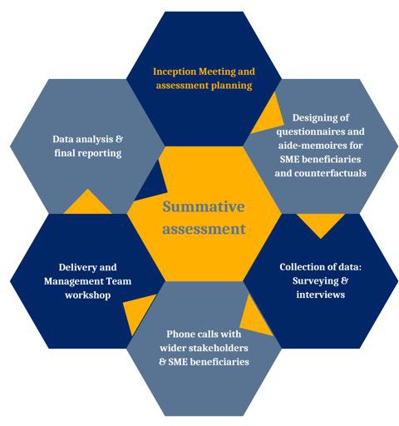

This methodology was conducted in three major stages:

**STAGE 1 - DESIGN AND PLAN THE SUMMATIVE ASSESSMENT**

#### Inception Meeting

EPM consultants met with the BHH ERDF management team during an online inception meeting on 24/11/2022 to agree the objectives, quality control, roles and responsibilities and programme of works.

#### Documentation familiarisation

The consultants familiarised themselves with the Application Form, Grant Funding Agreement, Logic Model, Project Change Request documents, Claims Forms and client relationship management and monitoring system used by the management and delivery team.

**STAGE 2 - DATA COLLECTION FOR SUMMATIVE ASSESSMENT**

#### Designing of questionnaires and ‘Aide Memoires’

EPM consultants prepared two sets of electronic questionnaires using Google Forms software: one for SME beneficiaries (beneficiaries are firms who registered for and received BHH project services), and one for SME counterfactuals (firms who were introduced to the project but did not take up any services or that registered for the project but subsequently withdrew). The purpose of the questionnaires was to collect core data with which to assess attainment of project targets, beneficiary outcomes and impacts and beneficiary satisfaction with the project, and also to identify the needs of SMEs for further support. The majority of the questions prompted a quantitative or multiple-choice answer to enable these assessments to be made in a rigorous way. These quantitative and multiple-choice questions were supplemented with a series of logic-driven questions that prompted qualitative answers that are tailored to the different types of beneficiaries. These qualitative answers enable us to interpret the quantitative answers, and provide quotes with which to emphasise key messages in this report.

‘Aide Memoire’ templates were prepared to support 1.2.1 phone interviews performed on a sample of SME beneficiaries and with three wider stakeholders. The purpose of the phone interviews is to check correct interpretation of the questionnaire answers, to make deeper enquiries about aspects of the project that generate interesting or unexpected questionnaire results, and to give the EPM consultants the contextual understanding to prepare this report in a rounded, engaging and relatable style (as opposed to dry, statistical style).

#### Questionnaires

The questionnaires were sent electronically to the full list of 1643 project beneficiaries and 668 counterfactuals. After a period of four weeks with multiple reminders sent to these beneficiaries and counterfactuals, 78 beneficiaries and 11 counterfactuals had responded to part of or all of the survey.

#### Beneficiary and wider stakeholder 1.2.1 phone interviews

EPM consultants conducted 25 phone interviews with a sample of the beneficiaries. They also conducted interviews with 11 wider stakeholders: Candida Goulden from Mole Valley DC, Tracie Davey from Worthing and Adur Chamber of Commerce, Max Woodford from BHCC, Matthew Heath from C2C LEP, Miriam Nicholls from Arun District Council, Anne de Sousmarez from WSCC, Nicola Wiley from YTKO, Nick Gregory, Dorset Growth Hub, Neil Clarke, BHCC, Micro Cordeiro, BHCC, Christina Ewbank, EDEAL Enterprise Agency.

#### Case studies

From the initial responses to the questionnaire, 5 beneficiaries were selected as case studies. These case study beneficiaries were identified as having had particularly great impact from participating in the project. The EPM consultants had in-depth conversations with these beneficiaries as well as with their project Advisors to collect the qualitative and quantitative information with which to assess the impact of the project on their individual firm.

#### Management and Delivery Team workshop

On 14 th February 2023, EPM consultants ran an online ‘ Delivery Partner Team

workshop’ and on 16th February 2023 an online ‘Management Team workshop’ to collect feedback on all aspects of project governance and management, team dynamics and complementarity with University of Chichester’s other support programmes, and to hear the various delivery staff perspectives on the beneficiary survey and interview answers.

**STAGE 3 - ANALYSIS AND REPORTING**

For the project context assessment, the EPM Consultants will reflect on whether the consensus is that the project is meeting its objectives. To do this, Microsoft Excel® was used to analyse the management team’s beneficiary tracking data (e.g. firm age, turnover, sector) as well as quantitative beneficiary survey responses relevant to assessing the project context. In the case of qualitative data, the EPM consultants used three-stage Framework Analysis to analyse the qualitative information and insights gained through the surveys, interviews and workshop. This analysis method begins by identifying the themes for which qualitative data exists (Thematic analysis), then separating this by stakeholder type (Typologic analysis) to create a matrix of qualitative responses from which patterns of responses between the different stakeholder types become apparent (Explanatory analysis). This analysis was independently completed by the two consultants and differences in results discussed until consensus was reached, removing any potential researcher bias in analysing the qualitative data.

For the project progress analysis, the consultants will use the latest project claims data to forecast attainment of the project targets by project end (number of enterprises receiving support, number of enterprises receiving non financial support, number of new enterprises supported, employment increase in supported enterprises, number of enterprises cooperating with research institutions, number of enterprises supported to introduce new-to-the-market products, and number of enterprises supported to introduce new-to-the-firm products). Because the claims forms for this project are not yet up-to-date, the consultants also considered other information sources, such as reassurances from the project management team as well as the beneficiary survey responses, when making these forecasts.

For the project management and delivery assessment, the EPM consultants reviewed the project’s approach to recruitment, communications and services delivery using the same data methods as described for the project context assessment above, namely Excel functions to analyse the relevant quantitative data and three-stage Framework Analysis of the qualitative data that helped add context and interpretation of the quantitative data.

For the project outputs and impacts and project value for money assessments, the EPM Consultants intended to use the gold-standard counterfactuals subtraction method. This involves subtracting the outcomes achieved by counterfactual SMEs during the project period from the outcomes achieved by beneficiary SMEs in order to remove the deadweight from the project economic impact calculation. (Deadweight is the impact that would have occurred even if the project had not taken place).

Only 11 counterfactuals completed our survey in the four-week period available for data collection in this already-closed project. Therefore, an alternative method for calculating the deadweight was used instead. Specifically, we used the survey responses from beneficiaries related to the extent to which they attribute their various outcomes to the project to subtract the deadweight from the gross direct effects.

Other corrections that were made to the gross direct effects value in order to calculate the net economic impact were:

* Leakage effects = % of intervention benefiting individuals or organisations outside the target beneficiary group of SMEs at the expense of the target group.
* Displacement = outcomes and outputs generated at the expense of outcomes or outputs elsewhere in the target beneficiary group.
* Substitution effects = activities undertaken to benefit from programme services at the expense of another resource.
* Multiplier effects = Further economic activities resulting down the supply chain, drawing on the Office for National Statistics “Input-Output Tables”.

Both the Gross Value Added (GVA) and employment impacts were calculated this way. The net economic impact was then considered against the project spend to calculate the project’s value for money. We compare these outputs and impacts results with results achieved in comparable ERDF-funded projects to form our value for money conclusions.

Finally, the EPM consultants amalgamate all the data and insights made in the process of conducting this summative assessment, including the gathering of best practice and lessons learnt, in order to make recommendations for how to maximise the legacy of this project.

## 2.1 Methodology challenges and Assessors’ appraisal

EPM Consultants left the questionnaires open for 9.5 weeks during the period from 9th December 2022 to 15th February 2023.

This is longer than some previous evaluations due to the size of the project and that it was open over the festive holiday period. Usually, EPM consultants leave the questionnaires open for three weeks on average, to give busy beneficiaries and counterfactuals the time they need to complete it.

A sizable number (78) and percentage of project beneficiaries responded to the questionnaire: 4.7%. Although this is a lower percentage than the EPM consultants have experienced in some other evaluations, it is perfectly sufficient for the purposes of this summative assessment.

The number of counterfactuals that complete our questionnaires is often very low, with 11 counterfactuals completing the questionnaire. Although this precludes use of the gold-standard counterfactual subtraction method for calculating the project’s impact deadweight, the alternative method of using the extent to which beneficiaries attribute their outcomes to the project is very sufficient. In fact, this is the method that the consultants end up using in most cases either because, for GDPR reasons, the project team did not store any details of counterfactuals, or because even when they did the response rate was insufficient to be meaningful, or because of considerable mismatch between the profiles of the beneficiaries and counterfactuals rendering their comparison inappropriate.

Our comparison of the profile of beneficiaries that completed the survey versus the profile of all project beneficiaries finds that the survey sample is representative of the full cohort along the major dimensions of age, number of hours of support received etc. Therefore, the insights gained from the survey data can be considered representative of the full cohort too.

# DATA

## Logic model

Diagram 2 introduces the logic model for BHH.

**Diagram 2: Logic model**

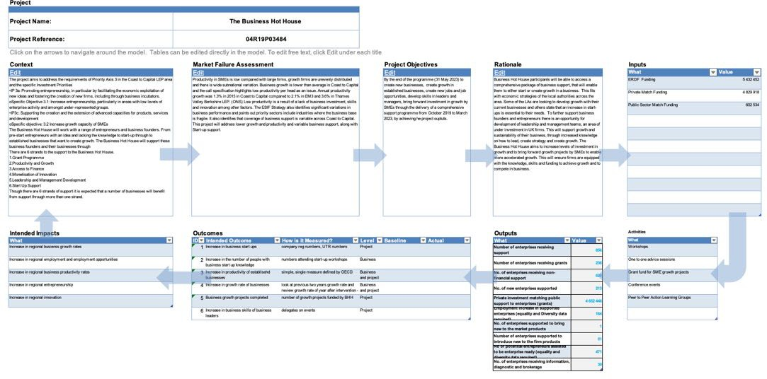

## Beneficiary profile

Baseline data from 1643 beneficiaries (including pre-start and established firms), who have benefitted from the BHH, were provided to the EPM team. The characteristics of this cohort are presented below.

**Figure 1: Breakdown of all firms by age**

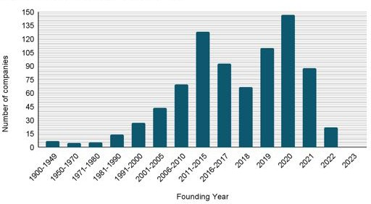

The majority of beneficiaries were founded between 2020, several were founded in the past 10 years, and a few firms were founded over a century ago. This reflects the rich past and present of a variety of industry sectors in the Coast to Capital LEP area. BHH attracted both newly formed and established firms.

**Figure 2: Breakdown of all beneficiaries by size**

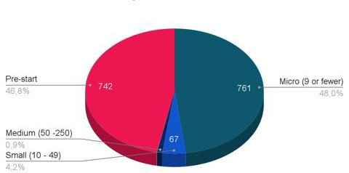

46.8% of BHH beneficiaries are pre-start firms, not yet incorporated and 48% of BHH beneficiaries are micro-firms with 9 or fewer FTE employees. The evaluators noted that this is on a comparable level to other ERDF-funded projects previously evaluated, also focusing on supporting pre-start and new start firms. This suggests that marketing and recruitment tactics used were effective to onboard young entrepreneurs into the BHH programme.

**Figure 3: Breakdown of all firms by turnover**

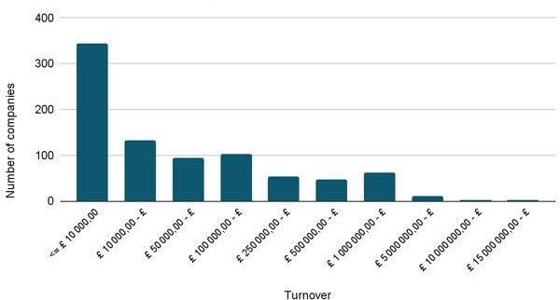

Exactly 40.33% of beneficiary firms have a turnover lower than £10k, 66.82% of beneficiary firms have a turnover below £50k. Only 9.38% of beneficiary firms have a turnover over £1M.

This demonstrates that BHH is primarily focused on young firms turning over little revenue and yet to scale-up and grow.

**Figure 4: Breakdown of all firms by gender of business director(s)**

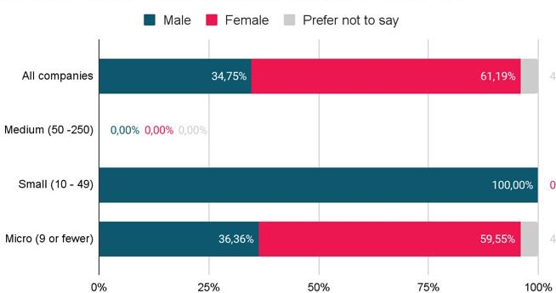

100% of small firms are led by male business directors but there is a very good representation of women amongst micro companies (59.55%). This is much higher than the national average as only 20% of new firms are now led by women (Source: www.diversityuk.org).

The assessors noted the effort made by the BHH project team and success in attracting women into the programme.

**Figure 5: Breakdown of all beneficiary firms by number of employees**

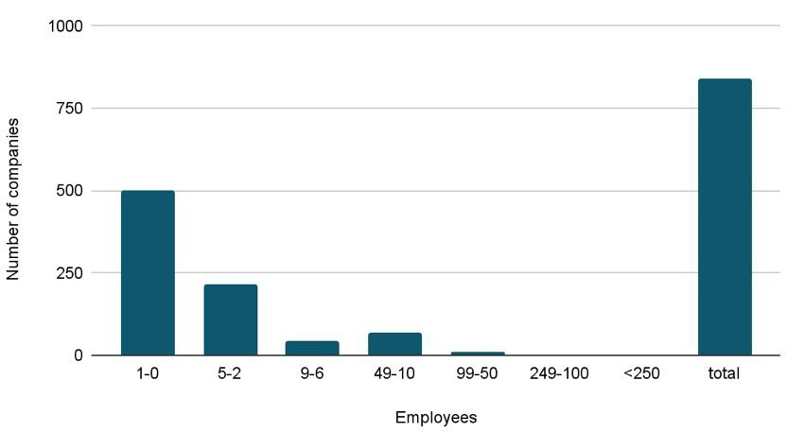

Breaking down firm size to exact number of employees, it can be seen that BHH is attracting mainly pre-start and newly established firms in need of support with 59.40% of firms with zero or one employee. Presumably, some of these firm owners may be generating income in other employment at the same time.

**Figure 6: Beneficiaries’ sector of industry by SIC code**

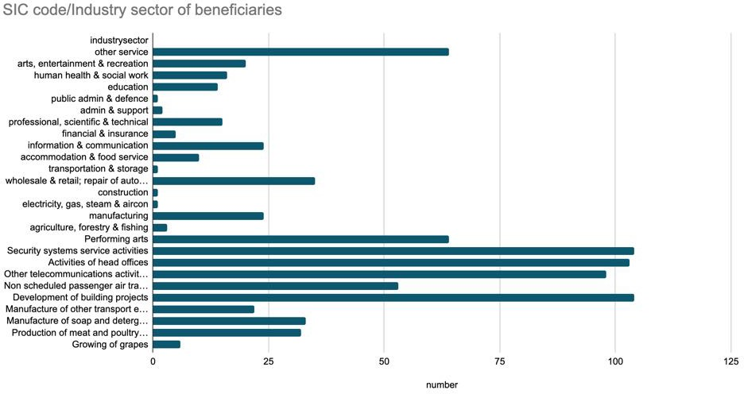

BHH supported a huge variety of sectors with the main sectors of industry represented amongst the beneficiaries being:

* Development of building project
* Security system services
* Telecommunication services
* Head offices

**Figure 7: Breakdown of all firms by date BHH support started**

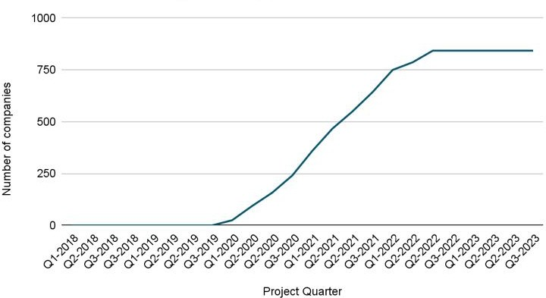

Recruitment of firms onto BHH was delayed following a long contract negotiation and started in Q3 2019. There has been a steady pace for recruitment through to Q2 2022. Since then, the rate of recruitment has slowed down as the project was drawing to a close.

**Figure 8: Breakdown of all firms by type of support received**

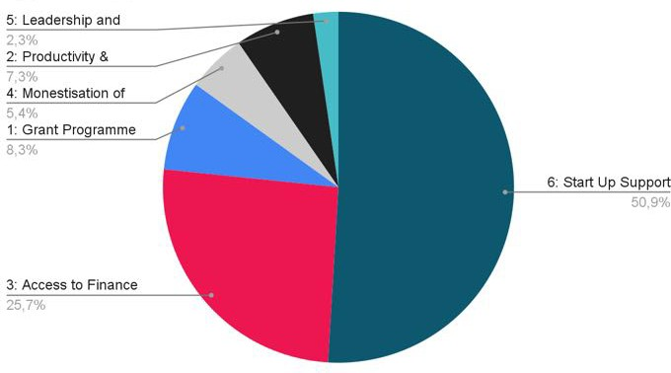

Exactly half (50.9%) of support provided was through the strand Start Up programme, followed by the Strand Access to Finance and investment readiness (25.7%) and the

Invest4 Grant programme (8.3%). Only 2.3% of beneficiaries benefited from the Leadership and Management Development Strand.

**Figure 9: Breakdown of all firms by number of hours of support they received**

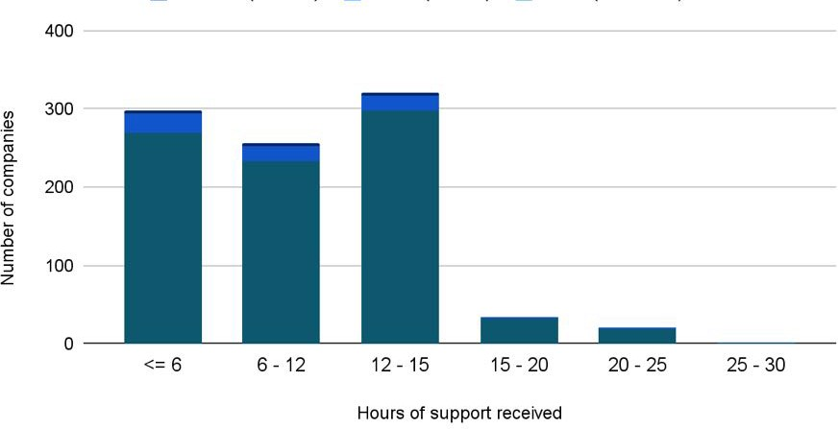

At the time of the final evaluation carried out 1 month before closure, there was still a majority with 52.74% of beneficiaries having not reached the 12 hours of support (C1). Several firms (16.36%) received over 20 hours of support and over 30 hours of support which demonstrates the BHH team going beyond expectations to assist firms.

## 3.3 Beneficiary survey respondents

### Characteristics of survey respondents

Survey answers were collected from 78 beneficiaries completing all questions or part of the survey. This equates to a 4.74% response rate. Figure 10 presents the type of the beneficiaries that completed the survey.

**Figure 10: firm type of beneficiaries that completed the survey at first engagement with BHH**

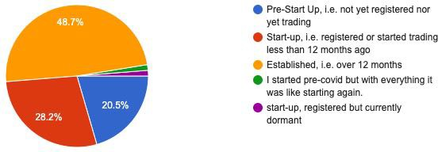

20.5% of all beneficiary survey respondents classed themselves as a pre-start up firm so not yet registered nor trading.

28.2% of the respondents classed themselves as a start-up firm so registered within 12 months and 48.7% were established businesses when they first engaged with BHH.

**Figure 11: Current firm type of beneficiaries that completed the survey**

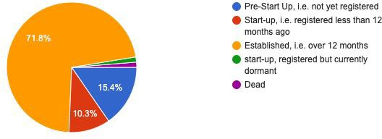

By comparing Figure 11 against Figure 10, it is possible to see that 17.9 % of start-up firms have become established firms and 5.1% of pre-start firms have become start-up firms with the help and advice benefitted from BHH.

**Figure 12: Social enterprises that completed the survey**

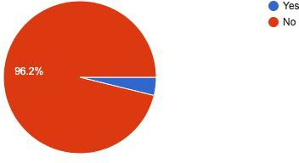

Only 3.8% of beneficiary survey respondents classed themselves as social enterprises.

**Figure 13: Rural enterprises that completed the survey**

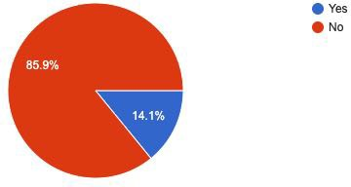

14.1% of beneficiary survey respondents classed themselves as rural enterprises which reflects some of the rural areas of Coast 2 Capital LEP.

* + 1. **Beneficiaries’ financial position Figure 14: Beneficiaires turnover**

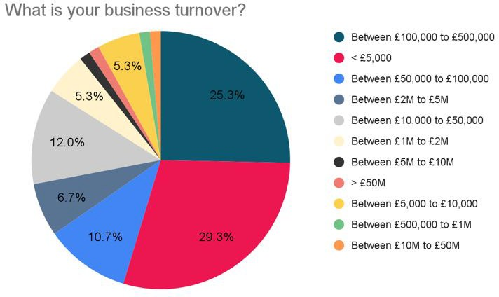

Figure 14 demonstrates that almost a third (29.3%) of beneficiaries have a turnover below

£5k and a quarter (25.3%) of beneficiaries between £100,000 to £500,000.

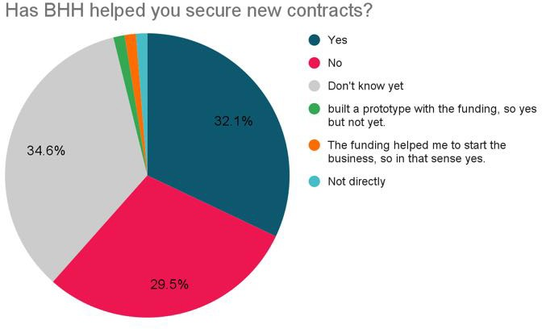**Figure 15: Beneficiaires securing new contracts**

32.1% of beneficiaries have indicated securing at least one new contract thanks to the support of BHH. A third (34.6%) are unsure yet but while contracts have not been signed yet, firms reported some improvements such as:

‘I built a prototype with the funding’’ or ‘the funding helped me to start the business’.

The value of contracts reported by beneficiaries secured a range from £250 to £2,000,000. The attribution to BHH on a scale of [0 -10] is 5.67 ± 2.53

### Main sources referrals

**Figure 16: Main sources of referrals**

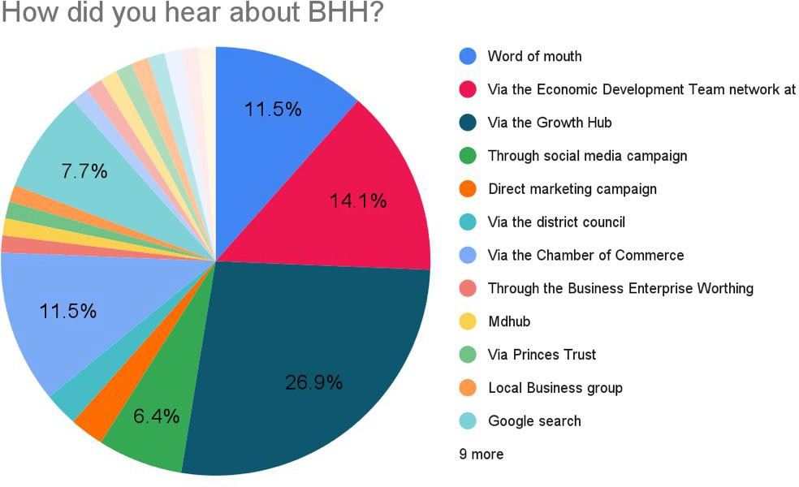

The biggest source of referrals into the BHH came from the Growth Hub (26.9%), then via the Economic Development Team at Local Authority (14.1%) and Word of mouth (11.5%) and via the Chamber of Commerce (11.5%).

The evaluator noted the variety of sources of referrals into BHH, which evidence a good positioning within the wider business support/innovation ecosystem.

### Hours of support

**Figure 17: Perception of beneficiaries (closed, closing and currently actively enrolled SMEs) of the hours of support that they have received.**

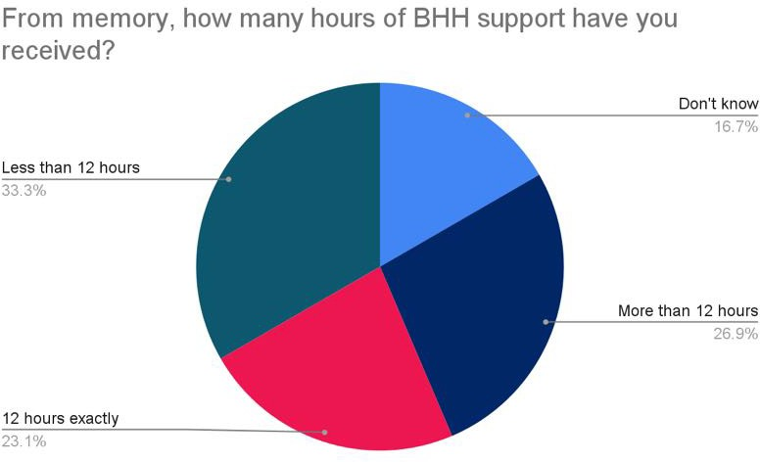

26.9% of beneficiary survey respondents perceived to have received more than 12 hours of support, whilst 16.7% of beneficiary survey respondents are unaware of how many hours of support they had received.

There are still 33.3% of respondents which have received less than 12 hours therefore BHH has the potential to achieve more C1 if these can be completed in time by project end.

Finally, the BHH Team continues to support beneficiaries beyond the minimum 12H which is commendable.

### Support received

**Figure 18: Range of support received by beneficiaries**

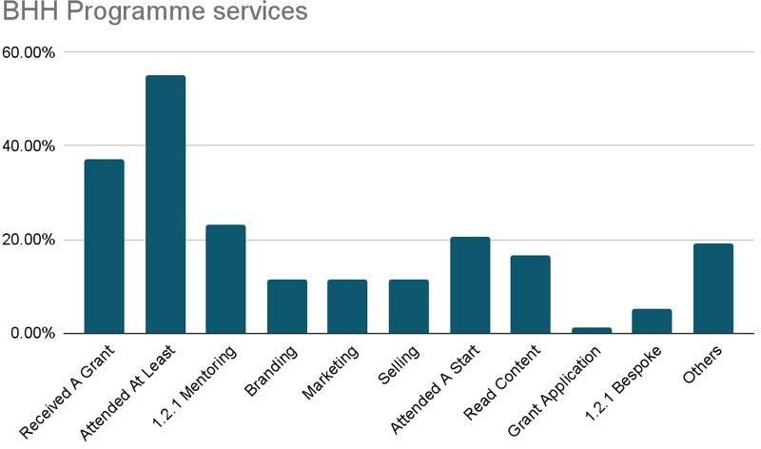

Not surprisingly, the most popular type of support accessed through the BHH programme are workshops/webinars (55.13%), followed by grant (37.18%) (i.e. grant application forms), the 1.2.1 mentoring support (23.08%) and then the Start Up Boot camps (20.51%).

**Figure 19: Single most useful services rated by beneficiaries**

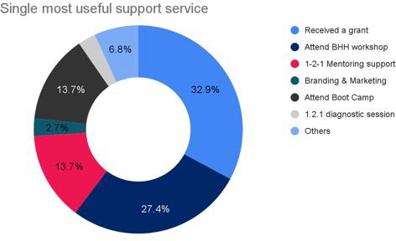

When survey respondents were prompted to select the one single most useful support to them, not surprising grants scored the highest with 32.9%, followed by workshops/webinars with 27.4% and then 1.2.1 mentoring with 13.7%.

### Barriers to innovation

**Figure 20: Comparison of beneficiary barriers to innovation prior to engaging with the programme and now**

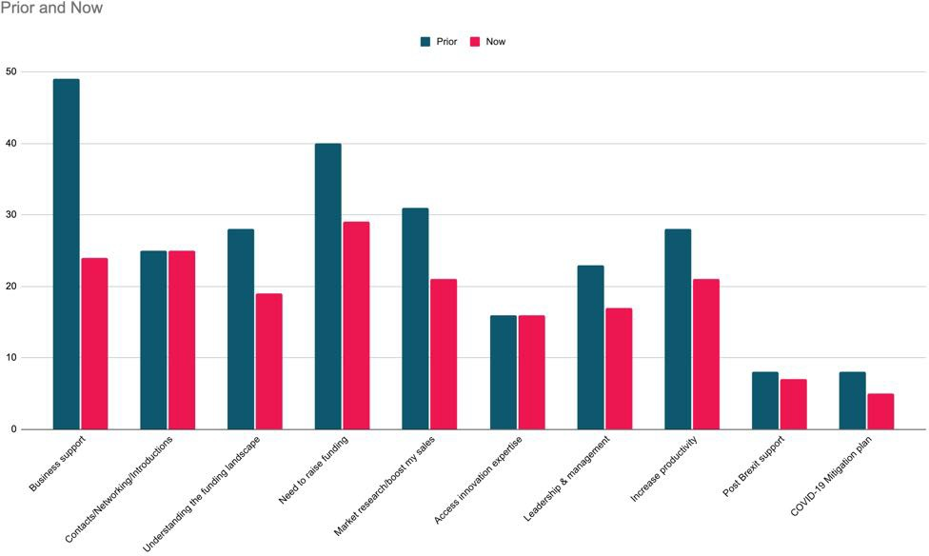

The top four most popular firm needs prior to joining the programme were: 1) Business support 2) Need to raise funding and 3) Market research/Boost my sales and 4) Increase productivity. There is a significant decline seen in most barriers to innovation which is excellent.

Some needs have remained stable following the BHH intervention and firms still desiring some further contacts/networking/introductions or access to innovation expertise.

Both the post-Brexit support and COVID-19 mitigation plan needs have decreased.

* + 1. **Product and service market readiness Figure 21: Progression of TRL levels**

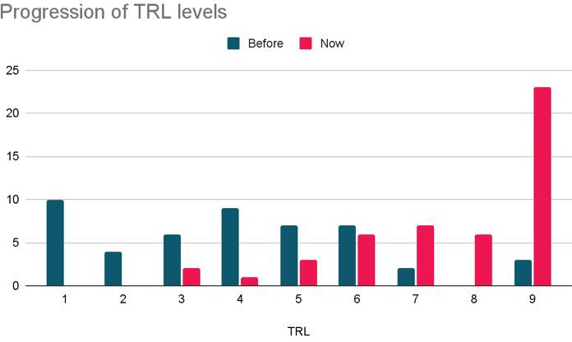

61.5% of survey respondents have tried to introduce a new-to-the-firm product or service.

The survey respondents reported that, on a scale of 1 to 10, their product/service was on average at 3.95 ± 2.25 close to market when they first engaged with BHH. These same products/services are now 7.6 ± 1.72 closer to market.

The average increase of TRL across the survey respondents is +3.64 with an attribution to BHH of 1.55 (=42% due to the BHH intervention).

This is a commendable jump in TRL and slightly higher than the average of ERDF projects recently assessed by the evaluators.

In addition, a majority of survey respondents have now reached TRL level 9.

### Jobs created and safeguarded

46.15% of survey respondents created new jobs and 38% safeguarded jobs.

Across all beneficiaries respondents, 75.5 FTE jobs have been created across 36 firms and

95.5 FTE jobs safeguarded across 30 firms.

### Productivity

**Figure 22: Impact of BHH on productivity**

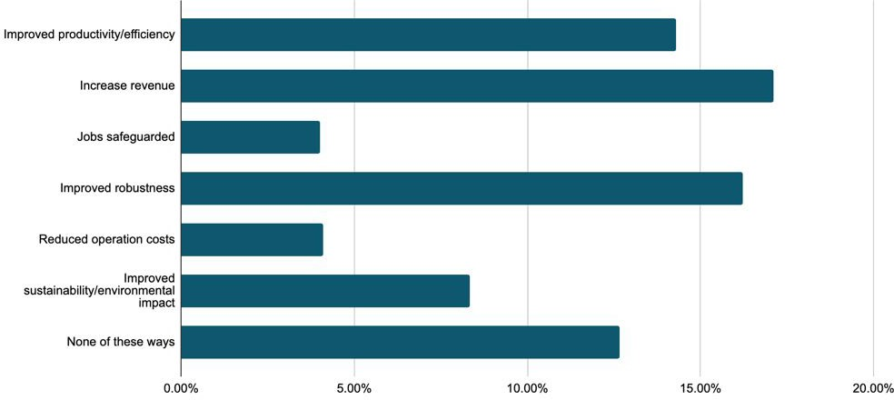

14.29 % of survey respondents reported an improvement in productivity. 17.11% of survey respondents reported an increase in revenue.

4% of survey respondents reported jobs safeguarded. 16.22% of survey respondents reported improved robustness.

4.11% of survey respondents reported reduced operation costs.

8.3% of survey respondents reported an improved sustainability/environmental impact

* + 1. Satisfaction and expectations

**Figure 23: Specific expectations**

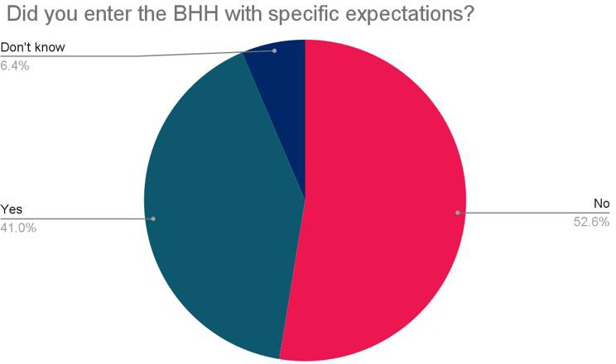

Only 41% of the beneficiaries entered the programme with expectations.

When prompted to explain their expectations while enrolling in BHH, notable answers included:

|  |
| --- |
| *“I wanted a grant ”* |
| *“I wanted a mentor.”* |
| *“I wanted to have a clear deﬁned path on how to start my business”* |
| *“We were looking for additional funding and for networking opportunities’’* |
| *“I needed a business plan”* |

**Figure 24: Achievement of beneficiary expectations of the programme**

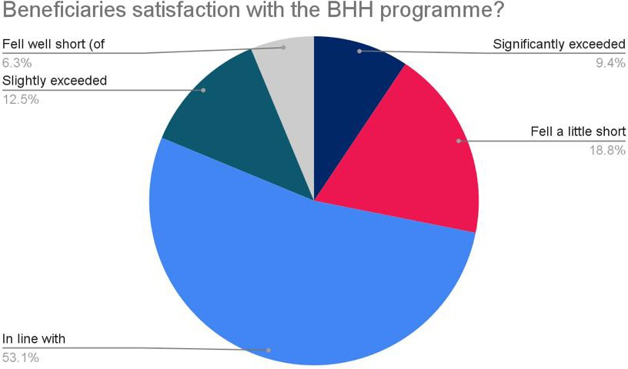

21.9% of survey respondents reported that their expectations were exceeded with the service they received from BHH. The majority (53.1%) reported that the service provided was in line with expectations. Only 6.3% of the respondents felt well short of expectations. In comparison with other ERDF projects that the evaluators have recently assessed, BHH is in line with other projects.

When prompted to explain their level of satisfaction in the programme, notable answers included:

|  |
| --- |
| *“The funding gave me conﬁdence to launch my new product and kick started my business”* |
| *“My experience of applying for the grant was surprisingly easy and quick with good, speedy responses from the team.*  *My main point of contact was really helpful, the communication was brilliant. ”* |
| *“My mentor keeps me focused. I am super creative and passionate with loads of ideas. My mentor helps me channel my many ideas and passions into a monetised business.”* |
| *“Having a coach helps me put things into perspective and work to a tangible plan without getting overwhelmed.”* |
| *“I am really grateful for this programme. Without the BHH support, I don’t think I would have this business”.* |
| *“It was so useful because I discovered how to write a business plan and we helped each other with the other start-ups on the course”* |

|  |
| --- |
| *“It has been a fantastic experience. The start up course was very good. They always followed up with the slides*  *quickly and always did what they said they would do. The team provided a very eﬃcient and professional service. I was really impressed”* |
| *“We found that the business development webinars were the best element for our business and we have used some of their presentations ourselves.”* |
| *“Our experience has been very good as they were all very responsive and helpful.”* |
| *“Service from Nicola was precise and informative”* |
| *“The facilitator gave excellent advice and his knowledge was superb”* |
| *“Support from local team excellent”* |
| *“We became aware of options to access ﬁnance we didn't know existed”* |
| *“Knew exactly what was on offer and received this.”* |
| *“We were awarded the maximum grant allowed”* |

Some suggestions for improvements:

*“Janet, my mentor/coach is amazing but she is one person and cannot be an expert in everything.It would be more*

*powerful if I had access to more experts eg; sales funnel specialist”*

*“We decided not to proceed with a grant in the end as the time and complexity was not worth it for the value of the*

*grant. ”*

*“I suggest that you put a threshold limit on the minimum value of items within the grant, say nothing worth less than*

*£100. The time it takes to ﬁnd the receipts and information for small items was not worth it.*

Also, I suggest not using word documents for the submission but another format and it was not very user friendly and was rather clunky.”

|  |
| --- |
| *“I didn’t quite get all the knowledge I’d hoped for”* |
| *“The grant was inaccessible to us due to funding the cost of innovation/purchase up front. ”* |
| *“We were unable to comply with the outputs required due to time /resource constraints”* |

|  |
| --- |
| *“Some of the advice was a little out of date”* |
| *“Asking more about each attendee's business so content could be tailored, a more customised support provided ”* |
| *“Maybe divide in separated group the totally new businesses from the established ones”* |
| *“It is a shame this was not more freely advertised. I know many people who would like to have something like this.* |
| *“It would be ideal if the group for the start up programme was bigger, there were only 4 businesses in my group and it would have been better for peer support and networking. It would be good to have an online chat room for 6 months after the project to keep in touch with other businesses who went through the same programme.”* |
| *“I think that I might have slipped through the net and not fully understood the range of business support services that I could have beneﬁted from. I think they needed a clearer onboarding system.”* |
| *“I struggle to ﬁnd programmes that are free, it would be most helpful if all this information was in one place. I did ﬁnd the Business Hothouse website a bit diﬃcult to navigate. I would prefer events more tailored to the journey of the businesses within the workgroups.”* |
| *“It would be ideal if the group for the start up programme was bigger, there were only 4 businesses in my group and it would have been better for peer support and networking. It would be good to have an online chat room for 6 months after the project to keep in touch with other businesses who went through the same programme.”* |
| *“I would recommend that for the potential grant applicants, it would be a better system to interview them ﬁrst so that they know exactly what was required before they spend days and weeks working on an application or attending workshops. .”* |
| *“An ongoing structure of start up support would be good to take my business to the next stage. If there is a progression I would like to apply for it. .”* |
| *“It was great that I could take my grant in two tranches but for additional funding there is nothing left in the pot for the next stage of businesses. It would be good if they could move funding around in the different pots. It was a great start but businesses need help at each stage of their growth..”* |

**Figure 25: Beneficiary ratings of different aspects of the service**

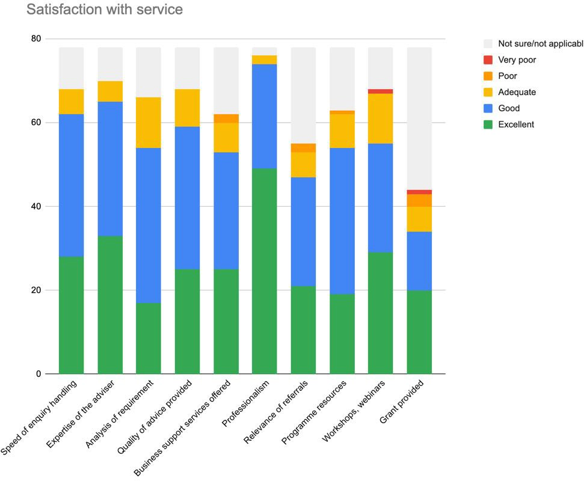

The aspects of BHH that survey respondents most frequently rated highly were the professionalism of the BHH Team, the expertise of the Advisers, the speed of enquiry handling, and the quality of the advice provided.

Only one firm rated low the workshops/webinars and grants provided.

Assessors note that the satisfaction rate is comparable to other ERDF-funded projects assessed in the past.

### Impacts of COVID-19 and BREXIT

**Figure 26: Impacts of COVID-19 and BREXIT**

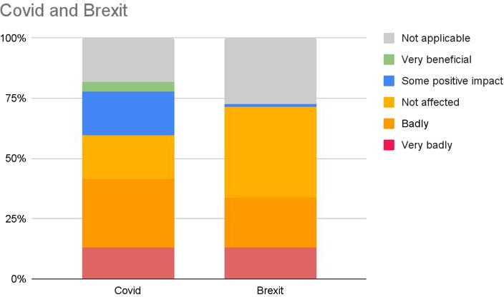

13% of firms reported to be badly or very badly affected by the pandemic. 13% of firms reported to be badly or very badly affected by Brexit.

Some positive impacts of COVID were also reported mainly on a move to digitalisation of processes and increase in efficiency. Only one firm reported some positive impacts from Brexit.

### Future Directions and Themes

Beneficiary survey respondents requested support along the following themes, which are aligned with their future business ambitions.

These themes are listed below from most frequently mentioned to least frequently mentioned:

1. *Funding*
2. *SEO, Social media, online presence*
3. *Marketing/Sales training/ Networking opportunities*
4. *Mentoring*
5. *Recruitment of staff*
6. *Product testing*

## Case Studies

The following 5 case studies illustrate some of the services delivered to firms through BHH.



Zest Psychology: Business Hot House - Case Study

**Value statement**

The Business Hot House (BHH) is a free business support programme, run by business experts to deliver support aiming to increase entrepreneurship and increase the growth capacity of SMEs. The programme delivers support to any business owner, start-up founder or sole trader across the coast-to-capital area. The BHH programme offers 6 strands of support: 1) Business Start Up Support; 2) Access to Finance Support; 3) Leadership and Management Development; 4) Monetisation of Innovation Support; 5) Business Growth and Productivity; and 6) SME Grants Programme. Through taking part in the BHH Zest Psychology has been supported to launch their new innovative platform service and in turn increasing their revenue.

**Challenge addressed**

Zest psychology is a company made up of Coaching and Occupational Psychologists who support individuals and teams in a variety of services and technologies, ultimately supporting them to become more confident and effective in the workplace. Zest Psychology were seeking business support to help them develop further as a company.

Role that BHH played

Following a one-to-one consultation with a BHH advisor, Zest Psychology were able to develop a business plan and access a grant to fund their feasibility study around a new technology platform build. The grant enabled Zest Psychology to explore their investments and safeguarded their business contacts, since launching their new platform they have experienced increased business income.

**Testimonial**

“It was a great financial support to receive the grant for our technology platform – the Authentic Confidence Hub. I found the process relatively easy to navigate and there was support available. This has really helped me grow the business and provide a technical solution that met specific client needs whilst ensuring we delivered a great product. From here we now feel well placed to expand our services to other clients.” (Anna Kane, Director - Zest Psychology)

**BHH**

The BHH project is a £10.9 million 4 year business support programme funded by the European Regional Development Fund (ERDF). BHH is led by the University of Chichester with support from its delivery partners, The Princes Trust, Brighton and Hove City Council, Sussex Innovation Centre, WSX Enterprise, EDEAL and Get Set for Growth. The project has been designed to increase entrepreneurship, particularly in areas with low levels of enterprise activity and amongst under-represented groups, and to increase the growth capacity of SMEs.



Enable & Thrive : Business Hothouse - Case Study

**Value statement**

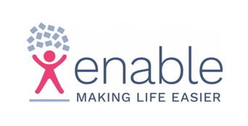The Business Hothouse (BHH) is a free business support programme, run by business experts to deliver support aiming to increase entrepreneurship and increase the growth capacity of SMEs. The programme delivers support to any business owner, start-up founder or sole trader across the coast-to-capital area. The BHH programme offers 6 strands of support: 1) Business Start Up Support; 2) Access to Finance Support; 3) Leadership and Management Development; 4) Monetisation of Innovation Support; 5) Business Growth and Productivity; and 6) SME Grants Programme. Through taking part in the BHH Enable & Thrive were able to launch a new customer relationship management software, join a membership of peer to peer support, create new full time

jobs and increase their revenue tenfold.

**Challenge addressed**

Enable & Thrive provide tailor made support assistant services that work to support vulnerable people with their accounts, appointments, care, gardeners and more. The company was looking to introduce a new customer

relationship management tool, a critical central element to their support services.

**Role that BHH played**

Enable and Thrive were seeking a grant to design and release their new customer relationship management tool, BHH provided them the financial aid to do so, furthermore introduced the company to BHH peer to peer services which they report particularly benefiting from as they attended regular meetings to focus on expanding their business, setting goals and sharing and gaining business expertise from other companies involved. Taking part in BHH allowed Enable and Thrive to create eight new full time roles, expand their services into new regions, increase their revenue by tenfold and work more efficiently.

**Testimonial**

“Being part of the Peer 2 Peer Business Hothouse project cohort during the lockdown period really kept me focused and on track, it was an incredible source of support and accountability. In addition we were able to obtain an Invest4 grant which allowed us to grow in size and capacity with a bespoke CRM growing the business in terms of staff, client capacity and turnover by around 400%!” (Emily Allchurch, Founder - Enable & Thrive Ltd).

**BHH**

The BHH project is a £10.9 million 4 year business support programme funded by the European Regional Development Fund (ERDF). BHH is led by the University of Chichester with support from its delivery partners, The Princes Trust, Brighton and Hove City Council, Sussex Innovation Centre, WSX Enterprise, EDEAL and Get Set for Growth. The project has been designed to increase entrepreneurship, particularly in areas with low levels of enterprise activity and amongst under-represented groups, and to

increase the growth capacity of SMEs.



FanRyde: Business Hothouse - Case Study

**Value statement**

The Business Hothouse (BHH) is a free business support programme, run by business experts to deliver support aiming to increase entrepreneurship and increase the growth capacity of SMEs. The programme delivers support to any business owner, start-up founder or sole trader across the coast-to-capital area. The BHH programme offers 6 strands of support: 1) Business Start Up Support; 2) Access to Finance Support; 3) Leadership and Management Development; 4) Monetisation of Innovation Support; 5) Business Growth and Productivity; and 6) SME Grants Programme. Through taking part in the BHH pre-start-up company FanRyde have established a secure business plan and benefited from increased understanding and confidence to launch their business in the near future.

**Challenge addressed**

FanRyde is a start-up company with the green business aim to create a digital marketplace for sports fans going to sports events wanting to share a ride. The company aims to launch at the start of the next football season, focusing on football fans initially then planning to expand to other sporting events following the launch. The company’s founder is an expert app developer and he was therefore looking for business planning support and guidance on running his business once his company is established.

**Role that BHH played**

FanRyde attended various training sessions hosted by BHH of which the company has learned more about accessing finance, cash flow forecasts, pitch decks, spreadsheets and profitability. Through accessing BHH sessions, FanRyde have established a secure business plan and are ready to launch their innovative app.

**Testimonial**

*"Both areas of support were really helpful, Access to Finance and the Business Start Up Programme both opened my mind. I did not know about cash flow forecasts, business plans, pitch decks, spreadsheets and profitability so it was great to have that expertise in business. The instructors were really helpful and clued up, they gave their time and were willing to support. They reviewed my work and gave me constructive feedback and helped me to improve. I really appreciated it."* (Emmanuel Squire, Founder - FanRyde)

**BHH**

The BHH project is a £10.9 million 4 year business support programme funded by the European Regional Development Fund (ERDF). BHH is led by the University of Chichester with support from its delivery partners, The Princes Trust, Brighton and Hove City Council, Sussex Innovation Centre, WSX Enterprise, EDEAL and Get Set for Growth. The project has been designed to increase entrepreneurship, particularly in areas with low levels of enterprise activity and amongst under-represented groups, and to increase the growth

capacity of SMEs.

Five Squirrels Ltd: Business Hothouse - Case Study

**Value statement**

The Business Hothouse (BHH) is a free business support programme, run by business experts to deliver support aiming to increase entrepreneurship and increase the growth capacity of SMEs. The programme delivers support to any business owner, start-up founder or sole trader across the coast-to-capital area. The BHH programme offers 6 strands of support: 1) Business Start Up Support; 2) Access to Finance Support; 3) Leadership and Management Development; 4) Monetisation of Innovation Support; 5) Business Growth and Productivity; and 6) SME Grants Programme. Through taking part in the BHH project, Five Squirrels Ltd have successfully expanded their company including increasing their revenue by four fold.

**Challenge addressed**

Five Squirrels Ltd are a unique skincare cosmetics company who help skincare professionals launch and develop award-winning products. The company was seeking to expand particularly following on from the Covid-19 pandemic where their outsourcing manufacturing supply chain was disrupted. To overcome this

challenge Five Squirrels Ltd brought their manufacturing in-house and have consequently required support to expand their company.

**Role that BHH played**

Through taking part in the Productivity and Growth, Monetisation of Innovation and Leadership and Management BHH project strands, Five Squirrels Ltd have been supported to seek further growth opportunities, engage in peer to peer networking, attend training for leadership and management and also receive a grant of £56K to kickstart their expansion and innovation into manufacturing their own skincare products.

**Testimonial**



**BHH**

“The business hothouse support could not have come at a better time for us, the process allowed us to challenge our business plan to make it more robust and the process meant we have been able to scale our business, increasing revenue by 400% and grow the team from 4 to 15 in 2 years” (Gary Conroy - Director of Five Squirrels Ltd)

The BHH project is a £10.9 million 4 year business support programme funded by the European Regional Development Fund (ERDF). BHH is led by the University of Chichester with support from its delivery partners, The Princes Trust, Brighton and Hove City Council, Sussex Innovation Centre, WSX Enterprise, EDEAL and Get Set for Growth. The project has been designed to increase entrepreneurship, particularly in areas with low levels of enterprise activity and amongst under-represented groups, and to increase the growth



capacity of SMEs.



Red Pigeon Media: Business Hothouse - Case Study

**Value statement**

The Business Hothouse (BHH) is a free business support programme, run by business experts to deliver support aiming to increase entrepreneurship and increase the growth capacity of SMEs. The programme delivers support to any business owner, start-up founder or sole trader across the coast-to-capital area. The BHH programme offers 6 strands of support: 1) Business Start Up Support; 2) Access to Finance Support; 3) Leadership and Management Development; 4) Monetisation of Innovation Support; 5) Business Growth and Productivity; and 6) SME Grants Programme. Through taking part in BHH Red Pigeon Media have established their start up company within the market and have doubled their turnover with a new video production service.

**Challenge addressed**

Prior to taking part in the BHH Red Pigeon Media were providing photography and videography services to their client’s for their social media platforms, they were unable to cater to larger video production requests due to limitations with their equipment. The company therefore were seeking financial support to upgrade their equipment to empower them to expand their services and market reach.

**Role that BHH played**

Red Pigeon Media were awarded a BHH grant that enabled them to upgrade their video production suite and in turn work more efficiently. Furthermore, the grant enabled the company to purchase a new lens, camera and computer which has allowed them to secure larger, higher paid contracts with multi-national companies. Red Pigeon Media also joined the BHH Business Start-Up Programme and benefited from tailored business expertise to sustainably establish their business plan and have since begun successfully working towards this.

**Testimonial**

‘’My experience with BHH has been fantastic. We were at a point in the business whereby we had to turn down larger jobs because we didn’t have the appropriate equipment. BHH helped us to upgrade our equipment and rethink our business plan which has now resulted in us working with multinational companies on large scale video production jobs.’’

(Jayac Heal, Founder - Red Pigeon Media)

**BHH**

The BHH project is a £10.9 million 4 year business support programme funded by the European Regional Development Fund (ERDF). BHH is led by the University of Chichester with support from its delivery partners, The Princes Trust, Brighton and Hove City Council, Sussex Innovation Centre, WSX Enterprise, EDEAL and Get Set for Growth. The project has been designed to increase entrepreneurship, particularly in areas with low levels of enterprise activity and amongst under-represented groups, and to increase the growth capacity of SMEs.

## Feedback from Management Team

On 16th February 2023, EPM Consultants conducted an online workshop with the following project staff:

* + - * Gareth Sear
      * Victoria Dall’igna
      * Alison Davis

Following is a summary of the insights gained in this workshop.

1. **To what extent does the original rationale of BHH remain valid? ( The BHH programme is designed to enable the creation of new firms and to support enterprise Growth, productivity and innovation in key priority sectors across the Coast to Capital LEP area).**

The project team felt that it has evolved over time as the whole geopolitical landscape and world has changed over the period since the project started. The original rationale included key priority sectors, in the end they supplied as many types of business with as much support as they could due to the changes in trading conditions but they did help to create new companies and support start-ups, growth and innovation.

1. **What was the economic and policy context at the time BHH was designed?**

When the BHH was designed, the government was still funding the LEPs and Growth Hubs so they were in a stronger position with funding from BEIS. From the moment the project started the funding from BEIS was being reduced year on year to LEPs and Growth Hubs. Also, the country was in a fairly robust financial situation 5 to 6 years ago and that all totally changed during project delivery. Helping businesses to grow and employ people became a challenge as businesses went totally into survival mode and needed support to survive.

1. **What are the needs/market failures being met by the project? (e.g. enhance competitive advantage against firms operating in low-wage economies, improve core competencies and survival rates of local SMEs etc)**

The market gaps were that businesses were not employing people, there was low investment in management and leadership. There was a low wage economy and low start-up rates. They needed to help businesses to create growth and survival rates. There were generic things that businesses needed such as access to finance, growth creation, management and business skills. UK banks only support about 50% of businesses so there was a clear need for access to finance and grants.

1. **Have you noticed any difference in services delivered to individuals, young SMEs vs more established SMEs?**

Yes, the project management team have seen the average hours of support over the project period to be 12.5 hours for pre start-ups, 9.5 hours for early stage businesses and 6.5

hours for more established businesses. The evidence showed that the more established the business was, the less they accessed the support but they still demonstrated the need for support. They also noticed that it is more challenging for start-ups to get a grant due to the risk whilst more established businesses were more successful at gaining grants. The project management team also noted that some larger and more established SMEs did not seek support to apply for the grants and had the capacity to apply successfully without needing the support.

1. **How have the different strands of the project work individually? And in complementarity to each other?**

(Strand 1: Productivity and Growth,Strand 2: Access to Finance,Strand 3: Monetisation of innovation, Strand 4: Peer support, mentoring, leadership and management development,Strand 5: Start-up)

The project management team felt that the strands of project support worked well and reached a good number of businesses. They felt that it would have been better to support the SMEs over a longer time of their journey but they were restricted by the 12 hours cut-off. The monetisation of the innovation strand went so well that it became a challenge for the delivery partners, Sussex Innovation. They had a new CEO just as the project started delivery and their delivery model changed. The mentoring element did not happen and the peer elements and leadership support was harder to sell but they felt that is normal in the UK. With stand 6, the Invest 4 fund, the cashflow and grant fund changed which then sat with Brighton & Hove Council which they felt was a good decision and they ended up managing the finance for the whole project.

The project management team felt that their initial EOI idea was good, to have each strand as a separate project but MHCLG requested that they merge them into one large project. This made the project management more difficult for the project management team.

1. **How have project management, internal communication, data collection and recording, governance, administration and financial management been? How has it been liaising with MHCLG / DLUHC?**

The project management team felt that communications and project management had been good. They felt that they had good relationships with their contract manager at MHCLG. The Project Manager, Administrator and Finance Manager were all the same individuals throughout the duration of the whole project. They found the black and white rules a challenge at the start of the project and the interpretation of the rules and level of legal advice required made them realise that if they had designed the project to procure a CRM system it would have simplified their project management and that they budgeted for a stand alone website for the project but their ethos was to maximise the funding to support the SMEs rather than increase the spend on managing the project. Unfortunately the project management team were not able to access the training from MHCLG at the start of the project due to the COVID pandemic so they had a huge delay on the first claims and had to follow the documented guidance to work their way through the process.

COVID also impacted on their cash flow as it delayed the start of the grant element of the project which used up their match as an organisation on staff costs before the flow of income came in from the grants. They advised their partners that they were all in the situation together and made it work. They voiced some frustrations with the level of data

collection, the spreadsheets, rules and regulations and the lack of flexibility over the budgets needing to balance to the penny. They mitigated the situation by hosting fortnightly online meetings with their delivery partners and sharing the E-claims system and transaction list with their delivery partners to explain it to them. A positive was that they kept the same contract manager at the Ministry for almost all of the duration of the project.

The project management team reflected on their learning from this project. They had no way to plug the BHH project finance system into the University finance system and they felt that they could have embraced tech better. They could have benefited from using a system such as Slack or Trello to track tasks and share things better across the University. They felt that they could have been more innovative but they had a challenge with the firewalls and strict security at the University. During COVID, they started using Zoom but had to move over to MS Teams as the University was concerned about GDPR and cyber security with Zoom.

1. **How effective has the partnership been and working as a Project Team?**

They felt that the partnership was effective with good communications. They had challenges with team changes and there is no one in post at their delivery partner organisations who was involved at the start of the project. Their delivery partners also had structural changes and staff turnover, however the Prince’s Trust were excellent and YKTO and WXS Enterprise experience of ERDF was very good and really supportive.

They all worked well together and the delivery team was great.

Upon reflection, they would have liked to increase the marketing team to 1.5 FTE and the Finance Manager needed more administrative support. The Finance Manager felt that she would have benefited from being full time on the project and could have worked with the research side of the University more for the project and inhouse lecturers but they had to go out to procurement as their own lecturers were already fully committed. They did make savings on the cost of events due to having to move to online delivery for events during COVID restrictions. They would have liked to have had a programme director role and an additional administrator. Their Head of the Business School was the Project Director and he helped them on cash flow issues and had a good standing with the Board and was their Vice Chancellors Group champion. The University had 3 Deputy Vice Chancellors and 2 to 3 Finance Directors since the project began.

The Finance Manager felt that the Project Manager and the Administrator helped her so much. They all felt that the COVID pandemic changes worked in their favour. They had monthly online partners meetings and shared best practices. They held fortnightly delivery partner meetings online and built stronger relationships because of the pandemic. They worked incredibly well together as a team with their stakeholders and the University marketing team and held good internal meetings due to COVID.

1. **What are your reflections on the value of partner capabilities and infrastructure e.g. academic facilities, links to wider ecosystems etc.**

The project management team felt that their partners had good capabilities but some massive recruitment issues. The Brighton and Hove Council legal team took a long time to sign the contract which caused a delay to the project start. They had a great bunch of delivery partners. The infrastructure used was MS Teams and Sharepoint but they also had

security system challenges working with Brighton and Hove Council. They found that although it was good to go to electronic signatures and paperwork during the pandemic, it was easier to get beneficiaries to sign physical paperwork during face to face events than during online delivery. The Ministry also took a while to agree to online document signatures during COVID.

1. **How effective have marketing, communicating and networking activities been for raising awareness of project activities and achievements?**

The project management team felt that the marketing and communications went really well. The brand creation was good and their marketing manager did a great job of working with local authorities on communications. They had challenges with the way that Coast to Capital LEP had structural changes but once the project was rolling, they did networking and attended business events and business shows. They have grown a huge email marketing database. It was always a challenge to get beneficiaries onto workshops with 50% of bookings versus attendance. They had to phone people in advance and they still did not turn up.

They felt that the delivery partners did a good job on branded marketing and they were impressed with their marketing manager and the different social media channels she used. She had a good relationship with their local radio and did more PR style marketing campaigns.

1. **How did you address the horizontal and cross-cutting themes of ERDF in your delivery/implementation? (e.g. environmental, equal access and diversity)**

The project management team felt that due to the COVID pandemic, this had massive sustainability benefits for the project. They did not create any printed materials for the first 18 months of the project. When they did have in person events, they ensured venues were accessible and close to trains and public transport options. Online delivery of workshops made the support more accessible for equality, diversity and inclusion. Their delivery partners had flexible, evening workshops and broke the workshops down into smaller chunks. They only marketed the support within the Coast to Capital LEP area but reached many businesses outside the LEP geography and internationally. They allowed them to participate as they brought a richness of experience and diversity to the workshops and peer learning.

Some of their delivery partners attended female founder business shows and did well on EDI recruitment of beneficiaries. The project management team felt that If they had had more staff on the marketing team, they could have targeted more marketing on BAME and female entrepreneurs recruitment onto the project.

The online delivery partners meetings worked so well that they continued them online throughout the project which saved time and resources without the need for everyone to travel to physical meetings. Also, all their financial data is secured on an online portal for audit purposes which has been saved on paper and printing.

1. **How were procurement activities delivered?**

The project management team followed the ERDF guidelines and regulations on procurement and their Contract Manager helped them to follow all the rules on their claims reports.

1. **What are your observations related to the project targets and spend? Please comment on geographic spread (transition / more developed), beneficiary profile, timings (staff availability), and future project delivery plans.**

The Ministry suggested that they reduced their targets but they have reached a huge number of businesses but the 12 hours of support to SMEs was a challenge, especially once things moved to online delivery so COVID made it a challenge.

The targets were originally based on the separate strands from Coast to Capital data, on reflection, they could have had more P13s and shared those around, then they could have proved more of their efforts. If they could have foreseen the impact on the businesses over the 3 years, they would have reduced their C8 target. They obviously cannot capture the jobs that will be created in the future as a result of the project interventions.

Geographically, they had a good local, national and global reach. They had strong coverage along the A27 and A23 with some rural areas around Horsham and Chichester well represented. The Mole Valley District and East Surrey areas were more of a challenge to engage.

1. **How effective has beneficiary recruitment been? What and who have been the major referral channels? Have there been non-target beneficiaries (leakage)?**

The Coast to Capital Growth Hub were a large referrer for recruitment and told businesses about the project but the project management team would have liked to have created a better referral system.

1. **How are project activities perceived by beneficiaries? What are the criteria and procedures to ensure BHH focuses on the right beneficiaries?**

The beneficiaries perceived the project well. They did not have any really negative feedback. They felt that they marketed the project well and had the right beneficiaries at the workshops.

1. **How has BHH benefitted from and in turn benefitted the University of Chichester’s other projects?**

It has been well received.

1. **How is the project perceived by wider stakeholders? Has BHH benefitted from other projects delivered in the area? Has the project contributed/enhanced other initiatives in the area?**

They felt that the perception of wider stakeholders was positive and the project had been well received. East Surrey and Mole Valley were a challenge but their beneficiaries did ok. They swapped some best practices with Brighton and Hove Council and benefited from the Coast to Capital Growth Hub and other ERDF projects in the area.

1. **How has COVID-19 impacted the BHH team’s internal operations? Have BHH services been adapted in response to COVID-19 restrictions and the new types of needs individuals/firms now have?**

As mentioned throughout their feedback, the project management team had no alternative other than to pivot and innovate their activities due to the COVID pandemic. They and their delivery partners moved onto online delivery of the project and since restrictions have been lifted, they have not fully reverted back to face to face events and workshops but now have adopted a more blended approach. The COVID pandemic has brought a huge amount of positives for innovation and the way that they work which have been documented throughout this feedback session.

They had a lot of queries requesting support for businesses in the retail and agricultural sector during COVID but they were unable to support them due to eligibility criteria.

1. **Has Brexit impacted the delivery of BHH? Have BHH services been adapted in response to BREXIT/ Transition?**

The project management team felt that Brexit did not have a huge impact on the project except for the supply chain issues which then impacted on time delays for the grant applications and the grant spend. They also felt that Brexit impacted on staff changes because of the end to ERDF funding, many staff in various delivery partner organisations and the steering group moved on and that slowed down the project and the focus of staff at the Ministry was potentially elsewhere.

1. **Please reflect on the added value of the BHH project. Has it resulted in any other Wider Economic Impacts e.g. inspired local policy etc?**

The project has helped the University of Chichester brand awareness to new audiences. It has inspired some local policy. Some local authorities have looked at business support under their UKSPF bids. Also, the SME beneficiaries who received grants would show a wider economic impact due to growth.

1. **Please comment on any Economic Impacts generated for the University e.g. consultancy services, Research Excellence Framework, publications, academic careers etc.**

The project management team felt that the income generated from the project would count towards the University’s HEIF funding. It was also used in a knowledge exchange and has put the University in a better standing. There was one academic involved and they wanted

to create a research paper on the project. They have put more businesses in touch with students and some businesses have interacted more with the University and also developed relationships with manufacturers in the region and brought them into the University’s fold and also increased PR.

1. **How well is the delivery model working from sourcing firms to delivering support?**

#### What has worked well overall? What have the successes been? Where is there transferable good practice?

The project management team felt that the project had reached a huge number of SMEs. The delivery partners had delivered well and many good relationships had been built. They felt that the use of digital signatures due to the pandemic was a positive and the pivot to a more digital delivery made the project support more accessible and increased its reach from local to global. Good practice included online tools and bite size chunks of workshop delivery online which was also more engaging for younger entrepreneurs and those with caring responsibilities.

Another positive was that this project was a huge risk for the University and demonstrates that small Universities can have a big impact. The HE sector was in a different place when the project started. The change to bringing onboard Brighton and Hove Council enabled the project management team to think differently and that was a positive.

#### What barriers and constraints do you feel the project has faced? How were they overcome? How well did this go?

The project management team felt that some of the barriers were the ERDF evidence heavy administration. They felt that it would have been easier if each strand had been an individual project. They would have liked to link the project more with other departments within the University and engaged with more graduates differently.

1. **How has ERDF funding contributed to the development of BHH? What are your recommendations for the legacy of the project?**

The project management team felt that a possible legacy of the BHH project is that they have created a digital platform to carry on which may be launched as a pay as you go, fee paying service. They could use the traction of the last few years' work. The legacy is there but they would have liked the government to fund it. They felt that it is important that Universities deliver projects like this, not just the glamorous R & D, innovative projects but by providing support via grassroots from the bottom up. It demonstrates that being involved with a University has not put businesses off locally. They felt that the government needs to look at whether schemes like this could be continued as the level of support has been positive for businesses. They recommend that new projects have less administrative burden.

## Feedback from Delivery Team

On 14th February 2023, EPM Consultants conducted an online workshop with the following project delivery partners:

* Claire Wheeler - Prince’s Trust
* Linda Butler - Dorset Growth Hub
* Lisa McKinnon - University of Chichester
* Luana Lefter - Get Set for Growth
* Miranda Morgan - WSX Enterprise
* Paul Dallbar - University of Chichester
* Maria Bedoya - Sussex Innovation

Following is a summary of the insights gained in this workshop.

1. **To what extent does the original rationale of BHH remain valid?**

*(The BHH programme is designed to enable the creation of new firms and to support enterprise Growth, productivity and innovation in key priority sectors across the Coast to Capital LEP area)*.

The delivery partners felt that the original rationale remained valid for the BHH. The objectives were good and once they started delivery and engaged with the beneficiaries, they found that most pre start-ups and start-ups did not know what they did not know. There was a lack of education of what a business is and the wider perspective of running a business. They also helped those businesses that started to innovate and go in another direction. The Young Entrepreneurs element had many hobby businesses that were not fully set up and were working on a side hustle.

1. **What was the economic and policy context at the time BHH was designed?**

The BHH project was approved back in 2018 and the delivery partners could not have run this level of workshops and business support without this funding. The economic, policy and geopolitics were very different when the BHH was designed. It started before the COVID pandemic, Brexit, the war in Ukraine and the cost of living crisis and all the economic and social impacts that followed.

1. **What are the needs/market failures being met by the project? (e.g. enhance competitive advantage against firms operating in low-wage economies, improve core competencies and survival rates of local SMEs etc)**

The market failures and needs being met by BHH are to improve the core competencies and survival rates of SMEs in the Coast to Capital area. Some of the delivery partners have over 20 years of business support experience and could see the lack of knowledge about how to run a business and core competencies in the beneficiaries. Following the BHH support, beneficiaries started to see themselves as a product and learnt to know their true value. Not all of them started a business, some of them returned into the labour market to be employed as more effective individuals.

1. **Have you noticed any difference in services delivered to individuals, young SMEs vs more established SMEs?**

The delivery partners found that the basic needs of most SMEs were the same but the delivery was slightly different. New SMEs needed at least 12 hours of support and they ensured all stages of businesses received 12 hours of support. Their events had a different strategy with 2 days of complete immersion workshops for new businesses. More established businesses preferred their 12 hours of support in smaller chunks of time and the delivery partners offered evening online events to help busy business owners. They felt that some busy micro business owners missed out and they could often not find the time to attend.

1. **How have the different strands of the project work individually? And in complementarity to each other?**

(Strand 1: Productivity and Growth,Strand 2: Access to Finance,Strand 3: Monetisation of innovation, Strand 4: Peer support, mentoring, leadership and management development,Strand 5: Start-up)

BHH enabled strand 5 delivery partners to work individually with start-ups and enabled them to access a new influx of beneficiaries to their programme. They found that their young people were not ready to access finance and interact with all the strands. Some delivery partners referred beneficiaries to strand 2 first, especially once the grants were available. Then they sign-posted them to strand 3 for some innovation elements and saw it as a good entry level into the process. They then moved on to strand 4 with peer support but many came to strand 4 from more established SME businesses and different stages of their journey. The MD Hub picked up strand 4 which worked well with more established SMEs. Some delivery partners started with strand 1 and strand 3, providing productivity, social media, website development support and then referred their beneficiaries onto the grant to access the funds to provide the resources to implement their development.

1. **How have project management, internal communication, data collection and recording, governance, administration and financial management been? How has it been liaising with MHCLG / DLUHC?**

Internal communications were dealt with via the University of Chichester along with the financial management and the relationship with the Ministries.

1. **How effective has the partnership been and working as a Project Team?**

The delivery partners all agreed that Gareth, Victoria and Alysia from the Project Management Team at the University of Chichester had been amazing and they were great at engaging with local partners. They hosted regular delivery partner meetings and shared feedback, comments and best practices. They were always quick to answer questions and if they did not know the answer, they would contact the funding officer for them to get a definitive answer. One delivery partner noted that the project management team was the best that they had ever worked with.

1. **What are your reflections on the value of partner capabilities and infrastructure e.g. academic facilities, links to wider ecosystems etc.**

The delivery partners felt that it was great to be part of a wider team and there was an understanding of everyone’s role and they were able to share learning and sign-post beneficiaries to other opportunities and support. They were constantly reminding SMEs to be aware of the wide range of support available in the wider ecosystem such as the new IP and business centres, Enterprise agencies, LEPs and Growth Hubs.

1. **How effective have marketing, communicating and networking activities been for raising awareness of project activities and achievements?**

The delivery partners felt that the communications and marketing activities were comprehensive and all partners were getting the message out, the physical message via word of mouth and via social media, LinkedIn, videos, Facebook. The momentum started to grow with word of mouth. They felt that it was very effective but it takes a while to get going. The grants were slow to get off the ground but the deadline helped to focus minds and actions. Many businesses had become accustomed to receiving free support and the fact that this is their last chance for EU funding, the urgency moved businesses to sign up more during the last 2 quarters. Sussex Innovation have 2 centres and many of their businesses thought the facility was there forever. External factors did have an impact, many sole traders were too busy when they wanted to provide the coaching sessions and it was difficult to book them in time.

They felt that the quality of the applicants demonstrated that the communications and marketing hit the right audience.

1. **How did you address the horizontal and cross-cutting themes of ERDF in your delivery/implementation? (e.g. environmental, equal access and diversity)**

The innovations and adaptations to our delivery methods that were necessary as a result of the COVID pandemic helped the delivery partners in their EDI and environmental impact. All delivery went online and has mainly continued online. They started with 2 to 3 days in person, face to face workshops and would only take 6-8 people at a time. With the online delivery it exploded and they could have up to 80 young people in one workshop. Also, the workshops became far more inclusive once they were online. They had beneficiaries from everywhere, many from outside the Coast to Capital geography and even some international people joined the online workshops. They could not be counted as outputs but they added a depth and breadth to the workshops. This enabled more beneficiaries to benefit from more of the strands as well and they added workshops at different times, including evenings.

They also recorded their online workshops and noticed young mums would take part at times to suit their schedules. The recorded workshops also suited a wider range of learning styles, especially for detailed elements such as the tax section that would be revisited many times.

The environmental impact was reduced as they went to a paperless system during COVID and used online document signing software for audit trails and cut down on travel to in

person events. This also saved money within the budget and some delivery partners were then able to loan out laptops to their young beneficiaries as they were trying to access workshops on their mobile phones.

The switch to virtual delivery broadened the scope of people benefiting from BHH and created more flexibility. They offered workshops from 10am to 12pm and then repeated them between 7pm to 9pm. This enabled more people to remain engaged with the programme and complete their 12 hours of support.

1. **How were procurement activities delivered?**

Question is for the Project management team only.

1. **What are your observations related to the project targets and spend? Please comment on geographic spread (transition / more developed), beneficiary profile, timings (staff availability), and future project delivery plans.**

The delivery partners felt that C1 and C29 targets are going well. C5 was hard to achieve as it was easy to get the evidence paperwork for Limited Companies but more of a challenge for those that are sole traders. P13 will be overachieved but C6 has been rather difficult whilst some found C8 more of a challenge. P11 they found easier. There is a gap between P11 and C5 for businesses to achieve, the businesses need time to develop. The delivery partners felt that they had to concentrate on the audience in front of them and found many beneficiaries were exploring a side hustle business in tandem to their employed job. Most beneficiaries were in the Coast to Capital area but some were outside the area and as mentioned, some were international.

1. **How effective has beneficiary recruitment been? What and who have been the major referral channels? Have there been non-target beneficiaries (leakage)?**

The main recruitment marketing was provided by the project management team. Some delivery partners also promoted the grants webinars but a lot of businesses enquired from out of the area as well. They found it difficult to explain the Coast to Capital geography in the recruitment process as it is not an easy geography to understand. All events were promoted via Eventbrite which gave them a broad reach.

The referrals were all well connected to other business support groups, The Chambers of Commerce and Local Authorities all shared communications and sign-posted to aid recruitment.

1. **How are project activities perceived by beneficiaries? What are the criteria and procedures to ensure BHH focuses on the right beneficiaries?**

Businesses already set up and looking to grow were one target audience along with start-ups. The challenge was explaining the eligibility criteria and to have the right stage of business, in the correct area and in the eligible sectors. Also businesses from Northern Ireland and Scotland were interested along with International businesses although they could not count their outputs.

1. **How has BHH benefitted from and in turn benefitted the University of Chichester’s other projects?**

The delivery partners were able to sign-post to some other University projects.

1. **How is the project perceived by wider stakeholders? Has BHH benefitted from other projects delivered in the area? Has the project contributed/enhanced other initiatives in the area?**

The delivery partners were able to sign-post beneficiaries to other projects such a LoCASE if they fitted the demographic profile, also to some other local authority funding opportunities. It was rare to have Innovation Grants, Invest 4 Grants and other strands of support available at the same time and this led to good levels of sign-posting between other support initiatives. The delivery partners worked well with their local authorities a lot and provided them with guidelines, emailed updates, events, networking and they were very helpful. They worked with Dorset LEP and attended their events for referrals.

There were good levels of communication throughout with various partners and stakeholders providing excellent support to those who are eligible or if not eligible, they have been sign-posted to other initiatives. They also ran joint events with a big event with Coast to Capital on finance and the BHH beneficiaries could also join online, also had mid-Sussex and Chichester College events.

The start-up element were engaged with one off workshops for just the Mole Valley local authority to support their initiatives. There was good feedback from the wider stakeholders with consent from their audience.

During the COVID grants period, many beneficiaries were eligible for other grants and so there was a good element of cross referrals with other initiatives. They met with the LEP and some SMEs were eligible for the COVID grants and these could be used as match funding for BHH grants.

1. **How has COVID-19 impacted the BHH team’s internal operations? Have BHH services been adapted in response to COVID-19 restrictions and the new types of needs individuals/firms now have?**

All the workshops were initially planned to be delivered in person, face to face so when the COVID lockdown initially delayed the recruitment process it had a big impact and put them behind but then they moved all delivery to online and the delivery partners had a big influx from many people who lost their jobs in the retail and hospitality sectors and a whole new group of people came forward, many looking to start a side hustle business. The delivery team adapted to online working, online documentation and evidence, software for online signatures and no need for printed materials. They are just doing some live, in person workshops again now with a more blended delivery approach.

1. **Has Brexit impacted the delivery of BHH? Have BHH services been adapted in response to BREXIT/ Transition?**

The delivery partners felt that it is almost too early to say about all the impacts of Brexit and the COVID lockdowns pushed the Brexit impact further down the line. The whole

dynamic geopolitical environment over the last few years from COVID, Brexit, the cost of living and supply chain disruption has combined challenges for businesses. Brexit does appear to have impacted talent recruitment and talent retention with a struggle to find talent and then keep them using hybrid working. Delivery has not had to change due to Brexit but it did for COVID.

1. **Please reflect on the added value of the BHH project. Has it resulted in any other Wider Economic Impacts e.g. inspired local policy etc?**

The delivery partners felt it was difficult for them to inspire local policy and with ERDF funding coming to a close they are still waiting to hear about the UKSPF opportunities. DIT and BEIS restructures and reshapes may also delay new funding. It feels like a difficult time for business support with so many changes in the government.

1. **How well is the delivery model working from sourcing firms to delivering support?**

#### What has worked well overall? What have the successes been? Where is there transferable good practice?

The delivery partners felt that it was positive having the project over 3 years as this gave time to get to grips with the administration. It gave them time to embed the support, recruit beneficiaries and hold their hand with continued support. Moving to online and virtual delivery with flexible times and video content was a big positive.

#### What barriers and constraints do you feel the project has faced? How were they overcome? How well did this go?

There was some confusion on the part of beneficiaries as there were so many organisations delivering different elements of the support. Some SMEs moved around the strands in a way that made it more difficult to claim their outputs. Many SMEs received support that could not be captured as an output.

The project was due to deliver elements in the rural areas or other specific areas but once the delivery moved to online it became more difficult to target these areas but the overall geographical reach broadened.

Some SMEs dis-engaged when they saw the amount of paperwork required to claim a grant and they felt that some job creation figures were missed due to the heavy administrative burden.

Once the delivery went online, it became more difficult to keep SMEs engaged to reach their 12 hours so they had to keep in touch with them and offer one to one time to catch up the hours and ensure the 12 hours were achieved.

1. **How has ERDF funding contributed to the development of BHH? What are your recommendations for the legacy of the project?**

The delivery partners felt it was difficult to discuss legacy as it will come from the Levelling-Up fund in the future. They are not optimistic that the support will continue to enable businesses to make the same level of progress. They are sad that all the partnership work will go back into silos. If they could build upon the partnership that would be a great legacy.

Although 3 years is a good time period for the project, they would like to have a review in a few years time to fully capture the jobs created and the full economic and social impact.

## Feedback from wider stakeholders

**11 wider stakeholder interviews took place with :**

* Candida Goulden, Economic Development Manager, Molle Valley DC
* Tracie Davey, CEO, Worthing and Adur Chamber of Commerce
* Max Woodford, Assistant Director City Development and Regeneration, BHCC
* Neil Clarke, ERDF Grant Fund Manager
* Micro Cordeiro, Project Impact Officer
* Matthew Heath, Project Manager, C2C LEP
* Miriam Nicholls, EDO, Arun District Council
* Anne de Sousmarez, EDM, WSCC
* Nicola Wiley, Director, YTKO
* Nick Gregory, operational director, Dorset Growth Hub
* Christina Ewbank, CEO of EDEAL Enterprise Agency

### Cross-referrals and the wider innovation ecosystem

The BHH offer is great with a good mix of offers to young entrepreneurs from an early stage to more established firms. Brilliant ambition for the project. Huge project with difficulty to understand the different strands with a number of individual contracts brought together at negotiations stages.

The partnership is good with a great representation from the C2C LEP area but the project has been delivered in silos with some missed opportunities. It was unfortunate that delivery partners’ did not meet in person until very recently.

Only at the beginning of 2021 a 2-page flyer was produced by YTKO to provide an overview of all the different strands available.

There is no common CRM and cross-referrals have generally been limited between delivery partners, which is a shame.

Each delivery partner is responsible for its own activities so partners are mostly promoting their own offering as opposed to providing an overview of events open across the entire partnership.

No common newsletters/articles, each delivery partner managing their own promotion. In some cases, there has been a bit of competition between delivery partners.

No common web-site promoting the overall offering, again the customer experience and journey is to go through each partners’ own promotional pages/tools.

Each delivery partner has its own docusign system. Again a central docusign system would have been more effective, checking the eligibility of recipients at the start.

It was difficult to find up to date information in one place. Partners had to rely on websites of delivery partners, which were not necessarily up to date and therefore made it difficult to relay the information back to SMEs.

There was a missed opportunity also to partner with START-UP Croydon which did not materialise. It felt like East Surrey missed a lot. E.g: they had to wait a long time to extract data for their geography covering Mole Valley. It felt the BHH programme delivered much more along the coast.

There is a missed opportunity in capturing more job creation as this often requires phoning companies and harassing them for the relevant paperwork to get signed.

In the case of attempts of referrals to other delivery partners, there have been cases of lack of responses with ‘no one came back to me’. A better process for filtering contacts would have been helpful.

The issues of linkages between the BHH strands reflects a much wider issue with linkages lacking in the wider business support ecosystem.

BHH project had a valuable role to play at the crucial time of Covid 19 offering business support and grants when businesses most needed it.

### Process

The ERDF bidding process was quite long for BHH and could be streamlined. It took a while for delivery partners to get paid at the beginning. They had to wait about a year before receiving the first payment as it took a while for the project to get momentum and go through the initial checks.

Invest4 Grants have been a good hook for the BHH programme. The engagement from the businesses was rendered more difficult at the time of the pandemic where the partnership was trying to offer an Invest4 grant at the same time of the COVID Grant, which did not require any match. The Invest4 grant ‘got lost in the noise’ in the first few months.

The initial focus for the Invest4 Grants has been on attracting match-funding as opposed to selecting projects delivering on C28/C29 or C8 targets as main drivers. As a result, BHH could have achieved even more job creation.

Some of the time spent on preparing the documentation for grants could have been saved by looking at other benchmarks and/or national archives. However, the process for applying for an Invest4 Grant got simplified through time and experience. The Invest4 Grant programme focuses now on smaller grants & easier grants. Lots of effort went into the accessibility to the Invest4 grant programme with project managers going on site to help with the claim process and reporting, running a phone line, evenings until 8.00pm and even at week-ends. The Invest 4 grant had good complementarity offers with other business support grant programmes in the area and particularly with the Brighton Energy & solar programme, LoCASE, Manufacturing Growth Fund. 10 applicants have received grant funding from both the Solar programme & Invest4. More recently, the Team initiated some links with the banks for potential joint investments.

It would have been helpful to set up a sub-group to test the marketing strategy.

A better selection of firms with high growth potential and filtered through accessing 1.2.1 support would have increased the impact. And the 1.2.many support should have mainly remained open for all the other firms.

There are some missed opportunities in terms of impacts of the programme for not being able to counter the aggregated fraction of C1 and element of support having been provided

across different partners as everyone is counting their C1 individually. A common CRM would have been helpful in that respect and to follow what others were delivering when they were supporting the same company.

The New Start programme has been very useful with a great demand from Arun. It helped firms to have a much more solid start about growing their businesses. The Leadership workshops were particularly well attended.

The accessibility to the Programme was good, everyone doing their best to push the programme out through everyone’s individual database and social media. Accessing the BIPC database through the library has been used to expand the reach in the area.

Some of the language had to be adapted by some of the partners as sometimes it was too academic and needed to be tailored/simplified for the business community.

While COVID 19 impacted the programme slightly at the beginning; the programme pivoted quickly online. Working online has then been perceived as mostly beneficial since, as allowing more flexibility and a better access into the programme, with a greater reach.

COVID 19, Brexit and now the Ukraine conflict are bringing economic uncertainties which are never good for business.

The Management Team was praised for its determination & persistence as the project had to flex several times to accommodate challenges. They saw the opportunity, brought the partnership together and took the risk. The BBH Team worked hard to make the programme accessible at all levels.

It has worked and it is a shame that there is no future to BHH as the EU funding has ceased and the UKSPF replacement fund is run/delivered locally as opposed to regionally or invested in ‘Place Making’ as opposed to ‘business support’. Overall, BHH has been a success and the partnership is unsure what will replace it.

BHH contributed to open up contacts amongst stakeholders such as local chambers, economic regeneration teams etc. with a very useful committee for knowledge sharing and making people more aware of what is available on their doorsteps.

# PROJECT CONTEXT, RELEVANCE AND CONSISTENCY

**What was the project seeking to do?**

BBH brought together five calls under one single application to provide a comprehensive business support programme in the C2C LEP area. The University of Chichester is the lead Partner and Accountable body for the programme.

BBH offers five strands of support:

with

* + Productivity and Growth
  + Access to Finance and Investment readiness
  + Monetisation of innovation
  + Leadership and management, peer support and mentoring
  + Business start up programme

Firms can access part of all of the support available.

The target market is pre-start entrepreneurs, established SMEs, pre-start social enterprises, social enterprises from the region.

There are six delivery partners and each partner is responsible for its activity.

* + Brighton & Hove City Council delivers the Invest4 Grant programme. The grant programme operates on a 60/40 slicing model.
  + The Sussex Innovation Center supports start-ups and innovative firms with innovation development. It also provides virtual and physical space.
  + The Prince’s Trust focuses on providing support to disadvantaged young people and NEET, helping those to find employment and start their own business.
  + Eastbourne and District Enterprise Agency (EDEAL) work with pre-start, start up and established businesses including social enterprises.
  + YTKO delivers the Access to Finance and investment readiness programme.
  + WSX Enterprise also delivers in partnershing the Access to Finance and investment readiness support but in a different geography.

The areas of responsibilities are split as below:

|  |  |  |  |
| --- | --- | --- | --- |
| Organisation | Strands | Delivery methods | Target market |
| University of Chichester | All strands + Management | 1.2 many,  Grant programme | All SMEs |
| Sussex Innovation | Monetisation of Innovation Proﬁtability and Growth | 1.2.1,  1.2 many | All SMEs |
| The Prince’s Trust | Start up Programme  Proﬁtability and Growth | 1.2.1,  1.2 many | Pre-start, New start, Focus on young people aged 18-30 |
| EDEAL | Start-up Programme | 1.2.1,  1.2 many | Pre-start, New start |
| WSX Enterprise | Start-up programme Access to Finance | Grant programme, 1.2.1, 1.2 many | Pre-start, Established SMEs |

|  |  |  |  |
| --- | --- | --- | --- |
| YTKO | Start up Programme Access to Finance | Grant programme, 1.2.1,  1.2 many | Pre-start, Established SMEs |
| Brighton and Hove City Council | All strands | Invest 4 grant programme management | All SMEs |

BHH was aiming to support both Tier 1 and Tier Local Authorities across the C2C LEP Area.

**What was the economic and policy context at the time that the project was designed?**

As a baseline, the project estimated that the annual productivity growth in the C2C LEP area in 2015 was 1.3% behind Enterprise M3 LEP area (2.1%) and Thames Valley Berkshire (3.6%). Low productivity tends to reflect a lack of business investment in skills and innovation according to the ONS.

BHH is aligned with:

* + The Intervention Area 3 of the C2C ESIF Strategy aims to improve business support for all stages of SME development and growth, including start-ups.
  + Two of the actions of the Industrial Strategy for the UK with support emerging technologies, improve access to finance for businesses
  + What were the specific market failures that the project was seeking to address? Was there a strong rationale for the project?

The BHH programme had the original intention to target scale up businesses (achieving at minimum 20% growth per annum), but in reality the programme supported a majority of start-up firms and established non-high growth SMEs. This is mainly due to the difficult economic circumstances at the time of COVID-19 where most firms were trying to survive and more recently facing the energy crisis.

**Was it appropriately designed to achieve its objectives? Was the delivery model appropriate?**

The range of services on offer with grants, 1.2.1 bespoke diagnostic support, 1.2.1 mentoring support, workshops or seminars/webinars, Start Up Boot camps, access to innovation, diagnostics/Action plan and referrals, programme resources were all deemed good or excellent by beneficiaries. It provided a full range of services that could meet the needs of almost any businesses from pre-start to more established ones.

The fact that grant funding was available to implement some specific actions coming out of the 1.2.1 bespoke diagnostic support and mentoring support has been beneficial to companies.

While complex, the delivery model has worked with some specific adjustments made for handling the impact of COVID and moving delivery online. The online aspect of the service has made the BHH programme more accessible locally, nationally and even internationally.

**Were the targets set for the project realistic and achievable?** BHH had a reduction in targets for C1,C2, C5, C6, C8, C28 and P11 after PRC. Only C4 and C29 were increased at that point.

BHH suffered from:

* The COVID pandemic and different lock downs with enterprises fighting for their survival
* Brexit impacted on the skills and supply chains of some firms
* The increased cost of living crisis following the invasion of Ukraine with some SMEs rescinding grants due to the need to protect cash flow.

**How did the context change as the project was delivered and did this exert any particular pressures on project delivery?**

BHH had to face both BREXIT and the COVID-19 pandemic during its implementation as well as the recent economic crisis with the Ukrainian war. Some of the beneficiaries were fighting for their survival as opposed to trying to develop new products and services.

The COVID grants released by the Central Government requiring no match were competing with the Invest4 grants which required some match-funding from the beneficiaries. Therefore, the Invest4 Grant really realised full potential after the COVID grant pot was allocated on the C2C LEP Area.

**Bearing in mind any changes in context or weaknesses in the project design / logic model, can the project reasonably be expected to perform well against its targets?**

The Assessors believe that the BHH project was relevant to the local industry and particularly helpful during the COVID-19 pandemic where a number of firms had to fight for their survival or by encouraging some entrepreneurs to start thinking about creating their own business at a time of change.

The range of service on offer was unique in the C2C LEP area and while the organisation of the work streams was complex, it worked; the project has been beneficial to the pre-start, start-up and established companies too with 75% of satisfaction rate.

The COVID-19 pandemic had an impact on the C8 (job creation ERDF target) but the evaluators note that a few of the firms we spoke to mentioned that they were thinking of recruiting when there is better visibility on the current economy.

# PROJECT PROGRESS

Table 3 presents the current and expected project-end attainment of the ERDF Priority Axis 3a and 3b indicator targets for the BHH project. As project delivery has already completed, the current attainment is the same as the expected project-end attainment. These figures have been gathered from the latest BHH claim documents with due consideration to beneficiary survey responses, management team workshop discussions and overall project context.

**Table 1: Original targets across the different BHH stands**

|  |  |  |  |  |  |  |
| --- | --- | --- | --- | --- | --- | --- |
| **Indicator** | **Strand 1 Productivity & Growth** | **Strand 2 Access to Finance** | **Strand 3 Monetisation of Innovation** | **Strand 4 Peer support, mentoring,**  **leadership and management development** | **Strand 5 Start-up** | **Original aggregated Targets** |
| C1 Number of enterprises receiving support | 250 | 155 | 243 | 116 | 158 | 922 |
| C2 Number of enterprises receiving grants | 90 | 51 | 90 | 65 | 0 | 296 |
| C4 Number of enterprises receiving non-ﬁnancial support | 68 | 58 | 40 | 46 | 41 | 253 |
| C5 Number of new enterprises supported | 88 | 46 | 75 | 0 | 109 | 318 |
| C6 Private investment matching public support to enterprises (grants) | £1,750,000 | £1,000,00 0 | £1,449,456 | £450,000 | 0 | £4,649,456 |
| C8 Employment increase in supported enterprises | 50 | 58 | 69 | 5 | 47 | 229 |
| C28 Number of enterprises supported to introduce new to market products | 7 | 0 | 13 | 0 | 0 | 20 |
| C29 Number of enterprises supported to introduce new to the ﬁrm products | 15 | 8 | 25 | 0 | 0 | 48 |
| P11 Number of potential entrepreneurs assisted to be enterprise ready | 0 | 0 | 0 | 0 | 548 | 548 |
| P13 Number of enterprises receiving information, diagnostic and brokerage support | 0 | 30 | 0 | 0 | 0 | 30 |

**Table 2: Spend and Outputs (lifetime estimates)**

|  |  |  |  |  |  |  |  |
| --- | --- | --- | --- | --- | --- | --- | --- |
| **Indicator** | **Original Targets** | **Revised Targets after PCR** | **Performance as of 31/12/22** | | **Projected performance at project closure** | | **Notes** |
| **Number** | **% of target** | **Number** | **% of**  **target** |
| Capital Expenditure (£m) | £3,755,500 | £5,960,981 | £4,478,555 | 75% | £5,797,233 | >95% | The project might be about  £160,000  under  depending on how defrayals and relevant evidence will be produced on time or not before closure |
| Revenue Expenditure (£m) | £7,211,500 | £4,903,923 | £3,809,362 | 77% | £4,597,342 | >90% | The project might be about  £305,000  under  depending on how defrayals and relevant evidence will be produced on time or not before closure |
| C1 Number of enterprises  receiving support | 922 | 856 | 625 | 73% | 856 | 100% | If these  indicators continue at the steady rate, the targets will be reach at  project end |
| C2 Number of enterprises  receiving grants | 296 | 236 | 168 | 71% | 210 | >85% | Another last  round of Invest4 grant is currently open but unlikely to reach full  target. The achievement of C2 indicator will depend on how likely are companies to complete  evidence of grant payment on time and before closure and any  possible  relocation of underspend to |

|  |  |  |  |  |  |  |  |  |
| --- | --- | --- | --- | --- | --- | --- | --- | --- |
|  |  |  |  |  |  |  | other companies. |  |
| C4 Number of enterprises  receiving  non-ﬁnancial support | 253 | 620 | 495 | 79% | 594 | >95% | C4 is linked to the  achievement of C1. |
| C5 Number of new enterprises supported | 318 | 213 | 135 | 63% | 213 | 100% | The project management  team is already aware of more C5s. More may be found from the beneﬁciary cohort over the next 2 months. |
| C6 Private investment  matching public support to enterprises (grants) | £4,650,000 | £4,649,635 | £3,499,616 | 75% | £4,475,586 | >95% | C6 depends on  the  achievement of C2. This is also the indicator to check against for raising the necessary match-funding to the project. |
| C8  Employment  increase in supported enterprises | 229 | 164 | 58 | 35% | 96 | >50% | Our survey  reveals 75.5 new FTE jobs created across  36 ﬁrms and  95.5 jobs safeguarded across 30 ﬁrms at the time of the evaluation.  Extrapolating  that up across 1643  beneﬁciaries  means there could be many more C8  outputs to identify.  However, it can be challenging to evidence all of these  outputs on time with the necessary paperwork signed by beneﬁciaries. |
| C28 Number of enterprises supported to | 20 | 1 | 2 | 200% | 2 | >100% | This target has already been  achieved at the time of the |

|  |  |  |  |  |  |  |  |
| --- | --- | --- | --- | --- | --- | --- | --- |
| introduce new to market products |  |  |  |  |  |  | December claim. |
| C29 Number of enterprises supported to introduce new to the ﬁrm products | 48 | 51 | 64 | 125% | 70 | >100% | This target has already been achieved at the time of the December claim. |
| P11 Number of potential  entrepreneurs assisted to be enterprise  ready | 548 | 471 | 496 | 105% | 525 | >100% | This target has already been achieved at the time of the December claim. |
| P13 Number of enterprises  receiving  information,  diagnostic and brokerage support | 30 | 30 | 97 | 323% | 107 | >100% | This target has already been achieved at the time of the December claim. |

**Overall achieved outputs by the project:**

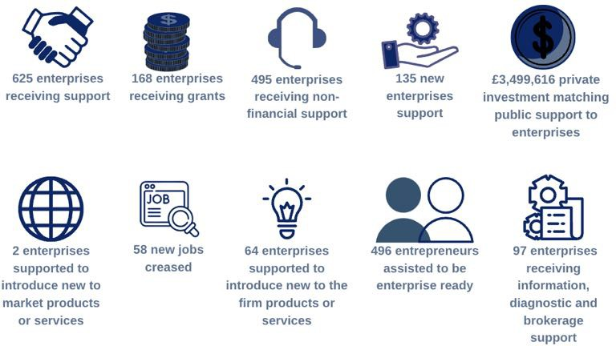

It is likely that six of the ten project targets will be met. For three other project targets, attainment will be at least 85%. For the remaining target C8, there could be significant underperformance at a level of 50% achievement.

Despite potentially not meeting its new C2, C4,C6 and C8 targets, the project is expected to exceed the original targets for the C28, C29, P11 and P11 (200, 137, 111 and 356, respectively). Hence, despite the challenges for project delivery during Brexit, COVID-19 and rising energy cost created, demand for the project from both pre-start and established SMEs was as envisioned during the project design phase. The project design team as well as the project management and delivery teams should be applauded for this.

# PROJECT MANAGEMENT AND DELIVERY

Was the project well managed? Were the right governance and management structures in place and did they operate in the way they were expected to?

The diagram 3 presents the organogram for the BHH Management and Governance structure

**Diagram 3: Organogram**

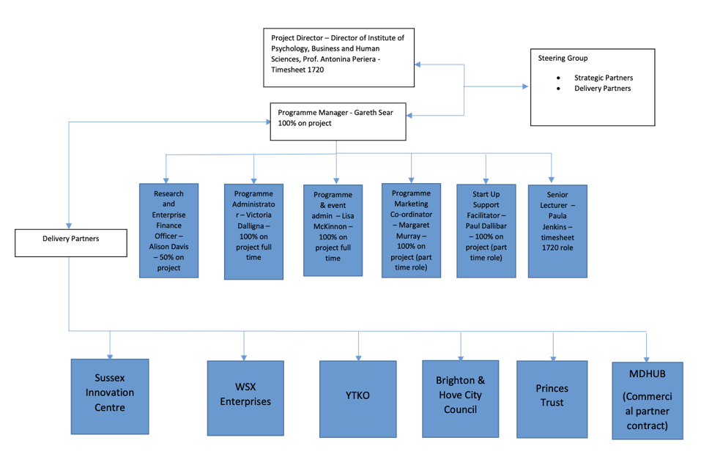

The BHH project had a complex structure and many delivery partners reflecting the original single lots that were pulled together at the negotiation stage. There has been some duplication between WSX Enterprise and YTKO on the delivery of the Investment readiness programme when the programme moved to online delivery as they were initially meant to share the geography. Sometimes they were ‘competing’ for the same customer base.

The Sussex Innovation Centre went through a lot of internal changes during the delivery period and the Management Team had to train up new starters onto BHH each time.

With hindsight, the Management Team recognised that it would have been beneficial to have further staffing to manage a complex programme such as BHH. Ideally, a project of this size and complexity would have required an additional Deputy Director to liaise with the Board and Vice Chancellor of the University and 2 further administrative support on marketing and finance respectively.

The COVID-19 pandemic, in a way, helped with all management and coordination meetings moving online. Many delivery partners had previous experience of ERDF which helped in smoothing some of the reporting process.

**Has the project delivered its intended activities to a high standard?**

The quality of the BHH programme services delivered is evidenced by the 75% of beneficiary survey respondents being satisfied or very satisfied with the service they received. The access to the Invest4 Grant/Investment readiness and the Start Up programme were particularly praised.

**Could delivery of the project have been improved in any way? How were project activities perceived by beneficiaries and other stakeholders?**

Several beneficiaries reported that they were not aware of the full breadth of services on offer through the BHH project. Only later in the delivery of the project, a brochure was created by the Management Team introducing the full offer.

Several beneficiaries consulted in our phone interviews reported that the Invest4 grant process was too bureaucratic for the money raised. The fact that there was no upfront payment was also a detriment to some firms which did not have the cash flow.

Wider stakeholders are very supportive of the BHH offer offering a good mix of support to young entrepreneurs and established firms but would have liked to see a common CRM and better cross-referrals mechanism between delivery partners, a more coordinated promotion of BHH across the geography with more activities being delivered in East Surrey and Mole Valley.

**Did the project engage with and select the right beneficiaries? Were the right procedures and criteria in place to ensure the project focused on the right beneficiaries?**

BHH had an impressive number of referral channels with the biggest source of referrals into the programme came from the Growth Hub (26.9%), then via the Economic Development Team at Local Authority (14.1%) and Word of mouth (11.5%) and via the Chamber of Commerce (11.5%). The network of libraries was also used to promote the programme to local citizens and potential entrepreneurs. Delivery partners have been very active in promoting the services to their respective local networks.

Good focus was made in the design of the project to attract both potential entrepreneurs and micro firms.

The aspect of the service being focused on high-growth versus any firms was less important to meet the demands, especially around the COVID-19 pandemic.

**How were procurement activities delivered?**

The project benefits from the University of Chichester (Lead applicant) well-established processes for running procurement activities.

All contracts were procured in line with the requirements of the ESIF Procurement Law with any expenditure incurred over £2,500 and up to £24,999 subject to three written quotes or prices being obtained.

A formal tender process was undertaken for any expenditure between £25,000 and

£164,176

# PROJECT HORIZONTAL THEMES

**To what extent have the horizontal principles been integrated into and shaped delivery?**

## Sustainability

The BHH Project has focus on sustainability has been driven mainly by the adoption of online delivery which had the potential of reducing carbon footprint and waste by:

* + Using less venues- with delivery done via Zoom and MS Teams
  + Less transport and driving – with delivery done via Zoom and MS Teams
  + Used less paper and printing – most marketing has been done digitally
  + Used less paper – with most forms, where possible being done by digital platforms such as DocuSign
  + Less transport and driving – with most meetings for delivery partners and the steering group being done online.
  + Less transport and driving – with allowing the Business Hothouse team to work in a hybrid manner and adopting digital tools to allow this.

## Equal opportunities and diversity

The BHH project has achieved the following figures when looking at equality and diversity. The programme has not specifically targeted different sections of society, but some of the delivery partners have focused their marketing to female business groups and BAME business groups. Workshops have not been specifically designed to work only with one group or another.

All venues that delivery has taken place, consideration has been given to disability access, whether that is for physical, visual or hearing.

Adaptations have been made when requested, for example changing fonts to support a visually impaired person.

Diversity data programme to date:

**Established businesses worked with:**

* + 52 were majority BAME led
  + 292 were majority female led
  + 30 businesses declared a disability Total engaged: 936

**Start Up**

* + 44 BAMEs
  + 132 Female Led
  + 21 Disability Total Engaged: 325

**Pre-start entrepreneurs:**

* + 132 declared a disability
  + 487 declared as female or self-describe
  + 310 declared as non-white background
  + 352 were aged <30
  + 137 were aged >50 Total engaged: 869

The management team is continuing into 2023 to ensure the effective collection of this data.

These numbers are not reflected in the official ERDF outputs, but are an indication of the numbers that the programme has worked with to date, based on the data collected from the participant entry forms. Furthermore, it should be noted that some of the data, on some of the PEFs, especially at the early stages of the programme, is missing.

# PROJECT OUTCOMES AND IMPACT

Ideally, project impacts would be calculated by subtracting the impacts experienced by counterfactuals from those experienced by beneficiaries between the times that they start receiving BHH services and afterwards. However, as only 11 counterfactuals completed the survey, the economic deadweight component of the economic impact will instead be calculated by subtracting the percentage that beneficiaries attribute their impacts to factors other than BHH.

The methodology employed for calculating the net Gross Value Added (GVA) impact of BHH is:

1. The number of barriers to doing research/innovation/business that beneficiaries have overcome since joining BHH, as reported by each beneficiary in their survey responses, was counted and multiplied by the percentage to which those same beneficiaries attribute overcoming those barriers to BHH. In this way, the GVA deadweight of the reported reductions in number of barriers was subtracted from the gross direct effects. (Deadweight = the outcomes that would have occurred even if the BHH project had not taken place). The average number of barriers that survey respondents indicated had been overcome during their time on the project was 1.87. Once deadweight was removed, this became 1.06 barriers on average.
2. The GVA gross direct effects were calculated by assigning an economic value to a beneficiary overcoming one barrier. This was done using the mean 3-year economic value of radical product innovation calculated in “Innovation types and performance in growing UK SMEs” Oke et al. (2007), uplifted to 2023 figures (2% compounded annual inflation was assumed) and divided by 10, which is the number of barriers to innovation on which our survey focussed. Oke et al. report on a survey of UK SMEs in manufacturing, engineering, electronics, information technology and telecommunications industries – a very relevant study on which to base BHH economic analyses. The uplifted mean 3-year economic value of BHH helping a beneficiary to overcome a barrier was calculated to be £76,899.
3. Evidence of GVA leakage, displacement and substitution was searched for amongst all the survey responses and phone calls from all the stakeholder groups and among the responses from the management and delivery team workshop. (Leakage = % of intervention benefiting individuals or organisations outside the target beneficiary group, at the expense of potential additional benefits to the target beneficiary group. Displacement = % of outcomes and outputs generated at the expense of outcomes or outputs elsewhere in the target beneficiary group. Substitution effects = activities undertaken in order to benefit from project services at the expense of another resource).

The eligibility check carried out during registration of prospective beneficiaries ensured that none of the beneficiaries were outside of the target beneficiary group (SME based in the relevant LEP area and seeking business support). Hence, the GVA leakage of BHH outcomes to out-of-target beneficiaries is £0.

The evaluators could not find any instances of displacement arising from BHH. For example, they could not find any instances of a business receiving free BHH services when they would otherwise have paid for them had project support not been available. Similarly, the assessors were reassured that the unique capabilities of BHH compared to other facilities meant that there was little possibility for this project to displace services offered at other facilities too. We consider the GVA displacement to be £0.

As there were no criteria for beneficiaries and counterfactuals to meet in order to benefit from BHH services (e.g. they did not need to make a capital purchase or recruit a new employee in order to be eligible), the GVA substitution effects of the project is £0.

1. The SIC codes of the beneficiaries were translated into Office for National Statistics Input-Output Analytical tables industries by matching the industry most closely related to each SIC code. The GVA multipliers for these industries were identified. For example, the GVA multiplier for the ‘Manufacture of plastic packing goods’ is 1.822. This means that for every £1 increase in GVA in that industry, there is 82.2p additionally created down the GVA supply chain (i.e. multiplier effects). These multiplier effects encompass both Type I multiplier effects (direct effects to the beneficiary firms, their employees and their supply chain firms and employees), as well as Type II multiplier effects (benefits resulting as a consequence of the Type I effects, e.g. increased disposable income of beneficiary and supply chain employees results in greater spending elsewhere in the economy).
2. Finally, for each beneficiary who completed the survey, the number of barriers that they have overcome since joining BHH (bullet point A above) was multiplied by the 3-year economic value of overcoming one barrier for that same beneficiary (bullet point B above). Any instances of leakage, substitution or displacement relating to that beneficiary (bullet point C above) were subtracted from this amount. The resulting amount was then multiplied by the GVA multiplier (bullet point D above) to give the fully corrected 3-year GVA impact estimate for each beneficiary. These individual GVA impacts were then summed and extrapolated to estimate the fully corrected GVA impact for all 1643 beneficiaries, i.e. it is assumed that the GVA benefits of BHH participation for all 78 beneficiaries is represented by the GVA benefits reported by the subset of beneficiaries who completed the survey.

As explained in bullet point E, the net impact is the following calculation:

Net impact = (Gross direct effects - Deadweight - Leakage - Displacement - Substitution) x Multiplier effects.

3-year net GVA impact = £111, 369, 940.62. This is a non-negligible GVA impact for the Chichester region, which currently has a manufacturing GVA output of roughly £7b/year (“Taking stock: an audit of Chichester’s economy in 2021”) - the largest single sector in terms of GVA in Chichester. Forecast projections by Oxford Economics for the Advanced Manufacturing Report (New Economy, 2014) estimated an increase of 23% in GVA in the sector between 2011 and 2022.

This project will have been one of the important steps taken to realise this GVA increase.

In the process of creating this GVA impact, employment impact was also created. This employment benefit was calculated as follows:

1. The number of FTE jobs created or safeguarded in beneficiary firms since they joined BHH, as reported by each beneficiary in their survey responses, was counted to give an estimate of employment gross direct effects. The employment deadweight was subtracted from this number by multiplying these same number of FTE jobs per beneficiary by the extent to which the beneficiaries attributed creation of these jobs to sources other than BHH.
2. Any employment displacement, substitution or leakage that occurred in the creation of jobs attributed to BHH, as indicated by beneficiaries in their phone calls or surveys or by the BHH management and delivery team in the workshop discussions, were then also subtracted. These corrections were all deemed to be 0, for the same reasons as those described in bullet point C.
3. The process described in bullet point D was repeated but this time to calculate employment multipliers for each beneficiary. For example, the employment multiplier for the “Manufacture of plastic packing goods’” industry is 1.624. This means that for every 1 FTE increase in employment in that industry, there is 0.624 FTE additionally created down the employment supply chain.
4. Finally, for each beneficiary who completed the survey, the deadweight was subtracted from the gross direct effects for each survey respondent (bullet point F). Any leakage, substitution and displacement (bullet point G) was subtracted from this amount. This amount was then multiplied by the employment multiplier effect (bullet point H) for each beneficiary. These amounts were then summed and extrapolated over all 1643 beneficiaries to give the fully corrected employment impact.

Net employment impact = 437 FTE. This is a non-negligible employment impact for the Chichester region, which currently employs roughly 80,000 people in the manufacturing sector alone (“Taking stock: an audit of Chichester’s economy in 2021”).

The steps leading to calculation of net GVA impact and net employment impact for BHH are presented in Table 3.

**Table 3: Gross and Net Additional Impact for Employment and GVA (full project lifetime). All figures include Multiplier Effects as these are applied at the individual beneficiary level**

|  |  |  |  |
| --- | --- | --- | --- |
| Impact |  | Measure | Adjustment |
| GVA (£) | Gross direct effects | £66,978m | - |
| Minus Deadweight | £66,978m | 0% |
| Minus Displacement and Substitution | £66,978m | 0% |
| Minus Leakage | £66,978m | 0% |
| Net Additional | £111,369m | 1.66 average Multiplier across beneﬁciaries |
| Employment (FTE) | Gross direct effects | £20,643m | - |
| Minus Deadweight | £20,643m | 0% |
| Minus Displacement and Substitution | £20,643m | 0% |
| Minus Leakage | £20,643m | 0% |
| Net Additional | £33,430m | 1.62 average Multiplier across all beneﬁciaries |

The net economic impact is the sum of the GVA impact and economic employment impact. We assume the economic impact of the job creation outlined in Table 5 is £25,500*3 per job. This is the average 3-year salary for a Marketing officer (Glassdoor website, February 2023). Thus, the economic impact of the 437 jobs created with BHH help is £33,430,500. Adding this to the GVA impact gives a total net economic impact of £144, 8m.

# PROJECT VALUE FOR MONEY

Total funds to deliver the BHH project was £10,864,904. Balancing this total delivery cost against the 3-year net economic impact, we calculate the project value for money to be:

→ Output/input unit cost: £13.33

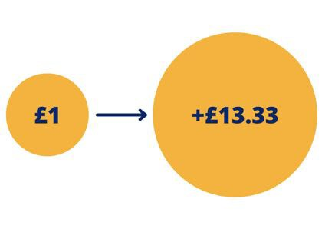

This means that for every £1 spent in delivering this project, £13.33 was created

The net economic impact was achieved with

£5,432,452 cost to ERDF.

## 9.1 Benchmarking

Table 4 compares the value for money of BHH against comparable ERDF projects. The comparator projects were chosen either because they also had an industry focus or because they offered similar services (access to grant equipment and services).

**Table 4: Benchmarking against comparable ERDF projects**

|  |  |  |  |  |  |  |  |  |  |
| --- | --- | --- | --- | --- | --- | --- | --- | --- | --- |
| **Project name** | **Lead partner** | | **Priority axis** | | **Focus / sector** | | **Total project value** | **Targets** | **Value for Money** |
| BHH | University Chichester | of | 3a 3b | and | Start-ups established SMEs  sectors | and all | £10.8m | C1 x 856  C2 x 236  C4 x 620  C5 x 213  C8 x 164  C28 x 1  C29 x 51  P11 x 471  P13 x 30 | £13.33 |
| TALE | Haven Gateway Partnership | | 3c 3d | and | Transport Logistics | & | £7.3m | C1 x 225  C2 x 185  C4 x 40  C8 x 100  C29 x 125  P13 x 375 | £11.76 |
| I-construct | Haven Gateway Partnership | | 3a, 3c and 3d | | Construction | | £7m | C1 x 220  C2 x 110  C4 x 110  C5 x 15  C8 x 60  C28 x 20  C29 x 110  P13 x 362  P2 x 629 | £18.75 |
| AMRC NW | University Sheﬃeld | of | 1b | | Advanced Manufacturing | | £5.7m | C1 x 270  C4 x 270  C5 x 22  C8 x 258  C26 x 200  C28 x 30  C29 x 30 | £4.52 |
| CIAMM | University Birmingham | of | 1 | | Quantum | | £1.2m | C1 x 40  C4 x 40  C5 x 10  C8 x 5  C26 x 30  C26 x 5  C28 x 5  C29 x 10 | £3.40 |
| AMCASH | University Birmingham | of | 1 | | Advanced Manufacturing | | £6m | C1 x 180  C4 x 180  C8 x 44  C26 x 141 | £8.13 |

|  |  |  |  |  |  |  |
| --- | --- | --- | --- | --- | --- | --- |
|  |  |  |  |  | C28 x 18  C29 x 95 |  |
| Manufacturing Growth  Programme (PanLEP) | Economic Growth  Solutions (West Midlands) | 3c | Manufacturing SMEs | £10.5m | C1 x 2463  C2 x 2463  C5 x 141  C8 x 3566  C9 x 818  C6 x £9.6m | £6.78 |
| ATETA | University of Birmingham | 4f | Low Carbon | £4m | C1 x 100  C26 x 30  C29 x 20 | £6.10 |

Compared with comparable ERDF-funded projects, BHH represented good value for money: a return of investment of £13.33 per £1 invested is top of the range and the sizes of its targets were some of the highest.

Given that the majority of this project was delivered during the COVID-19 pandemic, this is an excellent achievement.

# CONCLUSIONS AND LESSONS LEARNT

## 10.1 Conclusions

The BHH project is unique in the C2C LEP area. The strengths of this project include its very diverse and specialist array of business support services available to all businesses in the C2C LEP Area. The different strands of the programme have allowed it to support pre-start, start-up as well as established enterprises.

The project has been able to adapt well to the COVID-19 pandemic with services being delivered mostly online, making it more accessible. The use of libraries has been particularly helpful to advertise the programme close to citizens and to attract potential young entrepreneurs. A miss opportunity has been the involvement of graduates in the delivery plan.

The Invest4 grant scheme has been a good hock to attract beneficiaries into the BHH programme while it suffered from some competition from the Covid 19 grants at the beginning of delivery.

The management Team and delivery partners worked hard to get a variety of referrals into the programme. BHH is now fully integrated in the wider innovation and business support ecosystem. The biggest source of referrals into the BHH programme came from the Growth Hub, via the Economic Development Team at Local Authority, word of mouth and via the Chamber of Commerce.

The quality of the service being delivered is good with 75% of beneficiaries indicating that they were very satisfied or satisfied with the service. The services found most useful were grants (32.9%), followed by Workshops/webinars (27.4%) and then 1.2.1 mentoring (13.7%).

The Project Team has done particularly well in attracting women into the business support programme.

61.5% of firms reported making progress towards new-to-firm product or service with an increase in TRL of +3.64 and many firms reaching TRL level 9. This is much higher than other ERDF projects.

13% of firms reported to be badly or very badly affected by the pandemic but with some positive impacts following COVID-19 mainly on efficiency gain with the digitalisation of processes.

Six out of ten targets which will be met or exceeded. Three targets will be met above 85% attainment. Only 1 target, C8, will fall significantly short. The economic instability is preventing firms from employing new staff until better visibility.

The value for money was particularly good with every £1 invested in delivering this project,

£13.33 was created.

Some weaknesses of this project include a lack of a common website, CRM, central docusign system for the registration and monitoring of outputs with missed opportunities on capturing more C1 and associated performance indicators.

The main themes of interest mentioned by the beneficiaries for future activities are: more funding, SEO/social media/online presence, marketing/sales training/networking opportunities, mentoring, recruitment of staff, product testing.

## Lessons learned

|  |
| --- |
| Universities can be successful leaders of business support programmes (PA3) and not restricted to innovation and R&D (PA1) projects. |
| Complex ERDF projects require sufficient resources to be well managed and it should not be underestimated. |
| Switching the delivery of a business support programme to online makes the programme more accessible to All. |
| The use of Libraries is a good communication channel to engage with citizens and potential young entrepreneurs. |
| The use of an online grant application form makes a grant programme easier to manage and avoid the issue of compatibility between different softwares: I-phone, Macs etc. |
| While running a grant programme, making links and connections with the banks are positive to seek potential joint investments. |
| It takes time to build awareness and reputation of a new business support project. It is important to link up effectively with the wider ecosystem. |
| Using a common website, common CRM, and common docusign to check the eligibility of beneficiaries would make the registration and promotion of a complex programme involving many delivery partners easier. |
| A better selection of grant recipients promising to deliver on C28/C29 and C8 outputs would increase the programme impact as a whole. |

## Recommendations for legacy

* Provide a Team of mentors/Coaches as opposed to one specific allocated mentor to service a beneficiary having a range of needs & demands.
* Keep streamlining the grant application process using a more user-friendly interface for grant applicants.
* Enterprises are interested in a more customised approach to their business. Run different groups for start-ups and established companies.
* While the momentum and interest is there for a follow-up programme, explore new sources of match-funding such as under the new UKSPF.
* Explore the opportunity to involve other departments within the university with the involvement of graduate students.

# GLOSSARY

|  |  |
| --- | --- |
| ERDF | European Regional Development Fund |
| BHH | Business Hothouse |
| Managing Authority | DLUHC is the Managing Agent for ERDF Funding |
| DLUHC | Department for Levelling Up, Housing and Communities |
| SMEs | Small and medium sized enterprises |
| Summative Assessment | Final evaluation of an ERDF project |

# TEAM CONSULTEES

|  |  |  |
| --- | --- | --- |
| Name | Role | Organisation |
| Candida Goulden | Economic Development Manager | Mole Valley District Council |
| Tracie Davey | CEO | Worthing and Adur Chamber of Commerce |
| Max Woodford | Assistant Director City Development and Regeneration | Brighton & Hove County Council |
| Matthew Heath | Project Manager | C2C LEP |
| Miriam Nicholls | EDO | Arun District Council |
| Anne de Sousmarez | EDM | West Sussex County Council |
| Nicola Wiley | Director | YTCO |
| Neil Clarke | ERDF Grant Fund Manager | Brighton & Hove County Council |
| Micro Cordeiro | Project Impact Officer | Brighton & Hove County Council |
| Claire Wheeler |  | Princes’ Trust |

|  |  |  |
| --- | --- | --- |
| Linda Butler |  | Dorset Growth Hub |
| Lisa McKinnon |  | University of Chichester |
| Luana Lefter | Administrator | Get Set for Growth |
| Miranda Morgan |  | WSX Enterprise |
| Paul Dalibar |  | University of Chichester |
| Maria Bedoya |  | Sussex Innovation |
| Gareth Sear | Project Manager | University of Chichester |
| Victoria Dall’igna | Business Hothouse Project Coordinator | University of Chichester |
| Alison Davis | Finance Manager | University of Chichester |
| Nick Gregory | Operational Director | Dorset Growth Hub |

# APPENDIX

Beneficiary Survey Responses

Counterfactual Survey Responses

Aide Memoire notes from 25 beneficiaries

Aide Memoire notes from 10 Wider Stakeholders