

University of Chichester

Waste Management Plan

2023 to 2028

***Date: March 2023 Version number: 1***

|  |  |
| --- | --- |
| ***Approval route*** | ***SEEM*** |
| ***Date*** | ***19/4/23*** |

# Contents

|  |  |
| --- | --- |
| Section | Page number |
| 1.0 Context | 3 |
| 1.1 Background | 3 |
| 1.2 United Nations Sustainable Development Goals | 3 |
| 1.3 Our achievements so far | 4 |
| 1.4 Influencing factors | 5 |
| 2.0 Waste management data | 6 |
| 2.1 Operational waste current data | 6 |
| 2.2 Operational waste comparison with earlier years | 7 |
| 2.3 Construction waste current data | 7 |
| 3.0 Objectives and Targets | 7 |
| 3.1 Objectives | 7 |
| 3.2 Targets | 8 |
| 4.0 Action plan | 9 |
| 5.0 Monitoring and review | 11 |
| 6.0 References | 11 |

# 1.Context

## 1.1 Background

As an organisation we consume resources and produce large quantities of waste from our student accommodation, catering facilities, offices, and teaching departments. Waste and recycling are highly visible issues in the sustainability agenda. Careful and innovative waste management can demonstrate our commitment to sustainability to our students, staff and visitors and offer an opportunity for the university community to easily become involved in sustainability improvements.

We are committed to sustainable waste management practices as highlighted in our Sustainability Policy.1 This Waste Management Plan will contribute to our Environmental Management System (EMS) and our Sustainability Strategy 2023 to 20282. This plan also aligns with our University Strategic Plan 2018 to 20253 key targets, to remain financially stable and develop environmentally sustainable campuses.

The continued implementation of sustainable waste management practices offers the opportunity to cut costs through effective resource management. The University currently spends approximately £230,000 on waste management each year. Our aim is to manage resources more efficiently, prevent and minimise waste, increase recycling and participation giving us the following benefits:

• Legal compliance

• Reduced environmental impact

• Improved reputation

• Support for carbon reduction targets

• Cost minimisation.

More information on the roles and responsibilities of all stakeholders and the destination of wastes generated on our campuses is provided in our Waste Management Information and Guidelines4 document.

The actions identified in this plan aim to identify and build on existing good practice including the Waste Hierarchy and circular economy ideals.

## 1.2 United Nations Sustainable Development Goals

The University’s Sustainability Strategy aligns to the United Nations Sustainable Development Goals (Figure 1) to ensure progress is made in all areas pertinent to the University’s activities. Waste management is integral to the success of many of these goals, including specifically;

SDG 11 Sustainable Cities and Communities

SDG 12 Responsible Consumption and Production

SDG 13 Climate Action

SDG 14 Life Below Water

SDG 15 Life On land

Relevant aspects of these goals have been considered in the generation of this plan.

*Figure1 United Nations Sustainable Development Goals*

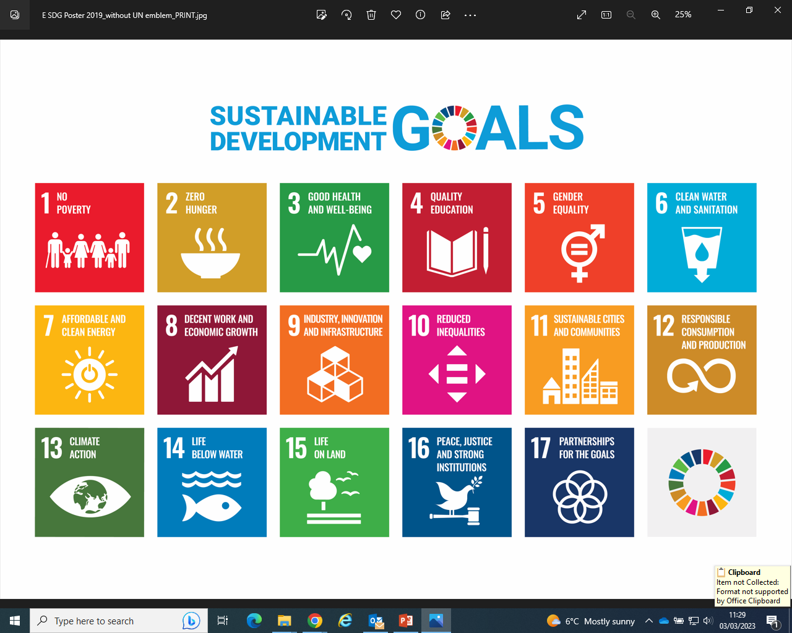

## 1.3 Our achievements so far

We have been working to improve waste management at the University since about 2008. A summary of some of our key achievements is given below (Table 1)

*Table 1 Summary of waste initiatives completed to date*

|  |  |
| --- | --- |
| External contracts | We have used the procurement process to ensure our waste contractor supports us in our aim for sustainable waste management and improve our service delivery. A requirement of our waste tender in 2021, was for the contractor to provide waste collection enabling a maximum number of waste types, including disposable hot drinks cups and lids, to be recycled. The successful contractor was required to have similar sustainability objectives to the University and achieve maximum diversion of general waste from disposal to landfill. Our catering contractor is also required to have similar sustainability objectives and has helped us to ensure food waste is collected for anaerobic digestion. |
| Composting | Green waste from the maintenance of our grounds is composted on our campuses helping to reduce waste sent offsite. Waste wood is left on the campuses to provide homes for wildlife. |
| Recycling infrastructure | Barriers to recycling on campus have been the subject of many surveys and student projects. In 2019 significant investment in recycling bin infrastructure, including positioning and labelling of bins, was made. With negotiation of a new commercial waste contract in 2021, further improvements in signage and awareness of where and what can be recycled was the focus. |
| Multi-functional device implementation | In 2013 we rolled out a University-wide programme to move from desktop printers, faxes, scanners and copiers to multi-functional devices. In 2016, this change was boosted with the initiation of Operation Papercut, a project led by our IT Skills team to reduce paper usage across the organisation. |
| Participation in external projects | The University is an active participant in a Higher Education Recycling Project run by West Sussex County Council and Chichester District Council. This project has enabled us to understand further the barriers to recycling on our campuses and the composition of our waste streams to help improve our recycling rate. |

## 1.4 Influencing Factors

Although we are proud of our achievements so far, we recognise there is much more to do. In producing our waste management plan, we have taken the following influencing factors into consideration.

***Waste Hierarchy***

The Waste Hierarchy (Figure 2) ranks waste management options according to their impact on the environment. As a mandatory requirement of the Waste (England & Wales) Regulations 2011, it should be considered when deciding the best option to manage a waste stream. This places more emphasis on waste prevention, and requires organisations to consider preparing waste for reuse, then seeking opportunities for recycling, before options such as anaerobic digestion, energy recovery, incineration or landfill.

*Figure 2 The Waste Hierarchy*

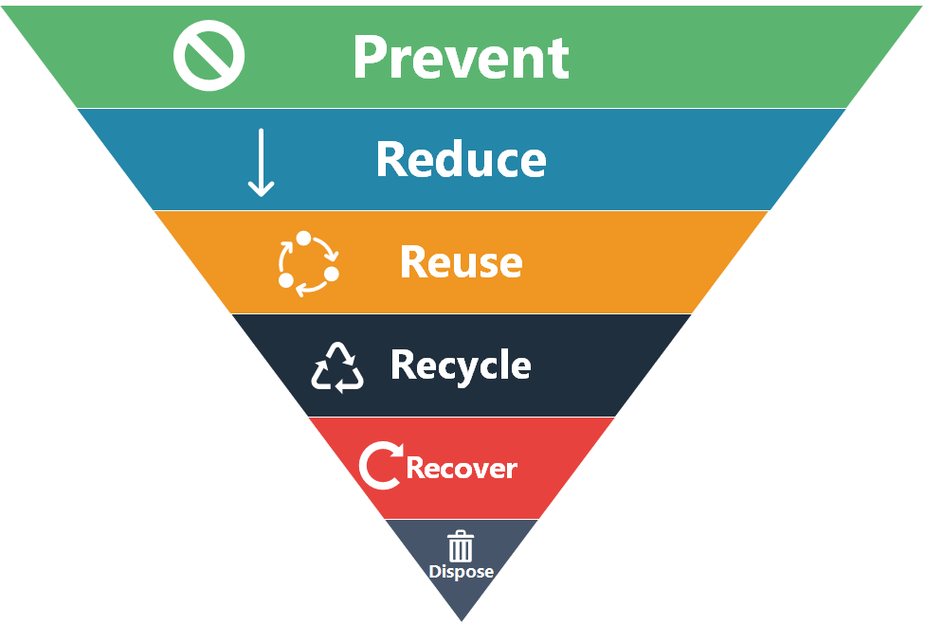

An integral part of the first stage of the waste hierarchy is reduce and reuse. It is now widely accepted that the traditional linear economy of make, use, dispose is not sustainable. The circular economy in which we keep resources in use for as long as possible, extract the maximum value from them whilst in use, then recover and regenerate products and materials at the end of each service life, is the way forward and is considered in this plan, along with life cycle thinking. We will consider these principles in our waste management choices and also in the procurement of goods, through our Procurement Policy 20225.

***Legal and other requirements***

As with all businesses we have a legal duty to provide appropriate arrangements for the disposal of our waste and ensure it is handled appropriately. Our Waste Management Information and Guidelines document includes details on how waste is managed on campus to ensure legal compliance, including through our contractors and partners. This document also outlines the roles and responsibilities for the whole of the university community in relation to waste, destinations for our waste and an A-Z of recycling4.

# 2. Waste management data

## 2.1 Operational waste current data

In the last academic year 2021/22, we produced 532 tonnes of operational waste. This is waste from our offices, teaching rooms and accommodation blocks. Of this 34% was recycled and 55% was used to generate energy. A small proportion 4% had to be landfilled. For the first time, 11.8t of food waste was collected for anaerobic digestion. Garden waste (25t) continued to be composted on our campuses. A breakdown of the destination of all operational waste is provided in Figure 3

*Figure 3 Destination of operational waste produced by the University 2021/22*

|  |  |  |  |  |
| --- | --- | --- | --- | --- |
| https://www.recycling.com/wp-content/uploads/recycling%20symbols/universal/Universal%20Recycling%20Symbol%20%28U%2b2672%29.jpg | Led light | Free vector flat biofuel production plant with corn field | Plant | Landfill |
| Recycled  34% | Energy generation  55% | Anaerobic digestion  2% | Composting  5% | Landfill  4% |

## 2.2 Operational waste comparison with earlier years

Accurate comparison of the waste amounts produced by the University and treatment methods is difficult. Most of the difficulties have been caused by the University’s drive to enable more accurate data for wastes generated, moving in 2018/19 from assumptions of waste weights, to actual weighing of waste as its collected from campus. This has caused wide discrepancies in the data obtained. More recently, the Covid 19 pandemic caused complete and partial closure of our campuses spanning the academic years 2019/20 and 2020/21, rendering waste data inaccurate. In November 2021, Chichester District Council were awarded our waste management contract. Although this change in contractor has again led to inconsistency in data collection, the benefits as outlined below, negate these issues.

* Reduced vehicle emissions due to locality of collection services
* Increased number of waste types included in mixed recycling
* Uniform messages on and off campus to the majority of students and staff residing in West Sussex.

Obtaining high quality waste data is featured in our targets and action plan for the next five years.

## 2.3 Construction waste current data

In the last academic year 2021/22 our construction and refurbishment activities produced 17.4 tonnes of waste. Most of this waste was recycled (85%) with a small amount requiring landfill (15%). It is widely accepted that the amount of construction waste varies year on year, depending on activities taking place on the campuses. Destinations for the waste is controlled by our contractor tender agreements. The University currently has ambitious plans to increase student accommodation on our campuses. Control of construction waste during this development period is featured in our targets and action plan for the next five years.

# 3.0 Objectives and Targets

## 3.1 Objectives

The following objectives have been established for this plan:

1. Eliminate waste and improve resource efficiency through consideration of the circular economy and the waste hierarchy principles.

2. Ensure legal compliance and best practice with waste management

3. Reduce the cost of waste disposal

4. Improve the quality of waste data.

## 3.2 Targets

Specific targets have been set as part of the Sustainability Strategy 2023 to 20282 in line with the United Nations Sustainable Development goals identified earlier (see Section 1.2).

|  |  |  |
| --- | --- | --- |
| **Initiative** | **Target** | **Target date** |
| Reduce the amount of operational waste generated by the university | Operational waste reduced by 5% from baseline year 2021/22.  Operational waste reduced by 2% year on year until September 2028. | September 2024  September 2025 to 2028 |
| Increase the amount of operational waste recycled by the university | Operational waste recycled increased by 5% from baseline year 2021/22.  Operational waste recycled increased by 2% year on year until September 2028. | September 2023  September 2025 to 2028 |
| Waste disposal practices have least effect on land. | Ensure operational waste to landfill remains below 5% | August 2028 |
| Minimise waste generation from new builds and refurbishments. | All new buildings and refurbished buildings, including Cornerstone accommodation, have low waste generation initiatives in place during the construction phase. | 2023 to 2028 |
| Maximise recycling of waste generated from new builds and refurbishments. | All new buildings and refurbished buildings, including Cornerstone accommodation, have waste recycling initiatives in place during the construction phase. | 2023 to 2028 |

# 4.0 Action Plan

An action plan to achieve the targets in Section 3.2 has been produced. It is anticipated that this will be a live document updated throughout the five year duration of this management plan.

|  |  |  |  |
| --- | --- | --- | --- |
| **Target** | **Key Actions** | **Timescale** | **Responsibility** |
| Operational waste reduced by 12% from baseline year 2021/22. | Campaign to reduce takeaway containers | From March 2023 | Sustainability Co-ordinator |
| Introduce reusable box scheme. | September 2024 | Sustainability Co-ordinator |
| Continue to identify single use items on campus. | From March 2023 | Waste Working Group and SU Environment Society |
| Work with departments to reduce paper usage | From March 2023 | IT Skills Team |
| Campaign to reduce food waste. | From September 2023 | Sustainability Co-ordinator |
| Procurement activities include consideration of waste generation | September 2028 | Procurement Officer |
| Reduce the sale of drinks in plastic bottles.  Stop the sale of drinks in plastic bottles. | September 2024  September 2026 | Head of Campus and Residential Services and Sustainability Co-ordinator |
| Join a food waste redistribution scheme. | September 2023 | Sustainability Co-ordinator |
| Remove one single use item from campus each year. | From March 2023 | Sustainability Co-ordinator |
| Remove 50% of plastic products from campus. | September 2028 | Sustainability Co-ordinator |
| **Target** | **Key Actions** | **Timescale** | **Responsibility** |
| Operational waste recycled increased by 15% from baseline year 2021/22 | Develop an outlet for flimsy plastics on campus | September 2028 | Sustainability Co-ordinator and Campus Services Manager |
| Continue to campaign to increase awareness of recyclable items. | From March 2023 | Sustainability Co-ordinator |
| Continue to be part of the Higher Education Recycling Project. | From March 2023 | Sustainability Co-ordinator |
| Extend food waste collection across campuses. | September 2028 | Sustainability Co-ordinator and Campus Services Manager |
| Increase collection of recyclable items at student departures | From March 2023 | Sustainability Co-ordinator |
| Ensure operational waste to landfill remains below 5% | Continue to work with waste management contractor to maximise other outlets for waste. | From March 2023 | Sustainability Co-ordinator and Campus Services Manager |

# 5.0 Monitoring and Review

The waste management targets described in Section 3.2 will be monitored by the Waste Group and Sustainability, Environment and Energy Management group (SEEM) in line with the University’s Environmental Management System.

The Waste Group will meet at least every six months to monitor progress and achievement of actions. The composition of the Waste Group includes individuals from different areas within the University and SU representatives6. Minutes from waste group meetings are reviewed by SEEM. An annual review of the plan, undertaken by the Waste Group, will ensure that the plan remains robust in terms of both future planned capital developments and growth in student numbers.

A periodic audit of legal compliance with regards to waste management will be carried out. This will cover waste storage, handling and controlled documents. The audit will be carried out as a minimum annually and results reported to the Waste Group and SEEM.

# 6.0 References

1. University of Chichester Sustainability Policy
2. University of Chichester Sustainability Strategy 2023 to 2028
3. University Strategic Plan 2018 to 2025 Open for change
4. University of Chichester Waste Management Information and Guidelines
5. University of Chichester Procurement Policy 2022 [Procurement-Policy-2022.docx (live.com)](https://view.officeapps.live.com/op/view.aspx?src=https%3A%2F%2Fwww.chi.ac.uk%2Fapp%2Fuploads%2F2022%2F11%2FProcurement-Policy-2022.docx&wdOrigin=BROWSELINK)
6. University of Chichester Waste Group Terms of Reference