Academic Engagement Enabling Strategy 2018-2025 (updated 2023)

This Enabling Strategy draws together elements of strategic plans relating to Recruitment, Marketing, Academic Partnerships and Community Engagement.

It is a concise blueprint for action, focused on two key sections for each of the

three Strategic Themes it encompasses:

1. ‘how’ the strategic themes will be delivered
2. ‘how’ progress will be measured

The key Strategic Themes covered by the Academic Engagement Enabling Strategy are:

2: To increase the size and diversity of our student body

5: To increase external academic engagement, meeting regional needs and securing national and international recognition

6: To build on our heritage in teacher education

# 2: To increase the size and diversity of our student body

The University’s total FPE had a sharp decline for 2017 entry and steadied for 2018, before growing until 2021, where it became effectively capped by limits to student accommodation. Given the relative size and growth patterns of our identified competitor HEIs, it is clear that we need to continue to increase the size and diversity of our student body in order to strengthen the University’s financial sustainability.

The proposed growth will be delivered through careful consolidation and management of the current portfolio, coupled with development and marketing of a diverse, attractive and industry/profession/employer-focused academic portfolio, and with enhanced expectation of the scale of growth across home, international, undergraduate, postgraduate, and degree apprenticeship enrolments.

The impact of incremental growth in student numbers will continue to be managed carefully by Estate Management, Academic Registry, Student Welfare, Learning & Information Services, and other University Professional Services.

## Delivery will be enabled by:

### Marketing, Recruitment and Admissions

1. Imaginative and confident multi-media and on-the-ground marketing throughout the recruitment, conversion and admissions cycle, including via all Applicant Open Days.
2. Development of a balance of institutional and subject specialist marketing to allow bespoke arrangements and activities to harmonise efficiently and effectively with central marketing campaign work.
3. Flexible approaches to physical, virtual and international auditions, interviews and offer-making, with timely and professional confirmation, pre-sessional and enrolment service.
4. Visible messaging and active championship of inclusivity, equality and diversity, specifically referencing all protected characteristics, both internally and externally.
5. Purposeful approach to growing ethnically diverse enrolments, with awareness of ethnicity complexity in relation to portfolio, curriculum, behaviours, influencers, and our own ethnically diverse students.
6. Aspirational feeder school/college engagement, high quality UCAS/HE recruitment events, and informed external positioning of our researchers, teachers, practitioners, students.
7. Reputation enhancing activity, showcasing positive metrics, league table performances, research/innovation achievements, PSRB accreditations, industrial/professional alliances.

### Academic Portfolio

1. Creation of a distinctive and authoritative portfolio of courses that are market-attractive, employment/industry-relevant, industry networked, high-quality and high-value.
2. Development of innovative, creative, exciting curricula and delivery methods that enable our graduates to be informed, confident and successful in their professional lives and careers.
3. Use of robust data to support course development, enable understanding of sector/industry/population trends, and enable course performance monitoring against specified indicators.
4. Definition of progression routes from schools/colleges/global partners into all levels of UG/PG study, and responsive approaches to accreditation of prior experience and learning.
5. Academic development to ensure universal digital literacy, explicit employability curricula, new access routes, Degree Apprenticeships, etc.

### International Engagement

1. Support and celebration of our international student community, suitably integrated and appropriately accommodated to meet their personal, social, educational and cultural needs.
2. Developing ‘global citizenship’ in our students, informing better understanding of diverse cultures, providing travel/study abroad opportunities, reflecting curriculum diversity, and embedding outward mobility in employability and personal advancement agendas.
3. Exploiting new curriculum developments (e.g., in STEM and PGT) to attract interest from fresh international markets post-Brexit.
4. Agreeing appropriate entry requirements and pathways for on campus international recruitment and providing focused international customer care to maximise conversions.
5. Publicised availability of pre-sessional, integrated, and additional International English Studies for students whose first language is not English.
6. Concentration of resource on small number of high-performing high-yield agents, with appropriate inbound familiarisation events, and competitive partner discounts and other incentives.
7. Pursuit of opportunities to collaborate with high quality international providers on sub-degree provision, progression arrangements, articulation, and short programme provision.
8. Integration of international marketing with that for the home market, improving web/social media and hard copy marketing, technical function, and content development.

### Progress will be measured by:

**KPI 1:** The University’s total Full-Time Equivalent (FTE) will increase to circa 6,500 by 2025 entry as reported in the HESA return.

**KPI 2:** The University will have at least 600 (Degree) Apprentices enrolled by 2025 entry, with those numbers contributing to KPI 1 (above)

**KPI 3:** The University’s total UG/PG international students will be 10% of total student FTE as defined in KPI 1

**KPI 4:** The University’s student population will exhibit greater diversity as new 1.2% Asian, entrant ethnically diverse numbers rise to 11.8% by 2025.

### Numbers modelling:

**Note 1:** All numbers shown in Figure 1 are FTE and are for all years not just intake. They do not include partner students (c. 250 in 2023) who are included in the HESA return (and thus also KPI 1).

Current modelling (updated 2023)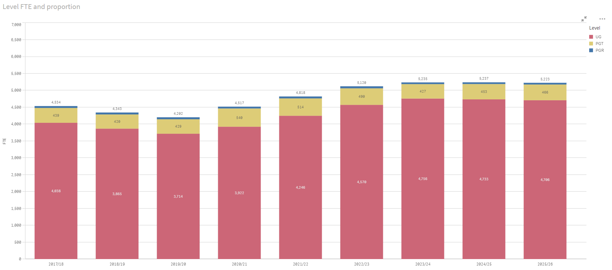

# 5. To increase external academic engagement, meeting regional needs and securing national and international recognition

Developing a strategic approach to increased external academic engagement to further the University’s role as a credible and authoritative anchor institution for West Sussex and the wider region, ensuring our academic provision is aligned to the region’s economic, educational and cultural needs, and that it gains traction with national and international markets and audiences.

This strategic theme will be delivered through mapping, aligning and developing the University’s external engagement across the region, maximizing regional presence, impact and visibility, and extending the reach and contribution of our learning community. It will be additionally delivered through a purposeful approach to national and international reputation enhancement, and in growth of annual income from high quality regional to international academic partnerships.

This theme requires skilled and committed capacity and expertise to realise its ambition with respect to national and international partnerships, press/media, and portfolio development.

## Delivery will be enabled by:

### Partnership quality and income

1. Ensuring clear income, scale, risk and entry/exit strategy parameters, confirming academic partner programmes align with the University’s academic portfolio (especially L6 and Degree Apprenticeships provision), and adopting nimble, proactive and business-like approaches to emergent opportunities.
2. Articulating direct and innovative progression pathways to the University’s on-campus UG/PG and Degree Apprenticeship provision for those studying under our regional and international partnership agreements, including via direct entry, RPL/RPEL, credit accumulation portfolio, joint delivery, etc.
3. Formalising our strong regional partnerships through development of the University of Chichester Regional Partnership Network to ensure consolidated and sustainable benefit and growth of cross-institutional opportunities.
4. Continuing to be a proactive member of the Sussex Learning Network, and extending our network of focused, relevant local and regional educational, business, municipal and cultural contacts to the benefit of our academic provision.

### Portfolio development to meet regional needs:

1. Developing evidence-based new and enhanced provision in line with regional economic/social regeneration needs, the imperatives of Government (e.g., UK Industrial Strategy and other relevant policies), the need to assert a strong presence in respect to LEP, county and local authority activity, and to be responsive to national Higher Education market demands.
2. The following are not exclusive or standalone, but point to where the University will develop in order to have graduates in, for example, Health, Law, Design-STEM-Business (potentially including Built Environment, Policing, Security and Criminology), cyber/biotech/digital industries.

### External reputation

1. Continuing to develop our institutional careers and employability support, embedding explicit employability skills in curricula, and growing work-based learning/placements to drive associated graduate prospects metrics upwards over the period, thereby improving league table rankings (Complete University Guide and The Guardian University Guide) and future TEF performance.
2. Refreshing the University’s approach to strategic communications, content generation, external engagement and public relations, to make a demonstrably positive impact on our reputation, and grow awareness of our brand and ambition amongst core local, national and international audiences and key stakeholders.
3. Being cognisant of our visibility in both Chichester and Bognor Regis – ‘town and gown’ awareness – ensuring academic and professional services colleagues are informed, appropriately experienced in reputation-management and fully-oriented towards our corporate and market needs.

### Progress will be measured by:

KPI 1: The University’s external engagement will be demonstrated through good partnership and progression mapping, a focused and well-maintained CRM database of local, regional, national and international contacts, and leadership of regional networks and initiatives.

KPI 2: The University’s annual income from high quality regional and international academic partnerships will be at least £2m by 2025.

KPI 3: The University’s academic portfolio will strongly align regionally and nationally with economic and educational needs, evidenced through curriculum innovations leading to planned growth in student numbers (cf. Theme 2).

KPI 4: The University’s enhanced reputation will be apparent through improved press/media quality coverage and reach, and via institutional league table ranking shift from 3rd to 2nd quintile/top 50 in The Guardian University Guide.

# 6: To build on our heritage in teacher education

The University has been engaged in teacher education since 1839: it has a well-established Education provision and sponsors a successful Multi-Academy Trust. These position it well to develop new and innovative teacher development projects and to expand the range of broader education programmes over the span of the Strategic Plan.

The University has a reputation for its high-quality student-centred education, its excellent learning and teaching activity, and its strong pedagogical approach. Over the past decade there has been a stronger focus nationally on school-focused Initial Teacher Education and the University works with School-Centred Initial Teacher Training (SCITTs) and Teaching schools to support this agenda.

Working to develop a range of routes into teaching and other education fields continues to be an area of importance for development, and recruitment to an expanded range of programmes is a priority. The University will explore new areas for growth to ensure the University’s longstanding contribution to teacher education continues to be valued internally and externally.

## Delivery will be enabled by:

1. Growth in student recruitment to an expanded portfolio of UG/PGCE, , pathways into teaching programmes, and provision of Education/STEM professional courses.
2. Promotion of progression for all undergraduates via a cross-University teaching career module, school volunteering opportunities, and the alumni PGCE progression bursary.
3. Growth of income from international short courses, provision of formal school improvement activities, including Continuous Professional Development (CPD) and National Professional Qualifications (NPQ), accredited mentor training, and increase in research funding.
4. Ofsted benchmark data measures for student achievement of good or outstanding outcomes, high quality trained mentoring, appropriate placements, and employment following graduation, with robust data management and analysis to inform management decisions.
5. Close partnership with the University of Chichester Academy Trust, Local Authority and other strategic schools and contacts.

### Progress will be measured by:

KPI 1: Growth in Education student recruitment to 750 FTE by 2025 intake, currently similar to 2017-18 baseline (653 FTE).

KPI 2: Increase income from international short courses to £500,000 by 2025, from 2017-18 baseline of £312,727 (currently £395,440).

KPI 3: Maintaining accredited ITT status and regaining ‘outstanding’ Ofsted grade.

KPI 4: Continued sponsorship of a high quality and financially sustainable Academy Trust that supports the priorities of the University.