1. **Policy Purpose**

The purpose of the Residential Student Parking Policy is to ensure that all staff and students are aware of the rules surrounding parking of vehicles belonging to students residing in University owned and managed accommodation.

1. **Equality and Diversity**

Where students require the use of a vehicle due to a disability or serious mental health/wellbeing concern, then all requests for a parking permit or permission to park will be reviewed seriously and with the utmost sensitively. Save for valid blue badge holders, requests for parking permits on the basis of medical or welfare reasons must be made via the appropriate team within the Student Support department and evidence may be required to review the request.

1. **Policy**

**3.1 Bishop Otter and Bognor Regis Campuses**

Residential students are generally prohibited from accessing permitted parking at the Bishop Otter Campus or the Bognor Regis Campus. However, resident students in possession of valid disabled parking documents (blue badge) are permitted to park but must follow the processes detailed in the University’s Car Parking Regulations and will need to follow the relevant payment schedule advertised in the Parking Regulations.

**3.2 Stockbridge Student Village**

Students accommodated at Stockbridge Student Village are, by way of their licence agreements, not permitted to park at the Stockbridge halls development save for any special mitigating circumstances.

In addition to the above, Stockbridge students are, by way of the Section 106 planning agreement stipulated by the local authority, not permitted to park in the lower parts of the southern quadrants of the city of Chichester as indicated by the following map:

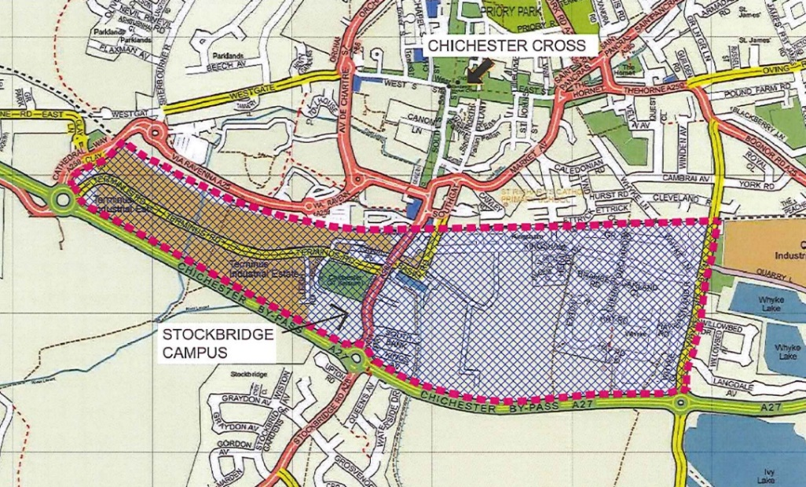

**3.3 Fishbourne Road East Halls of Residence**

Students accommodated at Fishbourne Road East Halls of Residence are, by way of their licence agreements, not permitted to park at the Fishbourne halls development save for any special mitigating circumstances.

Fishbourne students are also discouraged from parking in the local area and so are discouraged from bringing cars with them to University.

**3.4 University Managed Properties**

The accommodation in the University Managed Property Scheme are:

19 Millfield Close, Chichester

37 Lewis Road, Chichester

47 Spitalfield Lane, Chichester

Garth House, High Street, Bognor Regis

Prince of Wales, 1 Highfield Road, Bognor Regis

Villa Maria, Campbell Road, Bognor Regis

Students residing in off-campus managed properties in Chichester and Bognor are, by way of their licence agreement, not permitted to park in the immediate area of their accommodation – this is to include the entire length of the street/road on which their accommodation is situated. In any case, most residential roads in Chichester and Bognor do have Controlled Parking Zones (CPZ) / Resident Parking Schemes (RPS) which University accommodation residents will be unable to access. Therefore, resident students are discouraged from bringing a car with them to University.

In addition to the above, the properties in the University Managed Properties scheme have restrictions placed on the occupiers (student residents) by way of Section 106 planning agreements to prohibit the parking of cars in the local area.

**3.5 Section 106 Planning Agreements - Explained**

Section 106 Planning Agreements (also known as S106 agreements) are tools used by local planning authorities to ensure developers adhere to certain conditions on account of the planning request being granted. The types of obligations that can be found in S106 agreements can be anything from needing to build and develop ancillary services and facilities for a development (i.e. commercial units, doctors’ surgeries, etc), to ensuring that a development is managed in a certain way. It is also common to find parking restrictions appearing in S106 agreements and the University is not alone when faced with obligations to ensure that the wider community is not negatively impacted, in regards to parking, by new developments.

A suspected breach of a planning condition is a serious matter and the University will be obliged to assist the local authority with any investigation to determine whether a breach of condition is in effect. In regards to students found to be parking vehicles in contravention of their licence agreement, and so causing the University to be in breach of the S106 agreement, appropriate action will be taken to avoid enforcement action by the local authority.

1. **Teaching Placements**

Residential students embarking on a period of teaching placement will be entitled to a parking permit to park at their University owned and managed accommodation. The academic department responsible for the course will arrange the permits and they valid only for the period of placement. However, the University is unable to circumvent any parking restrictions or double-yellow lines which may be present on public roads outside managed properties in Chichester and Bognor. Therefore, these residents will need to ensure they follow any/all public parking restrictions if utilising a vehicle and the University will not be responsible should a Penalty Charge Notice be issued by the local parking enforcement authority.

1. **Mitigating Circumstances**

Where a residential student believes they have mitigating circumstances which should allow them to park their vehicle either on campus or at their residence, a special request will need to be made to TravelPlan on [travelplan@chi.ac.uk](mailto:travelplan@chi.ac.uk)

1. **Complaints**

Complaints regarding the Residential Student Parking Policy should first be made to the Accommodation Office via [accommodation@chi.ac.uk](mailto:accommodation@chi.ac.uk) or by calling 01243 816069. Complaints may be passed onto the University’s TravelPlan desk to deal with under the parent policy – the University’s Car Parking Regulations.