2024/2025

**STUDENT**

**ACCOMMODATION**

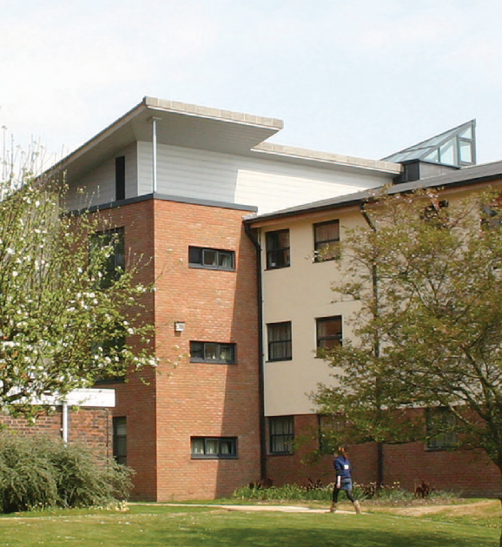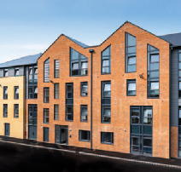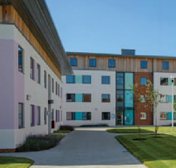

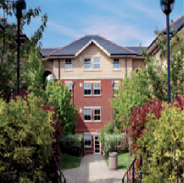

### [chi.ac.uk/accommodation](http://www.chi.ac.uk/accommodation) | Email: [accommodation@chi.ac.uk](mailto:accommodation@chi.ac.uk)

Your New Home

## Starting university for many people means moving out for the first time. While this is an exciting experience we understand it can also be a daunting one. So, we are here to help make the transition go as smoothly as possible.

Our university-managed accommodation is situated across our Chichester and Bognor Regis campuses as well as in the city of Chichester. We offer rooms to suit all budgets and lifestyles including catered or self-catered, ensuite or shared facilities and on or off campus.

Our accommodation varies from on campus traditional student halls of residence to new student accommodation villages in the centre of Chichester. Our halls of residence and University accommodation are professionally managed, secure and supported by our team in the Accommodation Office 24/7.

All of our rooms and facilities are comfortable and well equipped, we also include internet access, heating, electricity and basic contents insurance in the rent. Please see our website for further information on the internet access supplied in our bedrooms and whether the connection is WiFi only, wired (via an ethernet port), or both.

We are confident that you’ll find a room and options that suit you.

All our accommodation is professionally managed to the ANUK Code of Standards



Living in university-owned and managed accommodation is a popular experience and it makes it easier to meet other students and make new friends. You may find you meet people from other courses and develop good friendships within days of settling into your accommodation.

To help this process there are many activities and events throughout the year which will give your social life a real boost! On campus everything is close by, which helps minimise your travel experiences.

#### HIGHLIGHTS OF STAYING IN UNIVERSITY ACCOMMODATION

* A great way to meet new friends
* All utility bills are included
* Internet access is included
* All of our halls of residence are safe, secure and well managed
* There are accessible facilities and adapted rooms available on request
* All kitchens have a hob, oven, refrigerator, freezer, microwave, kettle and toaster
* Access to an on-site launderette

Whatever your accommodation choice you will find a great atmosphere with a welcoming student community. We feel it is a great place to live and study and we are sure you will have many lifelong memories to take away with you at the end of your stay.

**ACCOMMODATION GUARANTEE**

We can guarantee you a room in university-managed accommodation for your first year of study.

To be eligible for our guarantee, you need to:

* Have applied to us by the 31st January 2024 UCAS deadline
* Put us as your firm choice
* Be studying full time

Types of Accommodation – what are your options?

##### On Campus

Both our Chichester and Bognor campuses have on-site accommodation, which can enable a reduction in commuting time and means you have everything in one place. Some people really like this option for its convenience. There is a mixture of ensuite bedrooms, or rooms where the bathrooms are shared with others. There is also a choice between catered accommodation and self-catered (see further details below).

##### Off Campus

We have off-site halls throughout Chichester and Bognor. Some halls are larger student villages near conveniences like supermarkets, restaurants and entertainment, although we do have smaller properties with more of a ‘house’ feel to them. All Chichester offsite halls are within a 30-minute walk to the Campus, and the Bognor offsite accommodation is located within a 10-minute walk to the Campus there. The accommodation is self-catered with a fully furnished kitchen and communal area. Some halls have bus links to their local campus with onward connections to the other campus – check the website to see further information about transport and more.

##### Ensuite

These rooms include single occupancy bedroom space and come with your own bathroom – toilet, sink and shower.

##### Shared facilities

These rooms include single occupancy bedroom space where you will share a shower and toilet block with your flatmates. There are multiple toilets and showers per flat.

##### Catered

All accommodation on the Bognor Campus, and most of the rooms at the Chichester Campus are catered. This means, as part of your rent, you will be provided with a daily allowance to spend in the catering facilities at either campus. You get £9.10 per day Monday to Friday, and £4.50 per day at weekends. A brunch service is provided during Reading Weeks and Inter-Semester Weeks; and there is no catering service during the Easter and Christmas vacations but this is factored into the annual accommodation fee.

There are also communal kitchen facilities available in all halls of residence, should you wish to use them at any time.

##### Self-Catered

In self-catered accommodation you can cook for yourself in the communal kitchens.

Each kitchen will have a hob, oven, microwave, refrigerator, freezer, kettle and toaster. Please note, we do not supply cooking and eating equipment/utensils.

##### Quiet Block

Although many students enjoy the social aspect of university life, some prefer to be allocated a room in a quiet block. If this is something that appeals to you we do have rooms that cater for this requirement at Fishbourne Road East.

##### Adapted Rooms

We have a range of adapted rooms for students with a disability. Most are single rooms with large ensuite wet rooms and can be allocated on a catered or self-catered basis. We are happy to discuss individual housing requirements and would encourage you to contact our Disability and Dyslexia Service at an early stage. This will enable us to allocate accommodation to suit your requirements.

##### Other useful information

All shared facilities will be shared between five and seven people. In some of the blocks you may only be sharing with four other people.

Due to lack of parking facilities we are unable to offer parking to students living on campus. If you are allocated Havenstoke/Pinewood halls then you may be able to purchase a designated parking permit. Residents at all other offsite accommodation in Chichester and Bognor are not permitted to bring a car into the city due to planning restrictions.

Here is an overview of all the different types of accommodation available for first year students:

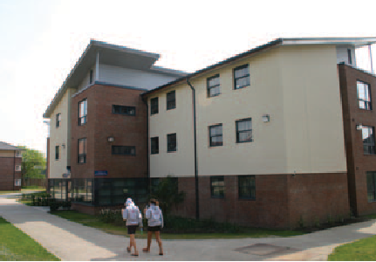

**CHICHESTER**

**On campus**

|  |  |
| --- | --- |
| **DUNCTON HALL, ARUNDEL HALL,**  **IFOLD HALL, PETWORTH HALL, LOXWOOD HALLS, MIDHURST HALL (CATERED, ENSUITE)**   * Catered * Ensuite * 39 weeks * 100 bedrooms across 9 buildings * Bedrooms arranged in cluster flats of 6 rooms, there is also  two 5-bed flats * **£212.66** per week (includes food allowance for our restaurants). | C:\Users\ABennett\AppData\Local\Temp\be1cbba5-7157-4950-9085-0ef2bd2b110f_wetransfer_uoc-amberley_2024-01-24_0830.zip.10f\UoC - Springfield 4\UoC - Springfield 4-3981.jpg  C:\Users\ABennett\AppData\Local\Temp\82821498-cad8-4f53-b45e-46f0e60a5ff4_wetransfer_uoc-amberley_2024-01-24_0830.zip.ff4\UoC - Springfield 6\UoC - Springfield 6-3976.jpg |
| **SPRINGFIELDS 1-4, HAMMOND 1 & 2 (CATERED, SHARED FACILITIES)**   * Catered * Shared bathroom facilities * 39 weeks * 70 rooms across 6 buildings * Facilities shared between 5-6 rooms * **£187.74** per week (includes food allowance for our restaurants). |
| **ASHLING 1 & 2, SPRINGFIELD 5 & 6 (CATERED, SUPERIOR SHARED FACILITIES)**   * Catered * Superior Standard shared facilities * 39 weeks * 40 bedrooms across 4 buildings * Facilities shared between 5 people * **£204.96** per week (includes food allowance for our restaurants). |
| **CHILGROVE HALL, AMBERLEY HALL, HARTING HALL (SELF-CATERED, ENSUITE)**   * Self-catered * Ensuite * 39 weeks * 124 bedrooms across 3 buildings * Bedrooms arranged into cluster flats of between 3-4 rooms * **£184.10** per week | |
| **HAVENSTOKE CLOSE (SELF-CATERED, SHARED FACILITIES)**   * Self-catered * Shared bathroom facilities * 39 weeks * 40 bedrooms across 10 buildings * 4 bedrooms per building * 5-minute walk from campus * **£143.71** per week |  |

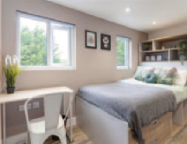**Off campus**

Students from either campus can apply for these Chichester city accommodation options and travel using the free inter-campus bus services\*.

|  |  |
| --- | --- |
| **WESTGATE HALLS (SELF-CATERED, ENSUITE)**   * Self-catered * Ensuite * 39-week licence * Bedrooms arranged into cluster flats of 6 rooms * 25-minute walk from campus * **£171.78** per week | C:\Users\ABennett\AppData\Local\Temp\1dba9e84-5a72-4a91-a2ae-29b70a3a319d_wetransfer_uoc-amberley_2024-01-24_0830.zip.19d\UoC - Westgate Halls\UoC - Westgate Halls-3792.jpg |
| **PINEWOOD HOUSE (SELF-CATERED, SHARED FACILITIES)**   * Self-catered * Shared bathroom facilities * 39 weeks * 52 bedrooms * Facilities shared between 5-7 people * 10-minute walk from campus * **£125.09** per week |
| **STOCKBRIDGE STUDENT VILLAGE (SELF-CATERED, ENSUITE)**   * Self-catered * Ensuite * 39, 40, 50 or 51-week licences * 405 bedrooms across 5 buildings * Bedrooms arranged into cluster flats of between 5-7 rooms, there is  also a 2-bed flat and an 8-bed flat * 30-minute walk from campus * **£176.05** per week |
| **FISHBOURNE ROAD EAST HALLS (SELF-CATERED, ENSUITE)**   * Self-catered * Ensuite * 39 or 40 weeks * 134 bedrooms across 2 buildings * Bedrooms arranged in cluster flats of between 5-7 rooms, there is also 3-bed flat * 30-minute walk from campus * **£176.05** per week |
| **CHICHESTER – MILLFIELD ROAD; LEWIS ROAD; SPITALFIELD LANE**   * Self-Catered * Ensuite/Shared Facilities (Lewis Road) * 50-week licence * Short walk from Bishop Otter Campus, Chichester * 6 single bedrooms in each of the 3 houses * **£168.84** (ensuite)/**£163.45** (shared facilities) * Picture is indicative of the properties | |

**BOGNOR REGIS**

**On campus**

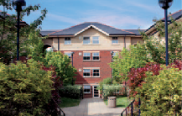

**BARBARA SMITH HALLS (CATERED, ENSUITE)**

* Catered
* Ensuite
* 39 or 40-week licences
* 160 bedrooms across 11 buildings
* Bedrooms arranged in cluster flats of between 6-8 rooms
* **£212.66** per week (includes food allowance for our restaurants).

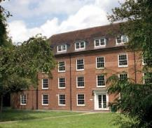

**LONGBROOK AND CHARLOTTE HOUSE (CATERED, SHARED FACILITIES)**

* Catered
* Shared bathroom facilities
* 39 or 40-week licences
* 59 bedrooms across 2 buildings
* Facilities shared between 6 people
* Large rooms available
* £**187.74** (single) or **£203.77** (large) per week (includes food allowance for our restaurants).

**Off campus**

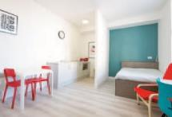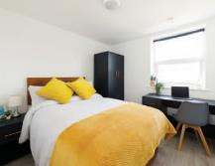

**VILLA MARIA (SINGLE ENSUITE AND STUDIO APARTMENTS)**

* Self-Catered
* Ensuite
* 50-week contract
* Short walk from Bognor campus
* Studio apartments for single or double occupancy
* 12 Single rooms – **£168.84**; 14 studios single occupancy – **£202.44**; double occupancy **£281.12** (weekly rates)

**PRINCE OF WALES BOGNOR (SINGLE ENSUITE AND STUDIO APARTMENTS)**

* Self-Catered
* Ensuite
* 50-week contract
* Short walk from Bognor campus
* Studio apartments for single or double occupancy
* 14 Single rooms – **£179.90**; 4 studios single occupancy – **£202.44**; double occupancy **£281.12** (weekly rates)

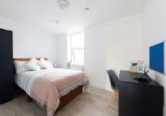

**GARTH HOUSE & HIGH STREET (SINGLE ENSUITE AND STUDIO APARTMENTS)**

* Self-Catered
* Ensuite
* 50-week contract.
* Short walk from Bognor campus
* Studio apartments for single or double occupancy
* 11 Single bedrooms – **£179.90.** 5 studios single occupancy – **£202.44**

double occupancy – **£281.12.** (weekly rates)

For all our accommodation, on and off campus, the accommodation fees are divided into three installments of 40%, 40% and 20%. The first being due shortly after your arrival in October, the second in early January and the third in late April. Prices are correct at the time of printing in February 2024. Visit [**chi.ac.uk/accommodation**](http://www.chi.ac.uk/accommodation)for the most up-to-date information.

Accommodation quick guide

Below is an overview of all the accommodation options we have to offer at University of Chichester. You can use this as a quick reference guide when looking at all the accommodation.

**CHICHESTER**

|  |  |  |  |  |  |  |  |
| --- | --- | --- | --- | --- | --- | --- | --- |
| Hall Name | Licence  Period | Self-  Catered | Catered | Ensuite | Shared  Facilities | On  Campus | Price per  Week |
| Amberley Hall | 39 | • |  | • |  | • | £184.10 |
| Arundel Hall | 39 |  | • | • |  | • | £212.66 |
| Ashling Hall | 39 |  | • |  | • | • | £204.96 |
| Chilgrove Hall | 39 | • |  | • |  | • | £184.10 |
| Duncton Hall | 39 |  | • | • |  | • | £212.66 |
| Hammond | 39 |  | • |  | • | • | £187.74 |
| Harting Hall | 39 | • |  | • |  | • | £184.10 |
| Havenstoke Close | 39 | • |  |  | • | • | £143.71 |
| Ifold Hall | 39 |  | • | • |  | • | £212.66 |
| Loxwood Hall | 39 |  | • | • |  | • | £212.66 |
| Midhurst Hall | 39 |  | • | • |  | • | £212.66 |
| Petworth Hall | 39 |  | • | • |  | • | £212.66 |
| Springfield 1-4  Springfield 5-6 | 39  39 |  | • • |  | • • | • • | £187.74  £204.96 |
| Pinewood | 39 | • |  |  | • |  | £125.09 |
| Stockbridge\* | 39, 40, 50  or 51 | • |  | • |  |  | £176.05 |
| Fishbourne Road East | 39 or 40 | • |  | • |  |  | £176.05 |
| Westgate Halls | 39 | • |  | • |  |  | £171.78 |
| Millfield Road, Chichester | 50 | • |  | • |  |  | £168.84 |
| Lewis Road, Chichester | 50 | • |  |  | • |  | £163.45 |
| Spitalfield Lane, Chichester | 50 | • |  | • |  |  | £168.84 |

**BOGNOR REGIS**

|  |  |  |  |  |  |  |  |
| --- | --- | --- | --- | --- | --- | --- | --- |
| Hall Name | Licence  Period | Self-  Catered | Catered | Ensuite | Shared  Facilities | On  Campus | Price per  Week |
| Barbara Smith Halls | 39 or 40 |  | • | • |  | • | £212.66 |
| Longbrook  Single  Large | 39 or 40  39 or 40 |  | •  • |  | •  • | •  • | £187.74  £203.77 |
| Charlotte House | 39 or 40 |  | • |  | • | • | £187.74 |
| High Street, Bognor | 50 | • |  | • | £179.90 | | |
| Studio single occupancy £202.44 | | |
| Studio dual occupancy £281.12 | | |
| Garth House, Bognor | 50 | • |  | • | £179.90 | | |
| Studio single occupancy £202.44 | | |
| Studio dual occupancy £281.12 | | |
| Prince of Wales, Bognor | 50 | • |  | • | £179.90 | | |
| Studio single occupancy £202.44 | | |
| Studio dual occupancy £281.12 | | |
|  |  |  |  |  | £168.84 | | |
| Villa Maria, Bognor | 50 | • |  | • | Studio single occupancy £202.44 | | |
|  |  |  |  |  | Studio dual occupancy £281.12 | | |

Students on our teaching courses will need accommodation which   
has a 40+ week licence, we will adjust the contract length as required

# How to apply

## Once you have received your offer of study you are able to apply for university-managed accommodation once the Accommodation portal opens in May. Rooms are allocated via a computer algorithm based on your preference – not a first come first served basis.

We can guarantee you a room in university-managed accommodation for your first year of study. To be eligible for our guarantee, you need to:

* Have applied to us by the January UCAS deadline
* Put us as your firm choice
* Be studying full time

*“I lived in Harting Hall which is an on-campus, en-suite, self-catered room. It was really handy for getting to morning lectures, I would be able to enjoy a coffee in my PJs until about 10 mins before! The rooms are a good size and it is a brilliant hassle-free base to have. I really enjoyed meeting my roommates and although not on the same course, I'd hope to stay in contact with them throughout my time in uni and beyond.”*

Xander, BSc (Hons) Physiotherapy, Harting Hall, Chichester Campus

## Once you have received your offer of study you will be invited to log on to the accommodation portal in May where you will be able to apply for accommodation. The following steps should help you through your application:

To make an online accommodation application you will need to log on to your ChiView account via the University website between

**1**

##### 7 May – 23 June.

Choose your accommodation, fill out the application form and click submit.

**2**

Once all applications have been received the accommodation will be allocated by a randomised allocation system – not first come first served

**3**

You will be notified via email in mid-August if you have been successful in gaining a place in accommodation.

**4**

Within seven days of receiving your offer, you will need to log in to the Accommodation portal, check the details of your allocated room and accept the offer and sign the license agreement.

**5**

**6**

After you have accepted your offer, we will send out helpful information regarding your allocated halls of residence and arrivals. We will also send you details on how to complete your e-induction in early September.

**7**

Read your Residents’ Handbook and Code of Conduct before you arrive.

**8**

On arrivals weekend, collect your keys and check the room’s inventory before you move in.

**Timeline**

##### 30th April

**Students with a disability or special housing needs**

If you have a disability or specific requirements you will have to apply for on-campus accommodation through the Disability and Academic Skills Co-Ordinator by 30th April to be guaranteed a room. Please note this will be subject to an assessment and medical evidence may need to be provided.

##### 7th May – 23rd June

**First year, full-time, home students**

If you are a UK, full-time student, with no special housing needs, you will be able to apply for university- owned accommodation from between 7th May – 23 June. (Please view the Allocation Policy on the Accommodation website for full details.) You must have made the University of Chichester your first choice and have accepted a firm offer of study before applying for university-owned and managed accommodation.

##### 23rd June International students

This is the deadline for all international students to apply for on-campus accommodation, as per the above details *for First Year, Full-Time, Home Students*. You will need to make sure you have accepted your offer of study, submitted your online accommodation application via your ChiView account and accepted your offer of accommodation (mid-August) within seven days of receipt to be guaranteed on-campus accommodation.

##### 31st August Successful applicants

If you have been successful, an offer of accommodation will have been made by this date, providing you have met the conditions for study, and have returned an application for University-owned accommodation.

##### 20th – 22nd September

**On-campus rooms ready to occupy**

All on-campus rooms will be ready for occupation for first-years start of term date. Information regarding Arrivals Day will be sent to you via email if you are successful in obtaining University Managed Accommodation, one week prior to your arrival.

If you are unable to access the portal between the 7th May – 23rd June 2024 please email [**allocations@chi.ac.uk**](mailto:allocations@chi.ac.uk)or call **01243 812120**

# Prices and accommodation choices

## Please take the time to view all our accommodation types to see which one would best suit your needs and lifestyle.

We would encourage visiting the campus and viewing our accommodation options in person at one of our Open Days. If you are unable to attend these dates then you can book a campus tour with one of our student ambassadors.

View the options to visit at: [**chi.ac.uk/visitus**](http://www/chi.ac.uk/visitus)

While every effort is made to open rooms throughout the year, students are living in the accommodation, so it might not be possible to view all accommodation types at the time of your visit. However, we do have virtual tours of all the room types available on our website.

Scan the QR code below or visit [**chi.ac.uk/virtual**](http://www.chi.ac.uk/virtual)

You can also watch video tours given by a student on our YouTube channel:

Or visit [**youtube.com/universityofchichester**](http://www.youtube.com/universityofchichester)and click on playlists, then accommodation tours.

*“I loved living at Stockbridge student halls. It’s a social hub with around 400 students living there. It helped me make friends so quickly and I always loved chatting with people on the walk up to uni.”*

Crystal, BA (Hons) Theatre, Stockbridge Halls, Chichester City

# Support and security

## Our halls are professionally managed, secure and well maintained. You will be supported by our team in the Accommodation Office 24/7, so you will feel right at home.

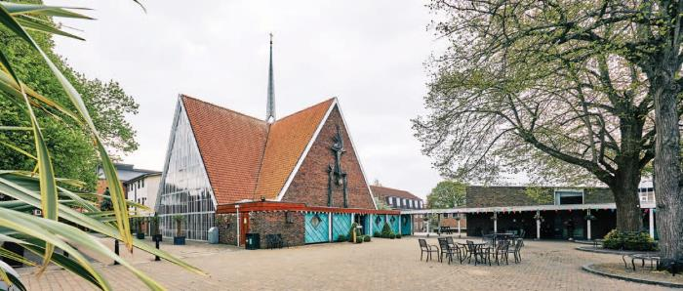

##### Our people

* David Bailey – Director of Estates and Facilities Management
* Charles White – Head of Campus and Residential Services
* Joe Ayres – Accommodation Manager

We pride ourselves on the support we provide to all of our residential students. That is why all of our halls are provided with dedicated Accommodation Office staff who, along with our out-of-hours staff and Security teams, provide round-the-clock cover for our students.

##### Support

* Accommodation Offices:
  + 8.00am to 4.30pm
* Security:
  + 4.30pm to 8.00am weekdays
  + 24-hours at weekends
* Duty managers:
  + 5.30pm to 6.00am every day
* Staff wardens (Chichester and Bognor Campuses):
  + 8.00pm to 12.30am, 3 days a week,

##### Transport

Both the Bognor and Chichester campuses are no more than a 15-minute walk from the respective city/town centre, and both are close to local parks offering plenty of green space in which to relax or socialise. The U7 inter-campus bus service travels between Chichester and Bognor Regis, calling at both campuses and key areas along the way. There is a train station in Chichester providing good transport links to Portsmouth, Brighton, and London – and Bognor has its own rail transport linking to London line with changes at Barnham for trains to Chichester.



# How to find us

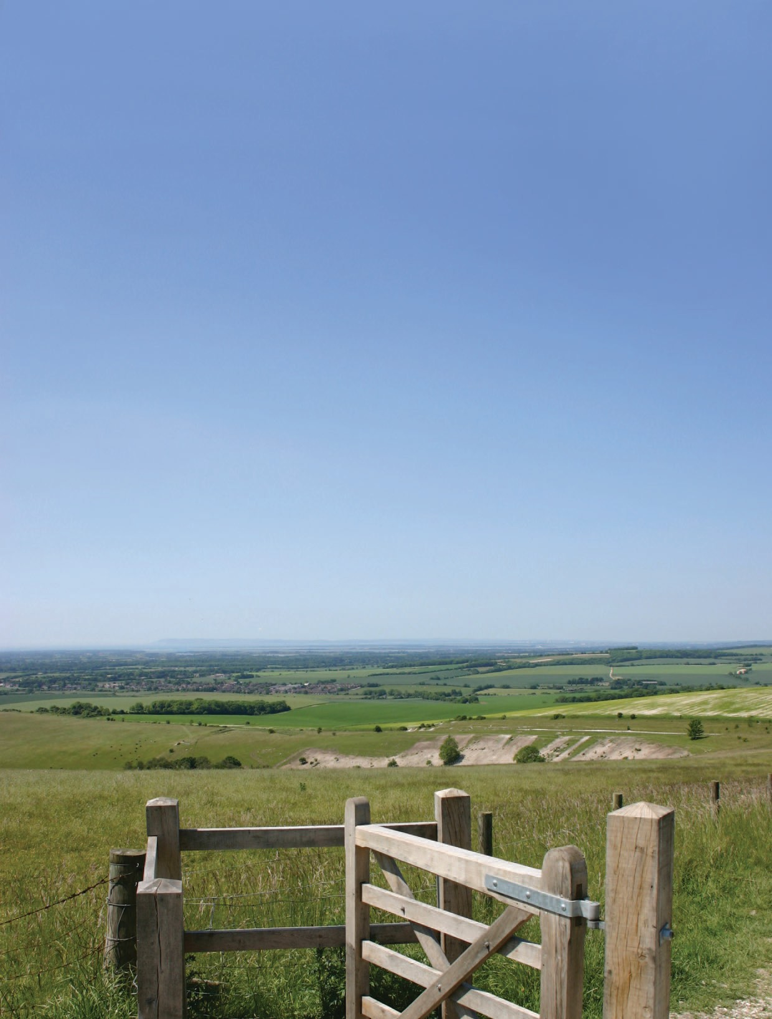

Our two campuses in Chichester and Bognor Regis are located on the South Coast in West Sussex, between Portsmouth and Brighton, they have excellent road and rail links to London.

##### Travelling to Chichester By train

If you are travelling to Chichester via London, the trains run from London Victoria station. Alternatively, you can travel from London Waterloo to Havant and change there for Chichester.

##### By car

Bishop Otter campus – PO19 6PE

##### Travelling to Bognor Regis By train

If you are travelling to Bognor Regis via London, the trains run from London Victoria station.

It is sometimes necessary to change trains at Barnham station for Bognor Regis, please check this before travelling.

##### By car

Bognor Regis campus – Felpham Way entrance, PO22 7BN

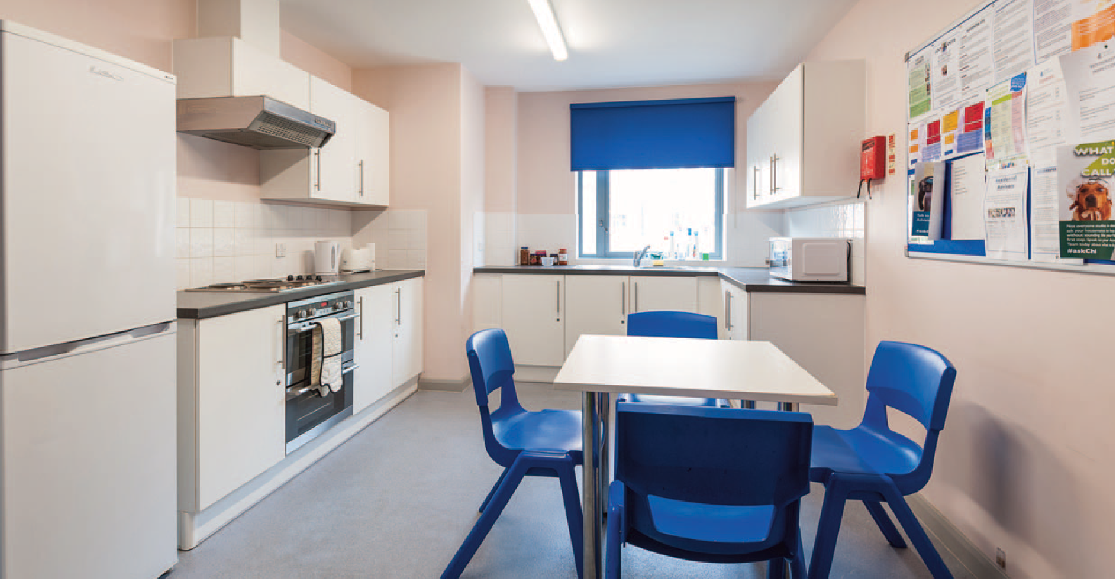

#### CONTACT US

This brochure provides you with information about the range of accommodation options available to you whilst studying at the University of Chichester. We hope it gives you all the details needed, however if you require any further information our Accommodation team will be happy to assist.

**Bishop Otter Campus** University of Chichester College Lane, Chichester West Sussex

PO19 6PE

• +44 (0)1243 816069

* + [accommodation@chi.ac.uk](mailto:accommodation@chi.ac.uk)

##### Bognor Regis Campus

University of Chichester

Upper Bognor Road, Bognor Regis West Sussex

PO21 1HR – For parking use the Felpham Way entrance, PO22 7BN

• +44 (0)1243 812120

* + [accommodation@chi.ac.uk](mailto:accommodation@chi.ac.uk)

##### Additional Contacts

* + Academic Registry: +44 (0)1243 816027
  + Admissions: +44 (0)1243 816002
  + Disability and Dyslexia Service: +44 (0)1243 812076
  + Financial Welfare: +44 (0)1243 816038
  + Students’ Union: +44 (0)1243 816394
  + Student Advisor: +44 (0)1243 816238
  + Health and Safety: +44 (0)1243 816488

#### DISCLAIMER

Information within this brochure is correct at the time of printing in February 2024. All descriptions of sharing ratios within accommodation are indicative of the large majority of buildings, however there are some variations to this between buildings due to layout and design. Check out our website for the most up-to-date information: [**chi.ac.uk/accommodation.**](http://www.chi.ac.uk/accommodation)

#chiuni | [chi.ac.uk](http://www.chi.ac.uk/)