Do you really know what I mean when I say I am autistic? (raising awareness for hidden disabilities)

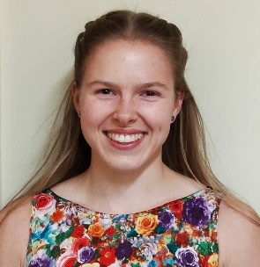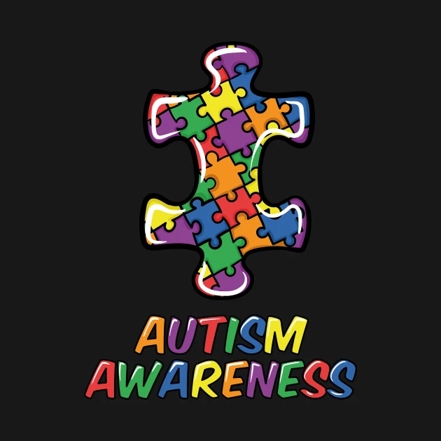

It is such a broad spectrum, varying from physically disabled and no level of communication to looking like others and being high functioning. This does not mean they do not experience similar difficulties though. I want to highlight that no autistic individual is the same hence the emphasis on the word individual.
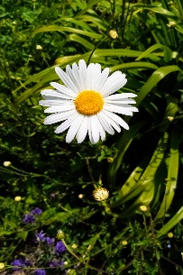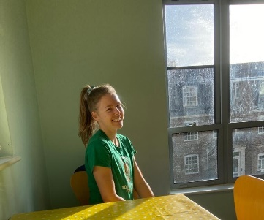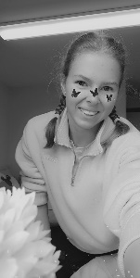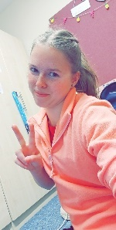
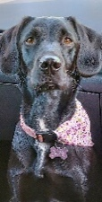
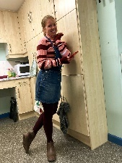
I am Mollie Jones and I have high functioning autism. I am a family orientated person passion is dancing, I love animals (meet my dog Betsy), baking , yoga

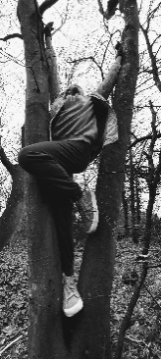
(helps me feel grounded), being out in nature and supporting others. I live the Buddhist way of life, treating others as you wish to be treated yourself. It is important to do this even if you do not receive kindness in return and trust me eventually you will. The problem people who are neurodivergent in society face, is living in a world that is fearful due to a lack of understanding and compassion. I wish myself alone could change this, unfortunately to stand any chance at being successful we must have a very strong mindset and passion. It is easy to believe we are not worthy and fall down an unhealthy hole. The thing about autism, is that although it may not be an obvious disability does not mean we are okay we can go from zero to a hundred due to constant changes causing butterflies in the tummy. I require straightforward instructions, structure, routine and like to know where I am at in order to function well. I understand the world is not made to suit me and adapting never came naturally to me.
The positives of autism despite the challenges
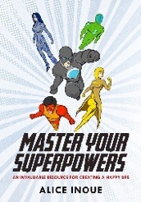

Autistic people have superpowers that deserve to be nurtured and our incredible brains deserve to be celebrated. The masking tool allows us me to appear ‘normal’. Socially I find life difficult, copying others behaviours makes this better for me but at the same time hides my personality. I can see more clearly when dancing, it offers me a safe place to be myself and a freedom to express what words cannot. This does not have to be articulated clearly or make sense to others as audiences interpret what they witness – that is the beauty of it. Others with autism will express their form of outlet through whatever their special interests are.
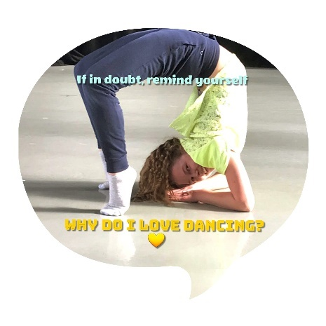

What I wish people knew about autism
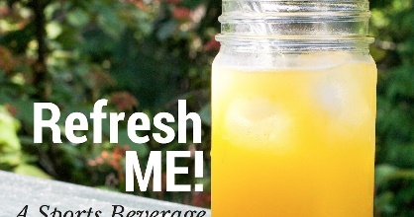

Autism should never be an excuse as to why we are not able to do something for example feel pressured into do something that causes huge levels of anxiety. Encouragement and support is a much better way to enable them to venture out their comfort zones. Autistic people do require a support network, let me get across this does not mean they are needy. Needing reassurance does not show any signs of weakness. Asking for help is not in my nature, I am used to dealing with things on my own, as asking for help is very tough, stressful and exhausting because I am not able to identify clearly why I am feeling a certain way. The smallest things can feel like a volcanic explosion in my mind. It is easy for my mind to get overstimulated / overwhelmed, this added pressure in my head can hurt and causes my vision to go funny then as a result collapsing (all the lights switch off, like a power cut) to allow my batteries to recharge. It is not a pleasant form of refreshment!!.

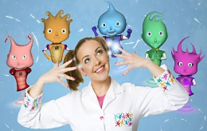
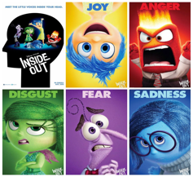
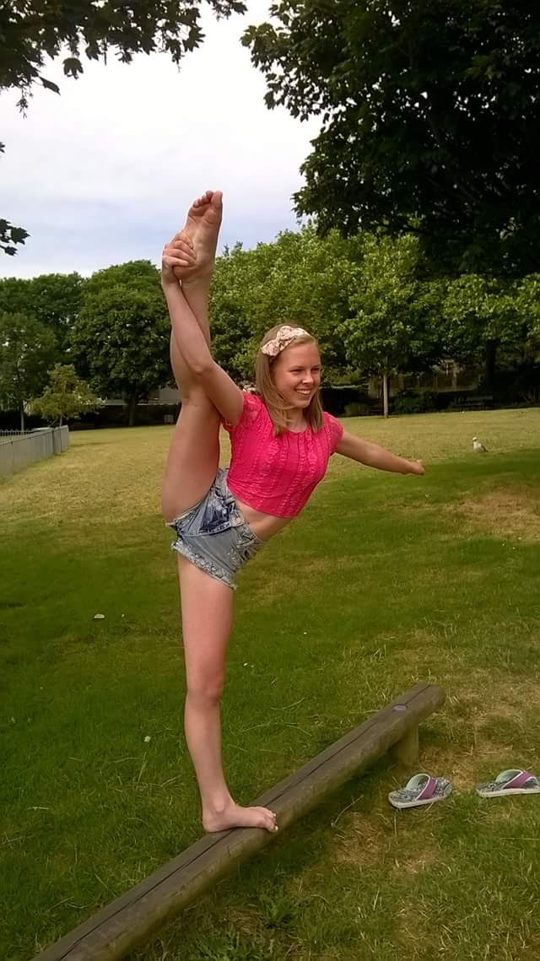
The way I perceive having autism and what enables me to manage it in daily life, is thinking of it as having little people inside my brain if anyone knows Nina and the Neurons or Inside Out (shows you may have seen as a child). They are very clever, but the emotions tend to also collide which is the way my mind works and when a situation occurs it feels much larger and overwhelming than it may actually be. My mind instantly sparks like fireworks (which is anger). I struggle to understand my emotional state, in general I say I am feeling fine as a safety barrier and to me my emotional state remains neutral most the time until the little people inside my mind have had enough of each other (this means that I am not able to identify what emotion I am feeling because they all collide at once). This also impacts my level of communication, some days I am able to find my voice and some days I find myself speechless which causes levels of frustration. There is not a switch that I can control my voice and it is not because I am choosing not to speak, it is because I physically am not able to find the words. Trust me I look really hard to find it again. Sometimes this can be momentary and sometimes this can last days….. What is helpful is that others show understanding and show patience towards us. Rushing someone with autism is never the solution, we function better at our own pace.
Mentally and emotionally, I may be behind my peers but that is okay. For example, I happily still go to the park, watch kids TV shows, enjoy colouring, painting, playing with dolls or having a dolls house. Role play is one of my favourite things to do, it is a form of expression that feels safe as no one else can hear but you. Adults are basically big kids with responsibilities, never stop loving anything just because it may be inappropriate for your age. Letting other people rule your life is damaging, I will not go down that road. I am lucky that my autism enables me to be hyper focused when I am passionate / interested about something, for example I love making hama beads or loom band bracelets aside from dancing. I find this helps me when feeling tense to focus my concentration, I tend to pick, rub and squeeze my skin (making it dry and sore) to mask how I am feeling, in times I not able to express it verbally or when my mind is bored. I find it hard to keep still and do nothing, my world is always tossing and turning….

How do I raise awareness for the autistic community using my passion for dance?
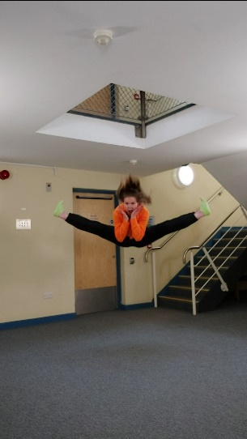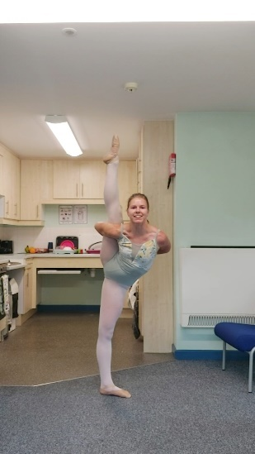
As a dancer, I do tend to communicate through gesture to assist my communication. Without dance, I would struggle even more with communication. It provides me with a safe space to express and be free without the need for verbal communication. I pore my heart and soul into it and when dancing I forget that I have a disability. Mine is hidden, which is much harder to identify signs of struggle, confusion and not being okay. To look at me you would think does she really have a disability? I tend to always look happy and smiley as I want others to see my bubbly, fun and unique personality. When I remove my mask, it puts me in a more vulnerable position. Think of it like living inside a cage or having security gates around your house. I remain inside my balloon, do not burst that balloon or I may come tumbling down. Autism is a constant change in emotions, one minute fine and the next minute the gun trigger is pulled…. ..

Autistic people are unpredictable, which I believe makes them interesting. We do not announce shutdown about to happen, it just does not work this way. I experience sudden reactions; I will feel okay then later be passed out on the floor due to overstimulation. I explored the feeling of going from ‘one extreme to another’ in my recent choreographic work and this is exactly what I am describing here.
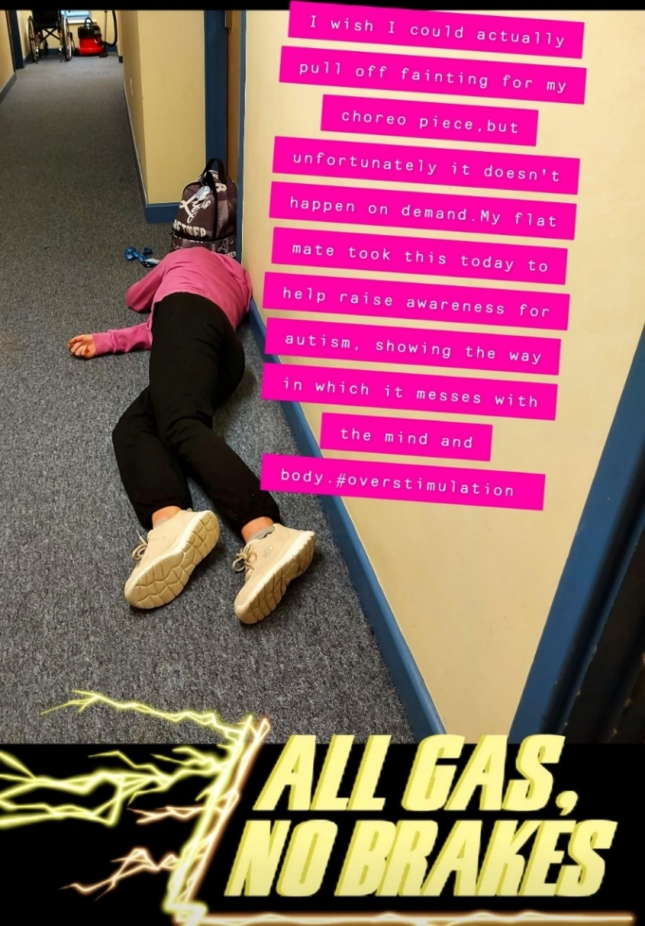
I am autistic, I am not broken and do not need fixing.

Dance Photoshoot:
