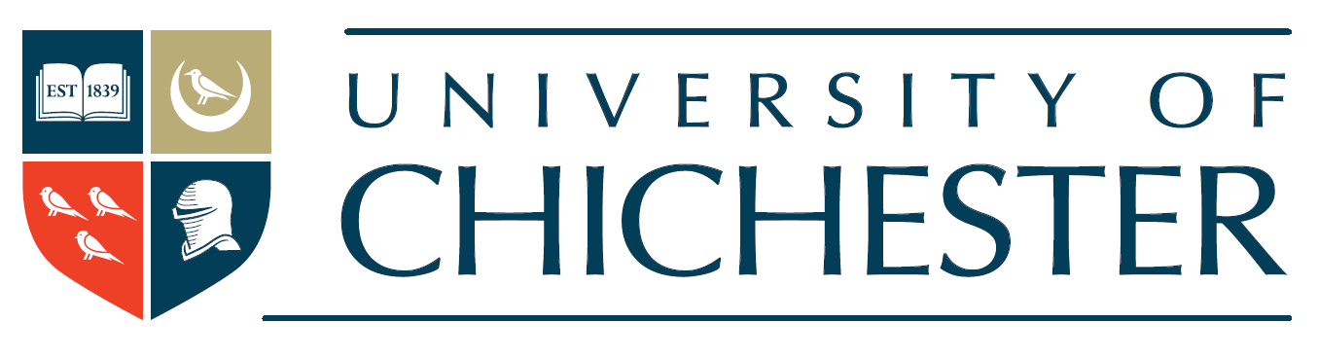
Statement on Modern Slavery 2022-23
Introduction
This statement is made pursuant to Section 54 part 6 of the Modern Slavery Act 2015 and sets out the steps that the University of Chichester has taken in the financial year ending 31 July 2023 to ensure that slavery and human trafficking are not taking place in any part of our business or our supply chains.
Modern slavery is a crime and a violation of fundamental human rights. We are committed to acting ethically and with integrity in all our business dealings and relationships and to implementing and enforcing effective systems and controls in our business to support the eradication of modern slavery globally.
Organisation structure
We are a university and a charity, established under the laws of the UK, with our administrative offices at our Bishop Otter Campus, College Lane, Chichester PO19 6PE.
Our company number is 4740553. We have nearly 1000 employees, all paid over the National Minimum Wage, and over 5000 students at any one time. Our annual turnover is in excess of £65 million, and while our key expenditure is on our academic and administrative staff, we engage with a range of suppliers nationally and globally to enable us to provide our services.
The University is organised into multiple academic institutions and departments, which are supported by our professional service departments. Our key supply chains include the purchasing of IT equipment and services, building works, printing and design work, catering and accommodation-related services, security services and medical support services.
The University has one wholly-owned subsidiary, Chichester Enterprises Limited (company number 5162778), through which it provides certain services such as consultancy and other commercial services.
The University is associated with, but is legally separate from, the University of Chichester Students’ Union (company number 11937134) and the University of Chichester (Multi) Academy Trust (company number 8595545).
Our policies on slavery and human trafficking
We are committed to ensuring that there is no modern slavery or human trafficking in any part of our business or our supply chains.
We have a clear framework of rules and behaviours and encourage the reporting of any concerns or breaches so that they can be dealt with appropriately in accordance with our policies and procedures.
Our Anti-Slavery and Human Trafficking Policy reflects our commitment to acting ethically and with integrity in all our business relationships and to implementing and enforcing effective systems and controls to ensure slavery and human trafficking are not taking place anywhere in our business or its supply chains. The policy is binding on all of our employees and is supported by our policies on Public Interest Disclosure (Whistleblowing), Risk Management, and our Financial Regulations. All of our policies are accessible via our website at https://www.chi.ac.uk/about-us/policies-and-statements/.
Procurement presents an opportunity to address the risk of slavery and/or human trafficking and as such, all suppliers are issued with contracts referencing the University’s policies and the requirements we expect them to meet on modern slavery. As part of our procurement process, suppliers are required to answer questions about their environmental and ethical practices in their business and in their supply chains. The responses to these questions enable us to identify and exclude any supplier who falls short our requirements.
What we have done this year
In addition to our standard procurement practices, in our financial year of 1 August 2022 – 31 July 2023, we have:
- introduced a new Procurement Policy, following the arrival of the Procurement Officer; who has liaised with colleagues across the University to provide related training;
- widened membership of our Procurement Working Group to ensure engagement with, and contributions from, academic areas.
- increased the use of frameworks to ensure consistency of approach and sector alignment on modern slavery, and to take the benefit of work done by purchasing consortia in this area (for example, affiliation with Electronics Watch);
- reviewed and (where necessary) streamlined our supplier due diligence process;
- continued to monitor the practices of major suppliers and significant developments in supply chains for risk in the context of the Covid-19 pandemic and any associated government-ordered measures;
- in appropriate procurements, emphasised the use of the Public Services (Social Value) Act 2012 requirements in procurement documentation and bid scoring;
- attended and contributed to the Southern Universities Purchasing Consortium’s Responsible Procurement Group events.
- Continued to engage with Higher Education Procurement Association (HEPA)/ British Universities Finance Directors Group (BUFDG)/ Association of Heads of University Administration (AHUA)/ Association of University Legal Practitioners (AULP) to ensure sector alignment on modern slavery;
- enhanced our Contract Approval Form to emphasise and surface supplier due diligence to decision-makers;
- reviewed the value of a formal contract review document for use when managing ongoing contractor relationships

What we plan to do next year
Following a review of the effectiveness of the steps we have taken this year, in the coming year, we plan to:
- continue to engage with Higher Education Procurement Association (HEPA)/ British Universities Finance Directors Group (BUFDG)/ Association of Heads of University Administration (AHUA)/ Association of University Legal Practitioners (AULP) to ensure sector alignment on modern slavery;
- continue to use framework agreements wherever possible to a) take the benefit of sector-level compliance and due diligence resource and b) reinforce the standards in procurement set by sector procurers.
- continue use of the Public Services (Social Value) Act 2012 and other requirements with a view to continued improvement in areas of corporate social responsibility;
- continue to develop and deliver policies, procedures, and internal training and publicity;
- continue to develop and promote University-wide compliance with procurement policy and procedure;
- implement the new Anti-Money Laundering & Counter Terrorist Financing Policy and provide associated training for relevant staff

We welcome feedback on our progress to date and suggestions for further improvement.


Professor Jane Longmore, Vice-Chancellor
University of Chichester
21 November 2023

