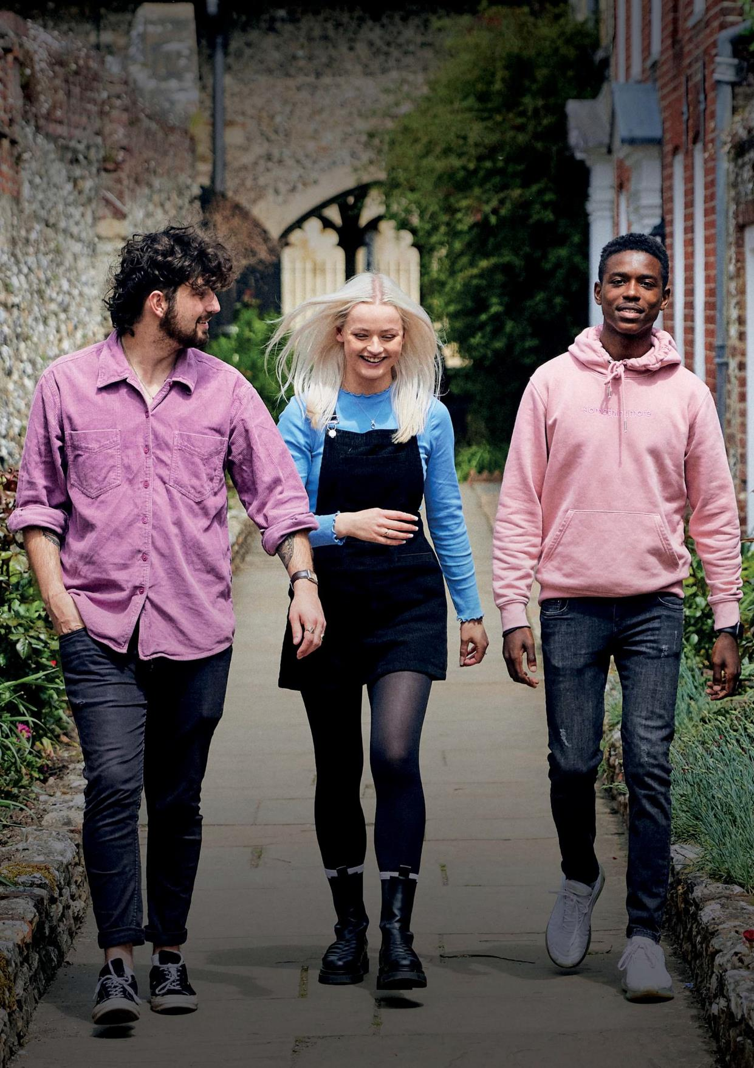



















DEGREE OUTCOMES
STATEMENT 2022/23

Degree Outcomes Statement, 2022/23
The purpose of this Statement is to articulate how the University of Chichester meets the expectation that “The value of qualifications awarded to students at the point of qualification and over time is in line with sector-recognised standards”. The principal authority rests with the Academic Board, with operational implementation overseen by the Education Committee, primarily through its oversight of the programme approval and annual monitoring procedures, and through oversight of external examiners’ reports.
Prior to this Degree Outcomes Statement being considered by the Board of Governors, it was reviewed by the Education Committee, and the Academic Board.

Update on actions (2021/22)
- Annual monitoring will focus on final awards and attainment for students from economically disadvantaged backgrounds and from black and ethnic minorities; we sought to reduce the volume of formal examinations, influenced by research undertaken by UCL. The outcome was positive – prior to the reduction of formal examinations, the pass rate for Asian students in 21/22 was 70% and in 22/23 was 89%. The pass rate for black and minority ethnic students in 21/22 was 79% and in 22/23 was 82.9%.
- The University created an internal teaching awards scheme as a precursor to enabling applications to the National Teaching Fellowship Scheme. Three colleagues were awarded a Vice-Chancellor’s Teaching Excellence Award.

Teaching practices and learning resources
The University of Chichester has invested heavily in the quality of teaching, continuing to situate the student learning experience and wellbeing at the heart of what we see as a transformational educational and personal journey. The following will have had a positive impact on improving student attainment:

Our ongoing commitment to continuing professional development for academic and professional services staff, with an increased number of HEA Fellows at the University, year on year. 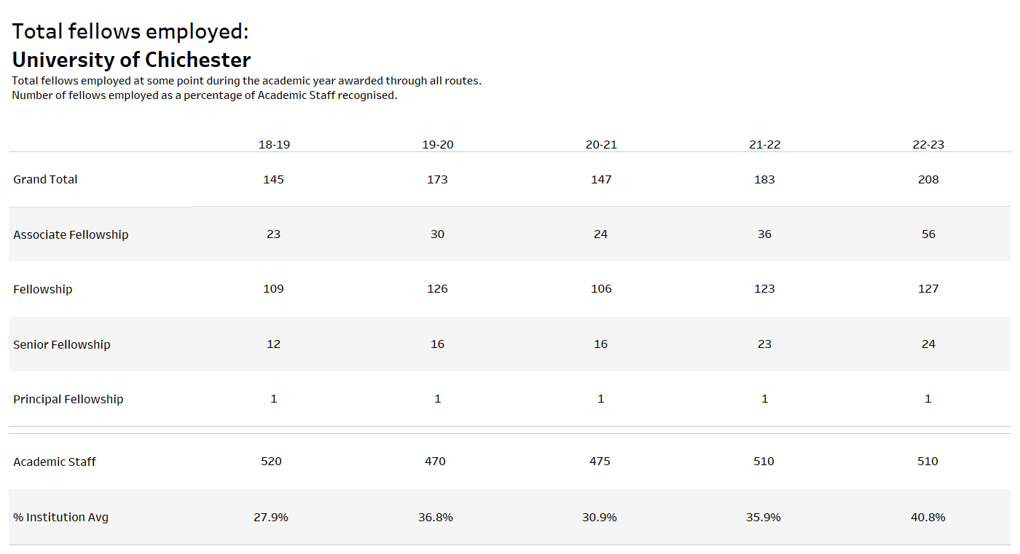
- The University has gained Gold in the Teaching Excellence Framework, 2023.
- Teaching quality is evidenced by the National Student Survey on with the University’s overall average ‘positivity’ score hitting 79.3% in 2023. Law students rated their course number one in the country, placing it top of 110 university law courses around the UK. Teaching satisfaction was high across the broad range of courses offered with an overall average of 86%, with Law, Sports Therapy and Football scoring 100%. 11 other subject areas scored above 90% for teaching including Counselling, Early Childhood Studies, English and Creative Writing, History and Politics, Maths and Education, Music and Musical Theatre, Physical Education, Social Work including Degree Apprenticeships, Sports and Exercise Sciences, Teaching and Learning Support and Theatre.
- We feature in The Guardian’s Top 40 of the best UK universities.

Assessment and marking practices
Assessment strategies take account of the OfS sector-recognised standards, alongside the relevant subject benchmark statements, and the appropriate elements of the UK Quality Code for HE (Quality Code). The following will have had a positive impact on improving student attainment:
Approvals panels are guided to comment upon intended learning outcomes, whether assessment tasks enable students to demonstrate achievement of the intended learning outcomes, and whether assessment criteria enable tutors to discern whether the outcomes have been achieved. The University then uses grading criteria to identify how well a student has achieved those outcomes.

Academic governance
The University’s Academic Board has responsibility for assuring the value of awards over time, including those delivered in partnership with others. To do this it receives an annual report on the outcome of the University’s quality assessment activities, evidences how we are continuing to meet our conditions of registration. The following will have had a positive impact on improving student attainment:
- In their annual report on the quality and standards of programmes, external examiners are asked to check and comment upon the standards of the qualification and of student performance is comparable with national frameworks and with the standards of similar programmes in other UK higher education institutions.
- External advisers are also employed as a key member of the University’s programme approval and periodic review process that considers and advises upon the academic standards of education provision, and enhancements to curricula and the student academic experience.
- In regard to partnerships, the University’s link tutors work closely with each academic partner on their marking practices, and moderate a sample of work. The outcomes of this moderation exercise are reported to the Academic Partnerships Forum.

Classification algorithms
The algorithm for all undergraduate students is based upon a 40/60 weighting (i.e. the second year/Level 5 provides 40% of the outcome, and the third year/Level 6, 60% of the outcome). The higher weighting reflects the notion that as students progress through their programme of study it becomes more challenging and difficult. Similarly, we do not weight the first year of study – as a University with a remit for widening participation, we focus on a transition to higher education during this year. All marks are included in the calculation from Level 5 and Level 6. There is an automatic uplift rule for students the very edge of the boundary of the classification (for example, a student with 69.6% will have their mark rounded up to 70% for a First).

Identifying good practice and actions
Individual departments and institutes are developing increasingly significant approaches to feeding back to students on their assessed work; for example, Sports have developed a template to enable consistent and transparent feedback across the department.
We have joined the Universities of Sanctuary. This is a national network of university staff and students, who are working to make institutions places of safety, solidarity and empowerment for people seeking sanctuary.
The Education Committee is continuing a strategic approach to Supporting Student Success through aggregating its overview of projects contributing to this, such as embedding employability within the curriculum. It has also created sub committees for the international student experience and for educational gain and learner analytics.
Our Professional Development Programme includes a section focussed on Enhancing the Student Experience: Learning and Teaching offering sessions on Engaging Learners, Learning Through Failure, Digital Accessibility (Designing out Barriers to Learning), Student Engagement Tools, Blended and Flipped Learning, Engaging Students in Blended Learning.

Actions for 2023/24
To monitor the Vice-Chancellor’s Teaching Excellence Awards scheme and its impact and successful nominations to the National Teaching Fellowship Scheme;
To review the ‘MAF’ (module assessment feedback), and associated assessment practices to inform transition to SITS;
To monitor the impact of the reduction of formal examinations specifically on the attainment of black and ethnic minority students

Risks and challenges
This is the fifth annual iteration of our Degree Outcomes Statement, and it will be reviewed and refreshed annually as we continue to investigate an extraordinarily complex area.
Katie Akerman MA (Exon) PgCert Dip.Q FAUA PFHEA
Director of Quality and Standards

Institutional degree classification profile
Universities in England have committed to reversing pandemic grade inflation in first and 2.1 degrees. In a first of its kind statement Universities UK (UUK) and GuildHE members have committed to return to pre-pandemic levels of ‘upper’ degree classification by 2023. Measures to ensure students were not unfairly disadvantaged during the unique circumstances of the pandemic contributed to increases in the proportion of first and 2.1 undergraduate degree awards. Universities will take the pre-pandemic year of 2019 as a benchmark for the commitment, when proactive action by universities to protect the value of degrees was leading to a levelling-off in the percentage of students achieving upper degree awards. The University has returned to pre-pandemic levels.
The statement recognises that grade inflation which cannot be explained by the developments in teaching and learning that combined with students’ hard work to improve results in the prior decade, risk undermining student, employer and public confidence in the system.
Data from the Office for Students indicates that for the University overall the Percentage of Firsts/2:1s awarded overall is:
2022/23 76.6
2021/22 76.6
2020/21 81.9
2019/20 82.6
2018/19 76.2
2017/18 74.9
2016/17 71.1

For the Business School, 61.1% of students gained a First or 2:1, compared to 71% in the previous year. In IoPBHS for 22/23 but grouping programmes together is 67.1%
For the Conservatoire, 89.6% of students gained a First or 2:1, compared with 92.1% of students in the previous year. This now includes Theatre (93.3% in 22/23), overall Conservatoire is 85.7%
For Creative Industries, 78.6% of students gained a First or 2:1, compared with 81.5% of students in the previous year.
For Arts and Humanities, 83.9% of students were awarded a First or 2:1; compared with 86% for the previous year. IoAH at 81.3%, no longer includes Theatre which was 96.2% in 21/22
For Education, Life and Social Sciences, 81.8% of students were awarded a First or 2:1; compared with 85.7% for the previous year. IoESLS without Psychology, Counselling or Criminology was 79.4% in 21/22 and 74% in 22/23
For ECAD, 80% of students gained a First or 2:1; compared with 77.4% for the previous year.
For the Institute of Sport, Nursing and Allied Health 59.4% of students were awarded a First or 2:1; compared with 59.7% for the previous year.
For IoPBHS 73.2% of students were awarded a First or 2:.
Institutes have been asked to comment upon changes in graduate attainment in their annual monitoring reporting.

Institutional classification profile |  |  | Year | 2017/18 | 2017/18 | 2018/19 | 2018/19 | 2019/20 | 2019/20 | 2020/21 | 2020/21 | 2021/22 | 2021/22 | 2022/23 | 2022/23
 |  |  | Value | % | # | % | # | % | # | % | # | % | # | % | #
 |  | Psychology, Business and Life Sciences
 | Age |  | Under 21 | 61.6% | 53 | 67.4% | 32 | 69.4% | 43 | 80.0% | 48 | 59.5% | 25 | 79.4% | 77
 | Age |  | 21-24 | 45.5% | 10 | 70.0% | 7 | 35.3% | 6 | 58.9% | 33 | 46.7% | 14 | 52.2% | 12
 | Age |  | 25-29 | 100.0% | 4 | 100.0% | 2 | 0.0% | 0 | 50.0% | 1 | 66.7% | 2 | 87.5% | 7
 | Age |  | 30-39 | - | 0 | 100.0% | 2 | 100.0% | 1 | 100.0% | 4 | 80.0% | 4 | 85.7% | 6
 | Age |  | 40-49 | 100.0% | 1 | - | 0 | - | 0 | 100.0% | 1 | 100.0% | 7 | 100.0% | 8
 | Age |  | 50+ | - | 0 | - | 0 | - | 0 | - | 0 | - | 0 | 91.7% | 11
 | Disability |  | Not Disabled | 61.2% | 63 | 69.7% | 38 | 66.2% | 45 | 70.9% | 78 | 59.8% | 49 | 75.6% | 93
 | Disability |  | Dyslexic | 33.3% | 2 | 66.7% | 2 | 37.5% | 3 | 33.3% | 1 | 75.0% | 3 | 85.7% | 12
 | Disability |  | Other Disability | 75.0% | 3 | 75.0% | 3 | 40.0% | 2 | 81.8% | 9 | 75.0% | 3 | 88.9% | 16
 | Ethnicity |  | ABMO | 38.1% | 16 | 50.0% | 8 | 55.6% | 15 | 60.0% | 30 | 36.4% | 4 | 75.0% | 9
 | Ethnicity |  | White | 72.9% | 51 | 77.3% | 34 | 66.0% | 35 | 82.3% | 51 | 85.7% | 42 | 84.2% | 101
 | Ethnicity |  | Unknown | 100.0% | 1 | 66.7% | 1 | 0.0% | 0 | 58.3% | 7 | 30.0% | 9 | 47.8% | 11
 | Gender |  | Male | 42.3% | 22 | 54.2% | 16 | 46.9% | 23 | 65.8% | 50 | 50.8% | 30 | 58.8% | 30
 | Gender |  | Female | 75.4% | 46 | 84.4% | 27 | 84.4% | 27 | 79.2% | 38 | 80.6% | 25 | 87.5% | 91
 | Tariff |  | - | 47.2% | 17 | 64.9% | 12 | 58.3% | 14 | 69.2% | 45 | 48.9% | 23
 | Tariff |  | 000-047 | 100.0% | 2 | - | 0 | 0.0% | 0 | 0.0% | 0 | 100.0% | 3
 | Tariff |  | 048-095 | 54.8% | 17 | 60.0% | 9 | 69.2% | 9 | 73.7% | 14 | 64.3% | 9
 | Tariff |  | 096-143 | 66.7% | 18 | 73.3% | 11 | 69.0% | 20 | 78.3% | 18 | 77.8% | 14
 | Tariff |  | 144-191 | 78.6% | 11 | 83.3% | 10 | 45.5% | 5 | 64.3% | 9 | 75.0% | 6
 | Tariff |  | 192-239 | 100.0% | 3 | 100.0% | 1 | 100.0% | 2 | 100.0% | 2 | - | 0
 | Tariff |  | 240-287 | - | 0 | - | 0 | - | 0 | - | 0 | - | 0
 | Tariff |  | 288-335 | - | 0 | - | 0 | - | 0 | - | 0 | - | 0
 |  | Conservatoire
 | Age |  | Under 21 | 83.6% | 247 | 87.3% | 258 | 91.0% | 213 | 92.5% | 245 | 88.7% | 252 | 86.4% | 338
 | Age |  | 21-24 | 71.4% | 5 | 87.8% | 18 | 91.3% | 21 | 87.0% | 20 | 100.0% | 16 | 76.9% | 20
 | Age |  | 25-29 | 60.0% | 2 | 100.0% | 2 | - | 0 | 100.0% | 1 | 100.0% | 5 | 100.0% | 1
 | Age |  | 30-39 | 50.0% | 1 | - | 0 | - | 0 | 100.0% | 1 | 100.0% | 2 | - | 0
 | Age |  | 40-49 | - | 0 | 100.0% | 1 | - | 0 | - | 0 | 100.0% | 1 | - | 0
 | Age |  | 50+ | - | 0 | - | 0 | - | 0 | - | 0 | - | 0 | - | 0
 | Disability |  | Not Disabled | 83.8% | 204 | 88.7% | 225 | 92.5% | 186 | 93.5% | 201 | 91.9% | 217 | 87.9% | 255
 | Disability |  | Dyslexic | 76.7% | 33 | 78.4% | 20 | 86.4% | 19 | 86.7% | 26 | 77.4% | 24 | 68.6% | 24
 | Disability |  | Other Disability | 86.4% | 19 | 85.2% | 35 | 85.3% | 29 | 89.1% | 41 | 85.4% | 35 | 86.0% | 80
 | Ethnicity |  | ABMO | 81.8% | 23 | 83.7% | 21 | 80.0% | 16 | 85.0% | 17 | 81.3% | 13 | 80.0% | 24
 | Ethnicity |  | White | 83.1% | 234 | 87.6% | 255 | 91.9% | 217 | 92.5% | 245 | 89.9% | 250 | 87.0% | 321
 | Ethnicity |  | Unknown | - | 0 | 100.0% | 4 | 100.0% | 1 | 100.0% | 6 | 92.9% | 13 | 73.7% | 14
 | Gender |  | Male | 76.6% | 48 | 85.3% | 58 | 92.9% | 39 | 89.7% | 61 | 75.9% | 44 | 84.1% | 69
 | Gender |  | Female | 84.6% | 209 | 88.0% | 221 | 90.7% | 195 | 92.8% | 207 | 92.8% | 232 | 86.3% | 290
 | Tariff |  | - | 80.0% | 8 | 85.7% | 15 | 90.0% | 18 | 92.0% | 23 | 100.0% | 10
 | Tariff |  | 000-047 | 100.0% | 2 | 100.0% | 3 | 80.0% | 4 | 100.0% | 1 | 75.0% | 3
 | Tariff |  | 048-095 | 72.2% | 26 | 76.3% | 23 | 76.0% | 19 | 83.3% | 30 | 74.3% | 26
 | Tariff |  | 096-143 | 77.7% | 89 | 85.0% | 117 | 91.0% | 91 | 89.8% | 106 | 88.0% | 110
 | Tariff |  | 144-191 | 89.3% | 108 | 90.9% | 90 | 94.2% | 81 | 96.8% | 90 | 93.7% | 104
 | Tariff |  | 192-239 | 100.0% | 20 | 96.6% | 28 | 100.0% | 19 | 100.0% | 16 | 100.0% | 19
 | Tariff |  | 240-287 | 60.0% | 3 | 100.0% | 4 | 100.0% | 2 | 100.0% | 2 | 100.0% | 3
 | Tariff |  | 288-335 | - | 0 | - | 0 | - | 0 | - | 0 | - | 0
 |  | Creative Industries
 | Age |  | Under 21 | 90.1% | 32 | 84.3% | 30 | 98.1% | 51 | 97.9% | 46 | 79.4% | 75 | 77.7% | 84
 | Age |  | 21-24 | - | 0 | 80.0% | 2 | 100.0% | 4 | 91.7% | 11 | 90.9% | 10 | 88.9% | 8
 | Age |  | 25-29 | 100.0% | 1 | 100.0% | 1 | 66.7% | 1 | 100.0% | 1 | 66.7% | 2 | 100.0% | 3
 | Age |  | 30-39 | 100.0% | 1 | - | 0 | - | 0 | 100.0% | 1 | 100.0% | 2 | - | 0
 | Age |  | 40-49 | - | 0 | - | 0 | 0.0% | 0 | - | 0 | - | 0 | 100.0% | 2
 | Age |  | 50+ | - | 0 | - | 0 | - | 0 | - | 0 | - | 0 | 60.0% | 3
 | Disability |  | Not Disabled | 88.5% | 27 | 87.5% | 25 | 94.0% | 39 | 98.0% | 48 | 81.0% | 68 | 78.8% | 71
 | Disability |  | Dyslexic | 100.0% | 4 | 57.1% | 2 | 100.0% | 10 | 100.0% | 2 | 80.6% | 15 | 75.0% | 6
 | Disability |  | Other Disability | 100.0% | 2 | 85.7% | 6 | 100.0% | 7 | 90.9% | 10 | 86.2% | 13 | 78.9% | 23
 | Ethnicity |  | ABMO | 55.6% | 3 | 60.0% | 2 | 80.0% | 4 | 85.7% | 6 | 71.4% | 5 | 85.7% | 6
 | Ethnicity |  | White | 95.3% | 31 | 86.1% | 31 | 97.1% | 51 | 98.1% | 52 | 83.4% | 88 | 78.4% | 87
 | Ethnicity |  | Unknown | - | 0 | - | 0 | 100.0% | 1 | 100.0% | 2 | 50.0% | 2 | 75.0% | 6
 | Gender |  | Male | 81.1% | 15 | 83.3% | 20 | 94.3% | 33 | 97.6% | 40 | 83.0% | 61 | 80.2% | 69
 | Gender |  | Female | 100.0% | 18 | 86.2% | 13 | 97.9% | 23 | 95.2% | 20 | 79.1% | 34 | 75.0% | 30
 | Tariff |  | - | - | 0 | 85.7% | 3 | 57.1% | 2 | 66.7% | 2 | 77.8% | 7
 | Tariff |  | 000-047 | - | 0 | - | 0 | 100.0% | 2 | 100.0% | 1 | 100.0% | 2
 | Tariff |  | 048-095 | 82.6% | 10 | 86.7% | 7 | 100.0% | 13 | 94.1% | 16 | 85.1% | 29
 | Tariff |  | 096-143 | 91.7% | 17 | 76.9% | 15 | 96.2% | 25 | 100.0% | 27 | 79.1% | 36
 | Tariff |  | 144-191 | 100.0% | 5 | 100.0% | 6 | 100.0% | 13 | 100.0% | 13 | 87.2% | 21
 | Tariff |  | 192-239 | 100.0% | 2 | 100.0% | 2 | 100.0% | 1 | 100.0% | 1 | 50.0% | 1
 | Tariff |  | 240-287 | - | 0 | - | 0 | - | 0 | - | 0 | 0.0% | 0
 | Tariff |  | 288-335 | - | 0 | - | 0 | - | 0 | - | 0 | - | 0
 |  | Department of Engineering, Computing and Design
 | Age |  | Under 21 | - | 0 | - | 0 | - | 0 | 69.2% | 9 | 66.7% | 12 | 76.5% | 13
 | Age |  | 21-24 | - | 0 | - | 0 | - | 0 | 0.0% | 0 | 88.9% | 8 | 85.7% | 6
 | Age |  | 25-29 | - | 0 | - | 0 | - | 0 | - | 0 | 100.0% | 3 | 100.0% | 4
 | Age |  | 30-39 | - | 0 | - | 0 | - | 0 | - | 0 | 100.0% | 1 | 50.0% | 1
 | Age |  | 40-49 | - | 0 | - | 0 | - | 0 | - | 0 | - | 0 | - | 0
 | Age |  | 50+ | - | 0 | - | 0 | - | 0 | - | 0 | - | 0 | - | 0
 | Disability |  | Not Disabled | - | 0 | - | 0 | - | 0 | 54.5% | 6 | 76.0% | 19 | 85.2% | 23
 | Disability |  | Dyslexic | - | 0 | - | 0 | - | 0 | 100.0% | 2 | 80.0% | 4 | - | 0
 | Disability |  | Other Disability | - | 0 | - | 0 | - | 0 | 100.0% | 1 | 100.0% | 1 | 33.3% | 1
 | Ethnicity |  | ABMO | - | 0 | - | 0 | - | 0 | 0.0% | 0 | 66.7% | 2 | 100.0% | 3
 | Ethnicity |  | White | - | 0 | - | 0 | - | 0 | 69.2% | 9 | 77.8% | 21 | 83.3% | 20
 | Ethnicity |  | Unknown | - | 0 | - | 0 | - | 0 | - | 0 | 100.0% | 1 | 33.3% | 1
 | Gender |  | Male | - | 0 | - | 0 | - | 0 | 61.5% | 8 | 74.1% | 20 | 84.0% | 21
 | Gender |  | Female | - | 0 | - | 0 | - | 0 | 100.0% | 1 | 100.0% | 4 | 60.0% | 3
 | Tariff |  | - | - | 0 | - | 0 | - | 0 | 0.0% | 0 | 100.0% | 8
 | Tariff |  | 000-047 | - | 0 | - | 0 | - | 0 | 100.0% | 1 | - | 0
 | Tariff |  | 048-095 | - | 0 | - | 0 | - | 0 | 50.0% | 3 | 54.5% | 6
 | Tariff |  | 096-143 | - | 0 | - | 0 | - | 0 | 83.3% | 5 | 87.5% | 7
 | Tariff |  | 144-191 | - | 0 | - | 0 | - | 0 | - | 0 | 50.0% | 1
 | Tariff |  | 192-239 | - | 0 | - | 0 | - | 0 | - | 0 | 100.0% | 2
 | Tariff |  | 240-287 | - | 0 | - | 0 | - | 0 | - | 0 | - | 0
 | Tariff |  | 288-335 | - | 0 | - | 0 | - | 0 | - | 0 | - | 0
 |  | Institute of Arts & Humanities
 | Age |  | Under 21 | 78.8% | 119 | 81.1% | 183 | 87.9% | 123 | 85.9% | 110 | 85.1% | 106 | 84.8% | 45
 | Age |  | 21-24 | 84.6% | 11 | 69.2% | 9 | 90.0% | 9 | 81.8% | 9 | 71.4% | 5 | 83.3% | 5
 | Age |  | 25-29 | 80.0% | 4 | 50.0% | 1 | 57.1% | 2 | 75.0% | 3 | 100.0% | 2 | 100.0% | 3
 | Age |  | 30-39 | 100.0% | 4 | 85.7% | 6 | 100.0% | 2 | 80.0% | 4 | 100.0% | 1 | 0.0% | 0
 | Age |  | 40-49 | 80.0% | 4 | 100.0% | 3 | 100.0% | 5 | 100.0% | 2 | 100.0% | 1 | 0.0% | 0
 | Age |  | 50+ | - | 0 | - | 0 | - | 0 | - | 0 | - | 0 | - | 0
 | Disability |  | Not Disabled | 80.4% | 119 | 81.0% | 156 | 91.7% | 94 | 88.2% | 97 | 84.9% | 73 | 76.5% | 33
 | Disability |  | Dyslexic | 80.0% | 12 | 72.7% | 16 | 68.2% | 15 | 76.9% | 10 | 79.4% | 14 | 100.0% | 5
 | Disability |  | Other Disability | 78.3% | 18 | 81.6% | 36 | 90.0% | 36 | 82.4% | 28 | 83.6% | 31 | 87.9% | 15
 | Ethnicity |  | ABMO | 77.8% | 7 | 83.3% | 10 | 77.8% | 7 | 75.0% | 6 | 71.4% | 5 | 75.0% | 3
 | Ethnicity |  | White | 79.9% | 139 | 80.2% | 195 | 88.7% | 137 | 86.3% | 126 | 84.3% | 110 | 81.8% | 45
 | Ethnicity |  | Unknown | 100.0% | 3 | 85.7% | 3 | 100.0% | 1 | 100.0% | 3 | 100.0% | 2 | 80.0% | 4
 | Gender |  | Male | 72.8% | 54 | 80.0% | 82 | 87.0% | 47 | 87.5% | 42 | 81.9% | 34 | 72.4% | 21
 | Gender |  | Female | 84.9% | 96 | 80.7% | 126 | 88.7% | 98 | 85.3% | 93 | 84.7% | 83 | 88.6% | 31
 | Tariff |  | - | 88.2% | 15 | 74.3% | 13 | 95.2% | 10 | 87.5% | 14 | 71.4% | 5
 | Tariff |  | 000-047 | 50.0% | 3 | 66.7% | 6 | 66.7% | 2 | 60.0% | 3 | 100.0% | 3
 | Tariff |  | 048-095 | 72.8% | 38 | 72.9% | 43 | 87.9% | 29 | 84.6% | 33 | 74.6% | 24
 | Tariff |  | 096-143 | 83.6% | 77 | 81.0% | 103 | 85.5% | 65 | 88.9% | 64 | 83.0% | 61
 | Tariff |  | 144-191 | 93.8% | 15 | 91.7% | 33 | 90.9% | 30 | 85.7% | 18 | 100.0% | 23
 | Tariff |  | 192-239 | 50.0% | 2 | 100.0% | 7 | 100.0% | 8 | 66.7% | 2 | 100.0% | 2
 | Tariff |  | 240-287 | - | 0 | 100.0% | 3 | 100.0% | 1 | 100.0% | 1 | - | 0
 | Tariff |  | 288-335 | - | 0 | - | 0 | - | 0 | - | 0 | - | 0
 |  | Institute of Education & Social Sciences
 | Age |  | Under 21 | 84.5% | 147 | 87.2% | 136 | 88.6% | 117 | 82.0% | 109 | 73.5% | 75 | 89.7% | 26
 | Age |  | 21-24 | 65.8% | 25 | 71.4% | 25 | 97.7% | 42 | 85.0% | 34 | 76.7% | 23 | 66.7% | 14
 | Age |  | 25-29 | 67.9% | 19 | 73.1% | 19 | 86.7% | 13 | 95.8% | 23 | 100.0% | 22 | 81.3% | 26
 | Age |  | 30-39 | 88.5% | 23 | 87.0% | 20 | 95.2% | 20 | 88.0% | 22 | 94.3% | 33 | 100.0% | 20
 | Age |  | 40-49 | 90.9% | 20 | 80.0% | 16 | 94.1% | 16 | 95.8% | 23 | 85.2% | 23 | 60.0% | 3
 | Age |  | 50+ | - | 0 | - | 0 | - | 0 | - | 0 | - | 0 | 77.4% | 127
 | Disability |  | Not Disabled | 82.5% | 198 | 83.0% | 181 | 93.7% | 177 | 87.3% | 172 | 81.5% | 141 | 65.0% | 13
 | Disability |  | Dyslexic | 77.1% | 27 | 82.8% | 24 | 73.9% | 17 | 75.0% | 12 | 85.7% | 18 | 61.3% | 19
 | Disability |  | Other Disability | 73.7% | 14 | 80.0% | 20 | 85.7% | 18 | 87.0% | 40 | 81.3% | 26 | 57.1% | 8
 | Ethnicity |  | ABMO | 58.8% | 10 | 57.9% | 11 | 80.0% | 12 | 71.4% | 5 | 66.7% | 8 | 75.3% | 149
 | Ethnicity |  | White | 82.6% | 228 | 84.5% | 213 | 92.0% | 196 | 87.1% | 217 | 83.7% | 175 | 66.7% | 2
 | Ethnicity |  | Unknown | 100.0% | 1 | 100.0% | 1 | 80.0% | 4 | 66.7% | 2 | 40.0% | 2 | 61.9% | 13
 | Gender |  | Male | 79.4% | 27 | 79.3% | 23 | 92.1% | 35 | 78.1% | 25 | 81.3% | 26 | 75.3% | 146
 | Gender |  | Female | 81.5% | 212 | 83.1% | 202 | 90.8% | 177 | 87.7% | 199 | 82.0% | 159 | 79.4% | 77
 | Tariff |  | - | 75.3% | 73 | 71.6% | 68 | 95.2% | 60 | 91.4% | 85 | 82.5% | 66
 | Tariff |  | 000-047 | 85.7% | 6 | 100.0% | 4 | 100.0% | 4 | 100.0% | 1 | 75.0% | 3
 | Tariff |  | 048-095 | 76.3% | 45 | 81.3% | 39 | 86.2% | 50 | 72.5% | 29 | 70.6% | 24
 | Tariff |  | 096-143 | 89.4% | 76 | 89.0% | 65 | 94.8% | 73 | 86.3% | 69 | 86.7% | 65
 | Tariff |  | 144-191 | 83.3% | 35 | 93.6% | 44 | 85.7% | 24 | 86.1% | 31 | 80.0% | 24
 | Tariff |  | 192-239 | 100.0% | 4 | 100.0% | 5 | 33.3% | 1 | 100.0% | 6 | 100.0% | 1
 | Tariff |  | 240-287 | - | 0 | - | 0 | - | 0 | 100.0% | 2 | 100.0% | 2
 | Tariff |  | 288-335 | - | 0 | - | 0 | - | 0 | 100.0% | 1 | - | 0
 |  | Institute of Sport, Nursing and Allied Health
 | Age |  | Under 21 | 55.6% | 145 | 59.4% | 164 | 64.2% | 138 | 58.4% | 108 | 59.0% | 102 | 57.2% | 83
 | Age |  | 21-24 | 59.3% | 16 | 73.1% | 19 | 69.6% | 16 | 63.2% | 12 | 60.0% | 12 | 80.0% | 12
 | Age |  | 25-29 | 66.7% | 2 | 100.0% | 4 | 100.0% | 2 | - | 0 | 83.3% | 5 | 75.0% | 3
 | Age |  | 30-39 | 75.0% | 3 | 100.0% | 1 | 100.0% | 2 | 100.0% | 1 | 0.0% | 0 | 75.0% | 3
 | Age |  | 40-49 | - | 0 | - | 0 | 100.0% | 2 | 0.0% | 0 | - | 0 | 100.0% | 1
 | Age |  | 50+ | - | 0 | - | 0 | - | 0 | - | 0 | - | 0 | 100.0% | 1
 | Disability |  | Not Disabled | 57.2% | 143 | 61.2% | 159 | 68.6% | 131 | 58.6% | 92 | 60.5% | 101 | 60.6% | 77
 | Disability |  | Dyslexic | 48.6% | 18 | 60.5% | 23 | 39.4% | 13 | 57.5% | 23 | 45.0% | 9 | 55.6% | 15
 | Disability |  | Other Disability | 62.5% | 5 | 66.7% | 6 | 80.0% | 16 | 60.0% | 6 | 69.2% | 9 | 68.8% | 11
 | Ethnicity |  | ABMO | 33.3% | 7 | 41.2% | 7 | 35.3% | 6 | 23.8% | 5 | 46.7% | 7 | 33.3% | 3
 | Ethnicity |  | White | 58.5% | 159 | 62.6% | 181 | 67.8% | 154 | 62.2% | 115 | 60.2% | 109 | 62.8% | 98
 | Ethnicity |  | Unknown | 0.0% | 0 | 0.0% | 0 | - | 0 | 100.0% | 1 | 75.0% | 3 | 40.0% | 2
 | Gender |  | Male | 48.9% | 90 | 53.1% | 103 | 57.0% | 90 | 47.0% | 54 | 52.9% | 63 | 51.5% | 50
 | Gender |  | Female | 68.5% | 76 | 75.2% | 85 | 81.4% | 70 | 72.8% | 67 | 69.1% | 56 | 72.6% | 53
 | Tariff |  | - | 63.2% | 12 | 52.4% | 11 | 82.4% | 14 | 33.3% | 5 | 47.8% | 11
 | Tariff |  | 000-047 | 62.5% | 5 | 33.3% | 2 | 0.0% | 0 | 25.0% | 1 | 66.7% | 2
 | Tariff |  | 048-095 | 60.0% | 39 | 65.1% | 41 | 57.7% | 30 | 56.4% | 22 | 50.0% | 19
 | Tariff |  | 096-143 | 55.8% | 53 | 65.7% | 69 | 63.6% | 56 | 63.8% | 44 | 75.0% | 51
 | Tariff |  | 144-191 | 52.0% | 53 | 58.2% | 64 | 69.4% | 50 | 58.7% | 44 | 53.0% | 35
 | Tariff |  | 192-239 | 66.7% | 4 | 0.0% | 0 | 88.9% | 8 | 100.0% | 4 | 50.0% | 1
 | Tariff |  | 240-287 | - | 0 | 100.0% | 1 | 100.0% | 1 | 100.0% | 1 | - | 0
 | Tariff |  | 288-335 | - | 0 | - | 0 | 50.0% | 1 | - | 0 | - | 0

