Accommodation FAQS

We guarantee ﬁrst-year accommodation, if you apply by the UCAS deadline of 31st January 2024, accept your course offer at the University of Chichester as your ﬁrm choice and be in your ﬁrst full-time year of undergraduate study.

Details of when the Online Accommodation Portal opens will be communicated via email and displayed on our web pages. You will need to make an online accommodation application via your ChiView account within the advertised dates to meet the guarantee requirements.

Moving away from home for the first time is an adventure. Our accommodation options enable you to make the right choice to feel at home while studying here.

We offer a host of different accommodation options, ranging from on-campus Halls of Residence on both our Bishop Otter and Bognor Regis Campuses, as well as off campus options. Our Stockbridge Student Village and Fishbourne Road East Halls offer over 500 self-catered
ensuite rooms within Chichester which are complimented by a new range of fully refurbished ‘HMO’ style properties across both Chichester and Bognor Regis enabling us to offer our newest type of studio accommodation to our students from September 2022.

Within our University Managed Accommodation we are able to offer different room types ranging from ensuite to shared facilities, catered to self- catered packages and even studio apartments either as a single or dual occupancy.

Our Halls of Residence and University Managed accommodation are professionally managed, secure and supported by our team in the Accommodation Office 24/7.
All shared facilities will be shared between no more than seven people and in some buildings you may only be sharing facilities with 4 others.

Find out more about all the options available by speaking to our Accommodation staff using the contact details below or come along to one of our University Open Days.

You can also experience the different types of accommodation online via:

- Virtual Tour: pan3sixty.co.uk/virtual_tours/ university-of-chichester/

- YouTube Playlist: www.youtube.com/c/ universityofchichester/playlists





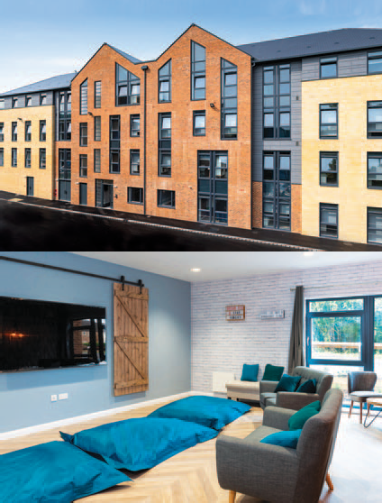





| chi.ac.uk/accommodation
The information in this document is correct at the time of printing. For the most up-to-date information, please refer to our website.

Frequently Asked Questions

When can I apply for accommodation as a UK student?
(For all other students please see Allocation Policy on the Accommodation Office website.)
You will be able to apply for your accommodation between May and June. You will need to do this via the Online Accommodation Portal once you have logged onto your ChiView account.

When should I expect to receive my accommodation offer?
You will be advised, via email, of the accommodation you have been offered by the beginning of September.

How many people share the facilities?
Most facilities are shared between five to seven people.
Can I bring a car?
Due to lack of parking facilities, we are unable to offer parking to students living in our university managed properties. Students allocated accommodation at Havenstoke Close can apply for a parking permit at a cost of £275.73 for the period of the accommodation license (39 weeks). Residents at Stockbridge and Fishbourne Road halls, along with all other off campus accommodation are not permitted to bring a car into the city due to planning restrictions.

When can catered residents use their meal allowance?
You can spend your allowance how you wish across the breakfast, lunch and dinner service provided at both Campuses throughout the week. At weekends, only a brunch service is provided. The opening times for the restaurants are as follows:
Bishop Otter Campus
Monday to Friday: 7.30am - 7.00pm Weekends: 10.30am - 12.00pm
Bognor Regis Campus
Monday to Friday: 7.30am - 7.00pm Weekends: 10.30am - 12.00pm
Are staff available 24 hours a day?
Yes, the Accommodation Office and/or Security staff are available 24 hours a day during the licence agreement period.

Will I have internet access in my room? Internet access is provided free of charge. All of our bedrooms come with WiFi internet
connectivity, with most on-campus bedrooms also able to connect via an ethernet socket within the bedroom. Further details about our internet service are available in the 'Handbook for Residents'.
Do I need a TV licence?
You need to be covered by a valid TV licence if you watch or record TV as it's being broadcast or via iPlayer. This includes the use of devices such as a computer, laptop, mobile phone or DVD/video recorder.
What do I need to bring?
You will need to bring bedding and towels, crockery, cutlery, cooking utensils, pots and pans and any start up groceries you may require. All kitchens will be provided with kettles, toasters, microwaves, ovens and mop/bucket. Further details will be included in your e-induction sent during the first week of September or can be found in your Handbook for Residents.
When are the accommodation fees due?
The accommodation fees are divided into three instalments of 40%, 40% and 20%. The first being due in October, the second in January and the third in April.

Can I stay in the accommodation during the vacation periods?
Yes, you will be able to stay in your room during all vacation periods until the end of your licence agreement; this will include Christmas and Easter.
Please bear in mind that there will be no catering at Christmas, Easter and Bank Holidays, and only brunch is served during Reading Weeks, Inter-Semester Weeks and at weekends.
Can I leave my accommodation early?
If you wish to leave your accommodation early you will need to advise the Accommodation Office of your intention to leave in writing and you will be responsible for the rent for the entire licence agreement, unless a suitable replacement is found.
Is there a launderette available?
All rooms have access to a launderette or laundry facilities nearby or within the accommodation.

Are there bicycle storages available? Bicycle stores are available on both campuses and also at Stockbridge Student Village and Fishbourne Halls.

Are the facilities suitably managed and maintained?
Yes, all University accommodation facilities comply with the ANUK Code of Standards, which is a nationally recognised accommodation accreditation scheme.
Can I have friends/family visit me whilst in Halls?
You are more than welcome to have visitors during your stay – please note that you will remain responsible for their behaviour and actions. Guests staying overnight will need to be signed-in for fire safety purposes. Please read our Residents Handbook for further information regarding overnight guests.
Are there recycling facilities?
Yes. There are recycling facilities and students are inducted in how to recycle as much waste as possible.
”

“I loved living in student halls. It helped me make friends so quickly and I always loved chatting with people on the walk up to uni.”
Crystal, BA (Hons) Theatre, Stockbridge Halls, Chichester

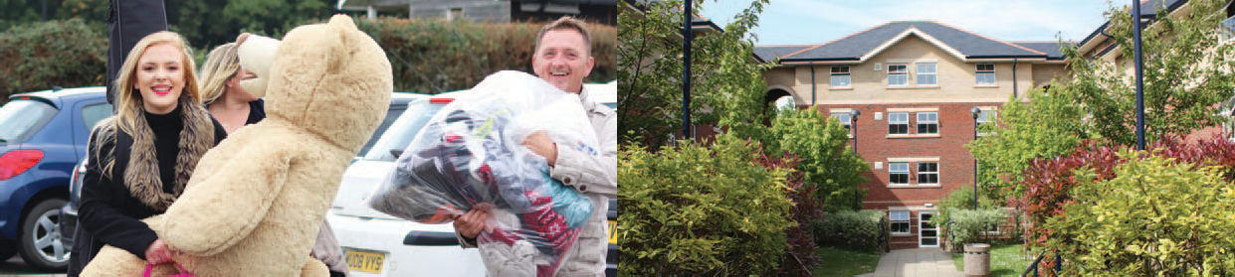
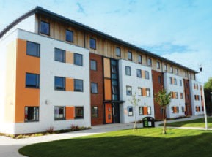

CONTACT US: +44 (0)1243 816069 | accommodation@chi.ac.uk
#chiuni | chi.ac.uk/accommodation
The information in this document is correct at the time of printing. For the most up-to-date information, please refer to our website.

