
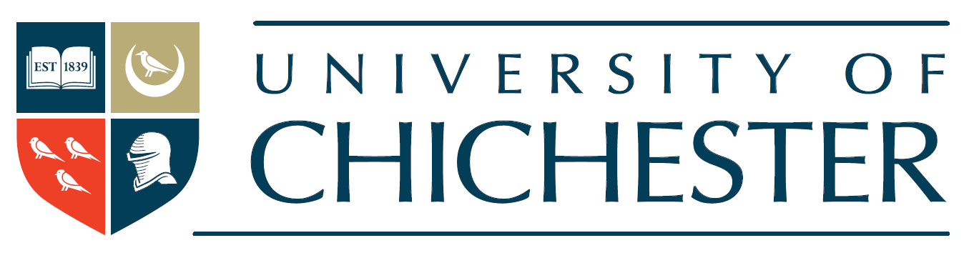

Masters in Research Methods – Research Proposal
Please complete the following template which provides an outline of your proposed research project.
Name:

Have you spoken with anyone at the University about this proposed project? If so, who have you discussed this with?

Proposed title of research project:

Aims and objectives of the research:
Please provide 2 or 3 statements that emphasise what you want to achieve in this research project.

Justification of the research:
Please provide a brief justification for your proposed research. This might include reference to current gaps in knowledge, how the research adds to existing knowledge, and/or what solutions it aims to provide (300 words maximum)

Method - Participants in the research:
Please outline the proposed sample group (i.e., who will participate, how many people) and how you envisage participants might be recruited (200 words maximum)

Method – Research Procedure
Please outline how you will collect data and any anticipated methods of analysis. In doing this you might outline any existing research skills you have and any skills you would like to learn on the MRes (300 words maximum)

Potential challenges to completing the research project:
Please consider any challenges that you might encounter in completing this project. These challenges might include (but are not restricted to) ethical issues, time management, research skills, participant recruitment (200 words maximum).

Key readings:
Please reference 2 or 3 key readings that have informed your ideas so far.

